PENTAHO DATA CATALOG 10.2.11 · IT ADMINISTRATOR
PDC ADMIN · USERS & ROLES
WORKSHOP 0 · PREFLIGHT
Provision Users & Roles
Reset the Catalog administrator, then create every Arizona Water Company account mapped to the least-privilege role its work requires — the groundwork every later workshop depends on.
Primary role: IT Administrator / Catalog Admin
Estimated time: 20 minutes
Prerequisite for: Workshop 1 onward

Why this workshop matters
Every governance journey begins with people, not data. Before Pentaho Data Catalog (PDC) can connect a source, profile a table, or govern a business term, the Arizona Water Company (AWC) team needs accounts — and each account needs exactly the access its owner's job requires, and no more. Workshop 0 is that groundwork. It runs once, before Workshop 1, and everything the cohort does afterward assumes the users and roles you create here.
AWC is a regulated water utility, and in a regulated utility who can change what is as important as the data itself. A business steward who curates the glossary should not be able to rewrite a data source; an analyst who reads metadata should not be able to administer the system. PDC expresses these boundaries through role-based access control, and this workshop maps each real AWC person to the role that matches their responsibility.
The business problem
Hand every trainee the same all-powerful login and two things go wrong: nobody can tell, from the catalog, who is responsible for what — and a single mistake can change data that a regulator expects to be controlled. Provisioning distinct, least-privilege accounts up front makes ownership visible and auditable, and it lets the rest of the course demonstrate real separation of duties rather than pretend at it.

What you will learn
- How PDC separates identity (who you are, held in Keycloak) from authorization (what you may do, expressed as PDC roles and communities).
- The seven default PDC roles across the Business and Expert tiers, and what each one can and cannot do.
- How to reset the Catalog administrator's password in Keycloak and grant it the full set of roles.
- How to add each AWC user in Data Catalog and assign the least-privilege role their work requires.
- Why least privilege and separation of duties are governance controls, not just IT hygiene.

Background: how PDC does identity and access
PDC delegates authentication to Keycloak, the identity provider bundled with the platform. Keycloak holds each user's identity and credentials in a realm — for this instance the realm is pdc — and PDC authenticates users against the pdc-client OIDC client. Authorization — what a signed-in user may actually do — is expressed in PDC as roles and communities. In practice this means two places do two jobs: you set or reset a password in Keycloak, and you assign roles in Data Catalog.
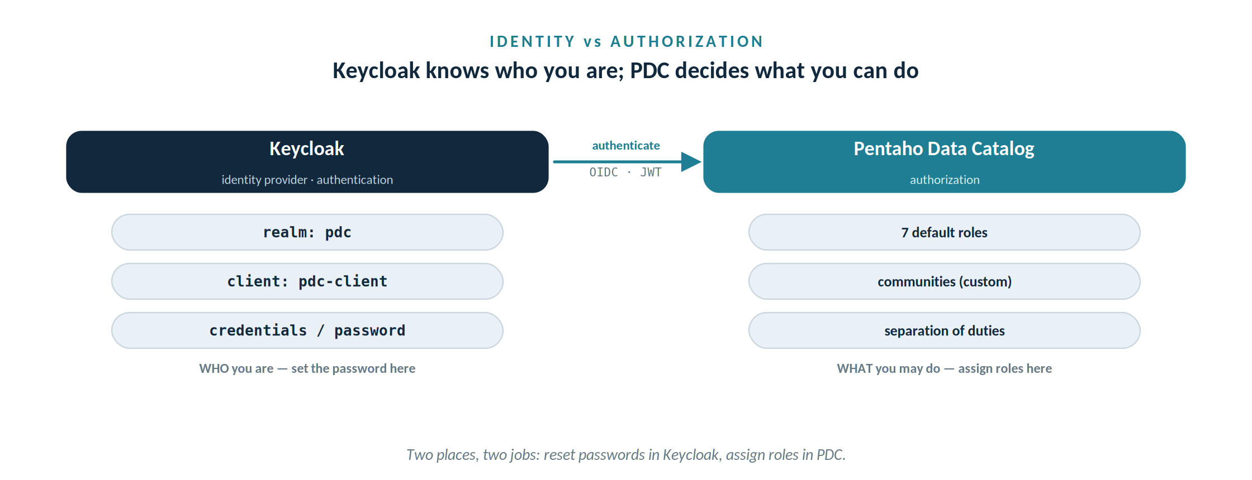
Keycloak authenticates you; PDC authorizes you. Set passwords in one place, assign roles in the other.
PDC groups its default roles into two licensed tiers. Business Users mostly view and explore; Expert Users create, ingest, and curate. When a user holds more than one role the highest-level role determines effective permissions, and the number of Expert seats you can assign is capped by your licence — worth remembering before you hand out steward roles freely.

Tier | Role | What it can do
Business | Business User | View business glossaries and policies. No data-source access.
Business | Data User | Business User, plus view/add/delete data-source content, dashboards, and BI.
Expert | Business Steward | Create, update, import/export business glossaries and policies. Cannot modify data sources.
Expert | Data Steward | Create and manage data sources, profiling, business rules, data-identification methods, and reference data.
Expert | Admin | Manage user accounts, roles, permissions, and system configuration.
Expert | Data Storage Administrator | Manage storage utilisation and Data Optimizer tiering across sources, folders, and schemas.
Expert | Data Developer | Design and maintain business rules, metadata and MDM rules, and data-domain logic.

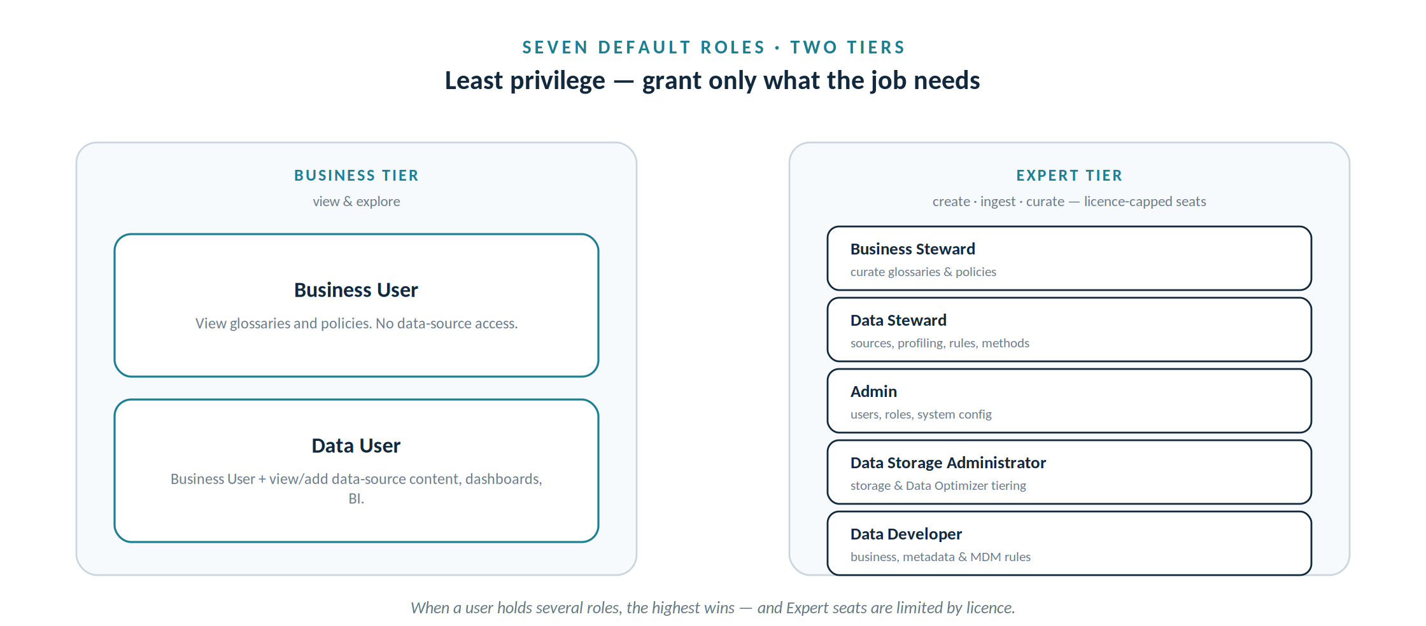
Two tiers, seven roles: Business users view and explore; Expert users create, ingest and curate.
Beyond the defaults, PDC also supports communities — custom roles built on a base role that narrow or widen access to specific assets (a Finance community that sees only finance glossaries, for example). This workshop uses the default roles; communities become useful once AWC scopes access by department.

Before you begin

Prerequisites
- A running PDC 10.2.11 instance with its Keycloak reachable, and the Keycloak administrator credentials (master-realm admin) to reset passwords.
- An initial account with the Admin role so you can open Management → Users & Communities. In this scenario that account is catalog.admin.
- The AWC roster below. All AWC emails follow the pattern name@azwater.gov.

Reference — admin parameters
Substitute your own host wherever pentaho.io appears.
Field | Value | Notes
PDC console | https://pentaho.io | Your instance root.
Keycloak admin | https://pentaho.io/keycloak | Admin console; sign in, then select the realm below.
Realm | pdc | The PDC tenant realm — not master.
OIDC client | pdc-client | The client PDC authenticates against.
Admin user | catalog.admin | Reset its password (Part A).
Admin password | azwater | Lab credential — set non-temporary; change in production.

Step-by-step

Part A — Reset the Catalog administrator (Keycloak)
- Open the Keycloak admin console at https://pentaho.io/keycloak and sign in with the Keycloak (master-realm) administrator credentials – admin / admin.
- At the top-left realm selector, switch from master to the pdc realm. Everything below happens in the pdc realm.
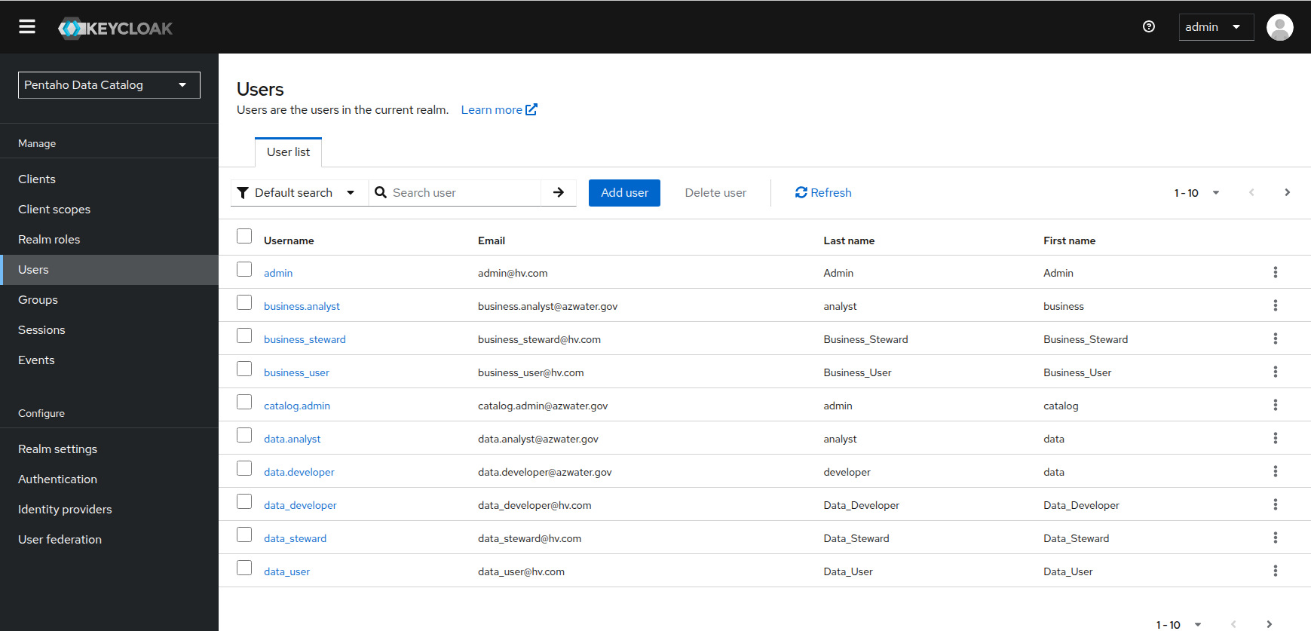
Ensure you’ve selected the PDC realm
- Go to Users, search for catalog.admin, and open the account. If it does not exist yet, click Add user, set the username to catalog.admin and email catalog.admin@azwater.gov, and save.
- Open the Credentials tab, click Reset password, enter azwater in both fields, and — importantly — turn Temporary off so the password works immediately without a forced reset. Save.
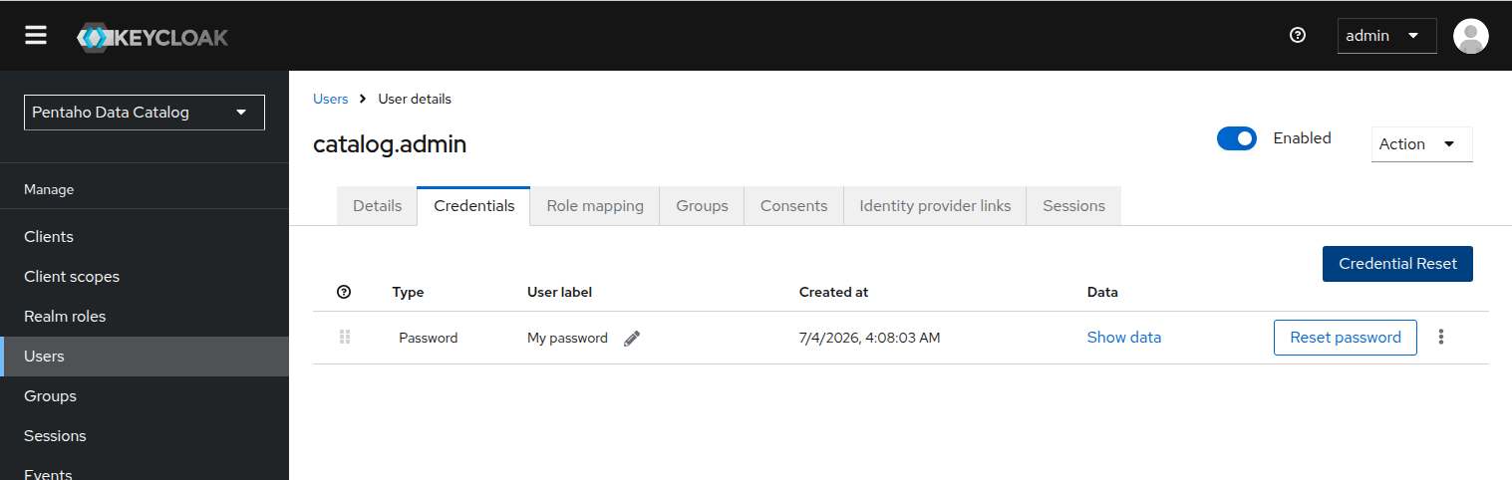
Rest password for all @azwater.gov accounts

- Grant every role. In PDC (signed in as an existing Admin) go to Management → Users & Communities → Users, open catalog.admin, click Add Roles, tick all seven roles, and click Done.
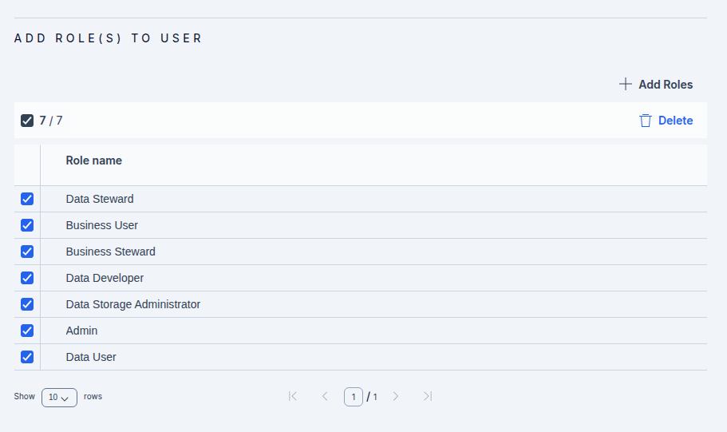
Add all the Roles
- Click Done again to apply the changes to the Role.
Why grant the admin every role?
Across the course the trainer account needs to demonstrate any action — connect a source (Data Steward), curate a term (Business Steward), administer users (Admin), model tiering (Data Storage Administrator). Granting all roles avoids switching accounts mid-lesson. If the PDC UI refuses an overlapping combination, assign the roles directly as Keycloak realm roles instead, which is not subject to the UI's same-base restriction. Watch for the licence cap on Expert seats.

Part B — Add the AWC users (Data Catalog)
Sign in to PDC as catalog.admin / azwater. Confirm the Administration area is visible — proof the Admin role took effect — then add each user from the roster.

The AWC roster — user to role mapping
User | PDC role(s) | Why
catalog.admin  catalog.admin@azwater.gov | ALL SEVEN ROLES | Course superuser / trainer. Password reset in Keycloak to azwater.
david.chen  david.chen@azwater.gov | Data Steward · Business Steward | Connects sources, profiles, runs identification; owns Usage / Operations terms.
maria.garcia  maria.garcia@azwater.gov | Business Steward | Owns Customer + Governance terms and policies.
robert.hayes  robert.hayes@azwater.gov | Business Steward | Owns Billing & Rates terms, including Customer Account Number.
susan.park  susan.park@azwater.gov | Business Steward | Displayed as Dr. Susan Park; owns Compliance & Governance terms (CDE).
data.analyst  data.analyst@azwater.gov | Data Steward | Profiling, data discovery, and lineage work.
business.analyst  business.analyst@azwater.gov | Data User | Reads metadata, searches the catalog, uses Galaxy View.
data.developer  data.developer@azwater.gov | Data Developer

- On the left menu click Management. The Manage Your Environment page opens.
- On the Users & Communities card, click Add New and select Add User. The Create User page opens.
- Enter the user's details — username and email from the roster (for example maria.garcia / maria.garcia@azwater.gov).
- Click Add Roles, tick the role or roles listed for that user in the roster, and click Save. Assign only what the mapping specifies — that is the least-privilege discipline in action.
- Click Done to create the user. Repeat for all six AWC users. If you see an “exceeded licensed limit” message, you have assigned more Expert seats than the licence allows — see Troubleshooting.

Part C — Set each user's initial password (Keycloak)
New PDC users have no usable password until one is set (or, if SMTP is configured, until they follow an emailed reset link). For a self-contained lab, set them directly.
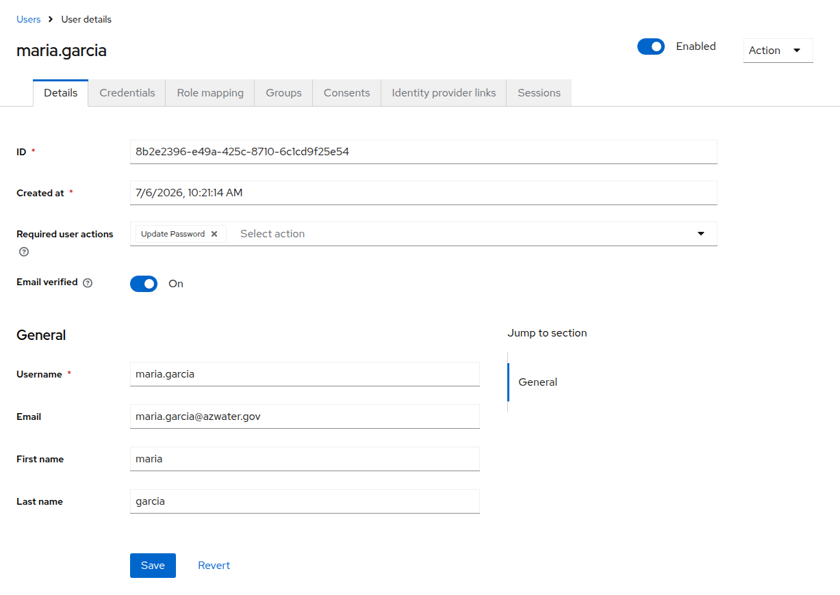
Keycloak – maria.garcia
- Back in the Keycloak admin console, pdc realm, open Users and select each newly created account Note the UUID that uniquely identifies the user).
- On the Credentials tab, Reset password to the shared lab password azwater, with Temporary turned off. Save.
- Repeat for each user. In production you would instead enable SMTP and let users set their own passwords via the reset link — never a shared credential.
Least privilege, from the first screen
Notice what you did not do: you did not give every steward the Admin role, and you did not give the analyst any steward role. maria.garcia can shape the glossary but cannot touch a data source; data.analyst can profile data but cannot administer users. That separation is exactly what a regulator expects to see, and it is why the later workshops can show real ownership rather than a single god-account doing everything.

Verify your work
You are done with Workshop 0 when all of the following are true:
- catalog.admin signs in to PDC with the password azwater and sees the Administration area.
- All six AWC users exist under Users & Communities, each with the role(s) from the roster.
- A Business Steward (for example maria.garcia) can open Business Glossary but not create a data source.
- A Data Steward (for example david.chen) can add a data source, which the analyst account cannot.
- No “exceeded licensed limit” warnings remain against any assignment.

Troubleshooting
Symptom | Cause and fix
“Exceeded licensed limit” when assigning a role | You have assigned more Expert-tier seats (Business Steward, Data Steward, Admin, Data Storage Administrator, Data Developer) than your licence allows. Free a seat, or use a Business-tier role where it is sufficient.
Cannot assign an overlapping role | The PDC UI blocks assigning a default role plus a community derived from the same base role. For catalog.admin's all-roles requirement, assign the roles directly as Keycloak realm roles, which the UI restriction does not govern.
A new user cannot sign in | The Keycloak password was left as Temporary, so PDC forces a reset the user cannot complete without email. Reopen Credentials and turn Temporary off, or configure SMTP so the reset link is delivered.
404 or auth error getting a token | Wrong realm or base URL. Use the pdc realm (not master) and the server root as the base — no port suffix and no /keycloak in the base URL you configure elsewhere.
Role change not reflected | PDC applies permission changes on sign-in. Ask the user to refresh the browser, or sign out and back in.

Why it matters & discussion
Access control is the quiet foundation of every catalog. By separating identity in Keycloak from authorization in PDC, and by assigning each AWC user only the role their work requires, you have made two things true before a single table is connected: the catalog can show who is responsible for what, and no account can do more than its job demands. Those are the same properties an auditor looks for. As the cohort moves into Workshop 1 and beyond, keep asking the governance question this workshop sets up — not just “can I do this?” but “should this role be able to?”

