PENTAHO DATA CATALOG 10.2.11 · BUSINESS ANALYST
PDC PROCESS · METADATA INGEST
WORKSHOP 1
Connect the Data Sources
Bring the Arizona Water Company database and document store under Catalog governance

Primary role: Data Steward / IT Administrator
Estimated time: 15 minutes
Dataset: Arizona Water Company (awc_operations + awc—documents)

Why this workshop matters
Every governance journey begins the same way: you cannot Catalog, profile, protect, or trace data that the Catalog cannot see. Workshop 1 is where Pentaho Data Catalog (PDC) first meets the Arizona Water Company (AWC) data estate. By the end, two very different worlds of data will be visible in one place — and everything you do in the remaining workshops depends on the connections you make here.
AWC is a regulated water utility serving 24 systems across Arizona, from the Pinal Valley around Casa Grande to Sedona, Apache Junction, Sierra Vista, and Bisbee. Like every utility, AWC runs on two kinds of information. The first is structured operational data — customers, meters, billing, water-quality readings — living in a PostgreSQL database. The second, and far larger, is unstructured content: EPA compliance reports, field inspection write-ups, customer correspondence, SCADA sensor feeds, and GIS exports. Industry studies put unstructured content at 80–90% of what an organization generates, and a utility is no exception.
The business problem
Before PDC, an AWC analyst asked “what do we know about Apache Junction?” had to search the billing database, then a compliance file share, then someone’s email. The answer was scattered, and nobody could be sure it was complete. Connecting both the database and the document store to one Catalog is the first concrete step toward answering that question in one place — and toward proving, to a regulator, that AWC knows where all of its data lives.

What you will learn
- How PDC models a data source, and why connection details are encrypted and tested before a source goes live.
- How to connect a PostgreSQL database and ingest its schema so the awc_operations tables become Catalog assets.
- How file and object-store sources differ from databases — why they are scanned rather than schema-ingested, and which engine processes them.
- How to connect the MinIO object store holding AWC’s documents, and preview how those documents are processed.
- Why a read-only connection user is the right choice for a Catalog, and how it reflects good governance from step one.

Background: how PDC sees data
A data source in PDC is a stored, encrypted definition of how to reach a system — its type, host, credentials, and options. PDC encrypts the user name and password before storing them, and a source stays OFFLINE until a successful Test Connection proves the details work. This is deliberate: a Catalog that holds connection secrets for every system in the business must protect them, and must never present a half-working connection as trustworthy.
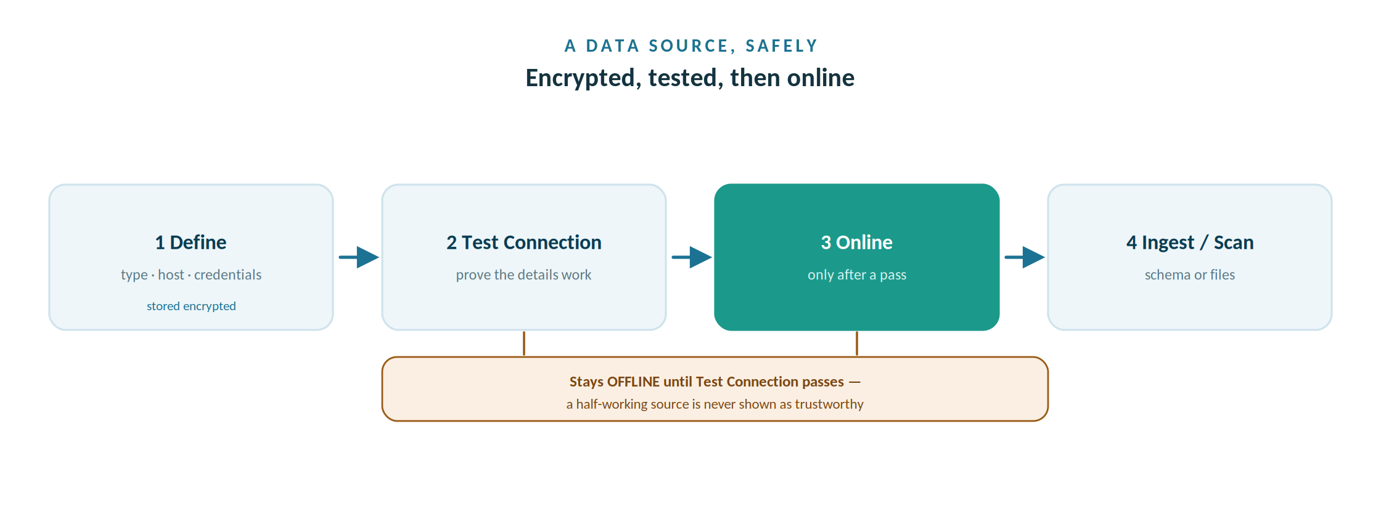
A source is defined with encrypted credentials and stays offline until Test Connection proves it works.

Two on—ramps: schema ingest vs. file scan
How a source is brought in depends on what kind of data it holds, and this distinction runs through the whole course:
 | Structured database | File / object store
Example at AWC | PostgreSQL awc_operations | MinIO awc-documents bucket
Load step | Ingest Schema | Scan Files
What loads | Tables, columns, types, keys | Files, formats, sizes, paths
Processing engine | Data Integration | Data Optimizer
Profiling later | Column profiling | Document Processing

Understanding this split is the single most useful concept in Workshop 1. A database is described by its schema, so PDC ingests that schema. A bucket of PDFs and CSVs has no schema, so PDC scans the files and reads their content with a different engine. Same Catalog, two on-ramps.

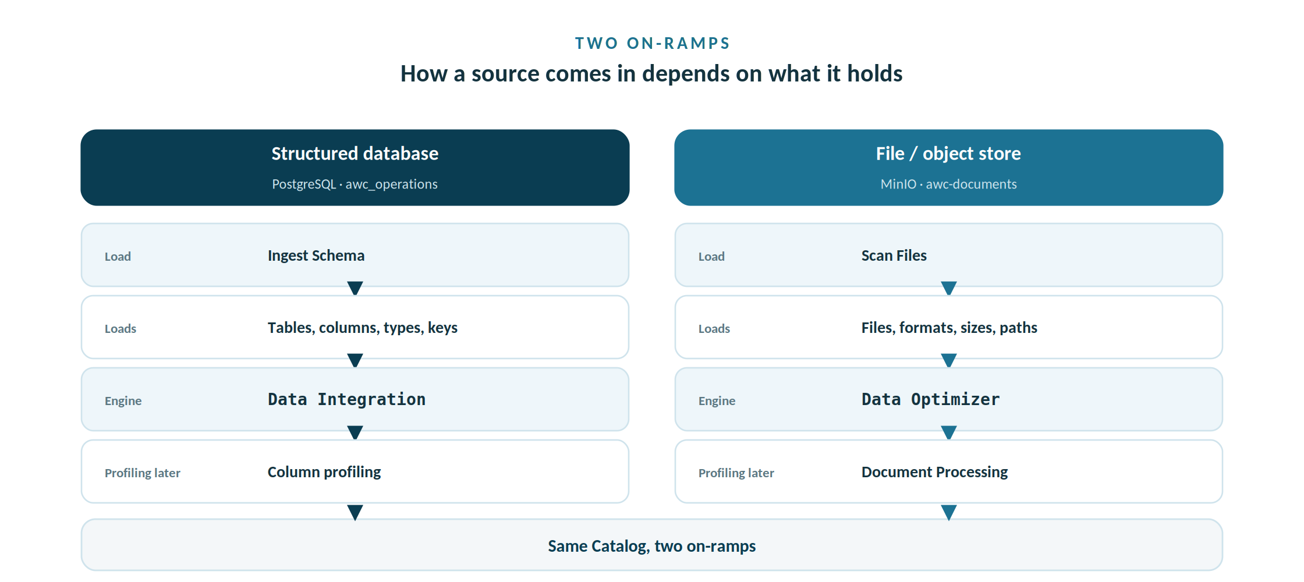
A database is described by its schema, so PDC ingests it; a bucket of files has none, so PDC scans it.

Before you begin

Prerequisites
- The AWC lab stack running (the awc-lab bundle: `make all`), so PostgreSQL and MinIO are both up.
- A PDC 10.2.11 login with Data Steward or IT Administrator rights (creating data sources is an administrative action).
- Network reachability from PDC to the two services – in-container names az-water-postgres and az-water-minio, or the VM/host IP. For the MinIO object-store Endpoint, use the VM/host IP rather than a name (see Part B).

Assets used in this workshop
This package includes everything Workshop 1 needs:
- Arizona-Water-Company-Realistic-Sample-Data.sql — the operational database (loaded automatically by the lab bundle).
- Awc-documents/ — the full document set (17 files across compliance, inspections, correspondence, scada, and gis).
- Workshop-1-Connect-Database.pptx — the slides for this session.
Keep these handy — you will enter them in the steps below. Test Connection must succeed before either source comes online.
Database — Arizona_Water_Operations (PostgreSQL)
Field | Value | Notes
Data Source Name | Arizona_Water_Operations | Letters, digits, and underscores only — no spaces
Data Source Type | PostgreSQL
Host | az-water-postgres | Docker service name; or localhost / the VM IP when reaching it from the host
Port | 5432 | Default PostgreSQL port
Database Name | awc_operations | The AWC operational database
User Name | pdc_user | Read-only — CONNECT, USAGE, SELECT
Password | catalog123! | Lab credential — change in production

Object store — Arizona_Water_Documents (MinIO via the AWS S3 type)
Field | Value | Notes
Data Source Name | Arizona_Water_Documents | Letters, digits, and underscores only — no spaces
Data Source Type | AWS S3 | MinIO is S3—compatible; connect it with the AWS S3 type
Region | us-east-1 | Any value works for MinIO
Bucket Name | awc-documents | The bucket holding AWC documents
Access Key | awc_minio_user | MinIO access key — read-only
Secret Access Key | minio_secret_123! | Lab credential — change in production
Endpoint | http://192.168.1.200:9000 | Use your VM/host IP, not localhost. An IP forces S3 path-style, which MinIO requires (the AWS S3 form has no path-style toggle)
Path | / | Scan the whole bucket from its root

Step-by-step

Part A — Connect the operational database
- In the left navigation menu, click Management. The Manage Your Environment page opens.
- In the Resources card, click Add Data Source. The Create Data Source page opens.
- In Data Source Name, enter Arizona_Water_Operations. Names must start with a letter and contain only letters, digits, and underscores — spaces are not supported.
- In Data Source Type, select PostgreSQL. PDC expands the form with database-specific fields.
- Enter the connection details: Host az—water—postgres (or localhost if PDC runs on the host), Port 5432, Database Name awc_operations, User Name pdc_user, Password catalog123!.
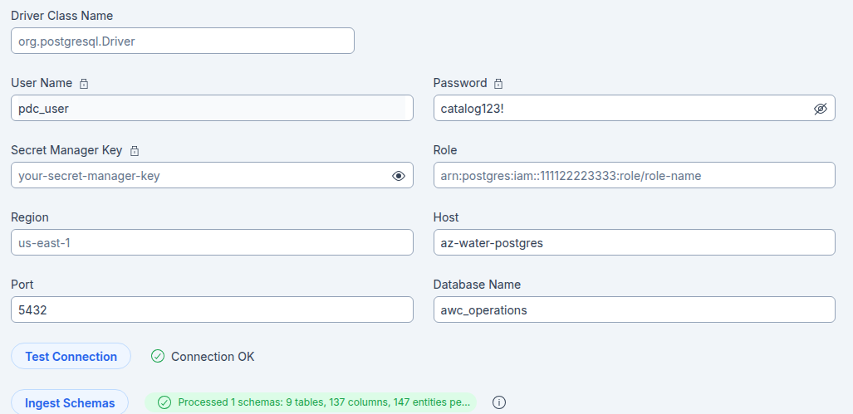
AWC Postgres connection

- Click Test Connection. Wait for the confirmation message. The source remains OFFLINE until this succeeds — if it fails, the message tells you what to fix (usually host or credentials).

- Click Ingest Schema. In the Select schemas dialog, choose the awc_operations schema. You can use include/exclude patterns to filter tables; for this lab, ingest everything in awc_operations.
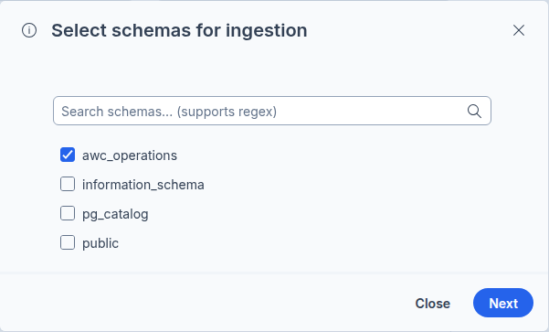
Ingest schema
- Click Ingest, then Create Data Source. PDC loads the six tables and their columns as Catalog assets.
Why a read—only user?
You are connecting as pdc_user, which has only CONNECT, USAGE, and SELECT. The Catalog only ever needs to read — it profiles and describes data, it never changes it. Using a least-privilege user means the Catalog literally cannot modify AWC’s billing or customer records, which is exactly the separation of duties Workshop 4 will discuss. Good governance starts at the connection screen.

Part B — Connect the document store
MinIO is an S3-compatible object store, already running in the lab stack. PDC connects to it as an object-store data source — a different on-ramp from the database.
- Back in Management → Resources, click Add Data Source. Name it Arizona_Water_Documents.
- In Data Source Type, select the S3-compatible / object-store type. The form changes to ask for bucket details rather than a database name.
- Enter: Endpoint http://192.168.1.200:9000, Access Key awc_minio_user, Secret Key minio_secret_123!, Bucket awc-documents. Use your VM/host IP for the Endpoint (here 192.168.1.200), not localhost — from inside the PDC container localhost is PDC itself, and an IP endpoint forces S3 path-style, which MinIO requires. The AWS S3 form has no path-style toggle, so the IP is what makes it work.
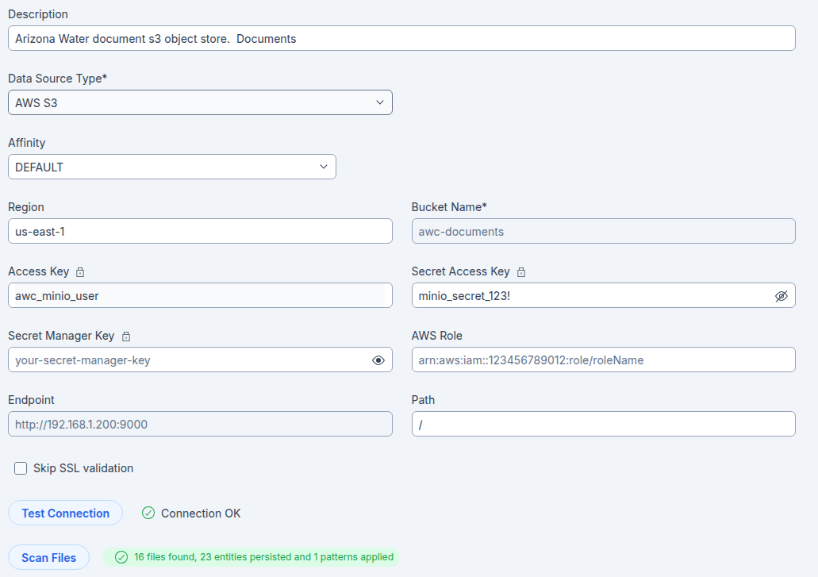
AWC - minIO connection
- Click Test Connection. As with the database, the source stays OFFLINE until the test passes.

- Click Scan Files. In the Scan Files dialog, accept the defaults for a first full scan. Note the options for later: Incremental Ingest (12 hours to 3 months), Include/Exclude patterns to scope folders, and Delete Empty Folders.
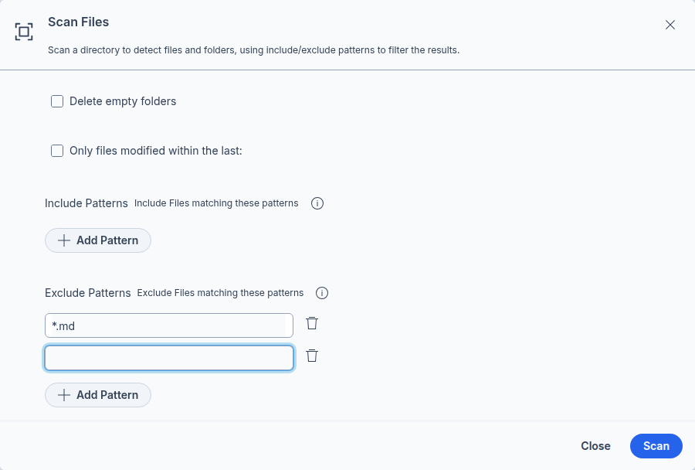
Scan files
- Monitor progress on the Workers page. When the scan completes, the awc-documents folders appear in the Data Canvas next to the database tables.

Part C — Preview processing
Scanning loads file metadata; processing reads content. You will do this fully in Workshop 3, but preview it now so the two on-ramps are clear end to end.
- Run Metadata Ingest first — it reads the files’ metadata into the Catalog. Then open the Choose Process pane (select the folder, then Process) to see the other jobs PDC 10.2.11 offers: Calculate Trust Score, Data Discovery, Data Identification, and PII Detection. We’re going to leave the deeper processing for Workshop 3.

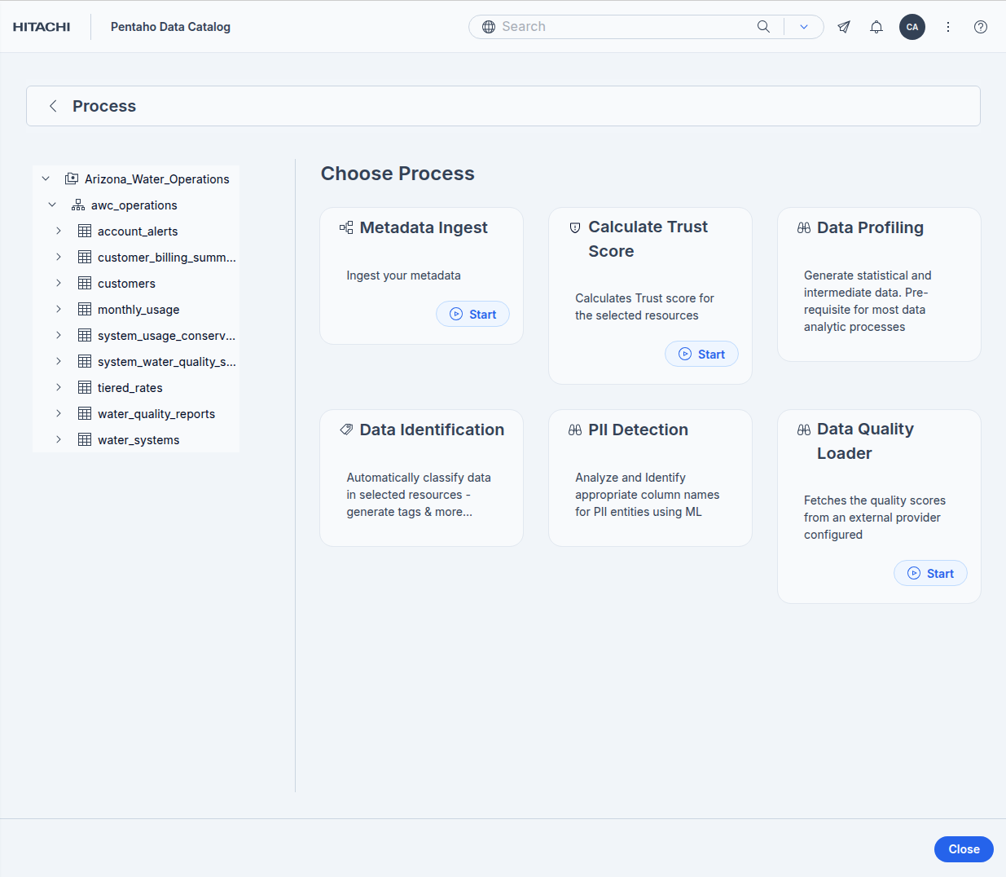

Process structured
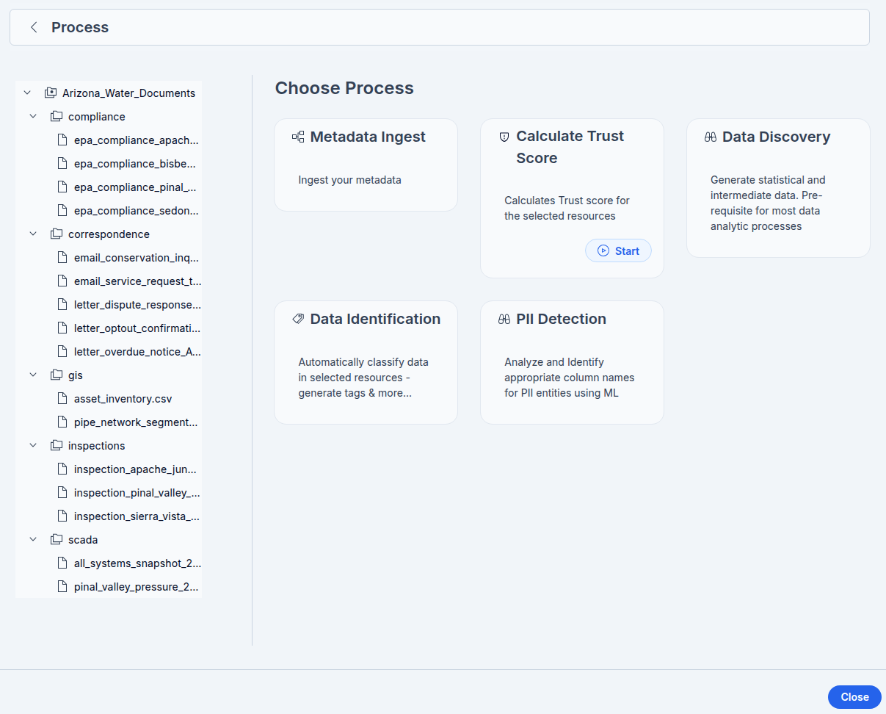
Process Unstructured

Choose Process: the jobs you can run on the documents
After Metadata Ingest, select the folder and choose Process to open the Choose Process pane. In PDC 10.2.11 it offers the jobs below — there is no LLM document summarizer in this build. Each job runs on the Workers page and writes its results back onto the asset. You run these in depth in Workshop 3.
Process | What it does, and where its results appear
Metadata Ingest | Reads each file’s metadata (name, type, size, timestamps, path) into the Catalog. Run it first — every other job depends on it.
Calculate Trust Score | Computes an asset—reliability score from data quality (completeness, accuracy, validity, uniqueness, consistency), user ratings (1–5 stars), data lineage (verified or not), and whether a glossary term is assigned. Shown in the asset’s Key Metrics panel; works for tables and files.
Data Discovery | Generates statistics, data patterns, and samples in a single pass through the data. It is the prerequisite for most downstream analytics — this is the data—profiling step.
Data Identification | Automatically classifies content and applies tags using dictionaries and data—pattern analysis — the built—in sets plus any custom dictionaries or patterns you add. This is PDC’s classification mechanism, and it is rule-based, not an LLM.
PII Detection | An ML check that identifies PII column names and tags them into an auto-created ML_PII glossary, shown in the Business Terms panel. Note the scope: only JDBC tables and CSV/TSV files with Korean or Japanese content — so it does not act on AWC’s English PDFs.

For the compliance/ folder: the realistic sequence is Metadata Ingest, then Data Discovery, then Data Identification, optionally Calculate Trust Score. PII Detection appears on the card but, given its language and format limits, will not apply to these English PDFs.

Scan & ingest scope options
Option | What it means
Delete Empty Folders | Removes folders that have no files under them from the Catalog’s metadata store, so empty directories don’t clutter the Data Canvas. It applies to full scans/ingests only.
Incremental Ingest | Ingests only the files whose created or modified timestamp falls within the period you choose — last 12 hours, 24 hours, 1 week, 1 month, or 3 months. It adds to what is already Cataloged and never removes earlier results, so it is a quick way to pick up recent changes without re-reading the whole bucket.

The two are mutually exclusive - Delete Empty Folders works on full ingests only, so it is unavailable while Incremental Ingest is selected. For the compliance/ folder in this lab, leave Incremental Ingest off (a full ingest) so every EPA document is read.

Optional settings: Physical Location, capacity, and cost
After Test Connection succeeds — and after Scan Files (object stores) or Ingest Schema (databases) — the Create Data Source page shows a group of optional fields before the final Create Data Source button. None are required to Catalog data: they describe where the data lives and what it costs, and they feed Pentaho Data Optimizer, the intelligent tiering engine that can migrate, delete, and rehydrate files to reduce storage cost. The three storage-optimization toggles require a Data Optimizer license.
Field | What it does
Physical Location | Where the data physically lives — a label plus address fields (name, street, city, state/province, postal code, country). Recorded for data—residency and compliance context and for reporting. It does not affect the connection.
Available for Migration | Includes this source in Pentaho Data Optimizer tiering. When enabled, Data Optimizer can migrate (tier) its files to lower—cost or archival storage. Requires a Data Optimizer license.
Available for Writing | Lets Data Optimizer write back to the source — needed to rehydrate (restore) tiered files. Turning it on also enables migration.
Available for Data Mastering | Includes the source in data—mastering activities.
Cost per Terabyte | Price, currency, and billing frequency (day, week, month, or year). Feeds cost modelling so the savings from tiering can be quantified.
Total Capacity | The source’s total size in terabytes — the denominator for cost and utilisation reporting.
Note | Free—text shared with anyone who opens the data source.

For this lab: leave all of these blank and click Create Data Source. We come back to Cost per Terabyte and Total Capacity when we look at Data Optimizer, where AWC can model the savings from tiering cold compliance PDFs into deep archive.

Verify your work
You are done with Workshop 1 when all of the following are true:
- Arizona_Water_Operations is online and a Discovery search for customers returns the table with its columns.
- All six awc_operations tables are visible in the Data Canvas.
- Arizona_Water_Documents is online and scanned, with the five document folders visible in the Data Canvas.
- You can explain, in your own words, why a database is ingested by schema while files are scanned, and which engine processes each.

Troubleshooting
Symptom | Cause and fix
Test Connection fails for the database | Host or credentials wrong. From the host use localhost:5432; in—container use az—water—postgres. Confirm pdc_user / Catalog123!.
Test Connection fails for MinIO | Endpoint or keys wrong. Most often the Endpoint is set to localhost — from inside the PDC container that points at PDC itself, so use the VM/host IP (e.g. http://192.168.1.200:9000). An IP endpoint also forces S3 path-style, which MinIO requires; a hostname makes the SDK prepend the bucket (awc—documents.host) and fail. Confirm awc_minio_user / minio_secret_123! and that the awc—documents bucket exists.
Scan finds no files | The bucket loaded empty. Re-run the lab loader (make load) and confirm 17 files with make verify-files.
Source stays OFFLINE | This is expected until Test Connection succeeds. Fix the connection details and test again.

Why it matters & discussion
PDC encrypts connection credentials and refuses to bring a source online until Test Connection succeeds. Discuss with your group: why are both of those behaviours essential for a regulated utility that holds customer PII and must demonstrate control of its data? Relate your answer to AWC’s obligations under its own privacy policy and the Safe Drinking Water Act reporting it must file.

What’s next
With both sources connected, Workshop 2 reads what the Catalog learned about them — the structure and metadata of the tables, and the document properties of the files. You will see that whether an asset is a billing table or a regulatory PDF, PDC describes it through the same three layers of metadata.

