PENTAHO DATA CATALOG 10.2.11 · BUSINESS ANALYST
PDC · METADATA & THE THREE LAYERS
WORKSHOP 2
Explore Structure & Metadata
Read what the Catalog learned about AWC's tables and documents

Primary role: Business Analyst
Estimated time: 30 minutes
Dataset: Arizona Water Company (awc_operations + awc—documents)

Why this workshop matters
A Catalog is only as useful as the metadata it holds. In Workshop 1 you connected two data sources; now you learn to read what PDC captured about them. For an Arizona Water Company analyst, this is the difference between staring at a table called customers and understanding that it holds personal data, is described by governed business terms, carries a trust score, and links to billing. Metadata is the context that turns raw data into something a business can trust and govern.
The business problem
A new analyst joins AWC and is handed the customers table. Which column identifies the account? Which holds personal data? Who owns the definition of “active customer”? Without metadata, every one of these questions means interrupting a colleague. With a well—described Catalog, the answers are on the asset’s own pages. Workshop 2 teaches you to find them.

What you will learn
- The three layers of metadata — technical, business, and operational — and what each tells you.
- How to read a table’s columns, data types, sizes, and nullability in the Data Canvas — and where key relationships appear once they are discovered.
- How to read an asset’s business metadata — its Description, Remarks, linked Business Terms and Sensitivity — and where governance roles like Domain, Classification, and Business Steward actually live.
- How the same three—layer model applies to an unstructured document, not just a table.
- How to spot a metadata gap — a missing definition or owner — that needs a steward’s attention.

Background: the three layers of metadata
PDC organizes what it knows about every asset into three layers. Learning to read all three is the core skill of this workshop:
Layer | Answers the question | Example for customers
Technical | What is it, physically? | Columns, data types, primary/foreign keys, row count
Business | What does it mean? | Description / Remarks, linked Business Terms, Sensitivity (Domain, Classification & Business Steward live on the Glossary term)
Operational | Can I trust it? | Quality score, last profiled date, lineage to other assets

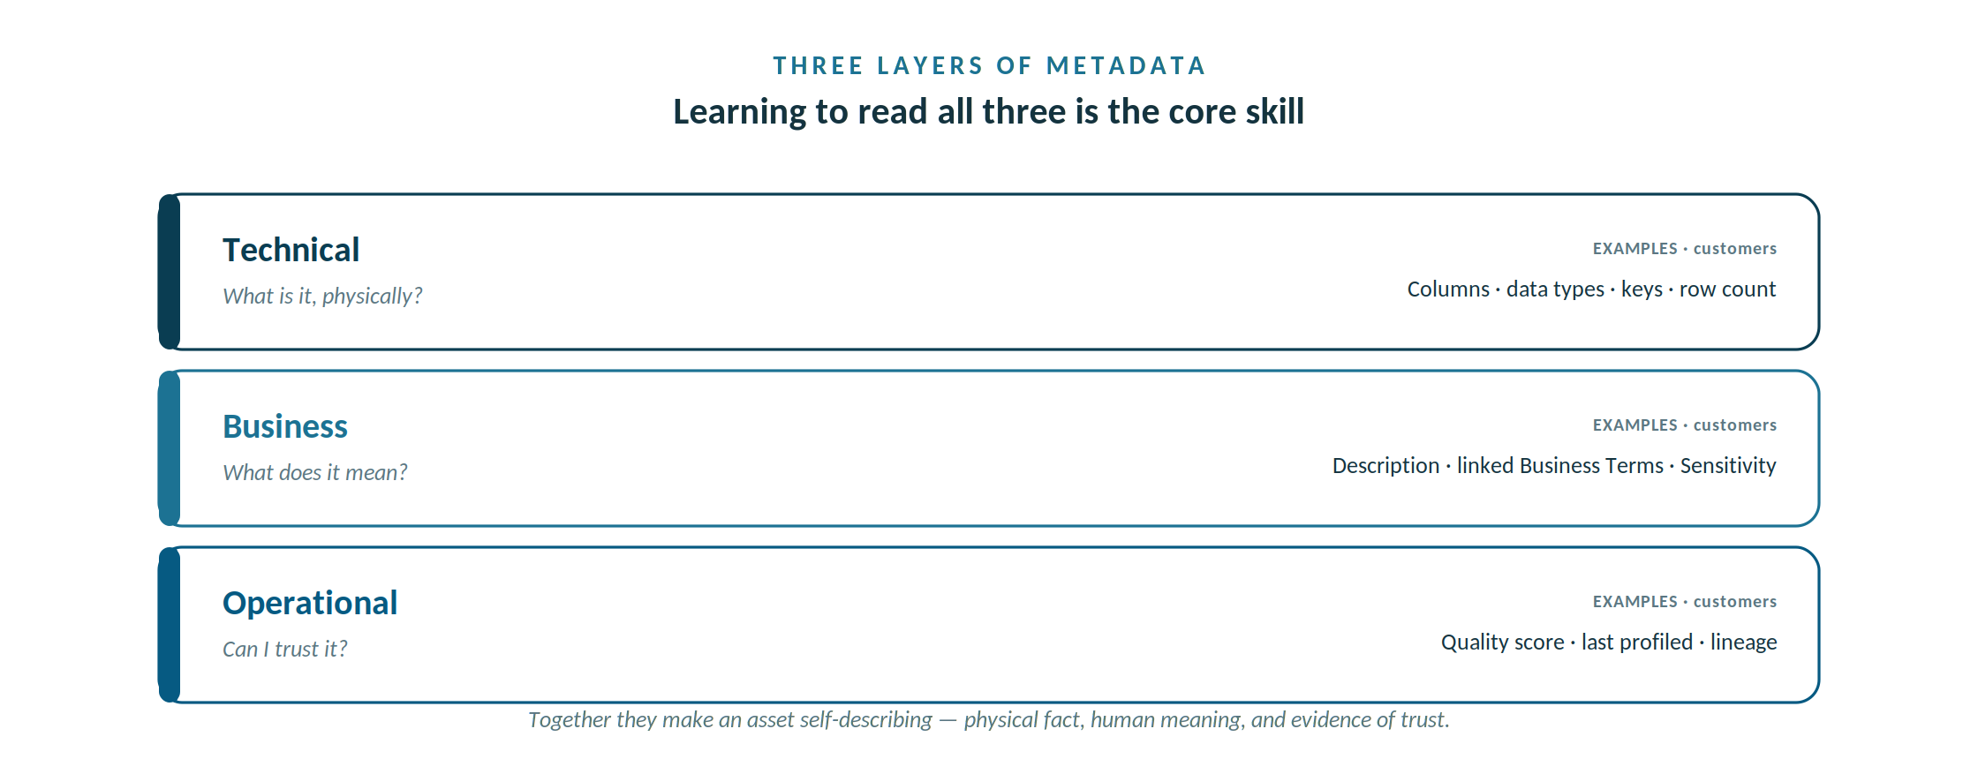
Technical answers what it is, Business what it means, Operational whether you can trust it.
Most technical metadata — columns, data types, sizes, and nullability — is captured automatically when you ingest a schema; row counts and the PK/FK column are added later by profiling: the PK/FK column reflects the keys declared in the source, surfaced by cross—table foreign—key detection once every related table is profiled.
Business metadata is partly automatic and partly added by stewards — it is where human knowledge enters the Catalog.
Operational metadata accrues as the asset is profiled and used. Together they make an asset self—describing.

What’s populated now — and what appears after Workshop 4
Workshop 1 ran only Metadata Ingest (for the schema) and Scan Files (for the documents). That fills in the technical layer completely, but the business and operational layers are produced by four processing jobs you run in Workshop 4. So in this workshop you learn where each field lives and read what is there — and several fields will be empty until Workshop 4. That is expected, not an error.
Processing job | What it populates | Available in Workshop 2?
Metadata Ingest (Workshop 1) | Technical layer — columns, data types, sizes, and nullability; file size and format for documents. | Yes — fully available now
Data Profiling / Data Discovery (Workshop 4) | Operational layer — column statistics, data patterns, sample values, total row count, and the last—profiled date. This also drives foreign—key detection, which surfaces the source’s declared primary and foreign keys in the PK/FK column once every related table is profiled. | No — empty until Workshop 4
Calculate Trust Score (Workshop 4) | Operational layer — the trust / quality score, built from data quality, user ratings, lineage, and glossary terms; shown in Key Metrics. | Default (0 / Untrusted) shows now; a real score needs Workshop 4 profiling.
Data Identification (Workshop 4) | Business layer — Tags and Business Terms applied from dictionaries and patterns; these link the asset to Glossary terms. | No — empty until Workshop 4
PII Detection  (Workshop 4) | Column—level PII flags — but only for JDBC tables and CSV/TSV files in Korean or Japanese. | Not applicable to AWC’s English data
One exception: later a business metadata a steward types in — a Definition, the Domain, the steward name, a Purpose – which does not depend on a processing job, so it may already be filled in. Part B is partly about spotting where those human—entered fields are still missing.
Why the Trust Score reads 0 / Untrusted before profiling
Every asset carries a Trust Score from the moment it is catalogued: it defaults to Untrusted (0), exactly as Sensitivity defaults to Unknown and Data Lineage to Unverified. Seeing the field on the Summary tab does not mean a score has been computed — you are looking at the default.
Trust Score is a roll—up of four inputs — Data Quality, User Ratings, Data Lineage (Verified or not), and whether a Glossary Term is assigned. Trust Score is a table— and file—level metric — it is computed for the asset as a whole, never per column — so one Glossary Term linked to the table satisfies that input; you do not need a term on every column. Running Calculate Trust Score recomputes that roll—up from whatever exists right now; on a freshly ingested table none are populated, so it stays 0 / Untrusted.
Only the Data Quality input needs profiling (plus the Pentaho Data Quality add—on and its Data Quality Loader), which is why a meaningful, quality—based score appears only after Workshop 4. You can move the score earlier by verifying lineage, linking a Glossary Term, or adding a rating — or set one by hand in Key Metrics — but the quality signal comes from profiling. The Trust Score is a sliding scale: it computes from whatever inputs are present and rises as each one is added, sliding from Untrusted toward Trusted and Highly Trusted — so even before profiling you can nudge it off 0 by verifying lineage, adding a rating, and linking a table—level term.

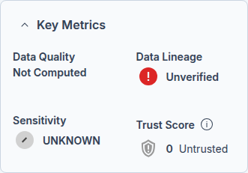

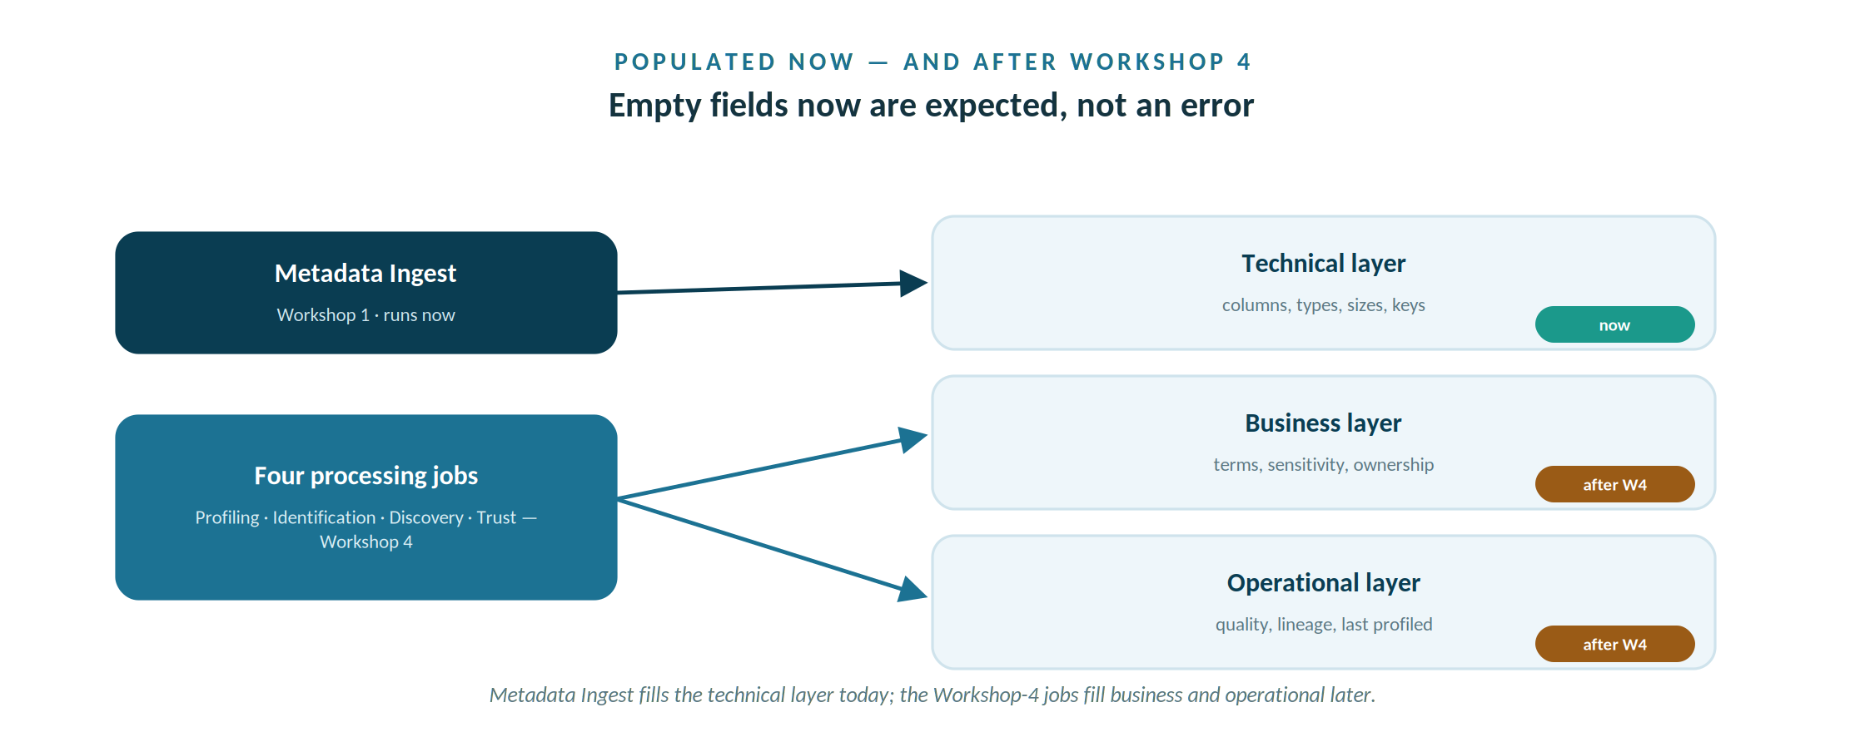
Metadata Ingest fills the technical layer now; the four Workshop-4 jobs fill business and operational later.

Before you begin

Prerequisites
- Workshop 1 complete — both AWC sources connected and visible in the Data Canvas.
- A Business Analyst (or higher) PDC login.

Assets used in this workshop
- The connected awc_operations database (the customers table is the focus).
- An EPA compliance PDF from awc—documents/compliance/ (to read document metadata).
- Workshop—2—Structure—and—Metadata.pptx — the slides for this session.

Step—by—step

Part A — Read a table’s technical metadata
- In the left navigation menu, click Data Canvas and open the Arizona_Water_Operations source.
- Select the customers table. The Summary tab opens with an overview of the asset.
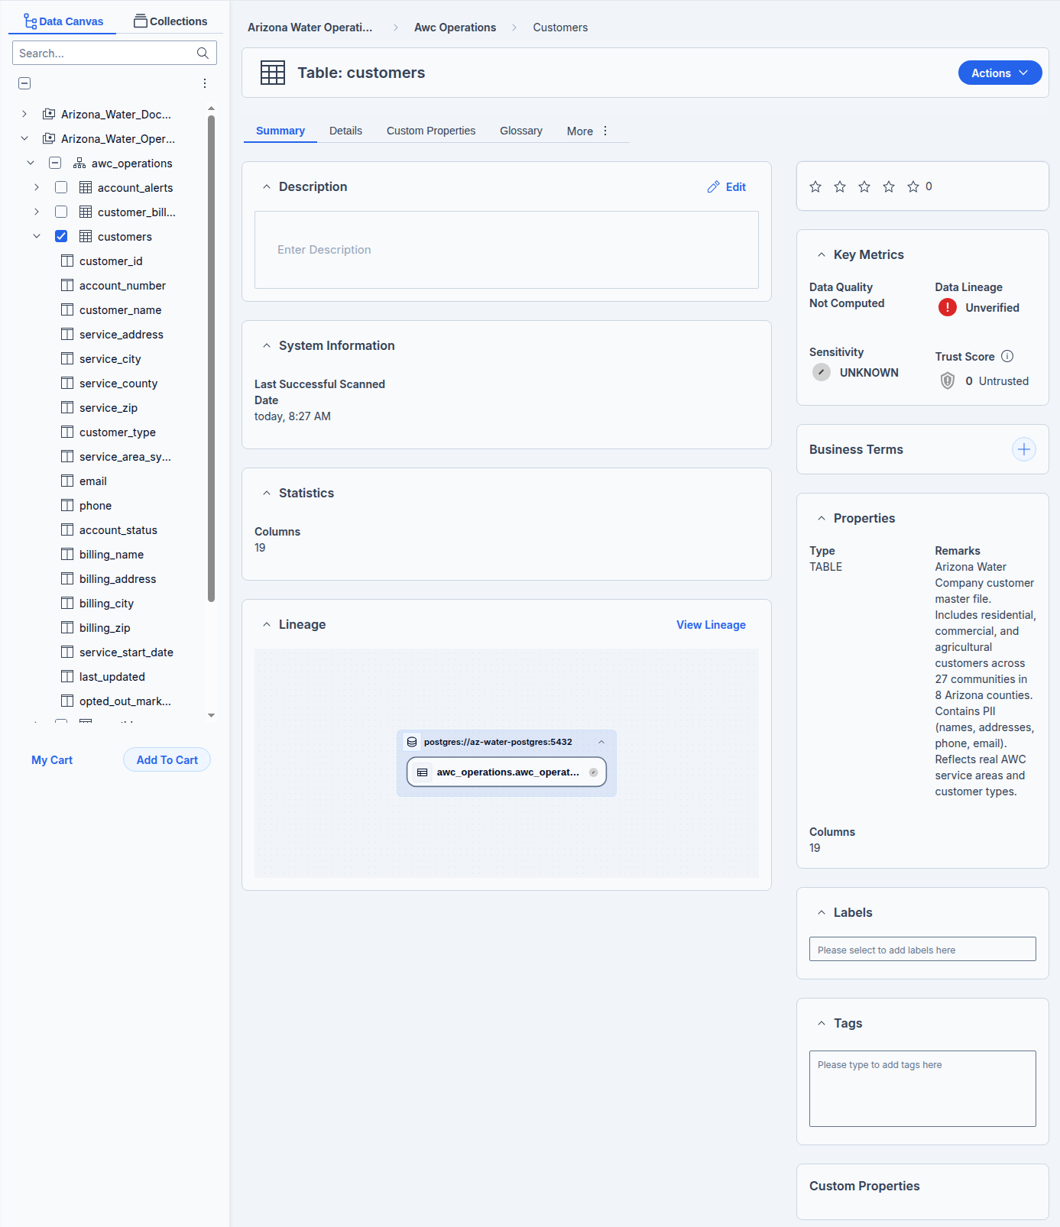
Customers Table
- Open the Details tab to see the Contained Items — every column with its Data Type, Column Size, and Nullable flag. Notice the PK/FK column is still blank: it reflects the keys declared in the source, but PDC only surfaces them through foreign—key detection, which runs on profiling output across related tables in Workshop 4. For now, predict which column is the key (customer_id) and which look like foreign keys; you will confirm them once every related table has been profiled in Workshop 4.
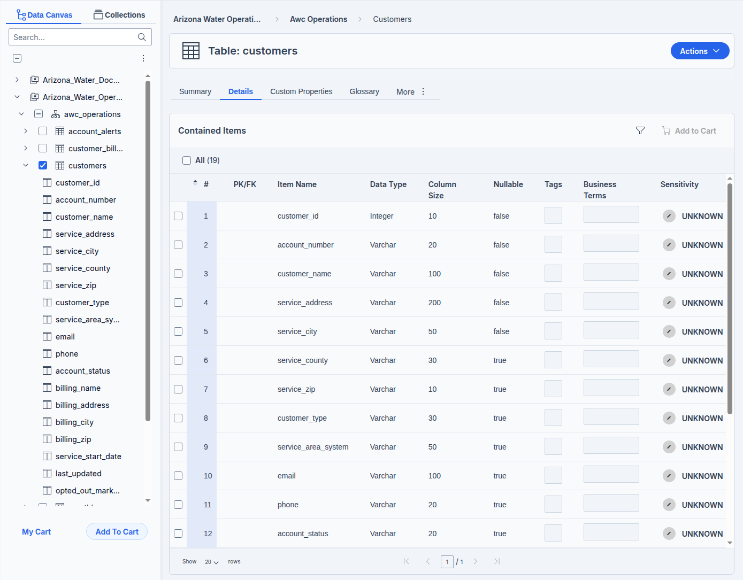
- Find a column whose meaning is not obvious from its name — for example opted_out_marketing. Note that the technical layer tells you it is a boolean, but not what it is for. That is the business layer’s job.

Part B — Read the business and operational layers
- On the customers Summary tab, read the asset’s own business metadata: the Description, the Properties (Remarks), and the Key Metrics panel — Data Quality, Data Lineage, Sensitivity, and Trust Score. A table has a Sensitivity level (Unknown until set), not a Classification field.
- Open the Business Terms panel (or the Glossary tab). A table carries no Domain, Classification, or Business Steward of its own — those are built—in properties of the Glossary term you link to it. Open a linked term to see its Domain, Classification, Business Steward, and Owner.
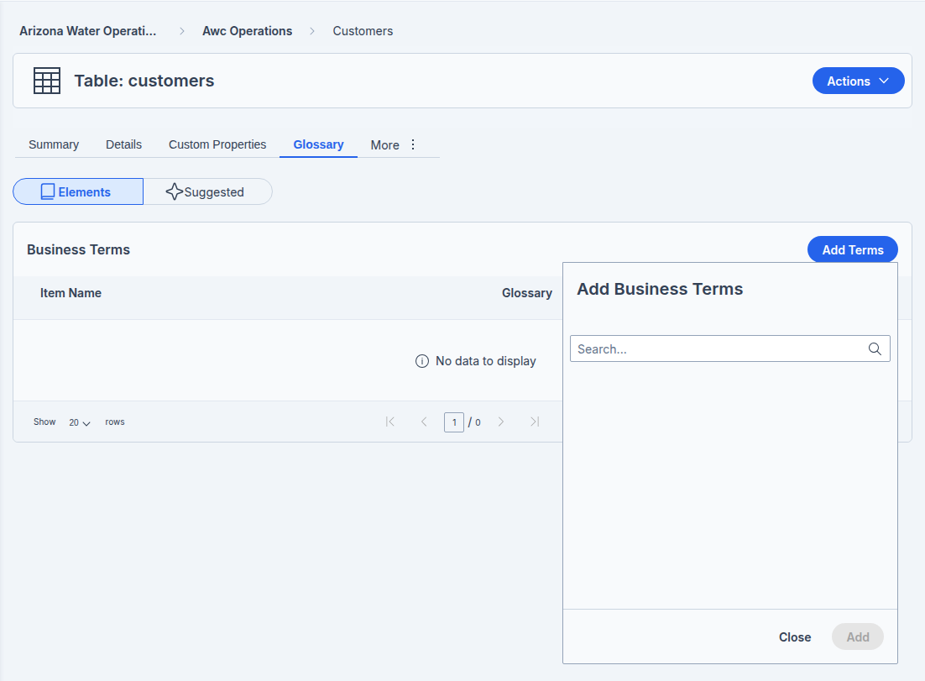
- Find where the data quality / trust score and the last—profiled date appear in the operational layer. Expect them empty for now — they are produced by Data Profiling and Calculate Trust Score in Workshop 4. Note where lineage would appear; you will explore it fully in Workshop 8.
- Identify at least one gap — an empty Description, no linked Business Terms, Sensitivity still Unknown, or a Trust Score of Untrusted — and note it as work for a steward.

Part C — The same three layers for a document
Metadata is not just for tables. Open a document and see the same model expressed differently.
- In the Data Canvas, open the compliance/ folder and select epa_compliance_apache_junction_2026Q1.pdf.
- On its Summary tab, find the Document Properties pane — file size, format, and (after Workshop 4’s processing) page count and owner. This is the document’s technical layer.
- Find the Business Terms, Tags, and Custom Properties panels — the business layer, identical to a table’s. Business Terms and Tags are applied by Data Identification in Workshop 4, so they may be empty now; Custom Properties can be set by a steward at any time.
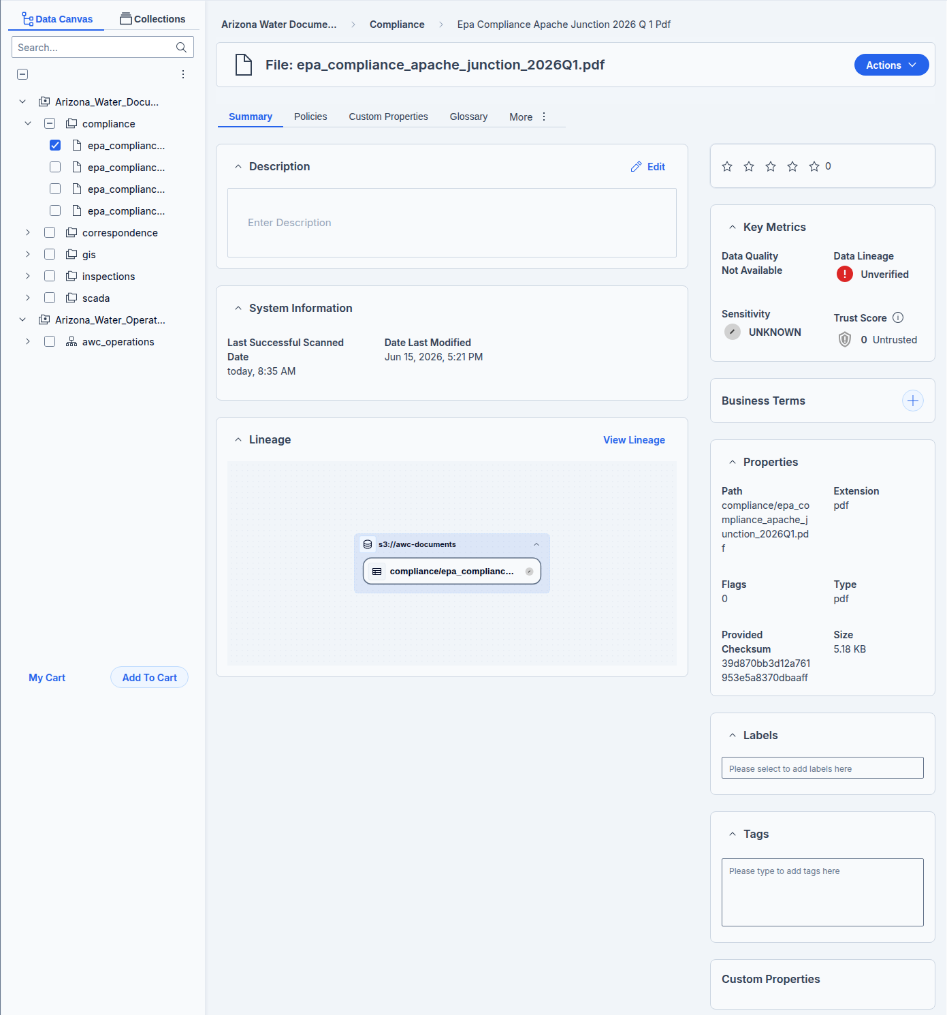

Verify your work
- You can state the data type, size, and nullability of any column in customers, and explain that key roles (PK/FK) surface once every related table has been profiled in Workshop 4.
- You can read the table’s Sensitivity, Trust Score, Data Quality and Data Lineage in Key Metrics, and explain that Domain, Classification, and Business Steward live on the linked Glossary term.
- You can locate where the quality score will appear (it populates in Workshop 4) and explain which tab shows lineage.
- You identified at least one metadata gap to hand to a steward.
- You opened an EPA report PDF and found its Summary tab and Document Properties.

Troubleshooting
Symptom | Cause and fix
The customers table is missing | Schema ingest did not complete in Workshop 1. Re—ingest the awc_operations schema.
No quality score shown | The table has not been profiled yet. That happens in Workshop 4; the field will be empty until then.
Document has no page count or owner | Those come from Document Processing (Extract document properties), run in Workshop 4. Format and size are available now.

Why it matters & discussion
A new analyst asks, “Can I email everyone in the customers table about a new payment plan?” Which single column answers that question, and which metadata layer does it belong to? Discuss why the answer (opted_out_marketing, a piece of business metadata with a compliance purpose) is far more valuable than any technical detail — and what it would cost AWC to get that answer wrong.

What’s next
You can now read what the Catalog knows. Workshop 3 builds the business glossary — the governed terms, sensitivity, and stewardship you link to AWC’s tables. Workshop 4 then measures how much you can trust the data — profiling its quality and processing the documents to summarize and de—duplicate them.

