PENTAHO DATA CATALOG 10.2.11 · BUSINESS STEWARD
PDC · BUSINESS GLOSSARY
WORKSHOP 3
Build the Business Glossary
Give AWC’s data a shared business vocabulary, then link it to the Catalog

Primary role: Business Steward
Estimated time: 15 minutes
Dataset: Arizona Water Company (awc_operations + awc—documents)

Why this workshop matters
In Workshops 1 and 2 you connected AWC’s data and learned to read its three metadata layers — and you saw the business layer come up empty, because that knowledge does not live on the table. It lives in the Business Glossary. This workshop fills that gap. You will build AWC’s glossary: the controlled vocabulary that turns a cryptic column like service_area_system into a governed term with a plain—language definition, an owner, and a sensitivity level — then link those terms to the Catalog so every analyst speaks the same language.
The business problem
A regulator asks AWC to show every field that holds customer personal data, who owns it, and how it is classified. Without a glossary, that means crawling 19 columns across a dozen tables and guessing which ones are PII. With a glossary, the customer’s personal fields — name, address, email, phone — are governed terms, each defined once, classified once, and linked to every matching column, so the answer is a single search. Workshop 3 builds that vocabulary.

What you will learn
- What a Business Glossary is, and how the Glossary, Category, and Term hierarchy organizes AWC’s business language — and why each layer exists.
- The built—in properties that carry governance — Domain, Sensitivity, Classification, Business Steward, and Owner — and why they live on the term, not the table.
- How to create a glossary, categories, and terms in the Data Canvas.
- How to import a glossary from a CSV or JSON Lines file — and how to get the exact format by exporting first.
- How to link business terms to their columns across every table in the source, and recalculate each table’s Trust Score.
- How the Similarity Score powers the Suggested Columns you approve — and where the engine behind it is configured and run (the Technical track).

Background: how a glossary is organized
PDC organizes business language as a three—level hierarchy. A Glossary is the top—level container; Categories group related terms; and Terms are the individual governed concepts, each with its own definition and properties. A term can sit under a category, directly under a glossary, or stand alone (in which case it shows as Unassigned). Tags are separate — lightweight, informal labels for quick discovery that complement terms rather than replace them.
Why these four parts exist: each solves a different problem. The Glossary is the single, definitive reference, so the business stops arguing over what a word means. Categories make that vocabulary navigable, so an analyst can find terms by business area instead of scrolling a flat list. Terms let you define and govern a concept once — definition, owner, sensitivity — rather than re—deciding it on every table. And Linked Data Elements connect that business language to the physical columns and files that implement it, across every data source, so one search answers “where does this live and how is it governed?” and one change shows its full impact.
Level | What it is | AWC example
Glossary | The top—level container for a body of business language. | Arizona Water
Category | A grouping of related terms within a glossary. | Customer; Billing & Rates; Water Quality
Term | A single governed business concept, with a definition and properties. | Customer Name; Tiered Rate; EPA Compliance Status

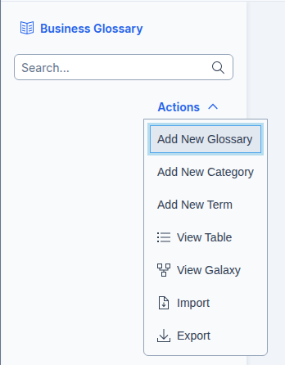

Glossary
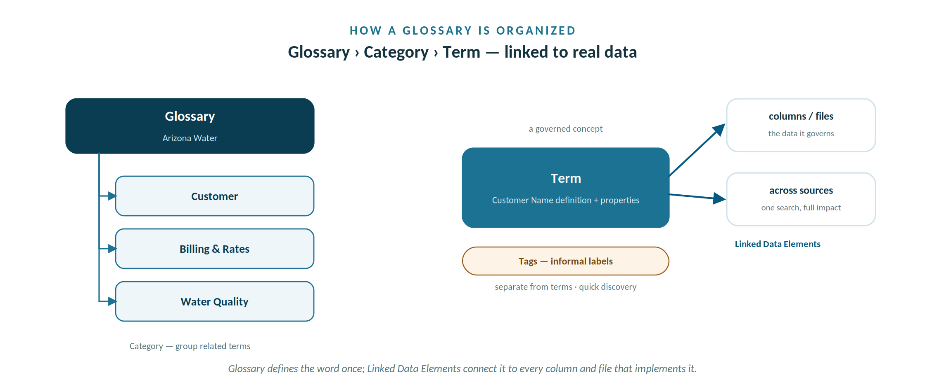
A glossary nests categories and terms, links each term to the real columns and files, with tags alongside.

The properties that make a term governed
Every glossary item carries built—in properties. These — not the table — are where AWC’s governance actually lives. Sensitivity, Domain, and Status are always present: PDC shows them on every term with a default value, so they are never blank — set them deliberately rather than leaving the default. The rest you fill in as policy dictates.
Property | What it records | Example for Customer Name
Sensitivity | Unknown, Low, Medium, or High. Always shown; defaults to Unknown. | High
Domain | The industry domain the term belongs to, chosen from PDC’s built—in domain list. Always shown; for AWC every term sits in Utilities. | Utilities
Status | Draft, Review, Accepted, or Deprecated. Always shown; defaults to Draft. | Accepted
Classification | Public, Private, or Company Confidential. | Private
Business Steward | The role accountable for changes to the term. | Maria Garcia
Owner | The role responsible for maintaining the term. | Maria Garcia
Custodian | The role or person who maintains the data day to day, distinct from the accountable Owner. | Maria Garcia
Review Date | When the term is next due for review. Shown in the UI as “Reviewed At”. | 30 Sep 2026
Stakeholders | People or roles with an interest in the term, beyond Owner and Steward. | Maria Garcia (Steward)
Link it and it sticks: these properties map straight to the Glossary tab you saw in Workshop 2 — assign a term to customers and the table inherits this governance context.

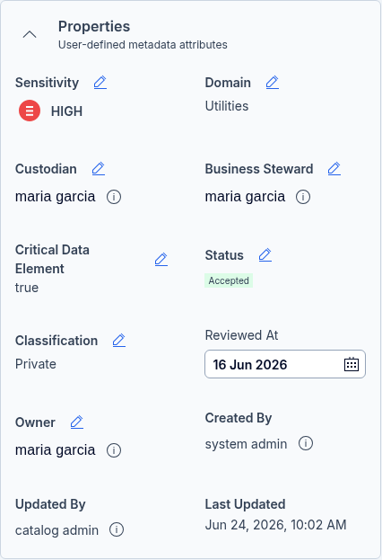
Glossary Properties

Tags and Custom Properties
A term carries two more layers of metadata beyond the built—in properties, and you set both on its Summary page.
Tags: lightweight, free—text labels for discovery and grouping. Type them into the Tags card on the right of the term’s Summary page, and reuse them across terms. For AWC, useful tags include PII, GDPR, CCPA, EPA, Compliance, Customer—Facing, Billing and Conservation. Tags complement terms — they do not replace them.
Custom Properties: admin—defined fields that extend the built—in set. An Admin defines each property once for the whole Catalog (a name and a type); a Business Steward then fills in its value per term, on the term’s Custom Properties tab. Because a property must exist before you can set it, creating custom properties is an Admin task covered in Workshop 9 — here you simply assign values to any that already exist. Properties you might define for AWC:
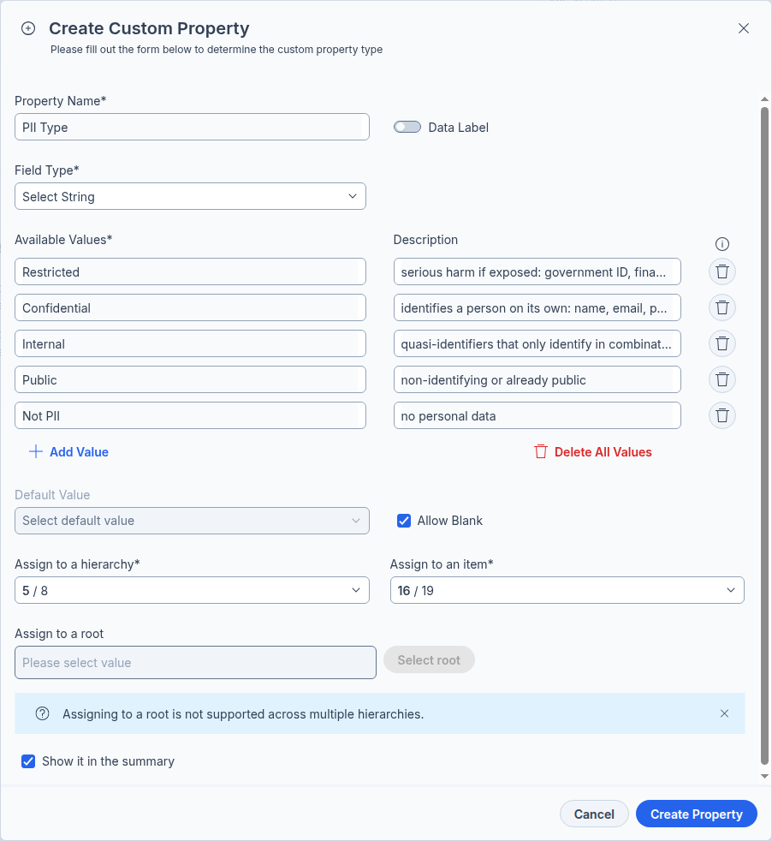
Custom Properties

Before you begin

Prerequisites
- Workshops 1 and 2 complete — both AWC sources connected and explored.
- A Business Steward (or higher) PDC login — creating, importing, and editing glossary items is a governed action reserved for the Business Steward role.

Assets used in this workshop
- The AWC glossary content table in this guide — your source of truth for the terms you will build.
- AWC—Business—Glossary.csv — a starter list of the same terms, provided with this workshop, that you can adapt for import.
- The connected awc_operations database — the customers table is where you will link terms.

The AWC glossary you will build
Here is a representative slice of the Arizona Water glossary — two terms from several of its categories. The full glossary holds terms across seven categories — 58 column—level terms plus one table—level term per table. Each row is a term, grouped by category; Domain is separate — chosen from PDC’s built—in domain list, which for AWC is Utilities on every term. Build this slice by hand in Part A, or import the full—term glossary (AWC—Business—Glossary.csv) in Part B.
Term | Category | Sensitivity | Classification | Business Steward | Definition
Customer Name | Customer | High | Private | Maria Garcia | Full legal name of the account holder.
Service Area | Customer | Low | Public | David Chen | Operational area where the customer receives service.
Customer Account Number | Billing & Rates | High | Company Confidential | Robert Hayes | Unique AWC billing account identifier for a customer.
Tiered Rate | Billing & Rates | Medium | Company Confidential | Robert Hayes | Block pricing that increases with consumption.
Usage Gallons | Usage | Low | Public | David Chen | Volume of water consumed in a billing period.
Meter Reading | Usage | Low | Public | David Chen | Recorded value from a customer water meter.
Water System | Water System | Low | Public | David Chen | A distinct system supplying water to an area.
Population Served | Water System | Low | Public | David Chen | Number of people served by a water system.
Lead Level | Water Quality | Medium | Company Confidential | Susan Park | Measured concentration of lead in water.
EPA Compliance Status | Water Quality | Medium | Company Confidential | Susan Park | Whether a water system meets EPA standards.
Trust Score | Governance | Low | Public | Maria Garcia | Roll—up score indicating confidence in an asset.
Tag | Governance | Low | Public | Maria Garcia | A quick, filterable label applied to an asset.

Step—by—step

Part A — Create the glossary in the Data Canvas
- Click Glossary in the left navigation menu to open the Business Glossary page.
- Click Actions, then Add New Glossary. Name it Arizona Water and click Continue. Add a Definition and a Purpose.
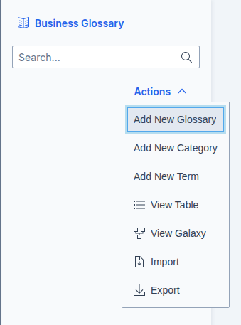
Create Glossary —> Category —> Term

- Click Actions, then Add New Category. Create the seven categories: Customer, Billing & Rates, Usage, Water System, Water Quality, Governance, and Records & Documents — each with the Arizona Water glossary as its Parent.

- Click Actions, then Add New Term. For each term in the table above, enter its name, choose its category as the Parent, click Create, then add its Definition.
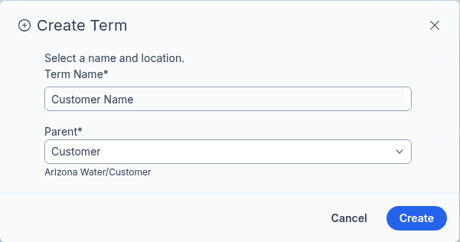
Create Term

- On each term’s Summary tab, open the Properties panel and set Sensitivity, Domain, Classification, Business Steward, Owner, Custodian, Stakeholders, and the Review Date. Set Status to Accepted when the term is ready.
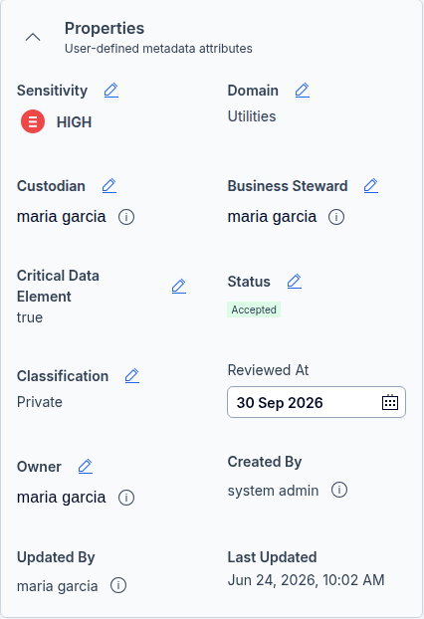
Properties
- (Optional) Add Tags such as PII, GDPR, or compliance for quick discovery — tags complement the term, they do not replace it.
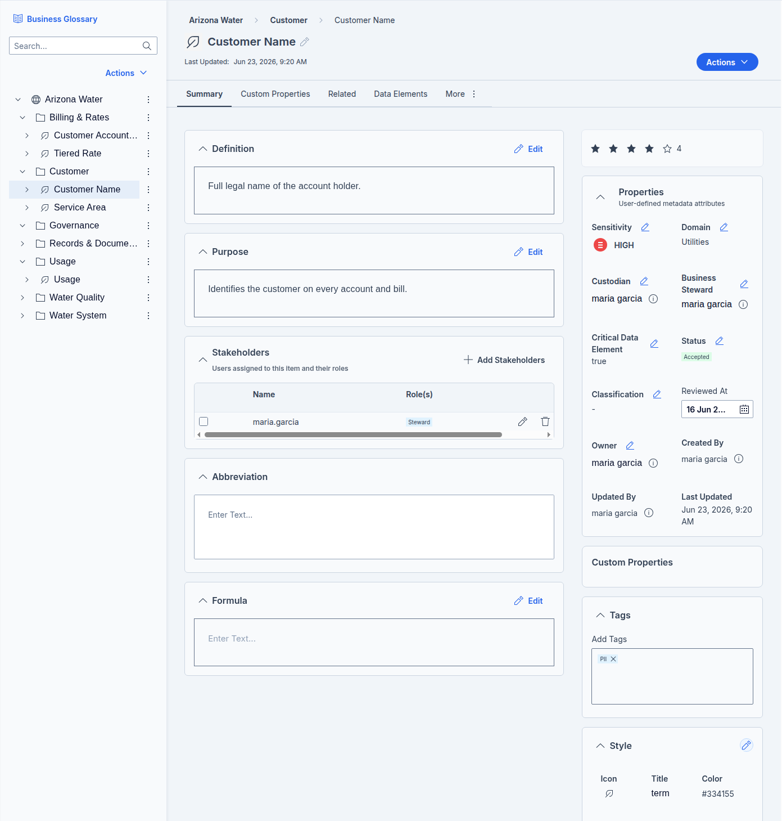

Part B — Import a glossary from a file (the bulk method)
Building terms by hand is fine for a handful; for a real glossary you import. PDC imports JSON Lines or CSV.
- Get the exact format first: after building one term in Part A, click Actions, then Export, choose CSV or JSON, and download. The exported file’s columns are the precise schema your import must match.
- Populate that exported file with the rest of the AWC terms from the table above (or map the provided AWC—Business—Glossary.csv onto those exact headers).
- On the Business Glossary page, click Actions, then Import, drag in your file, and click Submit.
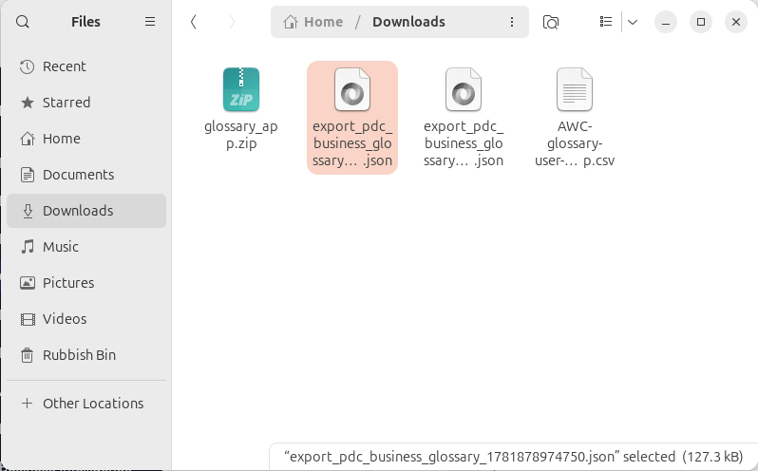
Import a Glossary
- Confirm the imported glossary, categories, and terms appear in the navigation tree.
Export before you import
Importer columns can vary by version, so never hand—build a file blind. Export a glossary first — even a one—term one — and mirror its exact headers and Parent references. An exported file is guaranteed to round—trip back in.

Set the people—fields in the UI after import
Import carries the descriptive properties — Definition, Sensitivity, Domain, Status, Classification, Business Steward. It does not carry Custodian, Owner, Review Date (“Reviewed At”), or Stakeholders. Those resolve to real users, so the people they name must exist in PDC first, then be assigned on each term’s Summary page after the import lands. Tags and Custom Properties are not in the import file either — tags are typed onto each term, and custom properties must first be created on the Custom tab before a value can be assigned. Plan to do a short pass through the imported terms to set all of these.

Part C — Link terms, then feed the table’s Trust Score
KEY POINT — TRUST SCORE IS A TABLE / FILE METRIC, NEVER A COLUMN ONE
Calculated at table/file level only.
A column never gets its own Trust Score, so linking a term to a column will never produce one — no matter how the term is linked.
The table reads a table—level term.
Link each table’s table—level term (Customer Record, Water System Record, …) to the table itself, then run Calculate Trust Score. That table term — not the column links — is the glossary—term input the score actually reads.
Column links still matter — just not for the score.
They carry the term’s meaning, sensitivity and ownership onto the column for search, lineage and governance. That is their job; feeding a column score is not.
The term input is binary.
The score asks only whether a meaningful term is assigned — not how many. Over—linking to inflate it is semantically wrong and degrades the governance the score measures.
Need a number on a column? It is authored, not calculated.
The Calculate Trust Score button never scores columns. To hold a per—column value you extract the entities, compute your own score, and bulk—write it back per column via the API / OpenSearch — a Technical—track exercise, not part of this workshop.

Where Trust Score lives
Trust Score is a native metric on two entity types only: tables and files. In PDC’s hierarchy a column sits inside a table and a folder sits above files, so the scored peers are the table and the file — a file is the unstructured twin of a table, scored the same way. A column and a folder are only a part or a container, and never carry a Trust Score.
Entity | Native Trust Score? | How it’s set | What it means / carries
Table | Yes | Calculate (4 inputs) or type a value in Key Metrics | Reliability of the whole table — Data Quality, ratings, verified lineage, and a table—level term
File | Yes | Same as a table; Data Quality comes from Data Discovery | Reliability of a document — the same four inputs
Column | No | Authored only — bulk—write per column via the API / OpenSearch | Profiling/DQ, sensitivity, tags and term links — for governance and discovery, not a score
Folder | No | — (a container) | The object—store equivalent of a schema; carries no score
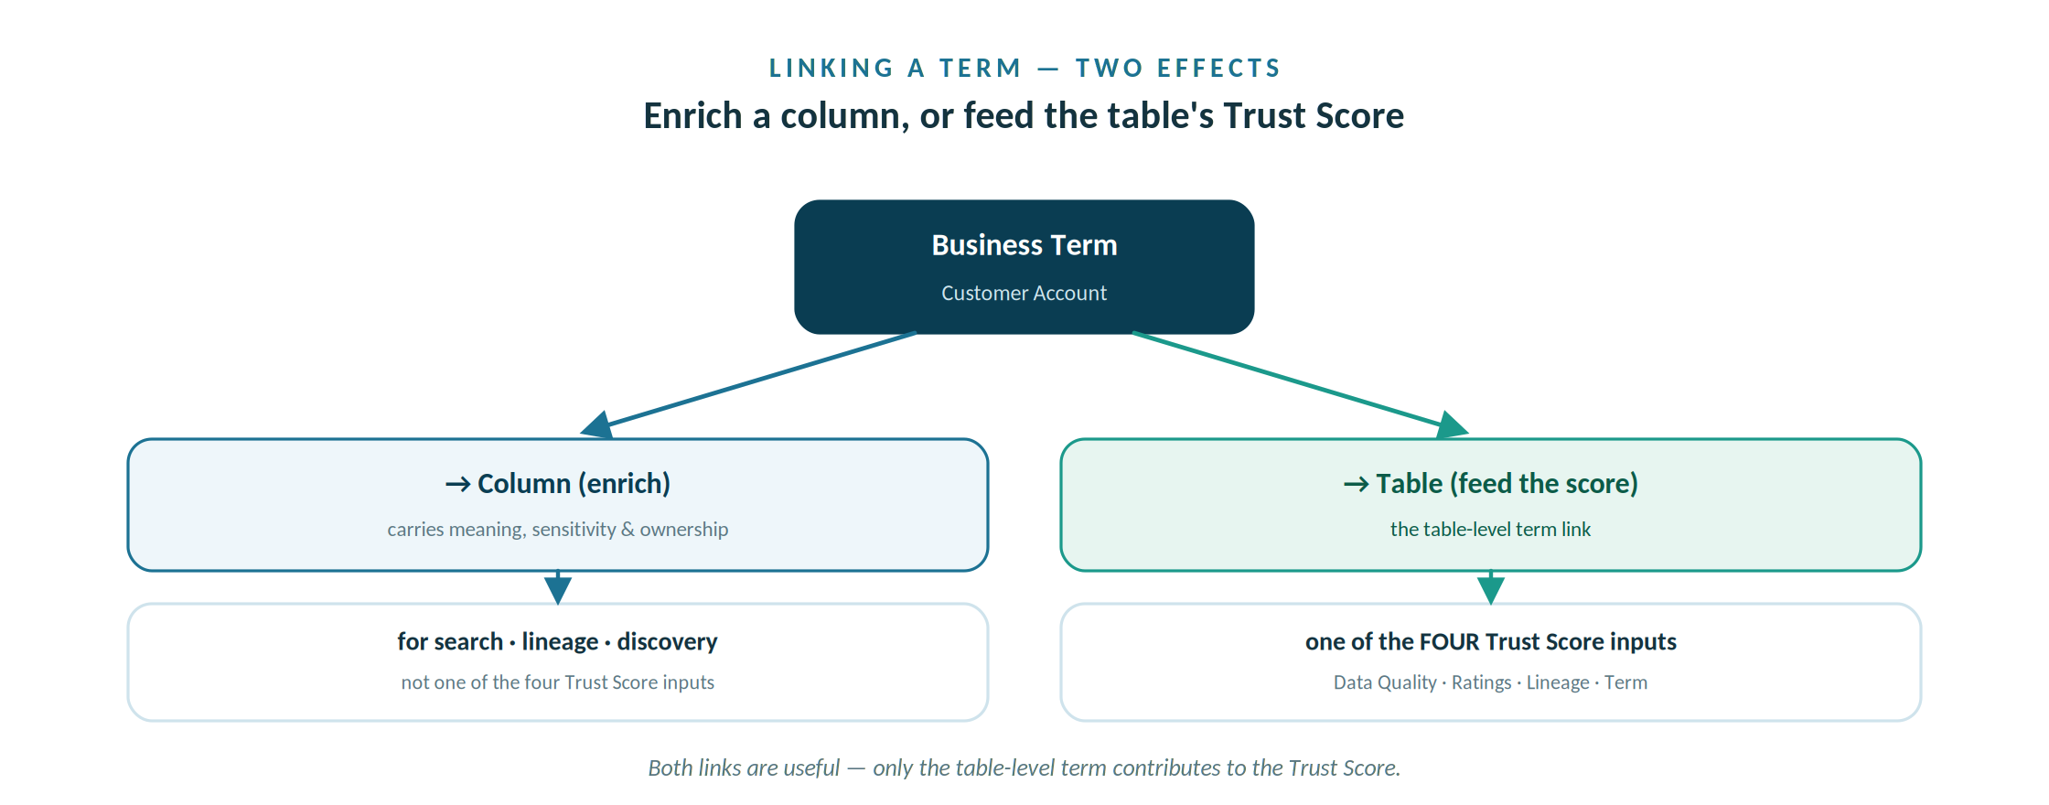
Linking to a column enriches it; only the table-level term link feeds the table's Trust Score.
Linking a term to a column (Column Trust Score) still matters — it carries the term’s meaning, sensitivity and ownership onto the column for search, lineage and discovery. It simply is not one of the four inputs to the table’s score; the table—level term (Table Trust Score) is.

Which terms to map
Not every term needs a column, and linking every term to every column to lift a score backfires — it pollutes governance, lineage, and search. Choose what to map by business relevance, then prioritize by risk and criticality:
CDEs and regulated or PII columns first:
your highest—care data. Flag these as Critical Data Elements, link the right term, set sensitivity and classification, and verify lineage. Then reporting and KPI columns; then the long tail as capacity allows.
Leave concepts unmapped:
governance and conceptual terms such as Trust Score and Tag name ideas the business needs defined, not physical columns, so they are expected to have no data element.

Column Trust Score — Enrich the columns (optional; this does not feed the Trust Score)
- Click Glossary in the left navigation, then open a term you want to link — for example, Customer Name under the Customer category.
- Click the Data Elements tab. It has two views: Elements (the columns already linked to this term) and Suggested Columns (matches PDC proposes for you).
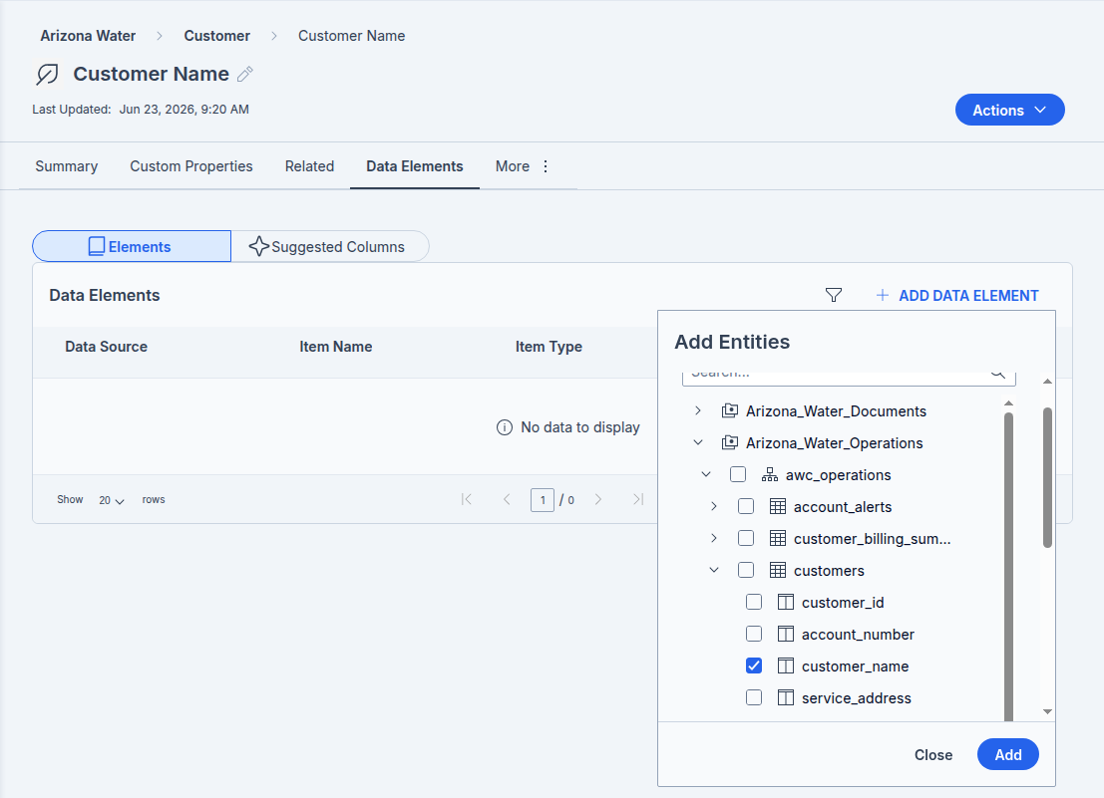
Customer Name — Data Elements

- Click + Add Data Element, choose the Arizona_Water_Operations source, and select the matching column — for Customer Name that is customers.customer_name. It then appears in the Elements list with an Item Type of COLUMN. (Faster: open Suggested Columns, review PDC’s matches, and Approve the right ones — approving assigns the term automatically.) See the Similarity Score section further on.
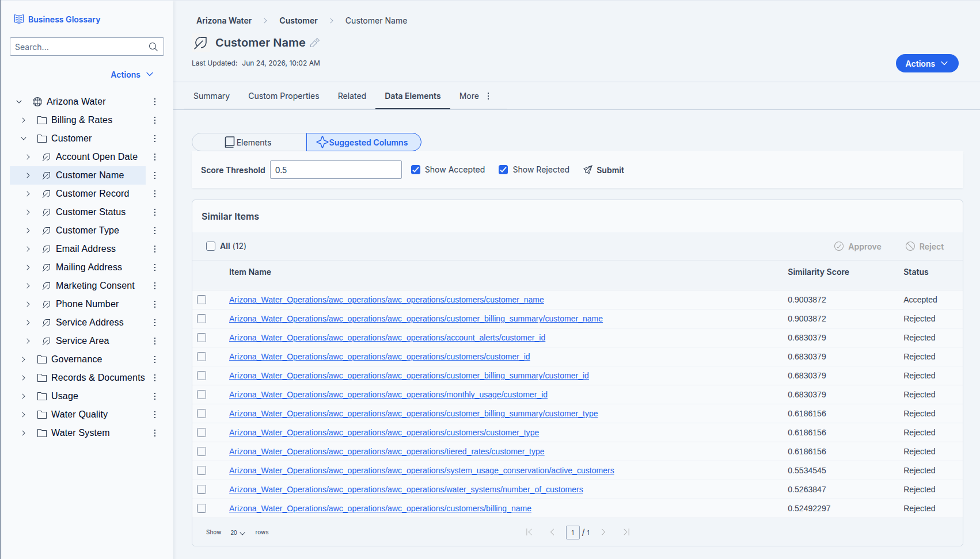
Suggested Columns – Customer name
- Repeat for the other terms you are linking — for example Customer Account Number to account_number, and Service Address to service_address.
These column links enrich each column for search, lineage and governance. None of them feed the Trust Score — that next, the table—level term.

What linking a term to a column means
Part C links terms to the Catalog through Add Data Elements (the Data Elements tab). When you map a term to a column this way you create a Business Term Association — a governed link between the business concept and the physical field, identified as table.column (for example, Phone Number → customers.phone). The column itself does not change; what you have added is a relationship. From that point:
- Meaning travels to the data. Anyone inspecting customers.phone in the Catalog now sees the term’s definition, sensitivity, classification and owner — none of which live on the table itself.
- Classify once, govern everywhere. The same term can map to phone columns in several tables — and across data sources, the structured database and the document store alike; set sensitivity and classification once on the term, and every linked element inherits them.

One term, many columns — a worked example: a single business term can carry several Linked Data Elements, and its one governed meaning applies to every column at once. In AWC, Customer Account Number links to both customers.account_number and customer_billing_summary.account_number — same definition, same sensitivity, two physical homes. Water System goes further, linking to four elements across a table and three views: water_systems.system_id, customer_billing_summary.system_name, system_usage_conservation.system_id, and system_water_quality_status.system_name. Define it once on the term and all four inherit it; rename or re—classify the term and every linked column follows. That is what delivers consistency across systems, and it is what lets the term answer “where does this live, and what changes if I touch it?” in one place. (Note: this column—level linking governs those columns consistently; it is separate from the table—level term each table needs for its Trust Score.)
- Discovery improves. Searching the term — or filtering by HIGH sensitivity, or by the PII tag — now returns that column. The regulator’s question becomes a single search.
- It appears in lineage and the Galaxy View. The association is a relationship edge connecting the business—term node to the data—asset node.
- It feeds the Trust Score. A linked term is one of the four inputs the score uses (with Data Quality, User Ratings and verified Lineage) — the only one you can set before profiling, though the number stays low until Data Quality is computed in Workshop 4.
You shouldn't link all terms to a column just to lift the score.

The Trust Score calculation does factor in glossary terms, but as one of several inputs. The score is calculated using multiple parameters like Data Quality, User Ratings, Data Lineage, and Classification, and specifically it considers Data Quality (Completeness, Accuracy, Validity, Uniqueness, Consistency), User Ratings (1–5 stars), Data Lineage (Verified or Not), and whether a Glossary Term is assigned or not. Worth noting: this feature is currently available for Tables and Files, so it operates at the table/file level rather than scoring individual columns.
The critical detail is that the glossary—term input is essentially binary — is a meaningful term assigned or not. It rewards having the right semantic coverage, not the volume of links. Linking every term you have to a single column would be semantically wrong: a column should carry the term (or small set of terms) that genuinely describes its content. Over—linking pollutes your glossary mappings, breaks lineage and impact analysis, misleads anyone searching the catalog, and undermines the very governance the Trust Score is trying to measure. You'd be optimizing a proxy metric while degrading the thing it's a proxy for.
The better path to a high Trust Score is to treat the four inputs as a checklist of genuine governance work: assign accurate business terms where they belong, verify lineage, run data quality processing (if you have Pentaho Data Quality configured), and gather user ratings. A column that's correctly termed, lineage—verified, and quality—checked earns its score honestly — and stays trustworthy when someone actually relies on it.
One practical combination worth calling out: your most important columns are often both CDEs and well—termed. Flag them as Critical Data Elements so they get prioritized stewardship, link them to the correct business term so people understand them, then make sure quality and lineage are verified for those specifically. That's where the effort pays off most.

In short: after Add Data Elements, the business term Phone Number is mapped to the column customers.phone, and that column now speaks the glossary’s language — definition, ownership and sensitivity included.

Table Trust Score — Feed the table’s Trust Score
- Map the table—level term to the table. AWC’s glossary already carries one table term per table — Customer Record, Water System Record, Rate Plan, Monthly Usage Record, Water Quality Report and Account Alert Record.
- Open the customers table’s Glossary tab (or the Customer Record term’s Data Elements tab) and link Customer Record to the customers table. This table—level term — not the column links in Column Trust Score — is the glossary—term input the Trust Score actually reads.
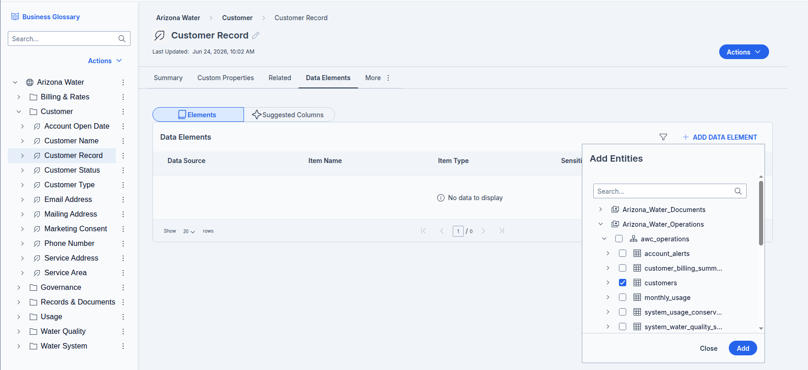
- Run Calculate Trust Score. In the Data Canvas, open the Arizona_Water_Operations source and select the customers table, then Actions → Process → Start Calculate Trust Score. The table term you just linked is one of the four inputs, so the number stays low until the others are in place.
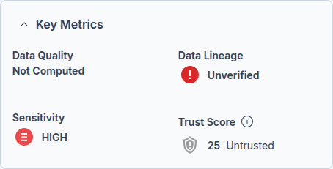
Customers Table — Trust Score

Why this works: the Trust Score is an aggregate of four inputs — Data Quality, User Ratings, verified Data Lineage, and whether a Glossary Term is assigned. Assigning a term satisfies one of them, and it is the only one you can set without profiling the data. On its own it will not lift the table out of Untrusted: Data Quality is the dominant input and stays Not Computed until the data is profiled in Workshop 4.
To watch the score climb now, also rate the table (stars) and set its Data Lineage to Verified, then re—run the calculation. In other words the Trust Score is a sliding scale: it computes from whatever inputs are present and rises as you add each one — a linked term, Verified lineage, a rating — then climbs furthest once Data Quality is computed in Workshop 4.

Part D — Link the rest of the Catalog
Part C linked one table; now repeat across the whole source. The map below lists every business term and the column it links to, grouped by table (Governance terms describe the Catalog itself and are not linked). The glossary is Arizona Water (named Arizona Water). Work table by table:
Also link each table’s table—level term: as you finish each table, link its table—level term to the table — Customer Record to customers, Water System Record to water_systems, Rate Plan to tiered_rates, Monthly Usage Record to monthly_usage, Water Quality Report to water_quality_reports, and Account Alert Record to account_alerts. That table term is the glossary—term input each table’s Trust Score actually reads.
- For each table, link every term to the column shown, using the term’s Data Elements tab exactly as in Part C.
- When a table is done, select it in the Data Canvas and run Actions, then Process, and Start Calculate Trust Score, so each table records its glossary—term input. (Expect the number to stay low until the data is profiled in Workshop 4.)
Table | Business terms to link (term → column)
customers | Customer Name → customer_name  Service Address → service_address  Mailing Address → mailing_address  Email Address → email  Phone Number → phone  Marketing Consent → opted_out_marketing  Customer Type → customer_type  Customer Status → status  Account Open Date → account_open_date  Service Area → service_area  Customer Account Number → account_number
monthly_usage | Billing Cycle → billing_cycle  Total Due → total_due  Payment Status → payment_status  Usage Gallons → usage_gallons  Meter Reading → meter_reading  Meter ID → meter_id
tiered_rates | Rate Schedule → rate_schedule  Tiered Rate → tier_rate  Base Charge → base_charge
water_systems | Water System → system_id  System Capacity → capacity  Source Type → source_type  Population Served → population_served
water_quality_reports | Lead Level → lead_ppb  Contaminant Level → contaminant_level  Test Date → test_date  EPA Compliance Status → epa_compliance_status
account_alerts | Account Alert → alert_type
customer_billing | Customer Name → customer_name  Customer Type → customer_type  Service Area → service_city  Customer Account Number → account_number  Payment Status → payment_status  Usage Gallons → avg_monthly_usage  Water System → system_name  Bills Generated → bills_generated  Paid Bills → paid_bills  Outstanding Bills → outstanding_bills  Total Outstanding Balance → total_outstanding  Peak Usage → peak_usage
system_usage_summary | Usage Gallons → avg_customer_usage  Water System → system_id  Total Revenue → total_revenue  Unpaid Accounts → unpaid_accounts  Payment Collection Rate → payment_collection_rate  Active Customers → active_customers  Total System Usage → total_system_usage
system_water_quality | Service Area → service_cities  Water System → system_name  Lead Level → lead_ppb  Test Date → report_month  EPA Compliance Status → compliance_status  Water Quality Rating → quality_rating  pH Level → ph_level  Turbidity → turbidity_ntu  System Alert Level → system_alert_level
The document store (Arizona_Water_Documents) is governed by this same glossary. Its Records & Documents terms link to whole folders — for example EPA Compliance Records to the compliance folder, Inspection Reports to inspections, and SCADA Snapshots to scada — so one vocabulary spans both the database and the file store.

Introducing the Similarity Score
In Part C you opened the Suggested Columns view and approved the matches PDC proposed. Those proposals are not name guesses — they come from PDC’s metadata similarity engine, and each one carries a Similarity Score. This short section introduces that score so you know what you are approving, and it sets the scene for the Technical track, where that engine is configured and run.

What the score measures
Metadata similarity uses machine learning to find and rank similar columns, tables, and terms across the whole Catalog. It scores each candidate on metadata structure and meaning rather than column names alone, and expresses the result as a number from 0 to 1 — PDC’s confidence that a term fits a column. A higher score is a stronger match.
Meaning over names: because the score reads structure and meaning, it can match a column whose name looks nothing like the term. In AWC, the Service Area term can be proposed for service_city in customer_billing, and Water System for system_name in system_water_quality — links a name—only search would miss.
It runs as a job, not on demand: the Suggested Columns you see are the results of a metadata similarity run, not generated the moment you open the tab. An administrator runs that job; you review what it produced.

Reading and acting on suggestions
The Suggested Columns list shows matches above a score threshold — 0.5 by default. Lower the threshold to see more, looser candidates; raise it to see only the closest. Then act on each one:
- Approve assigns the term to the column automatically — the same Business Term Association you would create by hand in the Elements view, only faster.
- Reject dismisses a wrong match. A rejected suggestion is excluded from future runs for that asset, so reject deliberately rather than to tidy the list.
Your judgment still decides: the score assists, it does not approve. A high score is a recommendation, not a verdict — approve the matches that genuinely describe the column, and the same over—linking cautions from the previous section apply. Good semantic coverage, not volume, is the goal.
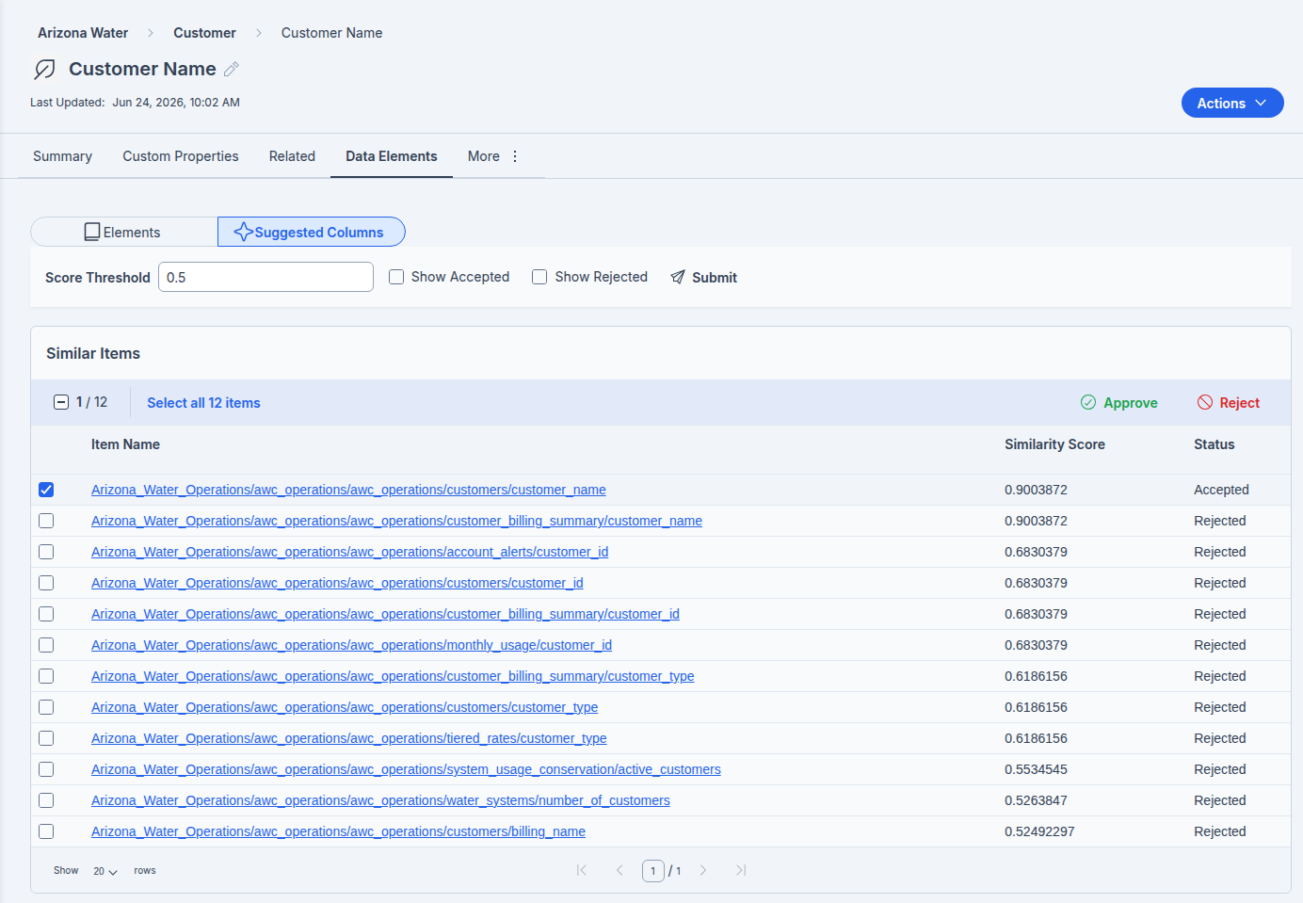
Suggested Columns — customer.customer.name

Verify your work
- The Arizona Water glossary exists, with seven categories and your terms beneath them.
- Each term has a Definition, a Domain, a Sensitivity, a Classification, and a Business Steward.
- Each term you linked lists its columns on the Data Elements tab, and the customers columns show their assigned business term.
- Every data table — all nine, customers through system_water_quality — has its terms linked, each carries its own table—level term (Customer Record, Water System Record, and so on) that its Trust Score reads, and each has had its Trust Score recalculated.
- After re—running Calculate Trust Score, the customers Trust Score is no longer 0 / Untrusted.
- You can explain why the score moved (the glossary—term input) and why a quality—based score still waits for Workshop 4 profiling.

Troubleshooting
Symptom | Cause and fix
Import fails, or terms land under Unassigned | Your file’s columns or Parent values do not match the expected schema. Export a glossary first and mirror its exact headers and parent references.
Term created but no governance shows | Sensitivity, Domain, Classification, and Steward are set per term in the Properties panel. Open the term’s Summary tab and fill them in.
Trust Score still 0 after linking a term | Re—run the Calculate Trust Score job after the term is linked. A completed job with activeMillis 0 means it had no inputs at the moment it ran.
Cannot create or edit glossary items | Glossary editing is governed by role—based access control. Creating, importing, and editing glossary terms and policies requires the Business Steward role (Data Steward cannot edit the glossary).

Why it matters & discussion
A new analyst searches the Catalog for customer personal data. Because AWC governs each personal field as its own term — Customer Name, Service Address, Email Address, Phone Number, all classified and owned by Maria Garcia and linked to every matching column — the search returns exactly the right fields with their governance attached. Discuss: what would that same search return with no glossary, and what would it cost AWC, in an audit, to assemble that answer by hand?

What’s next
Your business vocabulary now exists and is linked to the data. Workshop 4 runs Data Profiling and Data Identification: PDC profiles the data — the operational layer, row counts, and keys — and then uses your glossary to tag matching columns across the Catalog automatically, at scale. With both a linked term and profiled quality in place, Calculate Trust Score finally produces a real, quality—based number.
Beyond this business track, the Technical track goes under the hood of the Suggested Columns you approved here. Its Metadata Similarity & ML Inference module shows how the similarity engine is run and tuned, and how it connects to an inference backend — the production side of the suggestions you consumed here as a Steward.

