PENTAHO DATA CATALOG 10.2.11 · DATA ANALYST
PDC PROCESS · DATA PROFILING · TRUST SCORE
WORKSHOP 4
Profiling & Data Quality
Profile AWC’s tables to generate statistics, discover keys, and make the Trust Score real

Primary role: Data Analyst
Estimated time: 45 minutes
Dataset: Arizona Water Company (awc_operations + awc—documents)

Why this workshop matters
In Workshop 2 the customers table had a blank PK/FK column and a Trust Score of 0 / Untrusted; in Workshop 3 you linked glossary terms, but the score still rested on defaults. This workshop runs the engine that fills the operational layer. Data Profiling reads every value once and produces statistics, data patterns, and sample values; Data Catalog’s foreign—key detection looks across tables for relationships in that output; and Calculate Trust Score finally has real evidence to roll up. After this workshop, the question can I trust this table? has a defensible answer.
The business problem
An AWC analyst is about to build the conservation—billing report on monthly_usage. Is the data complete? Are there nulls in the gallons columns? Which column is the key, and does it join cleanly to customers? Without profiling, these are guesses. Profiling turns them into measured facts — row counts, null counts, cardinality, and discovered keys — so the analyst builds on evidence, not hope.
Profiling is a prerequisite: it is not an optional step. Until a table is profiled, Data Catalog flags it as Required, and Data Identification (Workshop 5) cannot run on it — so profiling comes first for every asset.

What you will learn
- How to run Data Profiling on a structured table, and why the default settings (a sample of up to 500,000 rows) suit most cases.
- What profiling produces: statistics (row count, null count, cardinality), data patterns, and sample values.
- Where the PK/FK column comes from — declared keys in the source plus Data Catalog’s relationship detection — and what to do when it stays blank.
- How Calculate Trust Score rolls up four inputs — and why the Data Quality metric needs the Pentaho Data Quality add—on.
- What the Profiling options do — sampling (Sample Type, Skip Recent) and the parallelism threads — and why AWC keeps the defaults.
- How AWC’s documents are profiled by Data Discovery, which extracts text, flags duplicate files, and can OCR scanned PDFs.

Background: what profiling produces
Data Profiling examines structured data in a single pass and computes detailed properties for every column. Along the way it generates intermediate data — a Roaring Bitset, a HyperLogLog cardinality estimate, and data—pattern analysis — that downstream jobs consume. Foreign—key detection depends on it directly, working across tables to infer relationships from that output. Profiling produces a Data Quality Pre—Analysis — an estimated quality percentage in the column's profile results — which is not the same as the licensed Data Quality metric shown in Key Metrics (Pentaho has discontinued the OEM relationship with DQLabs).
Profiling produces | What it is | Where you see it
Statistics | Total row count, null count, min/max, string widths. | Summary → Statistics; column details
Cardinality & HLL | Unique—value count and a ~2%—margin estimate. | Column details (Cardinality, HLL)
Data patterns | The most frequent value patterns, with RegEx suggestions. | Summary → Data Patterns
Sample values | A controlled sample of values per column. | Details → Sample Data (Raw / Aggregated)
Intermediate data | Bitset, HLL, and pattern analysis that foreign—key detection consumes. | Not shown directly; enables PK/FK

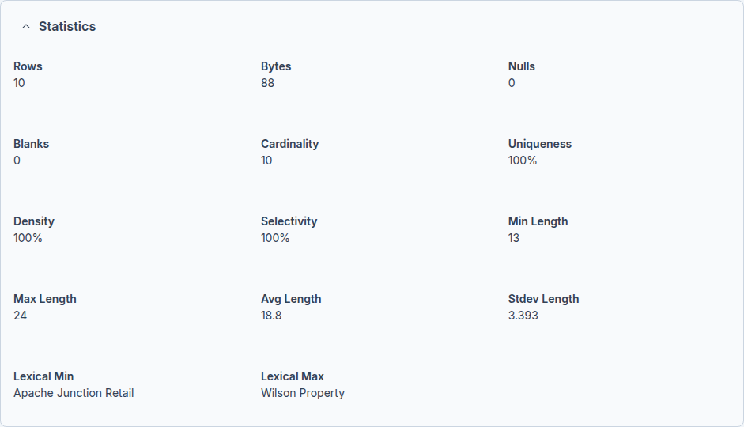
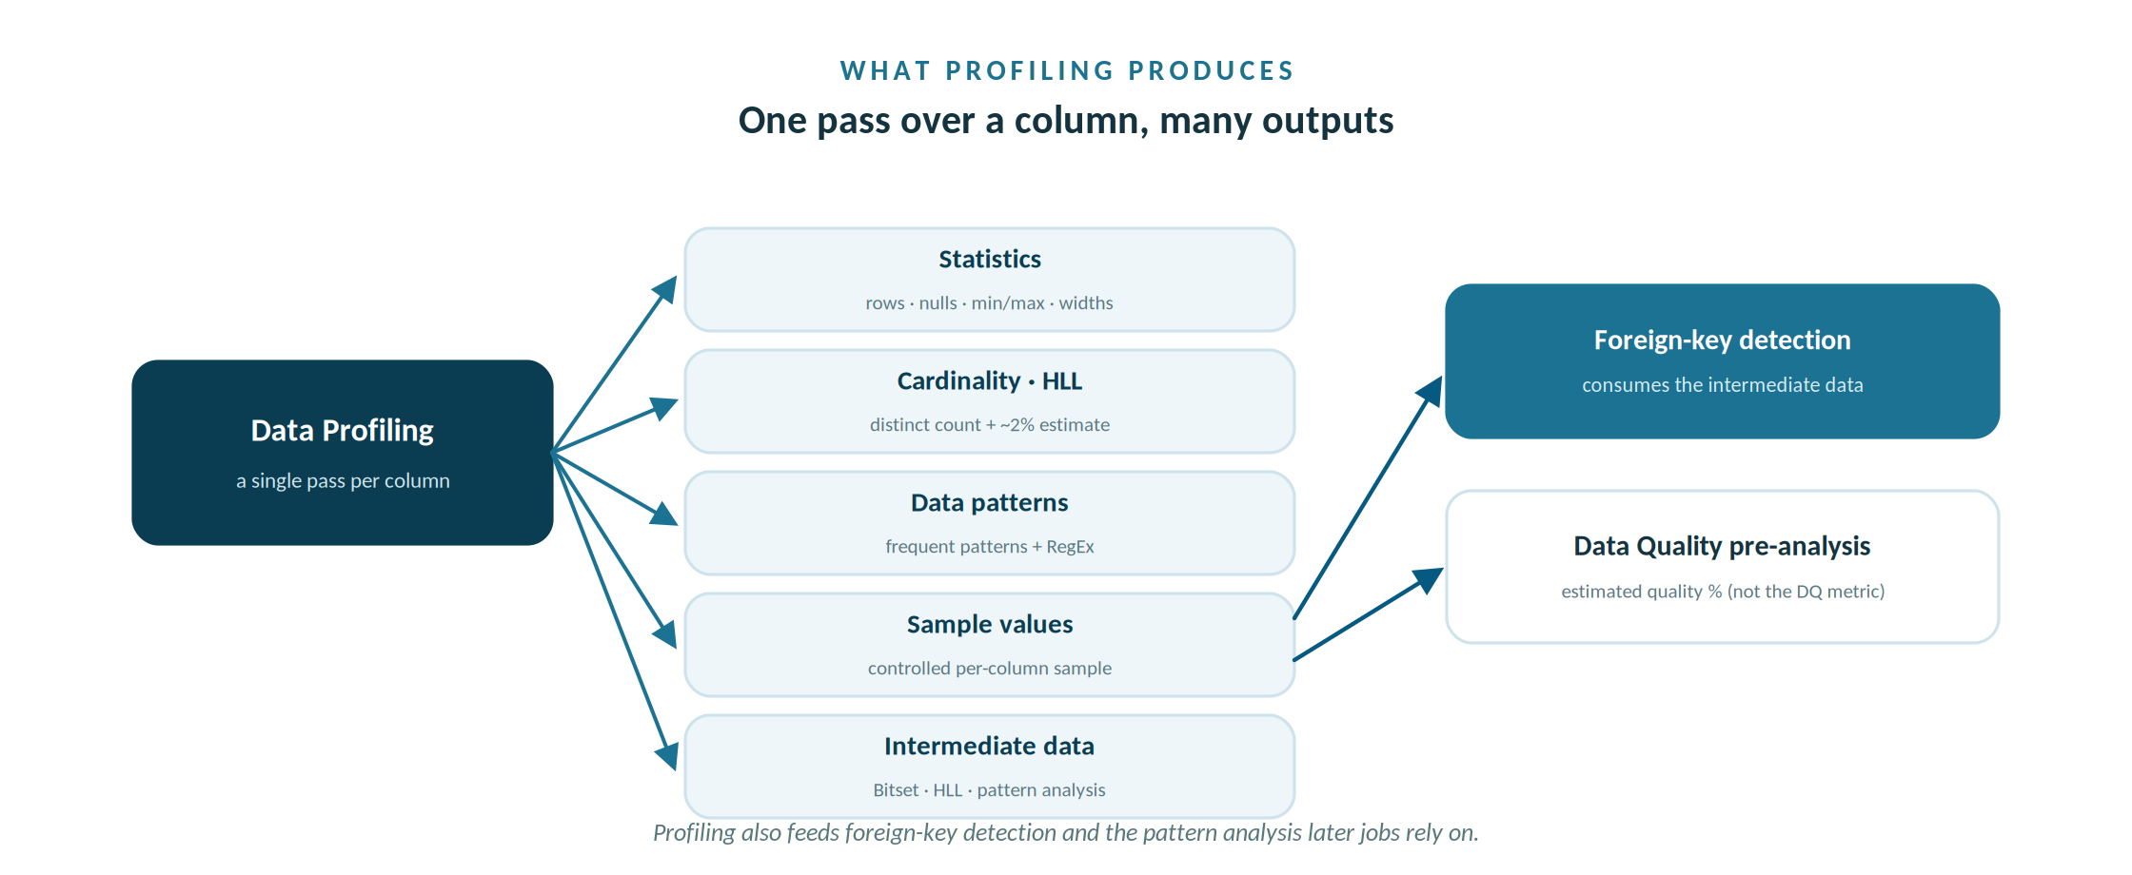
One profiling pass yields statistics, cardinality, patterns, samples and the intermediate data downstream jobs use.

Statistics – Customer Name

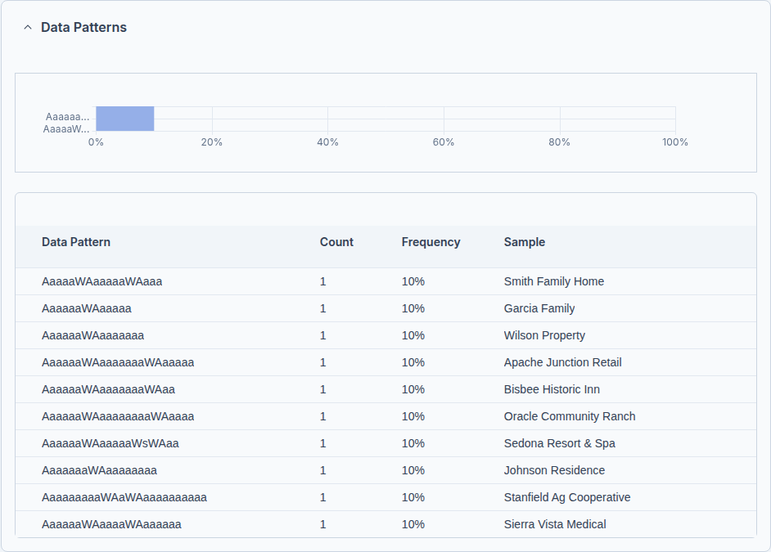

Data Patterns

The Trust Score, now with evidence
Trust Score is still the roll—up of four inputs you met in Workshops 2 and 3 — Data Quality, User Ratings, Data Lineage, and whether a Glossary Term is assigned. Workshop 3 satisfied the glossary—term input. Profiling now makes the rest meaningful, and once the Pentaho Data Quality add—on and its Data Quality Loader are in place, the Data Quality component reports across completeness, accuracy, validity, uniqueness, and consistency.
Trust Score input | Filled by | In this course
Data Quality | Pentaho Data Quality add—on + Data Quality Loader, over profiled data. | Workshop 4 (licensed)
User Ratings | Analysts rating the asset 1–5 stars. | Any time
Data Lineage | Reviewing and verifying the asset’s lineage. | Workshop 8
Glossary Term | Linking a business term to the asset. | Workshop 3 (done)

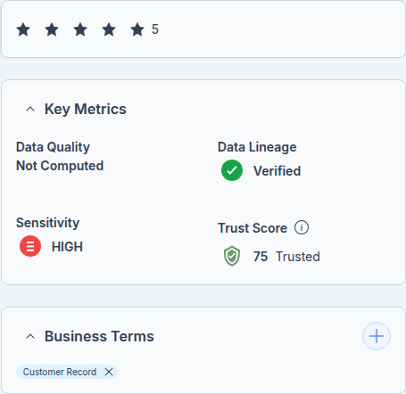
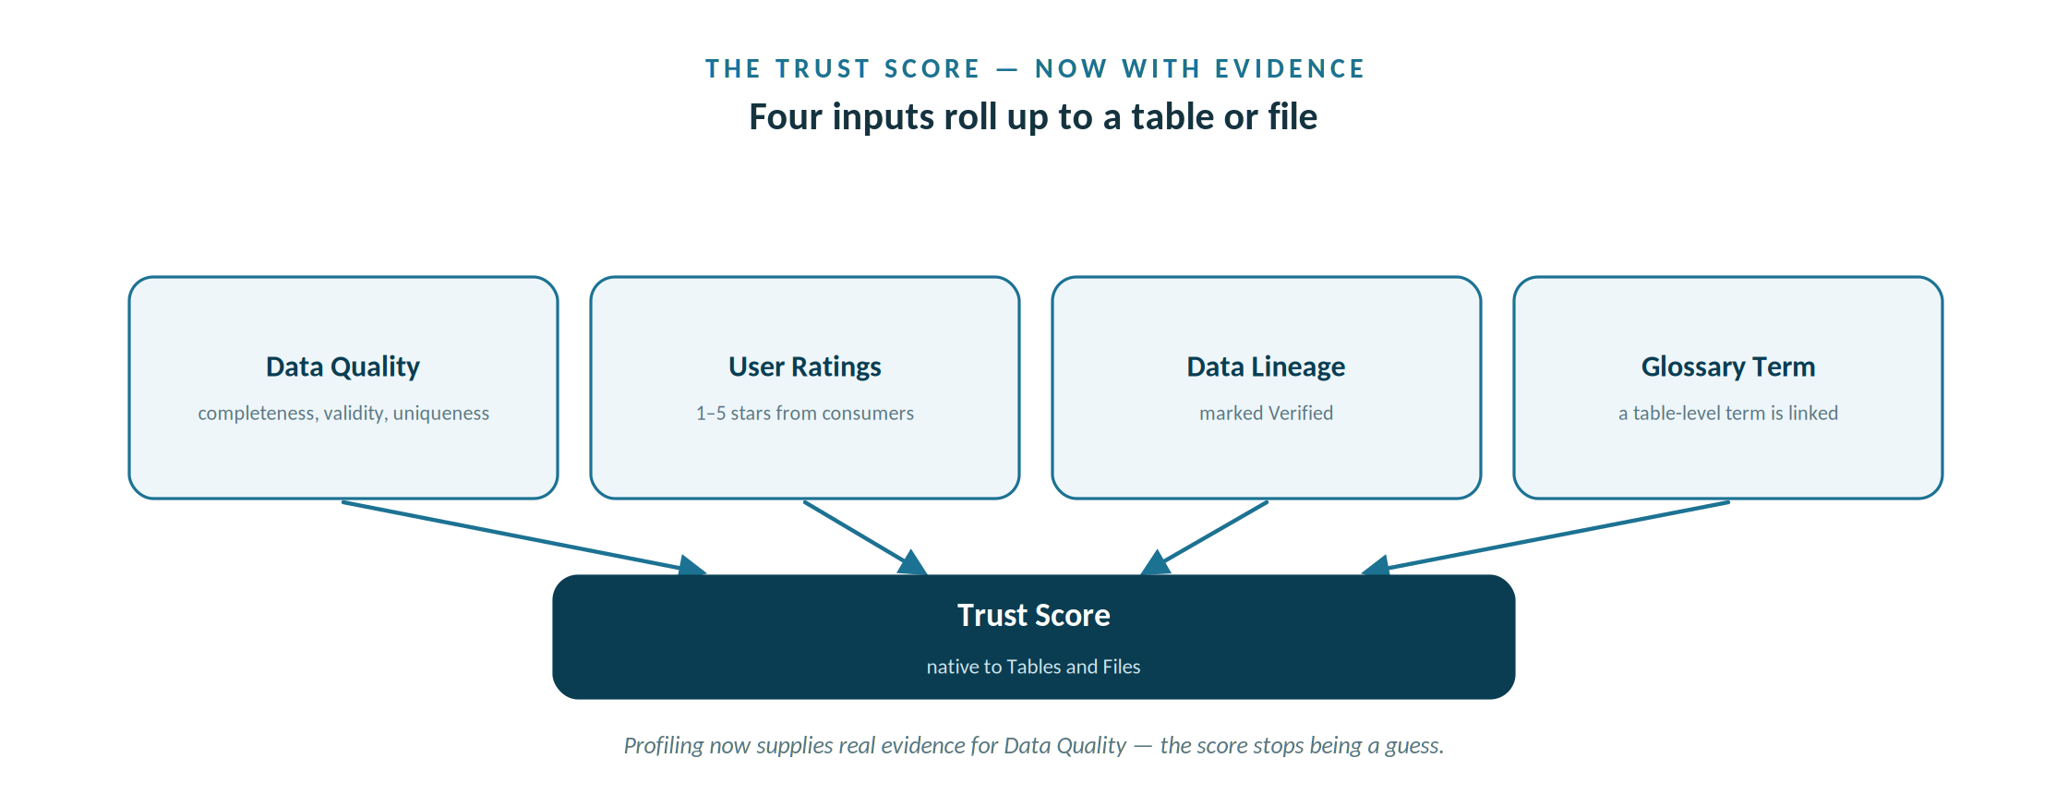
Four inputs roll up to a table or file — and profiling now supplies real evidence for Data Quality.

Key Metrics

Before you begin

Prerequisites
- Workshops 1–3 complete — sources connected, metadata read, and the glossary linked.
- A Data Analyst (or higher) PDC login.

Assets used in this workshop
- The customers, monthly_usage, and water_quality_reports tables in awc_operations.
- The EPA compliance PDFs in the awc—documents store, profiled in Part D via Data Discovery.
- The Workshop 3 glossary terms already linked to customers (so the glossary—term Trust Score input is satisfied).

Step—by—step

Part A — Run Data Profiling
AWC has two kinds of assets, and each is scanned its own way. Database tables — like customers — are profiled with Data Profiling, the structured—data scan you run in this Part. The EPA compliance PDFs in the awc—documents store are scanned with Data Discovery, its unstructured counterpart, in Part D.
- In the Data Canvas, open Arizona_Water_Operations and select the customers table.
- Open Actions, then Process, then click Start on the Data Profiling card — the scan for a structured table. (The other cards on this page belong to other steps; the table below maps each one.)
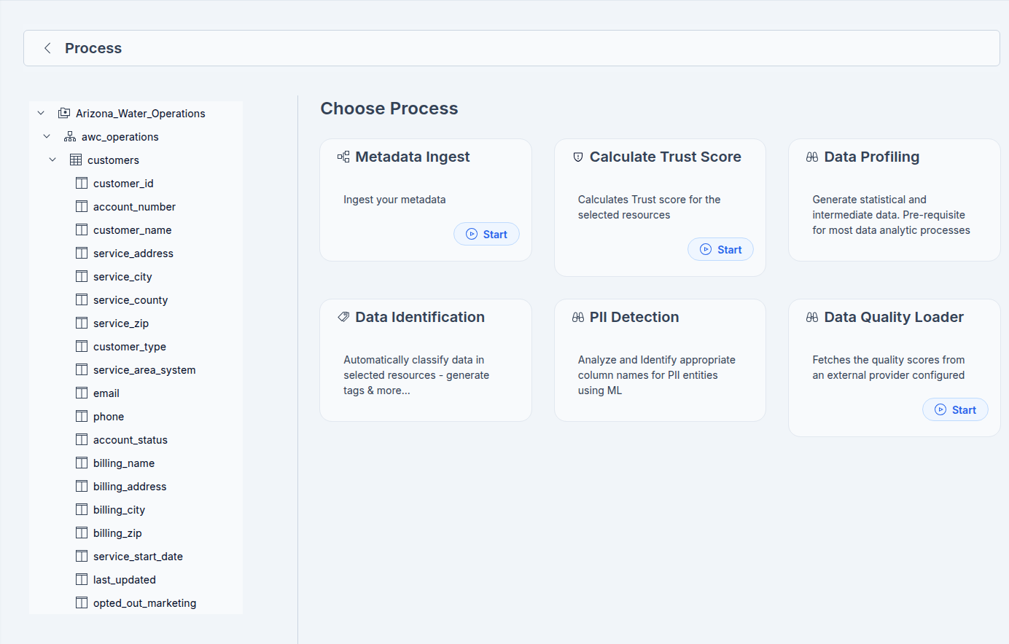
customers – Data Profiling
- Keep the default settings. Profiling samples up to 500,000 rows, which suits AWC’s tables, and Extract Samples is on by default so you get preview values.
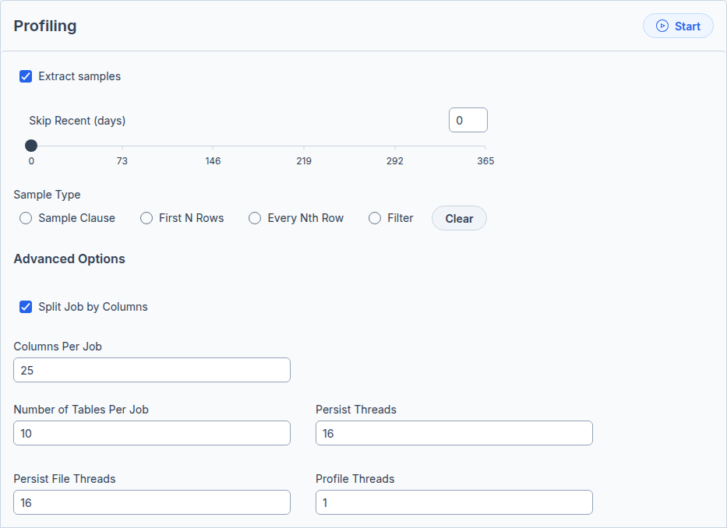
- Watch the job on the Workers page until it completes, then repeat for monthly_usage and water_quality_reports.

Which card, which asset: the Choose Process page lists every processing step as a card, but each belongs to a particular job. A structured table is scanned with Data Profiling; an unstructured document is scanned with Data Discovery — so a table has no Data Discovery card to run, and a document has no Data Profiling card.
Process card | When you use it
Metadata Ingest | Workshop 2 — capture structure & metadata
Data Profiling | This Part (A) — scan a structured table
Data Discovery | Part D — scan unstructured documents
Data Identification | Workshop 5 — tag PII & sensitivity
Calculate Trust Score | Part C — roll up the Trust Score inputs

The Profiling options
The Profiling page exposes sampling and performance controls. AWC’s tables are small, so you leave these at their defaults and profiling reads each table in full — but here is what each control does.
Option | What it does
Extract samples | Captures sample values during profiling and shows them on the Summary tab. On by default.
Skip Recent (days) | Skips any table already profiled within this many days; 0 means profile every time.
Sample Type | How much data to read: Sample Clause (a percentage, or a row count on Microsoft SQL / Snowflake only), First N Rows, Every Nth Row, or Filter (a custom SQL WHERE clause, e.g. country = ‘USA’). Clear resets these.
Split Job by Columns | Splits a wide table into parallel jobs by column, for performance.
Columns Per Job | How many columns each job handles when splitting by columns (25 by default).
Number of Tables Per Job | How many tables go into a single profiling job (10 by default).
Persist Threads | Threads used to write profiling results.
Persist File Threads | Threads used to persist profiling data to files for large datasets.
Profile Threads | Threads allocated to the profiling work itself, enabling parallel execution.

For AWC: leave every option at its default. The tables are far smaller than the 500,000—row sample cap, so profiling reads them in full, and the parallelism controls only matter for very large tables.
On sampling: when you choose a percentage, profiling uses Reservoir Sampling — for example 30% draws a representative 30% of the rows in a single pass. (Sample Clause by row count is supported only on Microsoft SQL and Snowflake.)
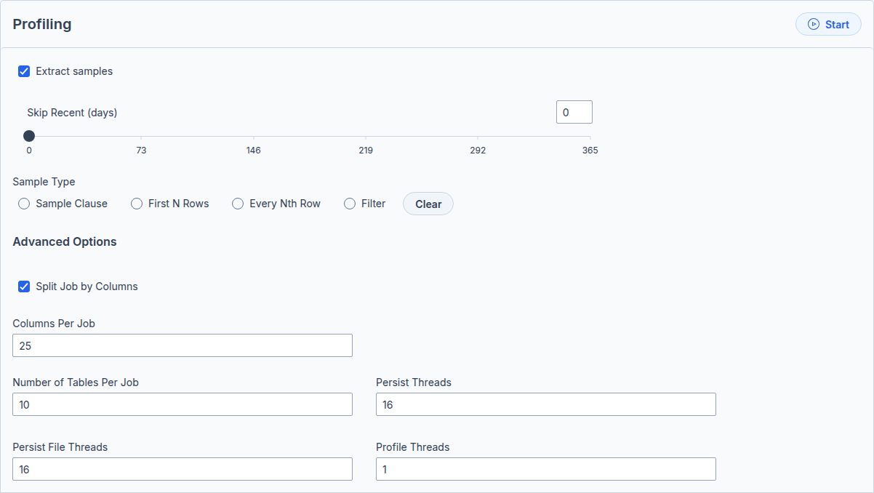
Profiling Options

Part B — Read the profile
- On the customers Summary tab, the Statistics pane now shows a Row Count alongside the Column count, and the Last Successful Scanned date is set.
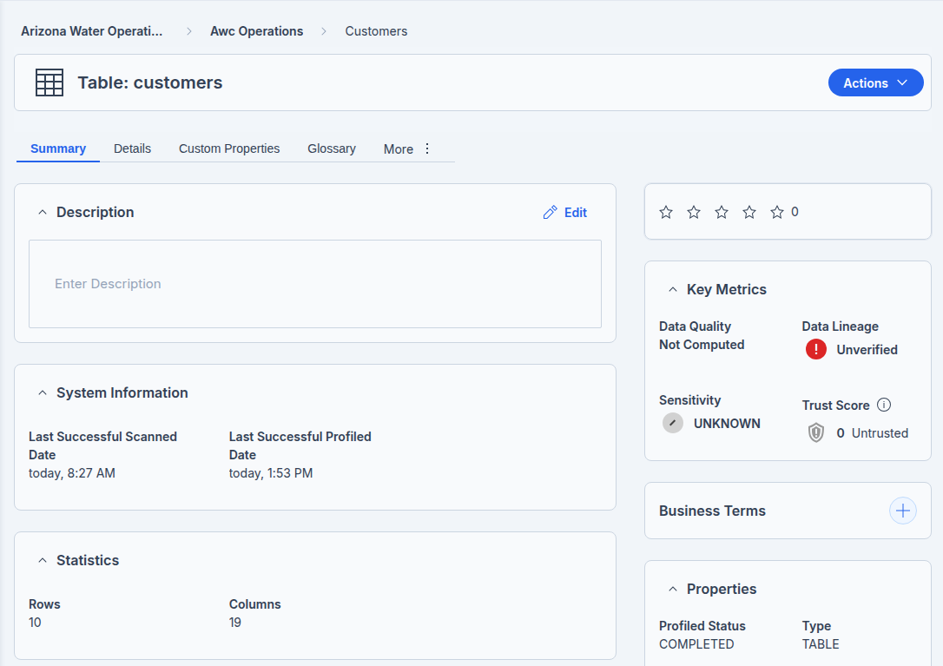
- Click a column (for example, email) to see column—level statistics — Null Count, Cardinality, HLL, Uniqueness, and Density — and a Data Patterns pane with RegEx suggestions.
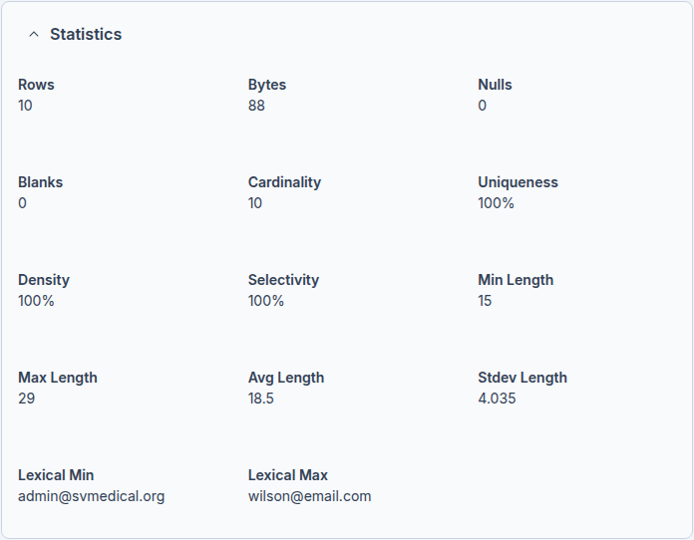
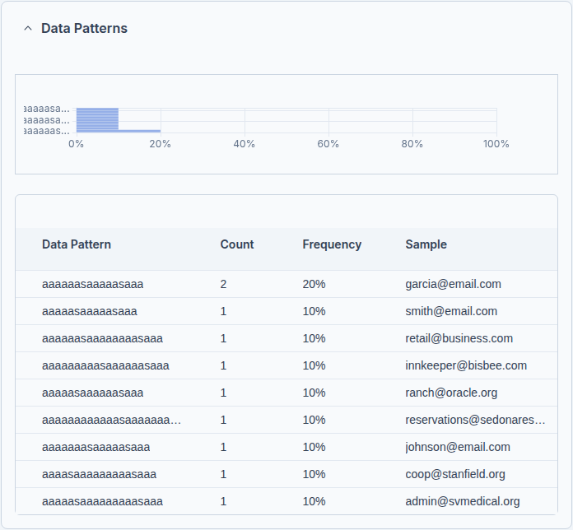
- Open the Details tab and the Sample Data pane (Raw and Aggregated) to preview real values and how often each occurs.
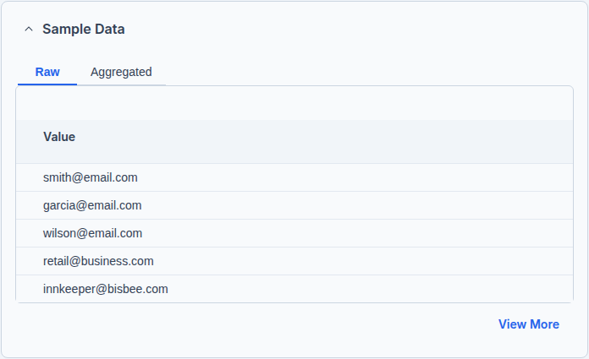
- Still on Details, look at the PK/FK column. It is populated by Data Catalog’s cross—table foreign—key detection, which runs on profiling output, so it fills in only once every related table has been profiled, not just this one. The box below explains what to do if it is blank.
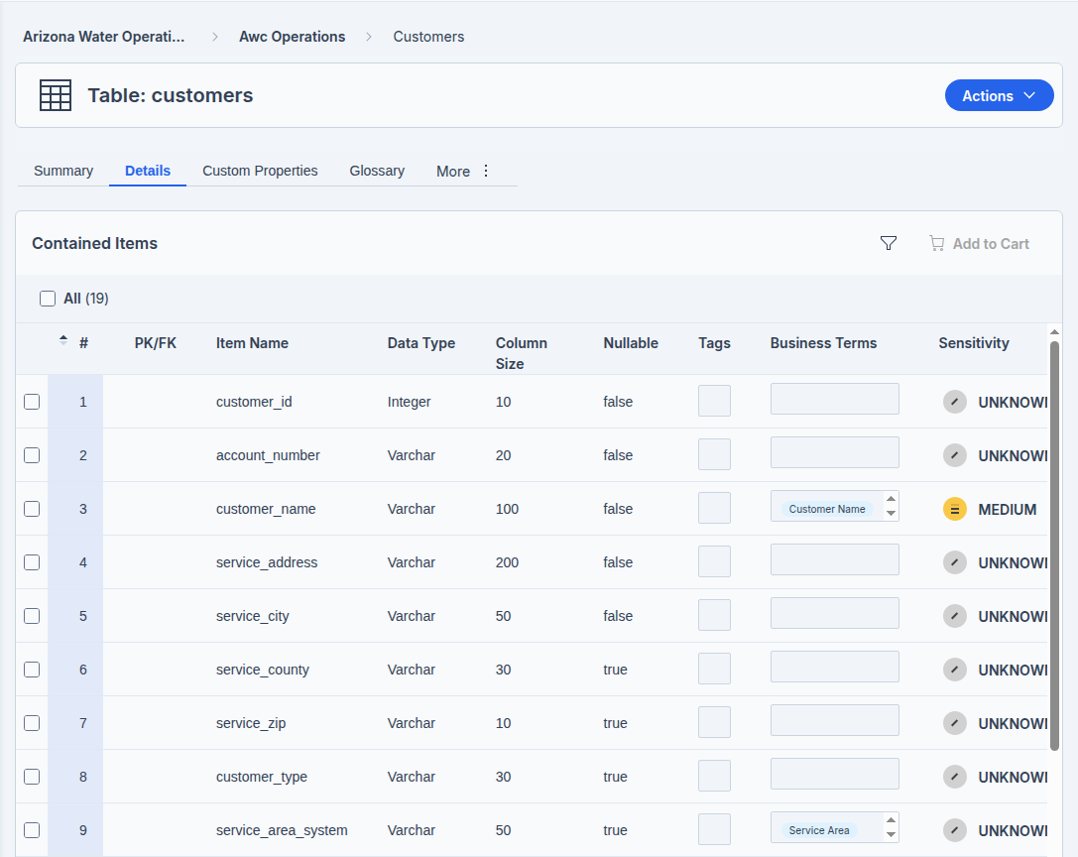
PK/FK detection

Why the PK/FK column can be blank: The PK/FK column is populated by Data Catalog’s foreign—key detection, which runs on profiling output and works across tables. AWC’s schema already declares every key — customers.customer_id is a primary key, and monthly_usage and account_alerts declare foreign keys to it — so the database is not the problem. The column stays blank when detection has not had both sides of a relationship to compare, that is, when only some of the related tables have been profiled. To fill it, run Metadata Ingest on the schema, then Data Profiling on every related table, not just customers:
—— The schema already declares all keys — nothing to add.
—— In PDC, process the WHOLE schema so detection has
—— both sides of every relationship to compare:
—— Actions > Process > Metadata Ingest (all tables)
—— Actions > Process > Data Profiling (all tables)
—— customers, water_systems, tiered_rates, monthly_usage,

—— water_quality_reports, account_alerts.
—— Watch every job finish on the Workers page, then
—— reopen the Details tab on customers.

What the column statistics mean
When you open a profiled column, Data Catalog shows a set of statistics. These are the ones you will read most often.
Statistic | What it means
Rows | Total number of records in the column’s table.
Nulls | Values explicitly marked as no data (database NULL).
Blanks | Empty cells with no characters at all — distinct from NULLs.
Cardinality | Count of distinct values; low cardinality means few unique values, which is a strong hint for keys and categories.
Min / Max Length | Shortest and longest values in the column, by character count.
Avg Length | Average number of characters across the values.
Stdev Length | How much the value lengths vary around the average — a wide spread can signal inconsistent or dirty data.
Bytes | Total storage size of the column’s data.
At the schema level too: profiling records a row count and the last—profiled date for each schema and table; the schema—level Sensitivity and a Confidence Score come later, from Data Identification in Workshop 5.

Part C — Compute the Trust Score
The Trust Score is a roll—up, not a fresh measurement. It combines four inputs — a linked glossary term, Data Lineage marked Verified, a User Rating, and the Data Quality metric — so you set those first, then run the calculation. Sensitivity sits in the same Key Metrics panel, but it is a separate metric, not a Trust Score input.
- Confirm the glossary term you linked in Workshop 3 is still attached to customers. A linked term is the first of the four Trust Score inputs.
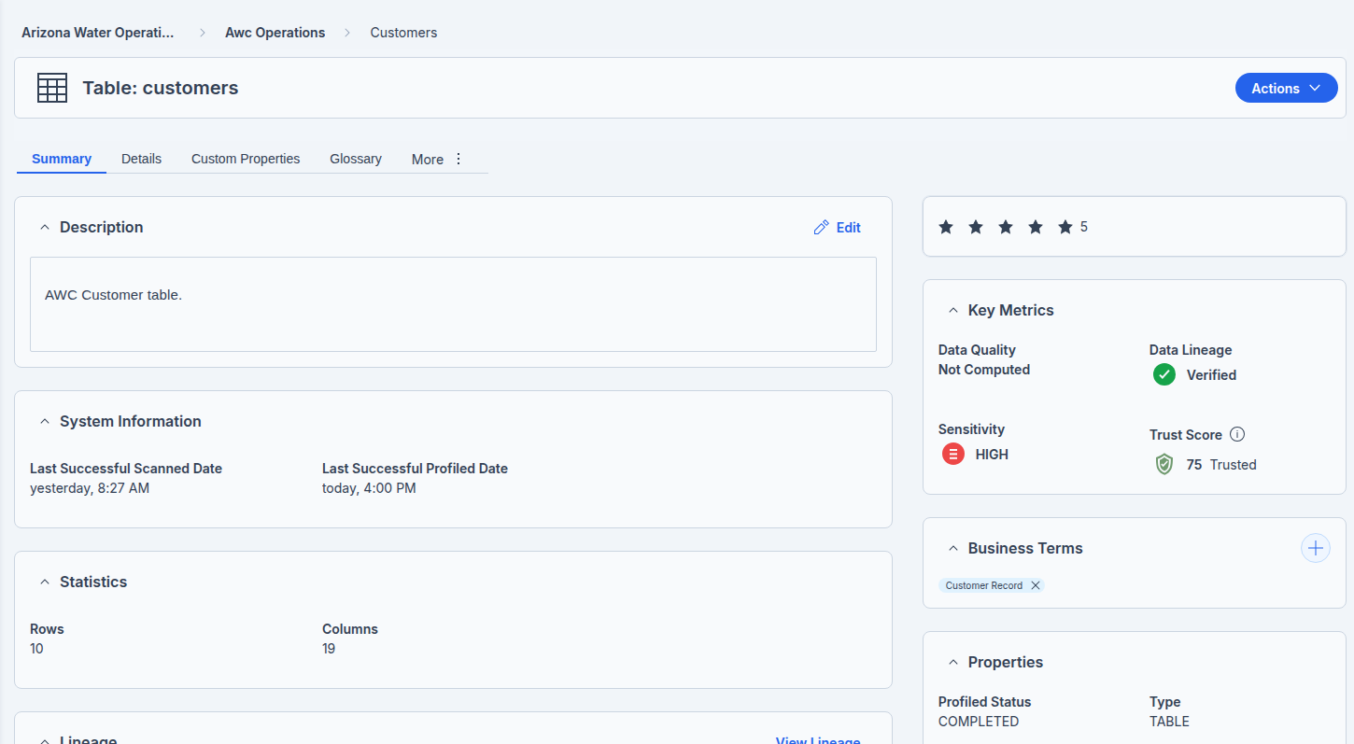
customers table

- Set Data Lineage to Verified. In the Key Metrics panel on the Summary tab, change Data Lineage from Unverified to Verified for the table — the second input.
- Apply a User Rating. Give the asset a 1—to—5—star rating in the Key Metrics panel — the third input.
- Handle Data Quality, the fourth input. With the Pentaho Data Quality add—on and its Data Quality Loader configured, this metric scores completeness, accuracy, validity, uniqueness, and consistency; without the add—on it stays Not Computed and the Trust Score rolls up the other three.
- Optionally set the Sensitivity to Low, Medium, or High in the same panel. It is good governance and drives the catalog’s risk view, but it is not one of the Trust Score inputs.
- Now run the calculation. Open Actions, then Process, and click Start on the Calculate Trust Score card. Watch the job on the Workers page.

- When the job completes, read the Key Metrics panel. With a glossary term, Verified lineage, and a rating in place, the Trust Score moves off 0 / Untrusted to Trusted or Highly Trusted, depending on the inputs.
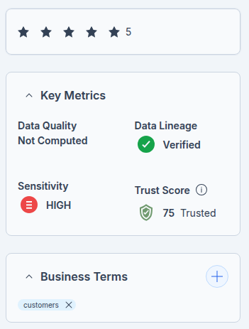
customers – Trust Score

The Trust Score is a sliding scale: it does not need all four inputs to compute. Calculate Trust Score rolls up whatever is present and positive right now — each input that is in place raises the number, each one missing holds it down — and the result slides along a band from Untrusted through Trusted to Highly Trusted. A table with only Verified lineage and a 4—star rating still scores (around the low—40s, Untrusted); add the glossary term and it rises; compute Data Quality and it rises further. Data Quality is the heaviest input, so until it is computed the ceiling stays low. Pentaho does not publish the exact weight of each input, so treat the inputs as levers that move the score, not as a fixed formula.

Trust Score — Documents
- Confirm the glossary term you linked in Workshop 3 is still attached to the file: compliance / epa_compliance_apache_junction_2026Q1.pdf. A linked term is the first of the four Trust Score inputs.

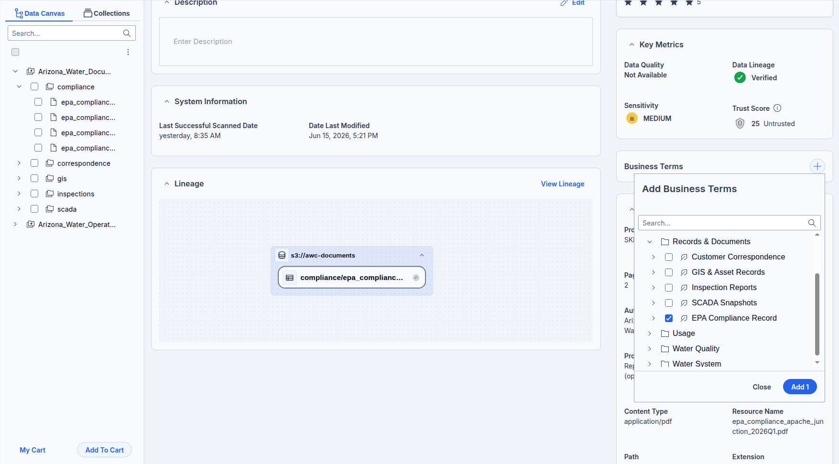

Term — EPA Compliance Record

Set: Rating, Verify: Lineage, Set: Sensitivity — Medium, Check: Business Term.
- Now run the calculation. Open Actions, then Process, and click Start on the Calculate Trust Score card. Watch the job on the Workers page.

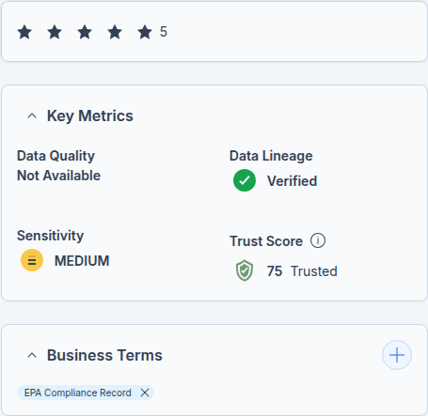

Key Metrics — EPA Compliance Apache Junction

Part D — Profile the documents (Data Discovery)
The awc—documents store holds AWC’s EPA compliance PDFs, not table rows — so they are scanned by Data Discovery, the unstructured—data counterpart to Data Profiling. The steps mirror Part A:
- In the Data Canvas, open the awc—documents store and select the compliance folder that holds the EPA PDFs.
- Open Actions, then Process. For documents the Choose Process page offers Metadata Ingest, Data Discovery, and Data Identification. Click Start on the Data Discovery card — there is no Data Profiling card for documents.
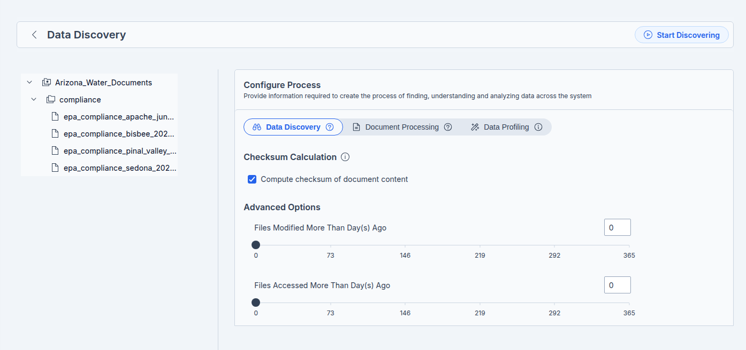
Data Discovery
- The Configure Process page opens with three tabs — Data Discovery, Document Processing, and Data Profiling. Keep the defaults, which suit AWC, and click Start Discovering.
- Watch the job on the Workers page until it completes.
Where Data Profiling computes column statistics, Data Discovery scans file contents. For AWC’s PDFs it:
- Extracts document properties and text from each PDF (and Office files), so the content becomes searchable in the catalog.
- Computes a checksum of the contents to flag duplicate documents, when Compute checksum of document contents is selected.
- Scans the text with dictionaries for keywords and patterns, which can trigger tags and glossary—term assignments.
- Runs OCR (Tesseract or EasyOCR) on scanned or image—only PDFs so their text can be read.
Data Catalog can also AI—assist on the documents — summarising each PDF, detecting addresses, and classifying it against business terms (for example, EPA Report or Compliance Notice) on the Document Processing tab.
Why it matters for later workshops: Data Identification needs either Data Profiling (for tables) or Data Discovery (for documents) to have run first. Discovering the awc—documents PDFs here is what lets Workshop 5 flag PII and compliance content inside them.

Verify your work
- customers, monthly_usage, and water_quality_reports each show a Row Count and a profiled date.
- Column—level statistics (Null Count, Cardinality, Uniqueness) and Sample Data are visible.
- Once every related table in the schema is profiled, the PK/FK column shows customer_id as the primary key; the AWC schema already declares the keys, so the remaining step is profiling the full related set.
- After Calculate Trust Score, the customers Trust Score is no longer 0 / Untrusted.
- You can name the four Trust Score inputs and say which one requires the Pentaho Data Quality add—on.

Troubleshooting
Symptom | Cause and fix
PK/FK still blank after profiling | Foreign—key detection is cross—table, so it needs every related table profiled, not just this one. Confirm the keys are declared in the source (the AWC schema declares them all), then run Metadata Ingest and Data Profiling across the whole awc_operations schema and check the Workers page. If it is still blank after every related table is profiled, the schema is provably correct, so treat it as a Data Catalog scan or version question for Pentaho support.
Data Quality shows Not Computed | The Data Quality metric requires the Pentaho Data Quality add—on and the Data Quality Loader. Profiling alone does not populate it; the rest of the Trust Score still computes.
Row count or samples missing | The table was not profiled, or Extract Samples was disabled. Re—run Data Profiling with the default settings.
Profiling skips a table | Skip Recent (days) may be set, so a table profiled within that window is skipped. Clear the value or wait.

Why it matters & discussion
Profiling is what turns a catalog entry into trustworthy evidence. Before Workshop 4, the customers Trust Score was a placeholder; now it rests on measured statistics, discovered keys, and a linked glossary term. Discuss: which of AWC’s tables would you profile first, and what would a low completeness score on a billing column mean for the conservation—rate report an analyst is about to build?

What’s next
With the data profiled and keys discovered, the catalog now knows the shape and quality of AWC’s data. Workshop 5 puts that to work for compliance: Data Identification scans the profiled tables with dictionaries and patterns to flag PII and confidential data automatically, and you set the Sensitivity that protects AWC’s customers.

