PENTAHO DATA CATALOG 10.2.11 · BUSINESS ANALYST · FOUNDATIONS
PDC PROCESS · DATA IDENTIFICATION · DICTIONARIES & PATTERNS
WORKSHOP 5
Data Identification
How PDC recognizes what your data is — using Data Dictionaries and Data Patterns to classify, tag, and prepare every column for governance.
Primary role: Business Analyst
Estimated time: 45 minutes
Dataset: Arizona Water Company (awc_operations + awc-documents)
Builds on: Workshop 4 (profiling) — the customers table must be profiled first

Why this workshop matters
As a Business Analyst you rely on the catalog knowing what its data is — that classification is what lets you search by business meaning, trust sensitivity labels, and reason about where information lives. Data Identification is the engine that produces it. This workshop builds a complete conceptual picture of how that engine works; the technical workshop then builds and tunes the methods behind it.
The big picture
Profiling tells you the shape of a column — its statistics, samples, and patterns. Data Identification tells you what the column means. It compares your data against two kinds of methods — dictionaries and patterns — and tags whatever matches, turning “we think this column is a phone number” into “the catalog knows it is.”

What you will learn
- What Data Identification is, and where it sits in the PDC pipeline.
- The two identification methods — Data Dictionaries (match by value) and Data Patterns (match by shape) — and when each applies.
- How a match becomes a tag — confidence, condition, and action — at a level a BA needs.
- How dictionaries and patterns combine into policies, and what a run produces in the catalog.
- That identification reaches unstructured documents too — the same methods, applied to file content through Data Discovery.

Where Data Identification sits
Identification is the second step of the catalog pipeline. Each stage feeds the next: you cannot identify data you have not profiled, and you cannot govern data you have not identified.
Stage | What happens | Why it matters
Profile | Generates statistics, samples, and data patterns for each column. | Produces the raw material identification matches against.
Identify | Matches columns against dictionaries and patterns; applies tags and terms. | Turns raw columns into classified, meaningful assets.
Tag & classify | Matched columns carry tags and linked business terms. | Makes meaning, ownership, and sensitivity explicit.
Discover & govern | Search, sensitivity, lineage, and the Galaxy View draw on the tags. | Everything downstream depends on identification being right.

Profiling comes first: Data Identification runs on profiled data — it needs the patterns and samples that profiling produced in Workshop 4. Profile a table before you identify it, or the job has nothing to match against.
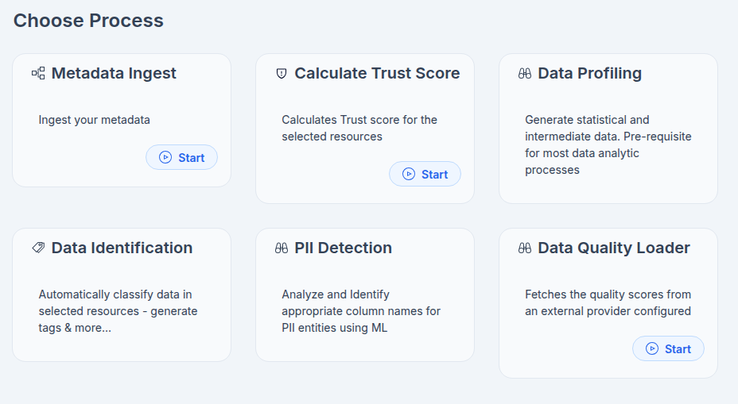
Process

The two methods
Every identification comes down to one question: “what is this column?” PDC answers it two ways. A dictionary matches by value; a pattern matches by shape. Most real-world identification uses both together.

Method 1 — Data Dictionary (match by value)
A dictionary is a curated list of terms or values. During identification PDC compares a column's actual contents to that list; a match means the value appears in the list. Dictionaries are the right tool for data that has no fixed shape — where the meaning lives in the values themselves.
- System-defined: 95 dictionaries ship built-in — ISO country codes, currency, marital status, US states, and more.
- User-defined: your own lists — upload a single-column CSV, build one in the UI, or extract terms from a profiled column.
Best for: country and state codes, product names / SKUs, department codes, and custom business terminology.
Example — Marital_Status
The column holds values such as Single · Married · Divorced. Identification compares those values to the Marital_Status dictionary. On a match, it applies the tags PII and Sensitive: Marital Status. These low-cardinality values have no regex shape, so a dictionary — not a pattern — is the correct method.

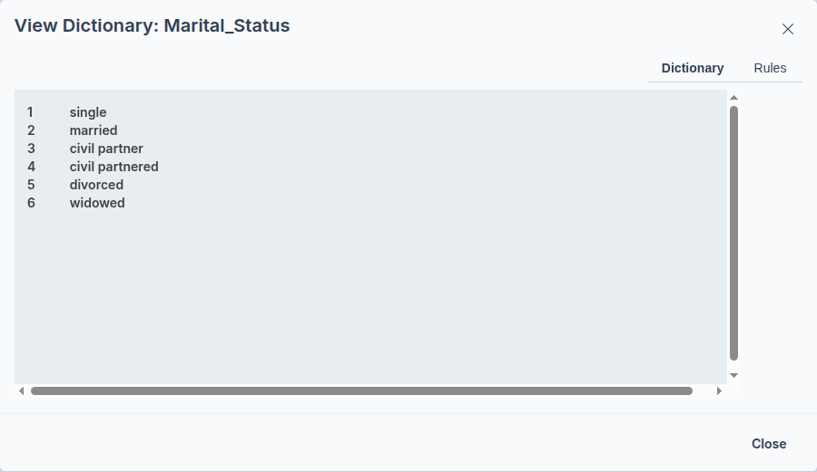

Dictionary – Marital_Status

Every dictionary and pattern carries an identification rule — the logic PDC evaluates during Data Identification to decide whether a column matches. (Note: this is the method's own rule, not a PDC "Business Rule," which is a separate data-quality feature.) Take the built-in Marital_Status dictionary.

Its rule needs a minimum sample of ~200 values, then computes a confidence score as a weighted blend of similarity (how closely the column's actual values match the dictionary's accepted list, weighted 0.9) and metadata score (hints from the column name, weighted 0.1) — so content matters far more than the column's name.

The rule only fires when two conditions are both met: confidence ≥ 0.7 and column cardinality ≥ 3 (a guard that stops columns with one or two distinct values being mislabelled). On a match, its action applies the tags PII and Sensitive: Marital Status. Those categories are also what drive the column's Sensitivity rating (UNKNOWN → LOW/MEDIUM/HIGH), and the dictionary's linked term lets the same match seed a business-term association.

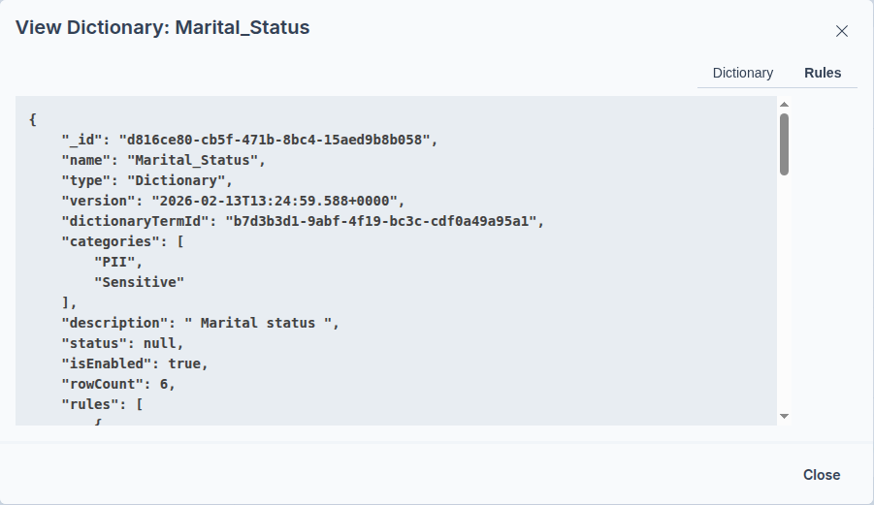

Data Identification Rule – Marital_Status

Method 2 — Data Patterns (match by shape)
Pattern analysis reduces each value to a simple shape string — one symbol per character position — then matches that shape, and an optional regular expression, against a known format. Patterns suit data with a recognizable structure, regardless of the specific values.
The pattern alphabet:
Symbol | Meaning
A | Upper-case letter
a | Lower-case letter
n | Digit 0–9
s | Symbol
w | Whitespace

Worked example — part code
The value KT1734-B reduces to the pattern AAnnnn-A — two letters, four digits, a dash, then a letter. From the top ~20 patterns it finds, PDC also recommends a tunable RegEx, which is reused later for data-quality checks that flag outliers.
Best for: email, phone, SSN, passport, IP address, dates, and structured part codes.
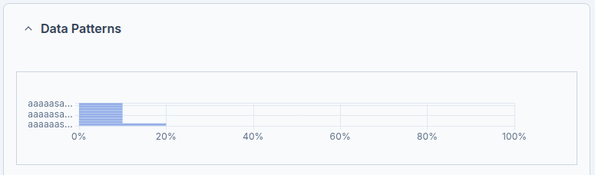
Data Patterns - email

The eMail method is a DataPattern — where a dictionary matches values against a list, a pattern matches them against a regular expression plus column-name hints. Its rule computes a confidence score as a weighted blend of two signals: regexScore (how well the column's values match the email regex, weighted 0.6) and metadataScore (how well the column name matches, weighted 0.4). The name hints live in metadataHints.aliases: a column called email scores 0.9, one matching E-MAIL scores 1.0 — so a well-named column gets a strong metadata signal even before the values are examined. The regexMatch block holds the actual email regex applied to the content.

What makes this pattern "loose" in a useful way is its condition, which uses or, not and: it fires when either the overall confidence is ≥ 0.5 or the regex score alone is ≥ 0.75. So it catches two cases — a column that's named like email and looks like email (combined confidence clears 0.5), or a column whose values are so clearly email addresses that the content alone is decisive (regex ≥ 0.75), even if the column name gives no hint. Like the dictionary, it needs minSamples: 200 before it evaluates.

On a match, the action applies three tags, each with a confidence value of 100: PII, eMail, and Non-sensitive. Those come straight from the pattern's categories. This is also a good teaching moment on why sensitivity can read differently than you'd expect: email is tagged PII (it identifies a person) yet also Non-sensitive (it's routinely public-facing), which is why an email column may not land as HIGH the way an SSN or account number does — the category tags, not the field itself, decide the sensitivity.

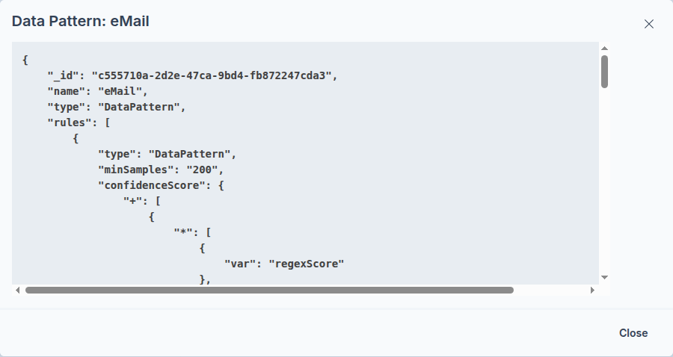

Data Identification Rule - eMail

From match to tag: scored, not guessed
Both methods work the same way underneath. Matching is graded, not a yes/no guess — which is why identification is reliable. You don't author these steps as a BA, but knowing their shape explains the results you see.
Step | What happens
1 · Compare | Profiled values are checked against the dictionary or pattern, plus a hint from the column name.
2 · Score | A confidence score blends content similarity with the metadata (column-name) hint.
3 · Condition | If the score clears the threshold — for example ≥ 0.7 — the match is accepted.
4 · Action | Apply the tags and link the business terms to the column.

For the technical workshop: you will set the weightings, write the conditions, and tune the thresholds behind each method. For now, the takeaway is that every tag is earned by a graded match clearing a threshold.

Policies: dictionaries + patterns together
A policy is not a pre-built object you pick off a shelf. In PDC a policy is simply the combination of dictionaries plus patterns you select for a run — the methods you choose at the Select Methods step. That selection is your policy.
You assemble it from the built-in dictionaries and patterns plus any of your own — for AWC, the Service Cities dictionary and the Account Reference pattern you’ll meet below. Apply, run, then review the results in the Data Canvas and visualize them in the Galaxy View.

Walkthrough — identify the customers table
Run Data Identification on AWC's profiled customers table (awc_operations), selecting the dictionaries and patterns that fit its columns. Each personal-data column is caught by the method that suits it, then tagged and linked to its Workshop 3 business term.

Part A — Run Data Identification
- In the Data Canvas, select the profiled customers table, then open Actions → Process.
- On the Choose Process page, click the Data Identification card. If it shows as Required, profiling has not completed — run Data Profiling first.
- Click Select Methods and choose the dictionaries and patterns that cover names, email, phone, and country names. Click Start.
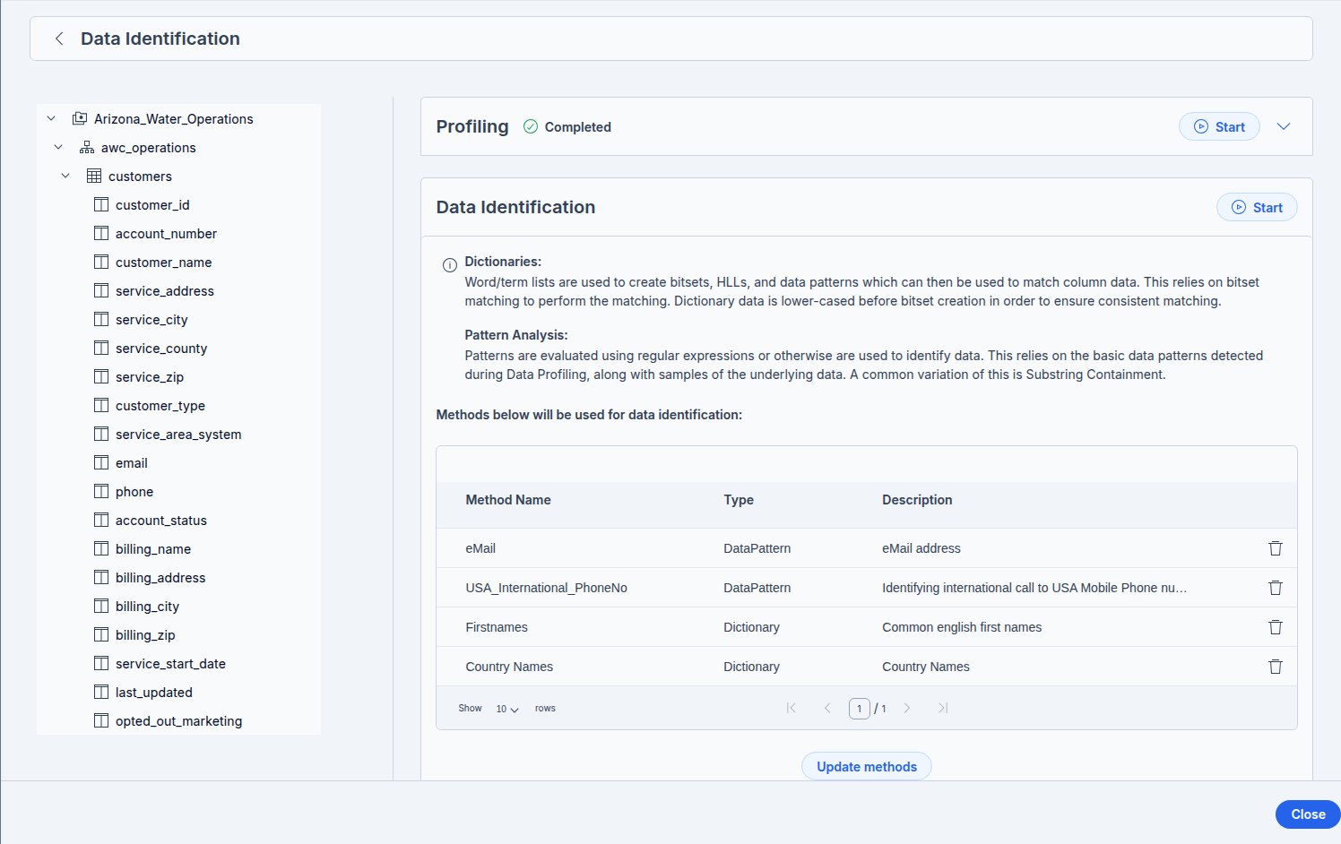
Data Identification Policy
- Click Start, and watch the job on the Workers page until it completes.

Part B — Review what was identified
- Open customers. On the Details tab, the matched columns now carry Tags and linked Business Terms.
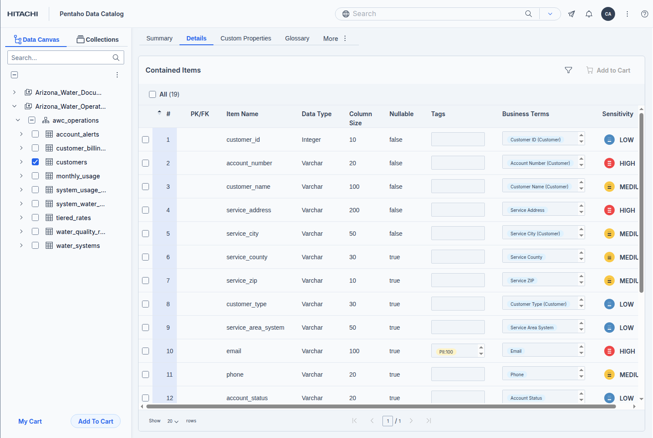
- As you can see not as expected, which should be no surprise! — built-in methods are a fast, a generic starting point, and their limits are exactly why every organisation ends up building custom dictionaries and patterns.
Dictionary vs pattern, in practice: names and the consent flag are caught by dictionaries (their meaning is in the values); email and phone are caught by patterns (their meaning is in the shape); an address takes both. The method assignments above are illustrative — confirm them against your lab's identification run.

Part C — Visualize in the Galaxy View
- With customers selected, open Actions → View Galaxy.
- Click Filters and turn on Show only Tagged Items (or items with business terms) to highlight exactly the columns identification classified.
custom dictionary/pattern must apply the exact same tag label as the glossary and everywhere else — but PDC won't enforce it, because Assign Tags is free text. So it's a discipline: one controlled tag list, reused verbatim across dictionaries, patterns, the glossary, and your Glossary Generator's Suggested_Tags. And when a method should carry glossary meaning, use its Assign Business Term action rather than typing a look-alike tag.

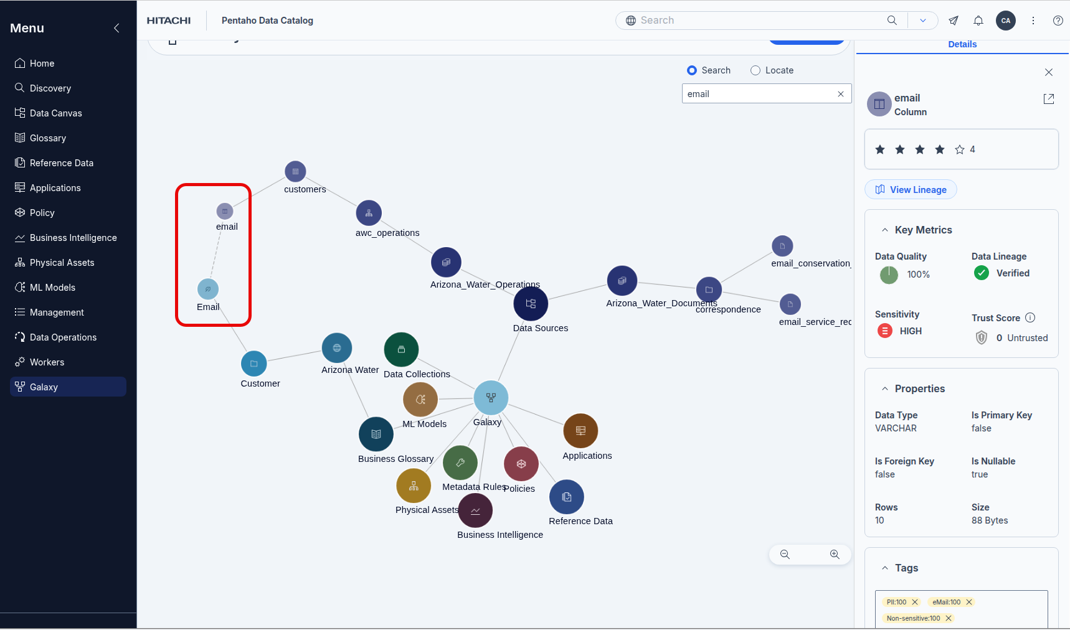
Galaxy View

Beyond tables: identifying unstructured documents
Identification does not stop at tables. PDC also profiles documents — PDFs, Word files, plain-text, and RTF — and points the very same dictionaries and patterns at their content. The pipeline differs slightly, but the methods are identical: a name dictionary or an email pattern works just as well inside a letter as it does in a column.
Two worlds, the same methods
A structured column is profiled, then Data Identification applies the scored rule logic — confidence, condition, action. An unstructured document is profiled by Data Discovery, and within it String Detection scans the text for the same dictionary and pattern values — flagging their presence, and optionally their count. (String Detection matches values directly; it does not apply the dictionaries’ scored rules.)

The document processing options
When you run Data Discovery on files, the Document Processing tab offers String Detection plus a set of machine-learning helpers that only apply to documents:
Option | What it does
String Detection | Scans document text for the values in selected dictionaries and patterns, and tags the file on a match — presence only, or presence and count.
Address Detection | Machine-learning scan for U.S. postal addresses; tags a business term you choose when an address is found.
Data Classification | Classifies a document by its semantic content; assigns the matching business terms you supply (for example, a document type).
Summaries & sentiment | Generates a concise document summary and a sentiment label, shown on the asset's Summary tab.
Document Metadata | Extracts properties such as owner, page count, and paragraph count (Office and PDF files).

Supported file types: PDF, DOC, DOCX, TXT, and RTF, among others. Structured and semi-structured files (CSV, JSON, Parquet) are profiled the same way, with structured outputs.

Walkthrough — PII in the AWC correspondence
The awc-documents/correspondence folder holds emails and letters about customers. The goal is the same as for the table: flag every document that contains personal data.
- In the Data Canvas, select the correspondence folder, then click Process. Run Metadata Ingest first.
- Click the Data Discovery card. On the Document Processing tab, add the PII dictionaries and patterns (name, email, phone, address) under String Detection.
- Optionally enable Address Detection (tag a Service Address term) and Data Classification (to label each letter by type). Click Start Discovering.
- Open each document on the Data Canvas. Files that contain personal data now carry the matching Tags and Business Terms, visible in the Document Properties and Business Terms panes.

Document | Type | Personal data it surfaces
letter_overdue_notice | Letter | name · address · account ref · amount
letter_dispute_response | Letter | name · address · account ref
letter_optout_confirmation | Letter | name · marketing-consent status
email_service_request | Email | name · email · phone · address
email_conservation_inquiry | Email | name · email · address

A pattern reaches into the letters too
The reference codes in the letter names — AWC-AJ-100118 — follow the shape AAA-AA-nnnnnn. A custom data pattern for that shape flags AWC account / case references wherever they appear in a document, not just in a column. The method assignments above are illustrative — the asset files were not available to inspect, so confirm them against the real correspondence.

Choosing methods for AWC
Most of AWC’s data is covered by methods that ship with the catalog. Start by selecting the built-in dictionaries and patterns that fit, then add two custom AWC methods for what the built-ins don’t know.

Recommended built-in methods — structured (customers)
AWC data | Built-in method | Type
customer_name | person-name dictionary | Dictionary
email | Email | Pattern
phone | Phone Number | Pattern
service_address | US States dictionary + ZIP / address pattern | Dict + Pattern
opted_out_marketing | low-cardinality flag — custom Yes/No dictionary (technical track) | —

Selecting methods: choose the built-in name dictionary, the Email and Phone patterns, and the US States dictionary together at Select Methods — that selection is your policy for this run. Exact built-in names vary by release, so confirm them in your lab’s method list.

Recommended methods — unstructured (correspondence)
Need | Method
names / email / phone | the same dictionary and patterns, run under String Detection
postal addresses | Address Detection (ML) + US States dictionary
letter type | Data Classification (ML)
account / case references | AWC Account Reference pattern (custom — below)
service-area cities | AWC Service Cities dictionary (custom — below)

Custom method 1 — the AWC Service Cities dictionary
Built-in dictionaries know US states and country codes, but not which Arizona communities AWC serves. A Service Cities dictionary lets identification recognise AWC’s service-area locations — in the service_address column and in the correspondence alike. The asset is a single-column CSV: AWC-Service-Cities-Dictionary.csv (header Term, one city per row).

Uploading the dictionary
- In the left navigation, go to Data Operations → Dictionaries, then click Add Dictionary.
- Enter a Name (“AWC Service Cities”), a short description, and a Category (pick Sensitive or add a new AWC category). Make sure the dictionary is enabled.
- Choose Upload Dictionary, upload AWC-Service-Cities-Dictionary.csv, and set a Confidence Score of 0.7.
- (Optional) add a Column Name Regex hint such as [Cc]ity|[Tt]own|service_city so a city column is matched on its name as well as its values.
- Click Create Dictionary. It now appears in the methods list — select it in a Data Identification run on a table, or under String Detection when discovering documents.

Rules vs upload: uploading the word list and setting a confidence score is all the BA workshop needs. Designing the matching rules behind it — conditions, actions, and weightings — is covered in the technical track.

Custom method 2 — an example AWC pattern
The correspondence (and any account_ref column) carries references like AWC-AJ-100118. A custom data pattern catches that shape wherever it appears. Use this as the worked example when you build it in the technical track:
Field | Value
Name | AWC_Account_Reference
Pattern | AAA-AA-nnnnnn
RegEx | AWC-[A-Z]{2}-\d{6}
Matches | AWC account / case reference IDs
Suggested tag / term | AWC Account Ref / Account Reference

You add this one: the pattern above is a specification, not a finished method. Creating patterns and dictionaries from scratch — regex authoring, confidence weightings, conditions, and actions — is the technical track’s territory.
- Data Identification has completed on customers.
- The matched columns carry Tags and linked Business Terms on the Details tab.
- You can name the two methods and say which one fits a given column, and why.
- You can explain how dictionaries and patterns combine into a policy.
- Data Discovery has run on the correspondence folder, and documents containing personal data carry Tags and Business Terms.
- You can explain why a table is profiled and identified, while a document is discovered and string-detected — using the same methods.
- The AWC Service Cities dictionary is uploaded and appears in the methods list, ready to select for tables or String Detection.

Troubleshooting
Symptom | Cause and fix
Data Identification shows Required or is disabled | The table has not been profiled. Run Data Discovery (Data Profiling) first, then return.
No columns were tagged | No matching methods were selected, or the data lacked samples. Re-run after selecting the relevant dictionaries and patterns, and confirm the data was profiled with samples.
A column you expected wasn't matched | Its values may not appear in any dictionary and its shape may not match a pattern. A user-defined dictionary or pattern is the fix — covered in the technical workshop.
Too many false matches, or confidence too low | Thresholds and weightings are tunable. Adjusting them is the technical workshop's focus; as a BA, note the column and method for follow-up.
A document wasn't tagged for content | String Detection runs only when at least one dictionary or pattern is added under Document Processing. Confirm Data Discovery completed and the methods were selected.

Why it matters & discussion
Identification is the foundation the rest of the catalog stands on. Search by business meaning, sensitivity labels, lineage, and data-quality checks all assume data — structured or not — has already been classified correctly. Get identification right and a compliance request that spans both the customers table and a folder of letters becomes a filter rather than a manual hunt.
Discuss: a regulator asks for every place a customer's data is held. Which method catches their secondary_email if it's added to the table next quarter — and how would you find the same customer's details inside the correspondence folder?

What's next
The technical workshop goes under the hood of everything you've just seen: building custom dictionaries and patterns, setting confidence weightings, writing the conditions that accept a match, and assembling those methods into a policy of your own.

