PENTAHO DATA CATALOG 11.0.0 · TECHNICAL TRACK
PDC PROCESS · GLOSSARY GENERATOR
APP WORKSHOP
Build the Glossary with the Glossary Generator
Scan, review, govern and apply CSCU's governed glossary — and author the Registry — with the app.

Primary role: Data Steward / Solution Architect
Estimated time: 60–90 minutes
Dataset: Copper State Credit Union (cscu_core + cscu-documents)
Prerequisites: the shared lab running with CSCU loaded (data_sources/lab → make up && make load SCENARIO=CSCU), PDC reachable over HTTPS, the CSCU domain pack installed (data_sources/CSCU/cscu-domain-pack.zip → unzip into glossary_generator/).

1. The scenario
Copper State Credit Union is a fictional Arizona credit union with six branches (Phoenix, Tempe, Tucson, Casa Grande, Globe, Prescott), ~13 pilot members, and a core banking schema (cscu_core, 11 tables) plus a document store (cscu-documents bucket, 18 files). Its data estate has exactly the governance problems the Registry approach fixes:
- PII everywhere — SSNs, DOBs, card PANs, account and routing numbers spread across members, cards, accounts, ach_payments.
- A planted PCI violation — cards.cvv_cd stores card verification values, which PCI DSS forbids after authorization. Your steward review must catch it.
- Cryptic core-banking names — mbr_no, prin_bal_amt, apr_rt, ach_rte_no. The generator's abbreviation expansion (plus the CSCU pack) turns them into readable terms: Member Number, Principal Balance Amount, APR, ACH Routing Number.
- A compliance story that spans sources — SAR 97001 (structuring: two $9,450 transfers just under the $10,000 threshold) exists as database rows (suspicious_activity, ach_payments, transactions) and as documents (the Q2 SAR summary PDF, the ACH batch JSON). One glossary must cover both.
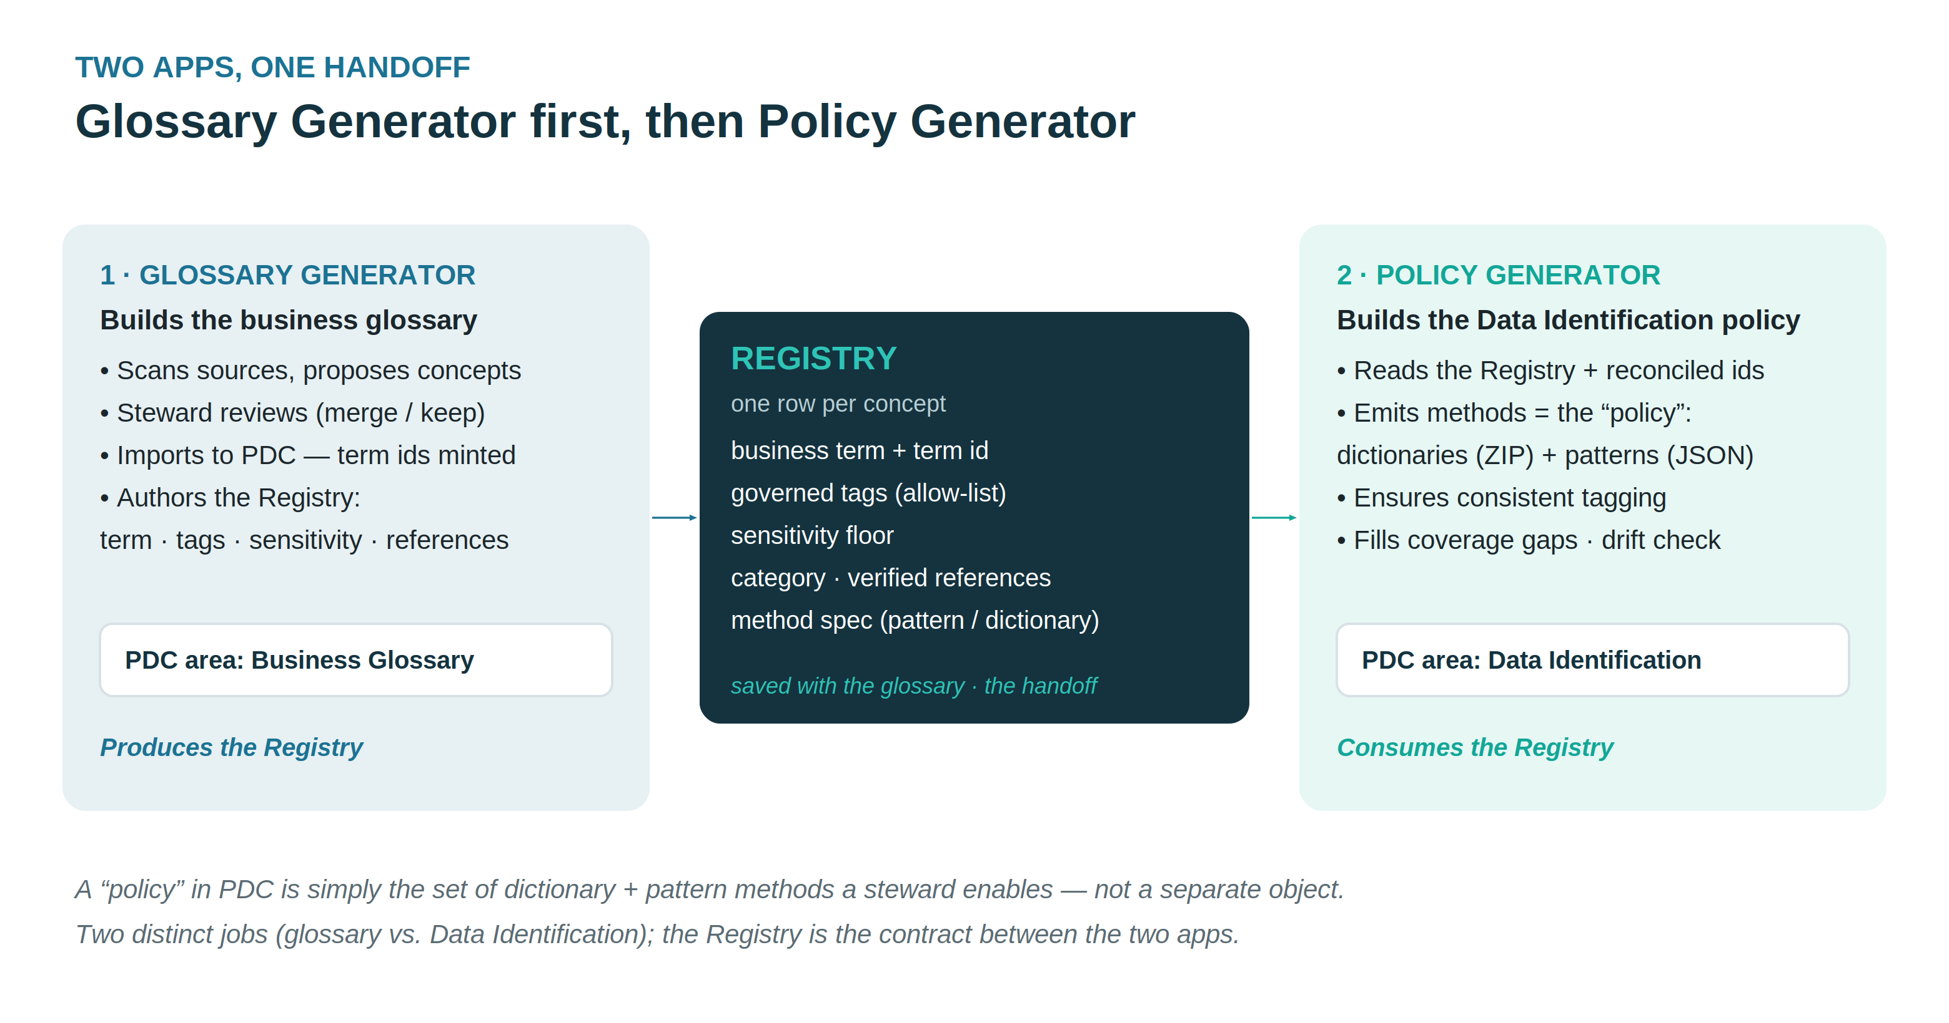

2. What you will build
An import-ready business glossary for PDC — one reviewed term per business-meaningful column and document folder, each with governed tags (pci, aml, lending, …), rule-based sensitivity, CDE flags, and steward assignments — plus the Registry the Policy Generator will later read to emit Data Identification methods.

3. Lab flow

Step 1 — Stand up the sources
cd data_sources/lab
cp .env.example .env
make up # shared postgres + minio (all scenarios)
make load SCENARIO=CSCU # cscu_core db + cscu-documents bucket, verified
make console reprints the PDC connection values (database CopperState_Core_Banking, object store CopperState_Documents).

Step 2 — Register the sources in PDC
Use the app's bulk loader (Connections → Bulk-load data sources) with data_sources/CSCU/cscu-datasources.csv, or create the two sources by hand. Then run Metadata Ingest → Profile → Data Identification in PDC, and click Scan Files on the document store. (Identify once — the steward's overrides come later and must not be clobbered.)

Step 3 — Install the scenario and start the app
Unzip cscu-domain-pack.zip into glossary_generator/ (this drops domain_pack.json and the people.json steward roster), delete any previous tag_dictionary.json, then ./run.sh. Confirm on /config that GLOSSARY_COMPANY=Copper State Credit Union.

Step 4 — Scan & review
Connect to cscu_core (schema cscu_core, read-only pdc_user), Scan, then Add to glossary from the MinIO bucket so one glossary spans both sources. On the review grid:
- Check the expansions: mbr_since_dt → Member Since Date, apr_rt → APR Rate. Edit anything weak.
- Confirm sensitivity: ssn, card_no, acct_no must be HIGH. The profiler and the pack's sensitivity floors should already say so — verify, don't trust.
- Find the planted violation: cvv_cd on cards. Its column comment and the PCI attestation PDF both flag it. Keep the term, set sensitivity HIGH, tag pci, and note the remediation in the definition — the glossary is where the finding becomes visible to everyone.
- Check the tags the CSCU pack derived: ach_rte_no → payments · ach, risk_rating_cd → compliance · aml, statements folder → statement · records. A bare document tag means a vocabulary gap — extend the pack, don't hand-edit. Tags are standardised lower-case (pci, never PCI) — they are search facets in PDC, and case variants would fragment the facet.

Step 4a — Put the agents to work
The grid carries a set of local AI agents. They share one contract: the deterministic rules run first, the model only adds judgment, every proposal is guardrailed to the governed vocabulary, and nothing applies itself — you click.
- AI suggest (evidence) — the model reads each row's scan evidence (the induced value format such as ^CSCU-\d{6}$, profiled reference values, PII class) and proposes the business name (as a suggestion chip), governed tags, and a tighten-only sensitivity.
- Duplicate groups come with advice. Every duplicate header now recommends Merge / Disambiguate / Keep separate, with the reason: a foreign key between the columns (same concept by construction), matching or conflicting induced formats, overlapping or disjoint code lists. AI advise escalates the ambiguous groups — it samples live values from the member columns over your connection and compares the actual populations, then lets the model adjudicate whatever is still unclear.
- AI QA definitions — a linter (circular, vague, echoed, copy-pasted definitions) plus the model judging whether each definition actually explains the business meaning; flagged rows get a proposed rewrite you apply per row. Run it before Generate — checkpoints 2 and 3 are easier to defend with clean definitions.
- AI categorize — files any uncategorized terms into the known categories.
- Find similar — proposes same-concept merges across different names (phone vs cust_phone_no), and now reads the data evidence too: a shape match is marked strong, while look-alike names holding different data are flagged different concepts with the merge withheld.

Step 5 — Govern
The roster is pre-seeded with the CSCU team, each steward carrying the expertise keywords the matcher uses. Auto-assign all slots and verify the result: Elena Ramirez stewards Member, Accounts & Deposits, Transactions, Branch Operations; Marcus Webb Lending, Finance & Ledger; Nadia Flores Compliance & Risk, Records & Documents; Tom Callahan Cards & Payments. Elena's Data Steward role fills the owner slots, and Omar Haddad (Data Storage Administrator) fills every custodian slot — every pick shows its confidence and matched terms. Set ratings (Auto/DQ), review date, and status.

Step 6 — Generate, import, resolve, apply
Generate JSONL (writes the Registry alongside), import it in PDC (Business Glossary → Actions → Import), Resolve term ids, then Apply to PDC — dry-run first, always. Finish with the Trust Score rollup.

Step 7 — Draft the Data Identification rules
Still on the Govern page, click Draft policies (AI). Every kept term whose scan produced a detection seed becomes a ready-to-import PDC rule: the induced ^CSCU-\d{6}$ becomes a Data Pattern, the profiled code lists (risk ratings, SAR statuses, …) become Dictionaries with their values CSVs — one zip, with an INDEX. The AI agent polishes each rule's column-name hint and tag pick, guardrailed to the governed vocabulary. Review every rule, then import under Management → Data Identification (the Technical Track's Module 03 teaches exactly what each field means).

4. Checkpoints
# | Check | Evidence
1 | 11 tables + 18 documents scanned | Sources chip on the Glossary page
2 | cvv_cd flagged HIGH / pci | The review grid row + your note
3 | SAR terms marked CDE, HIGH | suspicious_activity terms
4 | Tags all governed (no drift) | Dictionary page: 0 off-vocabulary
5 | Stewards assigned per domain | Govern page slots
6 | Registry written at export | registries/registry.<glossary>.json
7 | Definition QA clean, policies drafted | QA panel empty · drafted-policies.zip

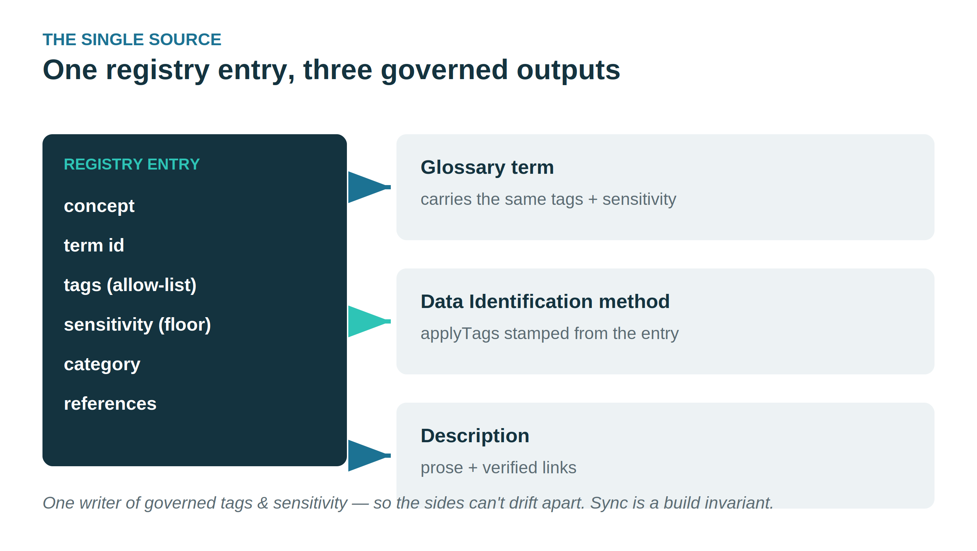

5. Where the story continues
The Registry you just produced is the input contract for the Policy Generator. Its authoring half already runs inside this app — Draft policies (AI) turned your detection seeds into importable dictionaries and patterns in Step 7. The remaining half — binding the rules to reconciled term ids over the API and drift-checking deployed methods against the Registry — is the separate Policy Generator session.
All Copper State Credit Union data — members, accounts, transactions, SARs and documents — is fictional and generated for training.

