PENTAHO DATA CATALOG · TECHNICAL TRACK
Automating the Glossary Workflow
With the PDC Public API
A hands-on technical workshop for Solution Architects and Developers
Copper State Credit Union (CSCU) scenario · PDC 11.0.0

Audience | Architect / Developer learning path (technical). Assumes the UI-driven workshops are complete.
Format | Guided hands-on lab, or instructor-led demo. ~75–90 minutes.
You will need | The Copper State Glossary Generator app — pre-installed on the lab VM, or stood up against your own PDC instance (see INSTALL.md) — a running PDC 11.0.0, and an admin or Business Steward account.
You will build | An end-to-end, token-driven pipeline that resolves, writes, scores and compares glossary metadata in PDC over the public API.

Contents
Contents 2
About this workshop 3
Learning objectives 3
The workflow, consolidated 4
Where this fits in PDC’s processing order 5
PDC Public API fundamentals 6
Authentication and the JWT 6
The endpoint map 6
Lab A — Authenticate 7
Lab B — Resolve term IDs 7
Lab C — Apply to PDC 9
Lab D — Calculate Trust Score 12
Lab E — Compare with PDC profiling 13
Lab F — Profile documents in PDC 14
Alternative input — harvesting from PDC 15
API reference card 17
Production notes & caveats 17
Appendix A — The API behind the app (Swagger reference) 19

About this workshop
What this is. Every other workshop in the set teaches Pentaho Data Catalog through its UI. This one is different: it teaches the PDC Public API by driving it from a custom companion tool — the Copper State Glossary Generator — that walks the whole glossary workflow on one screen: connect, review, govern, apply. You will see the same outcomes you produced by hand in the glossary and profiling workshops, this time executed over HTTP.
Custom tool, not a product feature
The Copper State Glossary Generator is a reference implementation built for this course. Buttons like Apply to PDC, dry-run and Compare with PDC profiling are app features that call public PDC endpoints. They are not Data Catalog UI features. Pentaho Data Catalog is the product; the app is the on-ramp.
Before you begin — install and connect to your PDC
If the app isn’t already running on your lab VM, follow INSTALL.md to stand it up against your own PDC instance — with Docker (docker compose up) or locally (./run.sh), setting GLOSSARY_COMPANY and GLOSSARY_DOMAIN_PACK for the Copper State vocabulary. Then open Glossary → Data Elements, enter your PDC base URL and version, and Get token. The token is held in memory only; an admin or Business Steward account is enough.

Why it comes after the manual workshops. You should already have built the CSCU business glossary and run profiling by hand. This session is the payoff: “you’ve done this in the UI — here is the automated path, and here is exactly which calls it makes.” Doing it manually first is what makes the API legible.

Learning objectives
- Authenticate to PDC and obtain a bearer (JWT) token, and read the role and expiry it carries.
- Explain the one hard boundary of the API: the glossary is created by import; the API only updates existing entities.
- Resolve business-term and column entity ids through the search and entities/filter endpoints.
- Merge and write term links, sensitivity, CDE and verified-lineage onto columns with PATCH, safely, using a dry-run.
- Apply a mapping policy so only the right terms — CDEs, PII and evidence-backed columns — are linked, instead of every scanned column.
- Trigger Calculate Trust Score as a job and poll it to completion.
- Pull PDC’s own profiling statistics and compare them against the app’s discovery.
- Trigger a Data Discovery job to profile object-store documents, and know where Data Quality comes from for files versus database columns.

Overview — the challenge, the goal, and the two apps
Before the mechanics, the point of the exercise. In PDC the same three facts about a column — which business term it maps to, what tags it carries (like PII), and how sensitive it is — get decided in more than one place, by hand, at different times: the Data Identification method stamps tags on a match, the glossary term carries its own tags, and the steward judges sensitivity. Nothing forces them to agree, because tags are free text on both sides. The result is drift between the glossary and the methods, mis-graded sensitivity (a member id guessed LOW when it should be HIGH and PII), and inconsistent tags with no compliance context — so a classification is hard to trust, keep consistent, or defend in an audit.
The goal is to build a Registry: one list, one row per concept, holding the single agreed answer for that concept — its business term (and PDC term id), its governed tags from a controlled list, its sensitivity decided by rule, its category, verified compliance links, and how to build its Data Identification method. Everything downstream is then generated from that one row, so the glossary term and the method tags cannot disagree, and a linter catches any deployed method that drifts.
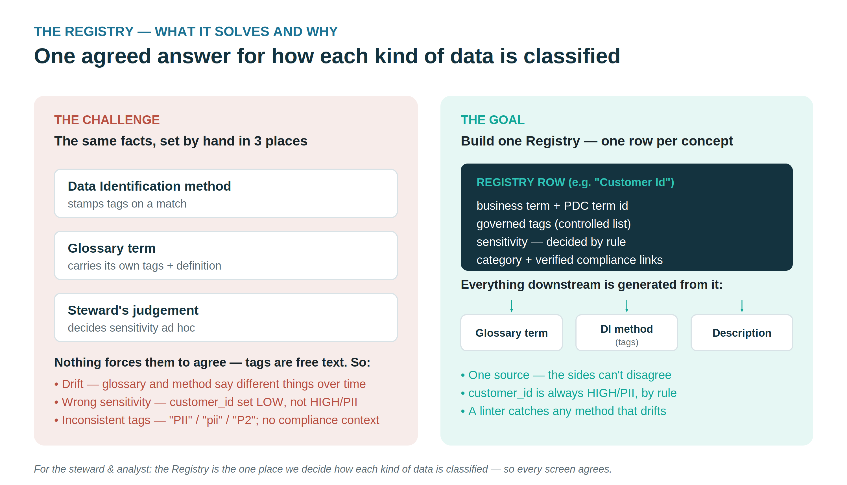
Figure. The challenge (the same facts set by hand in three places) and the goal (one Registry row that everything is generated from).

Two apps, one handoff
The Registry is the contract between two separate apps, used in order — and keeping them distinct matches PDC's own separation of the Business Glossary from Data Identification.
1 · Glossary Generator (first) builds the business glossary: it scans sources, proposes candidate concepts, lets the steward review them, and imports the glossary into PDC, which mints the term ids. In doing so it authors the Registry — the concepts, their governed tags, sensitivity, and references — and the Registry is saved with the glossary.
2 · Policy Generator (next) builds the Data Identification policy: it reads the Registry with the reconciled term ids and emits the methods — dictionaries (imported as ZIPs of JSON + CSV) and patterns (JSON), each bound to its term and stamping the Registry's tags. This is what creates the policy, keeps tagging consistent, and fills the coverage gaps, then flags any method that has drifted.
The Registry exists for the Policy Generator app. The Glossary Generator writes it as a by-product of building the glossary; the Policy Generator app reads it to build the policy. One app does glossary work, the other does Data Identification work, and the Registry is the bridge between them.
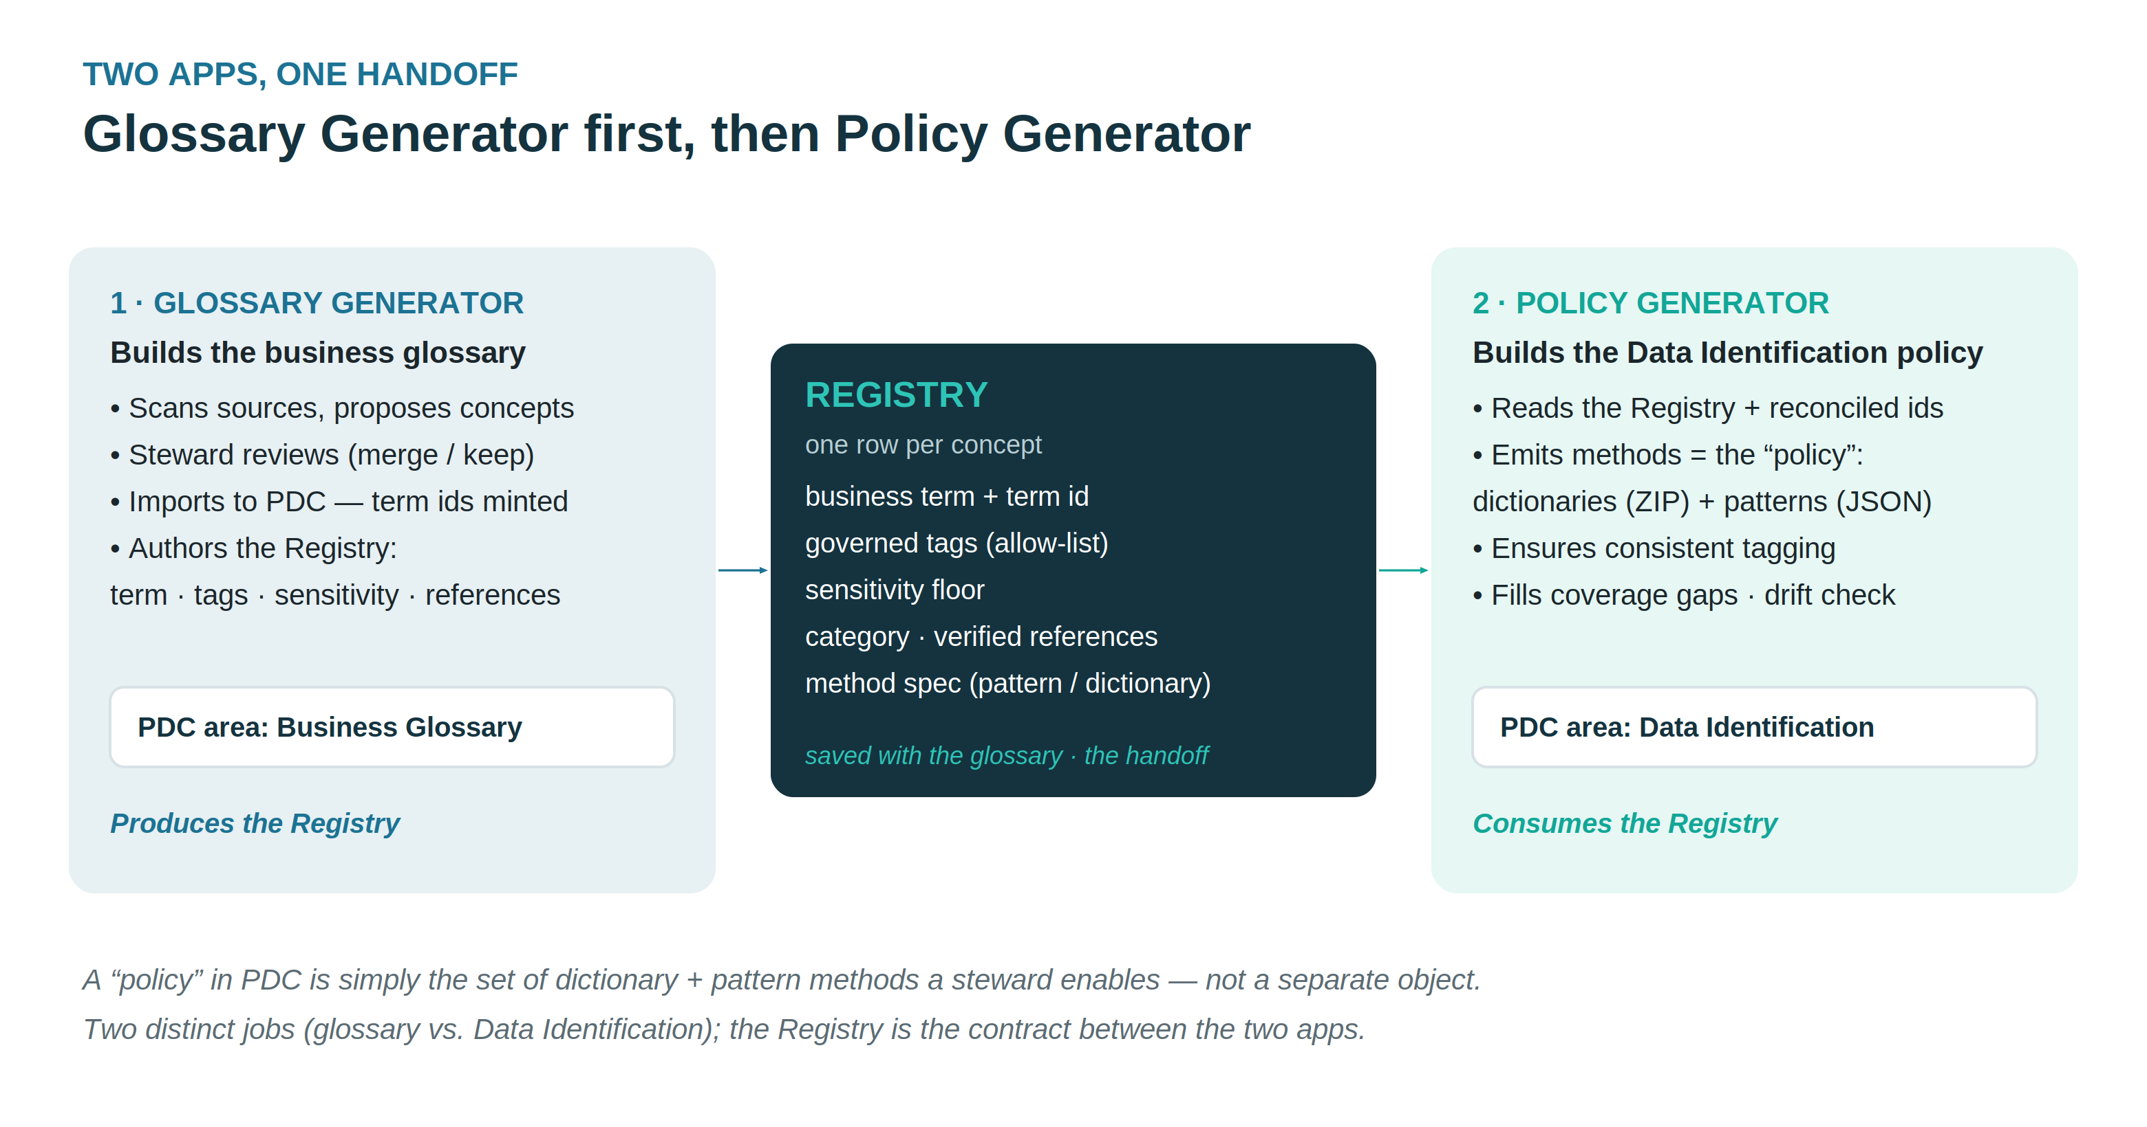
Figure. Glossary Generator authors the Registry; the Policy Generator app consumes it to build the Data Identification policy.
A note on the word policy: in PDC there is no separate Policy object. A Data Identification policy is simply the combination of dictionary and pattern methods a steward chooses to enable. The Policy Generator app builds those methods; the steward's selection is the policy.

The workflow, consolidated
The app’s four steps — connect, review, govern, then resolve & apply — expand into this pipeline. The crucial column is the last one: where each step actually runs. Two steps are UI-only by necessity; the rest are public-API calls the app makes for you.

# | Step | App action | Runs as
1 | Connect & scan | Scan the source, suggest terms | Local (app)
2 | Review & prune | Prune to the terms you want | Local (app)
3 | Govern & generate | Export import-ready glossary | Local (app)
4 | Import the glossary | — (done in PDC UI) | PDC UI · Actions → Import
5 | Get token | Authenticate to PDC | API · /auth
6 | Resolve term ids | Look up each term’s id + glossaryId | API · /search
7 | Apply to PDC | Resolve column, merge, write | API · /entities/filter + PATCH
8 | Score & compare | Trust score; app-vs-PDC profiling | API · /jobs + /profiling-info

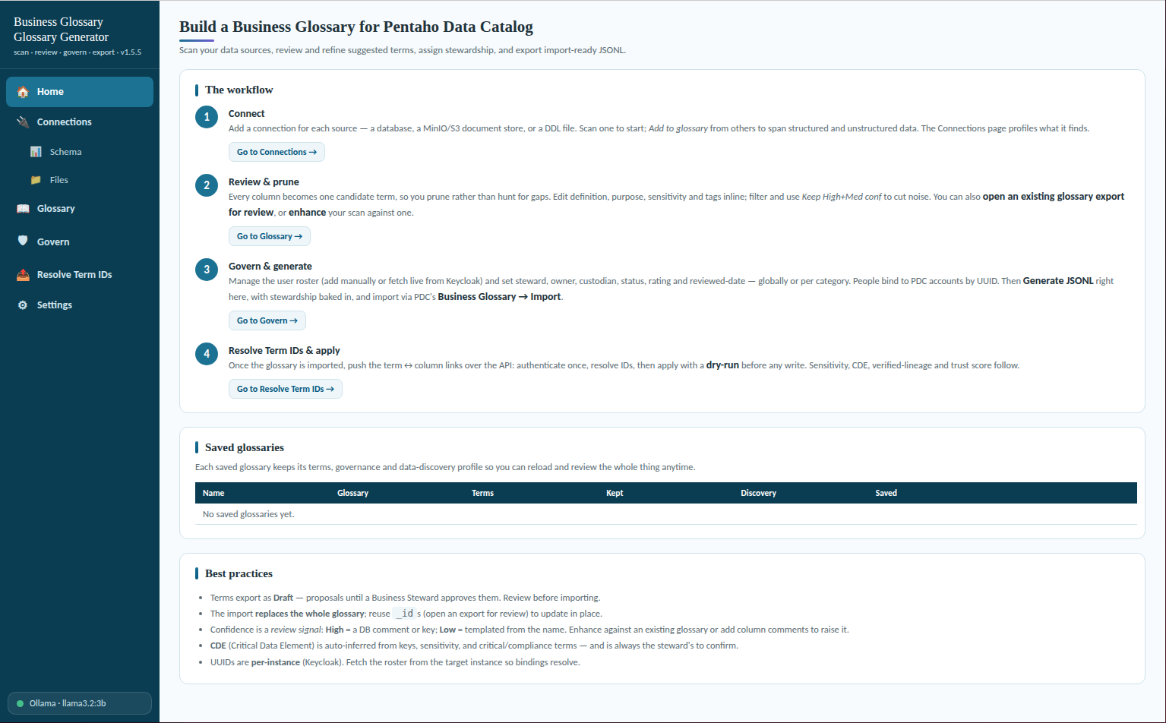
Glossary Generator

The golden rule
Step 4 is import-only. There is no “create term” endpoint in the public API. You import the glossary through the UI (JSON Lines or CSV), and only then can the API attach those terms to columns — because the API works by updating entities that already exist. That is why the order is import → resolve → apply, never apply-first.
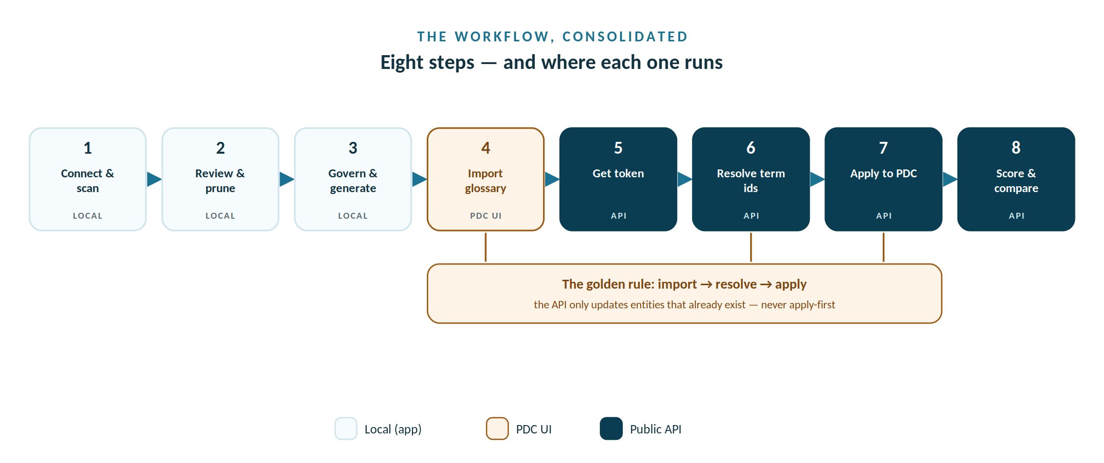
Eight steps across three runtimes: the local app, a one-time PDC UI import, then public-API calls.

Where this fits in PDC’s processing order
The app does not replace PDC’s data-scanning stages — it layers governance on top of them. Two things scan the actual data and own the fields they derive; the app owns the steward-driven metadata it writes over the API. Knowing which is which is what tells you the safe order.
PDC’s data scan owns — run first | The app writes — layer on top, over the API
Metadata ingest — schema, tables, columns, keys.  Data Profiling — stats + intermediate data (bitsets, HLL, pattern analysis, data-quality pre-analysis). Feeds foreign-key detection and data flow.  Data Identification + PII — dictionary / pattern tags and auto-sensitivity. Requires profiling first. | Glossary terms — the term↔column links.  Stewardship — steward / owner / custodian.  Governance flags — sensitivity confirm / override, CDE, verified-lineage, rating, a manual quality score.  Trust Score — the calculate-trust-score job, run last.
Recommended order: Ingest → Profile → Identify (+ PII) → import the glossary → Resolve → Apply → Calculate Trust Score (last).
Why the order matters
Profiling and identification re-derive the data-scanned fields — tags, classification, data quality — from the actual data. Run them after the app and they overwrite what you set; run them first and the app’s Apply merges its governance on top.
Trust Score is computed from Data Quality, Ratings, Lineage, Classification and whether a glossary term is assigned — so it must be calculated last, after both PDC’s scan and the app’s writes. If nothing changes the inputs afterward, you do not run it again.
Skip profiling and identification only if you do not need the stats, foreign-key detection, data flow or pattern-based tags — then the app’s governance stands alone.

Build the glossary in the app
Everything so far has said where the app sits; this section is the app itself. Before a single API call, the Generator does its real work locally: it connects to your sources, scans them into candidate terms, lets a steward review and prune those terms, then bakes in stewardship and exports an import-ready glossary. These are steps 1–3 of the four-step workflow — all Local (app) — and they produce the JSONL you import in step 4 and apply over the API in Labs A–F. Get these three right and the API half is mechanical.
One screen, four steps
Connect → review → govern → apply, on a single screen. Steps 1–3 never touch PDC’s API — they read your sources and write local JSON. Only after you import the generated glossary (step 4, in the PDC UI) does the API attach terms to columns. Everything before the import is yours to redo freely; nothing is written to the catalog yet.

The scan step has two lanes
Structured and unstructured data share one processing spine — they differ only at the scan step. A database is described by its schema, so PDC profiles it; a bucket of files has no schema, so PDC discovers it. The Generator mirrors that split when it scans, then Add to glossary merges both lanes into a single glossary. At CSCU the cscu_core database takes the profiling lane and the cscu-documents object store takes the discovery lane — one glossary, spanning both.
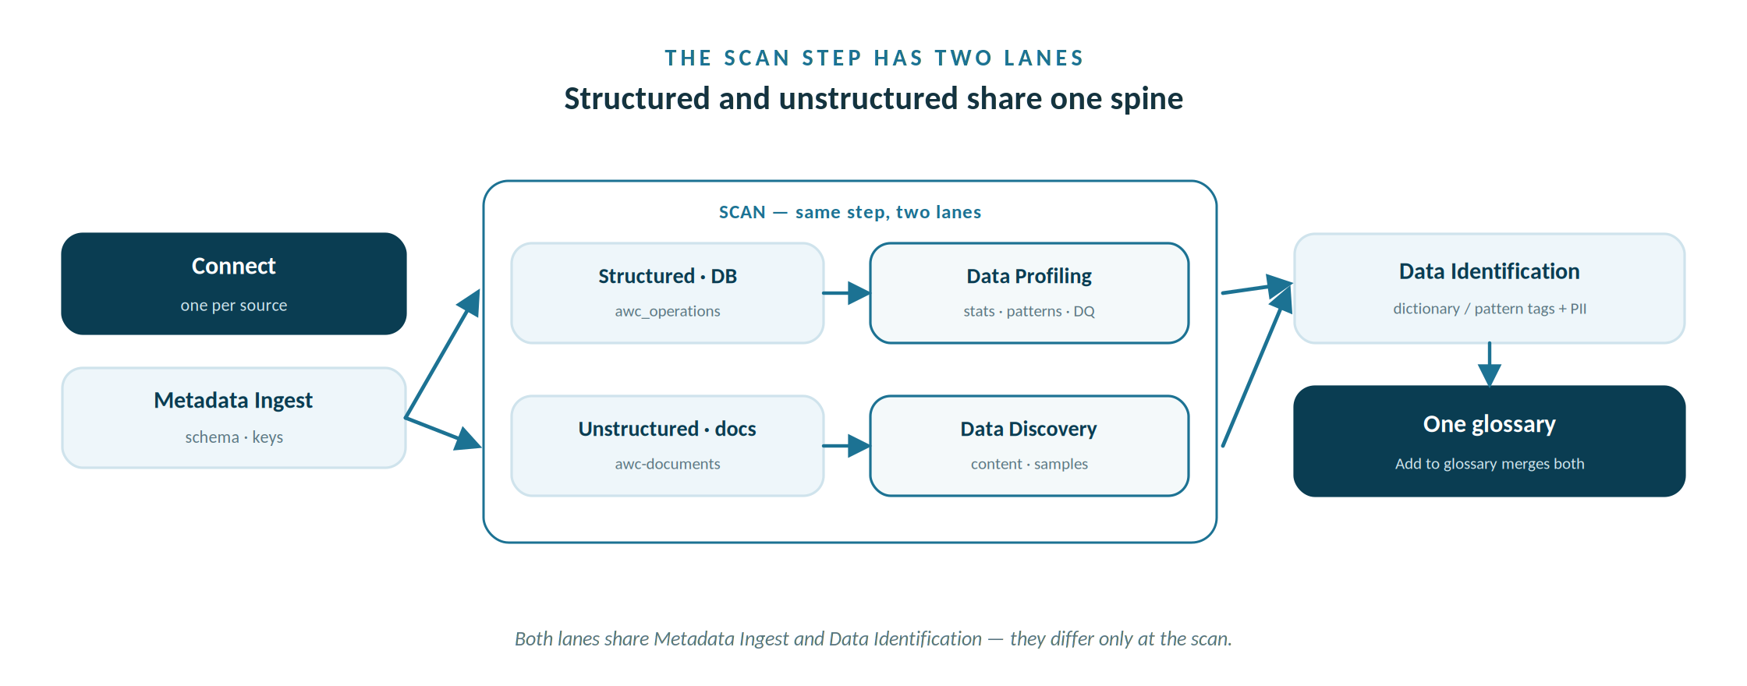
Structured and unstructured data share one spine — they split only at the scan, then merge into one glossary.

Step 1 · Connect the sources and scan

Connections are pulled from PDC
1 · Bulk-load into PDC. On Connections, the Bulk-load data sources into PDC card takes a CSV (per row: kind, and either host/port/database/schema for a database or endpoint/region/bucket/keys for an object store) and, for each row, creates the data source in PDC and triggers its ingest. A source that already exists is detected and shown as EXISTS (re-scanned, not re-created), so re-runs don't hit a duplicate error. Grab a starter CSV from Download a sample CSV on the card and replace the placeholders.
2 · Harvest from PDC. The Harvest from PDC card lists what PDC has already cataloged and pulls the glossary straight from that metadata — table columns for a database, files for an object/document store. Because it reads PDC's catalog, it needs no re-created connection and no database password. Filter, tick the sources you want, and harvest; terms PDC already governs are flagged so you don't overwrite existing work.

3 · Add to app connections (for Schema / Files / live-scan). The same CSV can also populate the app's own connections in one click — preview the list and tick just the ones you want. These drive the Schema diagram, the Files browser, Test and live-scan. Because the app runs outside Docker, set an app reachability remap as you import — e.g. 192.168.1.200=localhost, 5432=5433 — so the app's copies point at addresses it can reach, while the CSV keeps the Docker names PDC uses.
Two vantage points. The same source needs different host values depending on who connects. PDC runs on the Docker network and resolves the service names in the CSV (192.168.1.200, 192.168.1.200). The app is a host process and can't resolve those — it needs a host-reachable address (localhost:5433 for the DB you published to the host, or the VM IP). The MinIO endpoint, being an IP, works for both — which is why only the database usually needs a remap.
Object stores are file systems. PDC registers an AWS S3 / MinIO bucket with databaseType = AWS (a file system), not a database type — the loader now does this automatically (earlier S3 / AWS_S3 values left the type blank and the scan failed). Creating the source over the public API works and it comes up correctly typed; the file scan itself is run from PDC's Scan Files (the public API doesn't expose that trigger), then you Harvest. See the reference note PDC — AWS S3 / MinIO for the full detail.
Goal. Register each source, scan one to start, then Add to glossary from the rest so a single glossary spans structured and unstructured data.
The Connections screen holds one connection per source. The app reads your data with whatever credentials you give it, so give it read-only ones — it never writes back to a source. Three connection types cover the CSCU estate:
Connection | What it reads | Notes
Database (live scan) | Schema, keys and comments; sampling refines sensitivity and data quality. | PostgreSQL / MySQL / SQL Server, read-only. Set the schema on the connection (e.g. cscu_core).
Object store (MinIO / S3) | Browses a bucket over the S3 API; each file becomes a document term. | Use the host / VM IP for the endpoint, not localhost — inside a container it points at the wrong machine.
DDL file | Parses a CREATE TABLE script — same suggestions, no live connection. | For when you can’t reach the database. Upload the .sql file and scan it like a source.

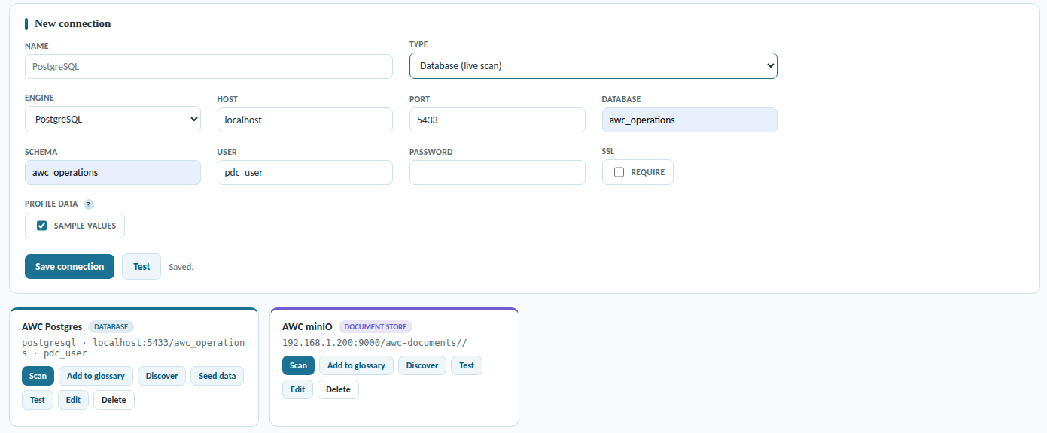

Connections

Add a connection and scan
- Open Connections and click Add connection — pick Database, Object store or DDL.
- Enter the details. Database: host, port, database, a read-only user, and the schema to scan (cscu_core). Object store: the S3 endpoint (host / VM IP), bucket, access key and secret. DDL: upload the script.
- Scan. The app reads the source and turns every column — or every file — into a candidate term. The Connections page shows what it found and profiles it locally.
- Add to glossary. From the first source this seeds the glossary; from each further source it merges in, so one glossary spans the database and the document store.
Read-only, and the right endpoint
Two things trip people up here. Give the app read-only credentials — it never needs to write, and least privilege keeps the scan safe. And for an object store, the endpoint must be the host / VM IP — from inside a container or another host, localhost resolves to the wrong place and the bucket looks unreachable.

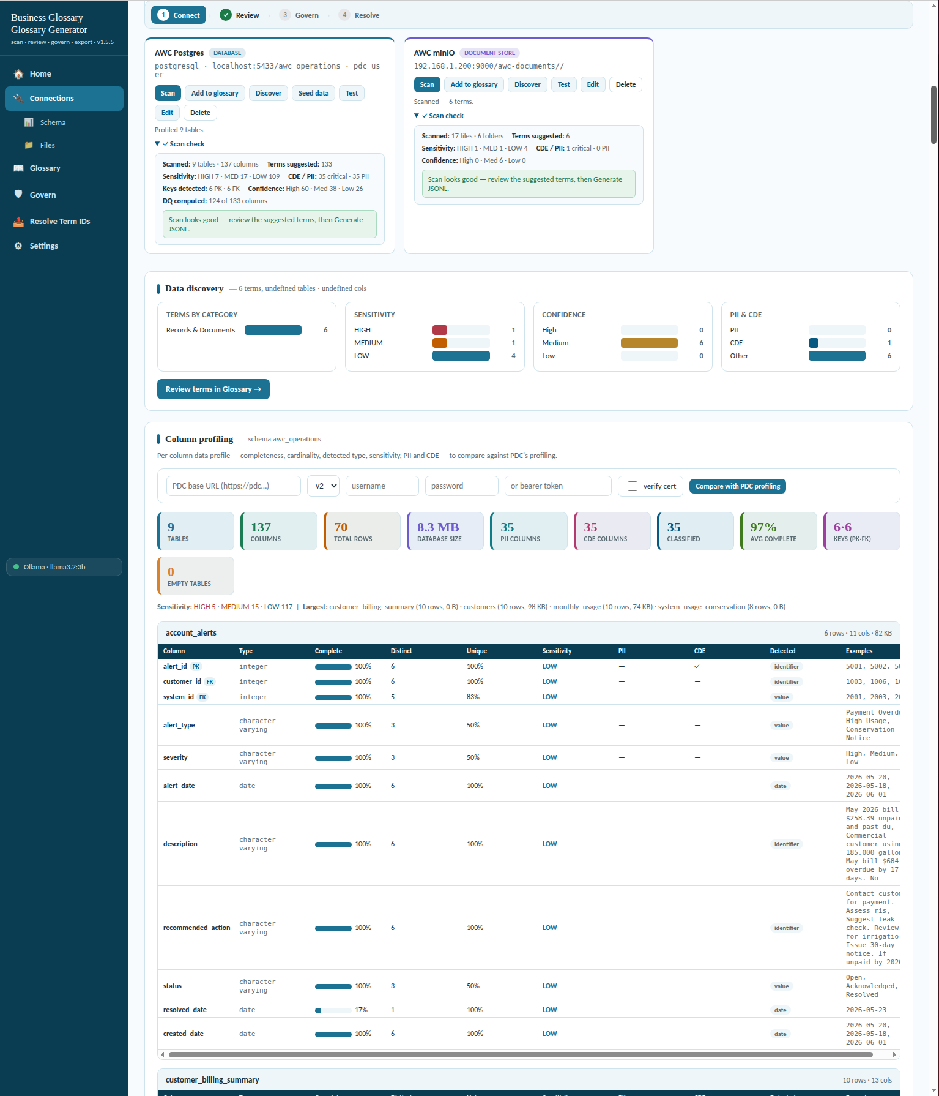

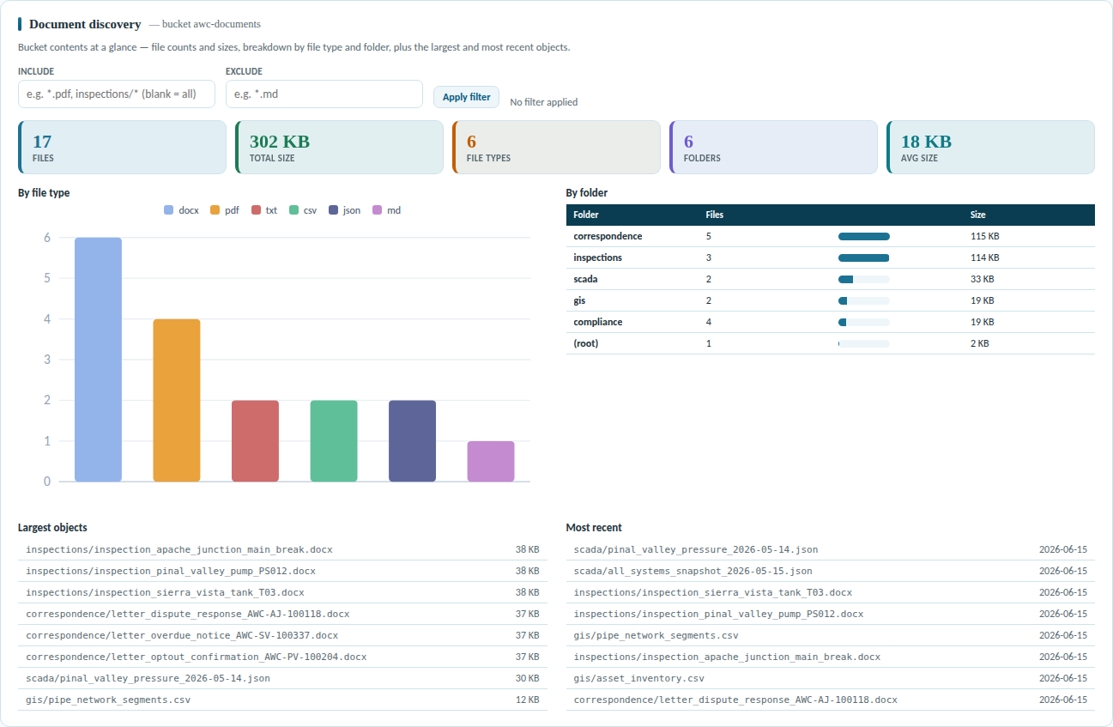

Scan minIO S3 bucket

What a scan turns up
A scan is not a name-matching guess — it reads structure and samples to produce evidence. From one pass it derives, per column:
- One term per column — every column becomes a candidate, so review is pruning, not gap-hunting.
- Definitions and purpose — drafted locally from names, comments and keys at scan time.
- Sensitivity and PII — flagged HIGH / MED / LOW with PII categories, inferred from names and samples.
- CDE and keys — reads primary/foreign keys and infers Critical Data Elements for the steward to confirm.
- Data quality — profiles distribution, uniqueness and patterns: evidence, not name guesses.
- Bulk registration — a starter CSV (/api/pdc/bulk-load/sample.csv) registers many sources at once; replace the CHANGE_ME placeholders.
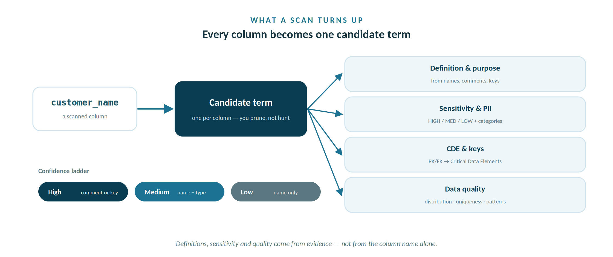
One scan pass turns each column into a candidate term with evidence-backed definitions, sensitivity and quality.
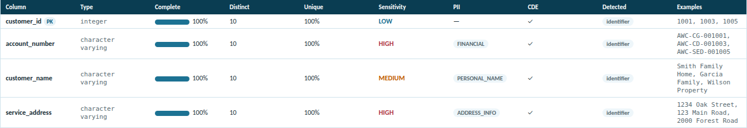
Schema & Files
Check out the option to view the database schema and view the unstructured files in the minIO bucket. There are expandable ‘Under the hood’ panels that will explain the SQL / PDC API request / response calls.

Under the hood — what a scan actually calls
The scan never touches PDC's public API. It reads your sources directly and writes local JSON; the two lanes just speak different protocols. Nothing here writes — read-only credentials are enough.
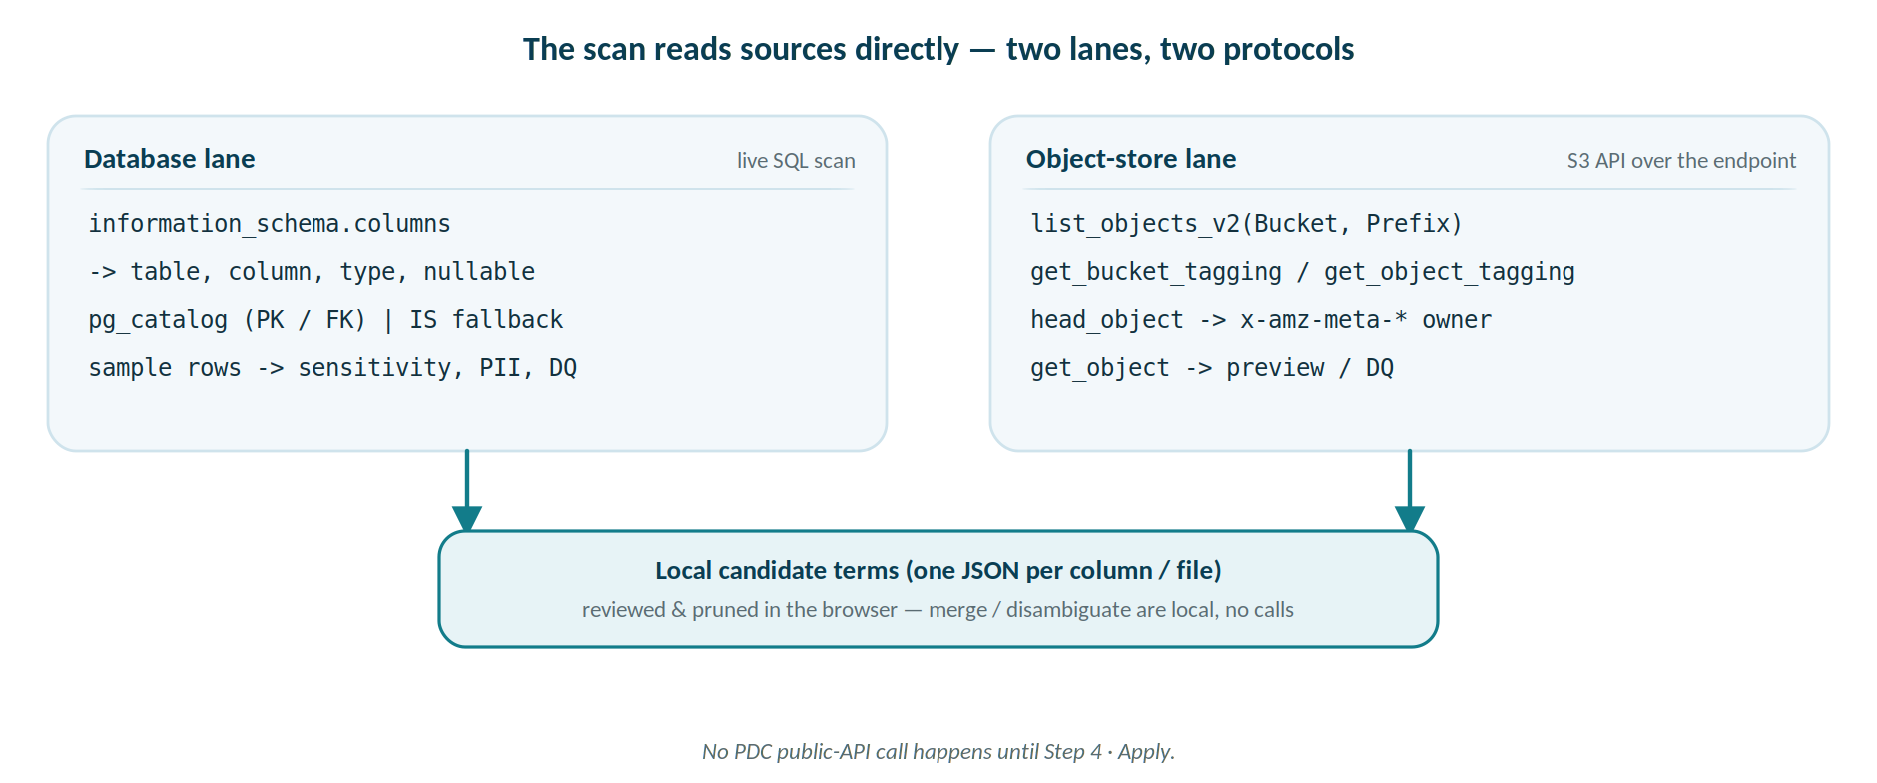
Database lane — SQL over information_schema
-- columns, types, nullability (PostgreSQL / MySQL / SQL Server)
SELECT table_name, column_name, data_type, ordinal_position,
(is_nullable = 'NO')
FROM information_schema.columns
WHERE table_schema = :schema
ORDER BY table_name, ordinal_position;
-- primary & foreign keys: pg_catalog on PostgreSQL,
-- information_schema.key_column_usage fallback elsewhere
Then a bounded per-column sample refines sensitivity, PII and the data-quality dimensions — evidence, not name guesses.

Object-store lane — S3 API (boto3, path-style, SigV4)
list_objects_v2(Bucket, MaxKeys=1) # test: bucket reachable?
get_object_tagging(Bucket, Key) # test: does tagging work?
get_bucket_tagging(Bucket) # bucket-level owner tag
list_objects_v2(Bucket, Prefix) <paginated> # walk every object -> folders
get_object_tagging(Bucket, Key) # per-object owner tag (sampled)
head_object(Bucket, Key) # x-amz-meta-* owner fallback
list_objects_v2(Bucket, Prefix, Delimiter='/') # browse one folder level
head_object / get_object # metadata + content preview
Point it at your MinIO/S3 endpoint — use the host / VM IP, not localhost — with read-only keys.

Merge and Auto-disambiguate issue no calls at all. They rewrite the candidate list in your browser: a merge collapses same-named rows into one term whose Source_Column is the union of their columns; a disambiguate appends each row's source table so names become unique. That choice only reaches PDC later, at Apply — the merged term's columns become the businessTerms superset PATCHed onto each column entity (Step 4).
These calls aren’t only in this guide — the app surfaces them live. Every stage has an expandable Under the hood panel:
Connections shows the database SQL (columns, keys, column comments reused as definitions, and the optional sample);
Files shows the S3 API;
Glossary shows the local review transforms above (Merge / Auto-disambiguate / Keep High+Med conf — no calls); and
Apply shows the full PDC public-API choreography — each with a View source button. The in-app panels are the authoritative, always-current reference.

Step 2 · Review & prune the candidate terms
Goal. Every column is already a candidate term — so you refine and prune, you never hunt for gaps.
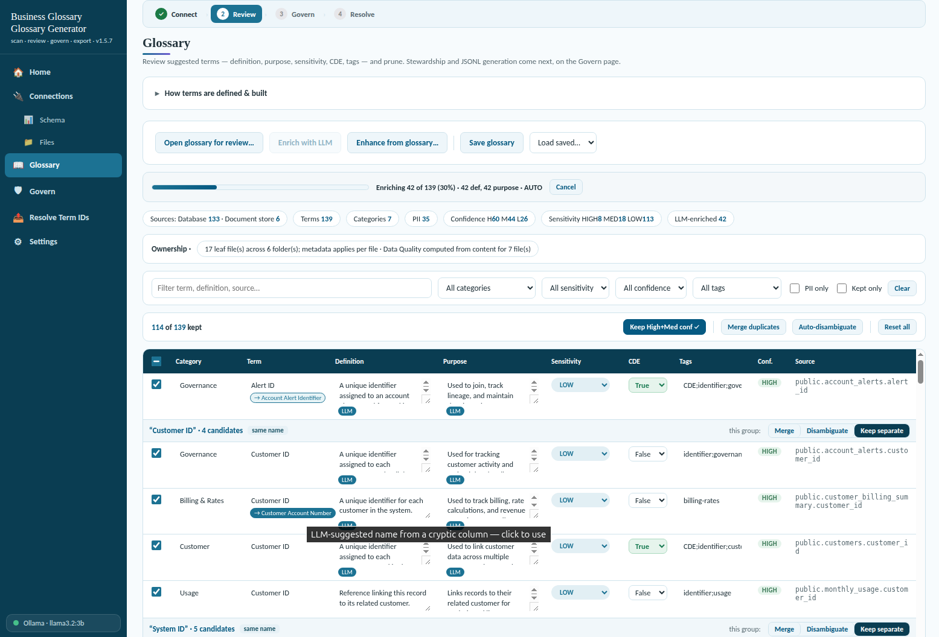
Candidate Terms – LLM enrich – merge or disambiguate
Goal. Every column is already a candidate term — so you refine and prune, you never hunt for gaps.
Because the scan proposes a term for every column, review is subtractive: cut the noise and sharpen what remains, rather than searching for what’s missing. Open the Glossary screen; each row is a candidate term with a definition, purpose, sensitivity, tags and a confidence level. Four moves get you from raw scan to a clean glossary:
- Edit inline. Change definition, purpose, sensitivity and tags directly on the row — your edit always wins over the app’s guess.
- Cut the noise. Filter the list, then apply Keep High + Med confidence to drop weakly-evidenced guesses in a single move.
- Reuse existing work. Open an existing glossary export to review it, or enhance your fresh scan against one — matching columns inherit the curated definitions.
- Optionally enrich with an LLM. The single optional, non-local step: point the app at Ollama and it drafts one-sentence definitions and purpose. Everything else runs locally.

Merge duplicates & auto-disambiguate
Because the scan turns every column into its own candidate term, two options tidy the list before you govern it — one folds terms together, the other keeps them apart:
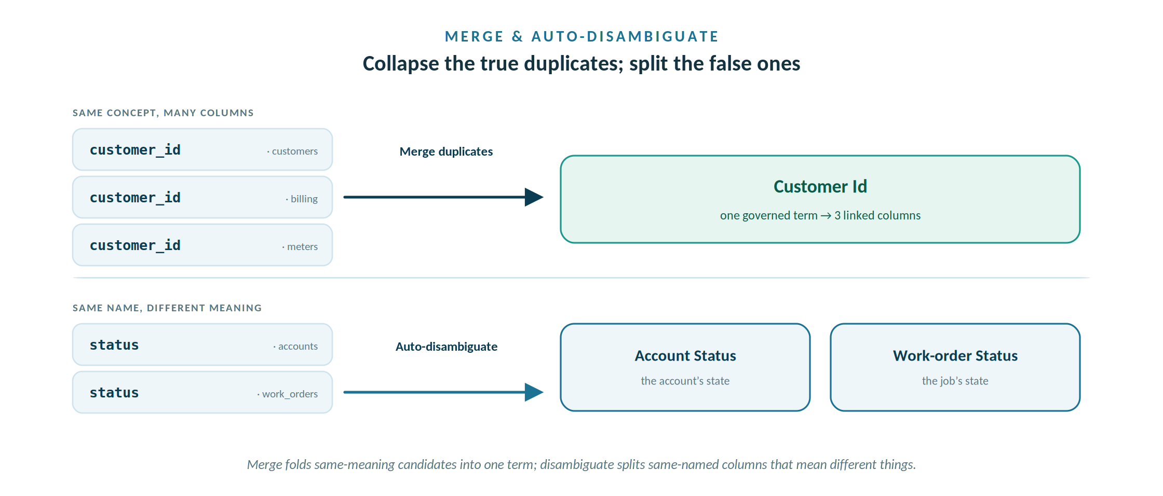
Merge collapses same-meaning candidates into one term; auto-disambiguate splits same-named columns that mean different things.
Merge duplicates. The same concept usually shows up in many columns — customer_id in members, billing and meters, for instance — so the scan proposes the same term over and over. Merge duplicates folds those same-meaning candidates into a single governed term and links it to every column that implements it. You end up with one term per concept carrying several linked data elements, instead of a near-identical term for each column — the “one term, many columns” shape a real glossary wants.
Auto-disambiguate. The opposite hazard is two columns that share a name but mean different things — status on an account versus status on a work order, or name meaning a member versus a water system. Left unchecked, a merge would fuse them into one wrong term. Auto-disambiguate spots same-named candidates whose context gives them away — a different table or category, a different data type or value pattern — and names them distinctly (Account Status versus Work-order Status) so they stay separate terms.
The two are complementary: disambiguate splits the false duplicates, merge collapses the true ones, and what’s left is one term per real concept. Both run locally during review and only propose — your inline edits and per-row choices still win, so treat them as a fast first pass, not a final verdict.
Per-term review, now reversible
The review controls highlight when applied and revert on a second click. On the Glossary page, Keep High+Med conf, Merge duplicates and Auto-disambiguate each show an applied state and undo when clicked again; Reset all returns the grid to the raw scan. Each duplicate name also has its own three-way Merge / Disambiguate / Keep separate control, so you can merge one name and disambiguate another in the same pass — every choice reversible. Keep High+Med conf never drops a table term.

How confidence is set
Confidence is a triage signal — how much evidence backs a suggestion — not a verdict to trust blindly:
The confidence ladder
High — a database comment or a key backs the column.
Medium — inferred from the column name plus its type.
Low — templated from the name alone.
Raise it at the source (add column comments) or by enhancing against a curated glossary. Triage by it; don’t treat Low as wrong or High as final.

Terms export as Draft
Nothing here is approved yet. Every term leaves the app as a Draft — a proposal, not an approved definition. A Business Steward approves them in PDC after import. Careful review here is exactly what makes that approval fast.

The Term & Tag Dictionary — one governed vocabulary
What it is. The Dictionary page governs the vocabulary that tagging and term-naming draw from — a generic baseline of common terms and tags, plus a company layer seeded from your domain pack and grown, under review, from every scan. It is the controlled allow-list: a term is only tagged with tags that live here, and it is saved to tag_dictionary.json. Per-glossary term review happens on the Glossary page; this page governs the words those tags come from.
Why it exists — and why it isn't the same as the glossary's tags. Setting a tag on a term in the glossary describes that one concept. A Policy Generator method, by contrast, is a rule that PDC runs during Data Identification to find and tag data automatically across the whole estate — columns you never mapped, tables that arrive next month, unstructured files. Those are two different jobs. The dictionary is what keeps them speaking the same language: it is embedded in the Registry at export, so the Policy Generator's Assign-Tags actions can only use the same allow-list the glossary uses. That is the tag-consistency contract between the two apps.
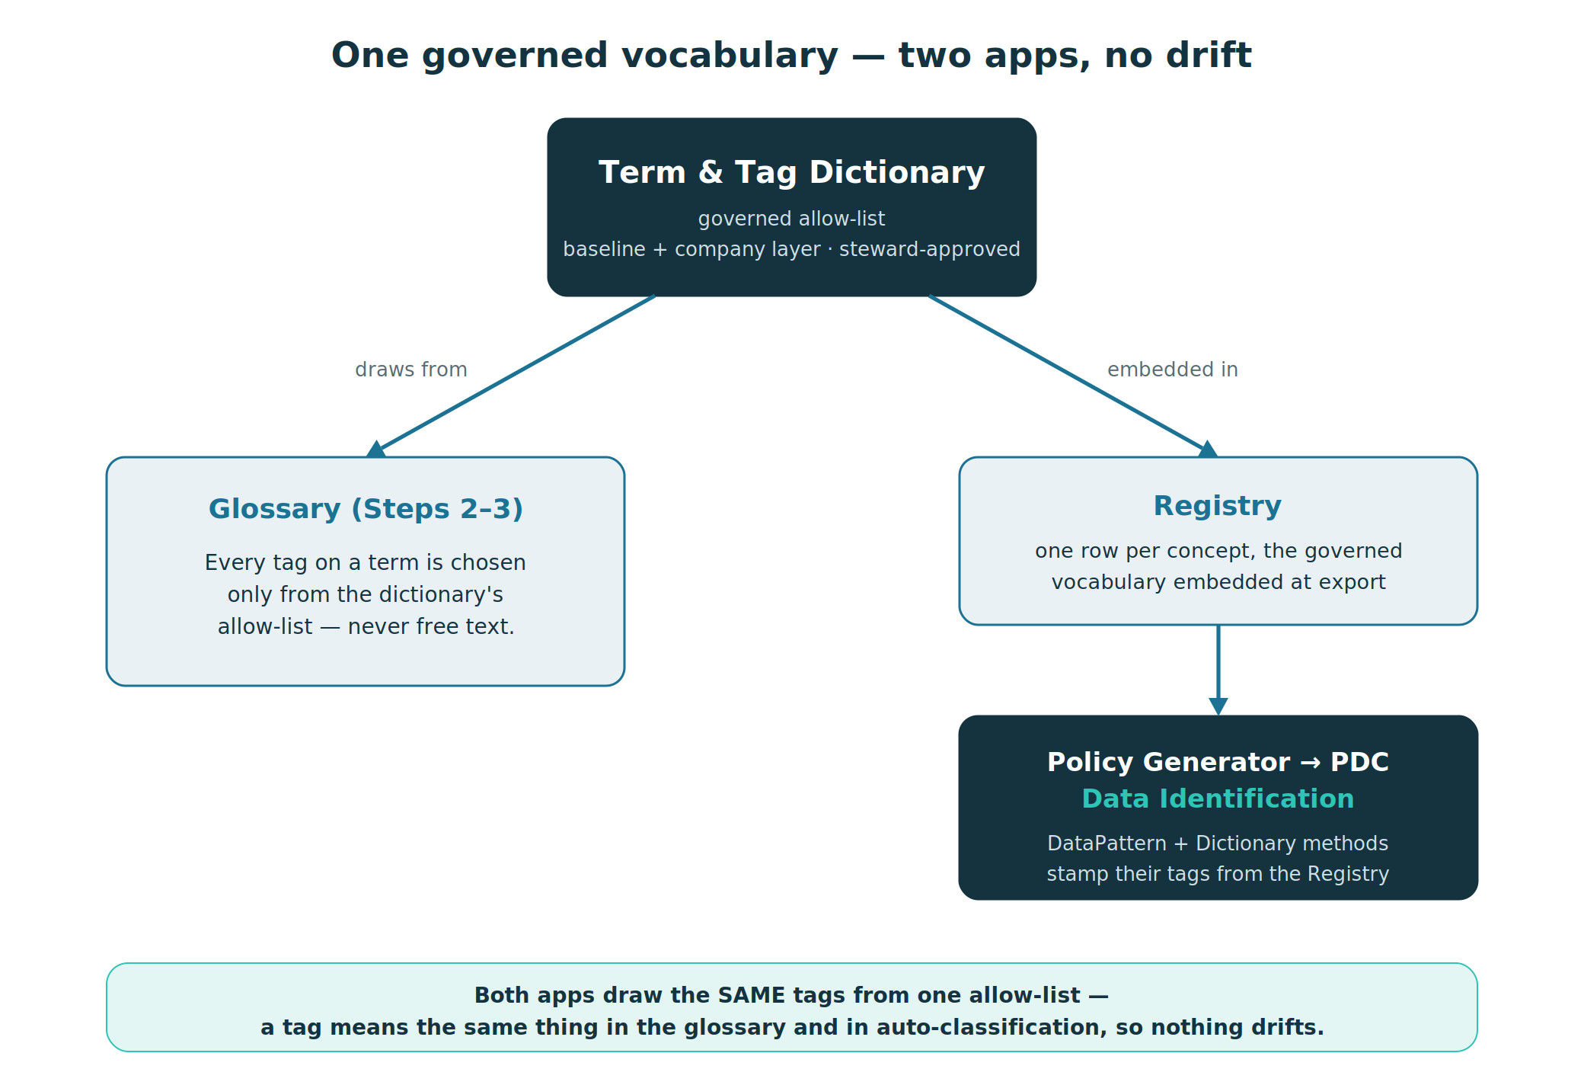
Figure. One allow-list feeds both the glossary's tags and the Policy Generator's Data Identification methods — so a tag means the same thing in each, and cannot drift apart.

Two layers, and an approval gate
Two layers. The generic baseline is built in and protected — common terms and tags with sensible sensitivity, which can't be deleted. The company layer is specific to this deployment: seeded from the water_utility domain pack and accreted from your scans, steward-owned.
An approval gate. New terms and tags a scan turns up don't govern anything yet — they land in Pending steward review. Only when a steward approves them do they enter the governed vocabulary and reach the Registry; reject discards them. Guard-rails keep the set honest: the baseline can't be removed, every rule's tags must already exist, and a tag's or term's sensitivity floor only raises a term — it never lowers it.
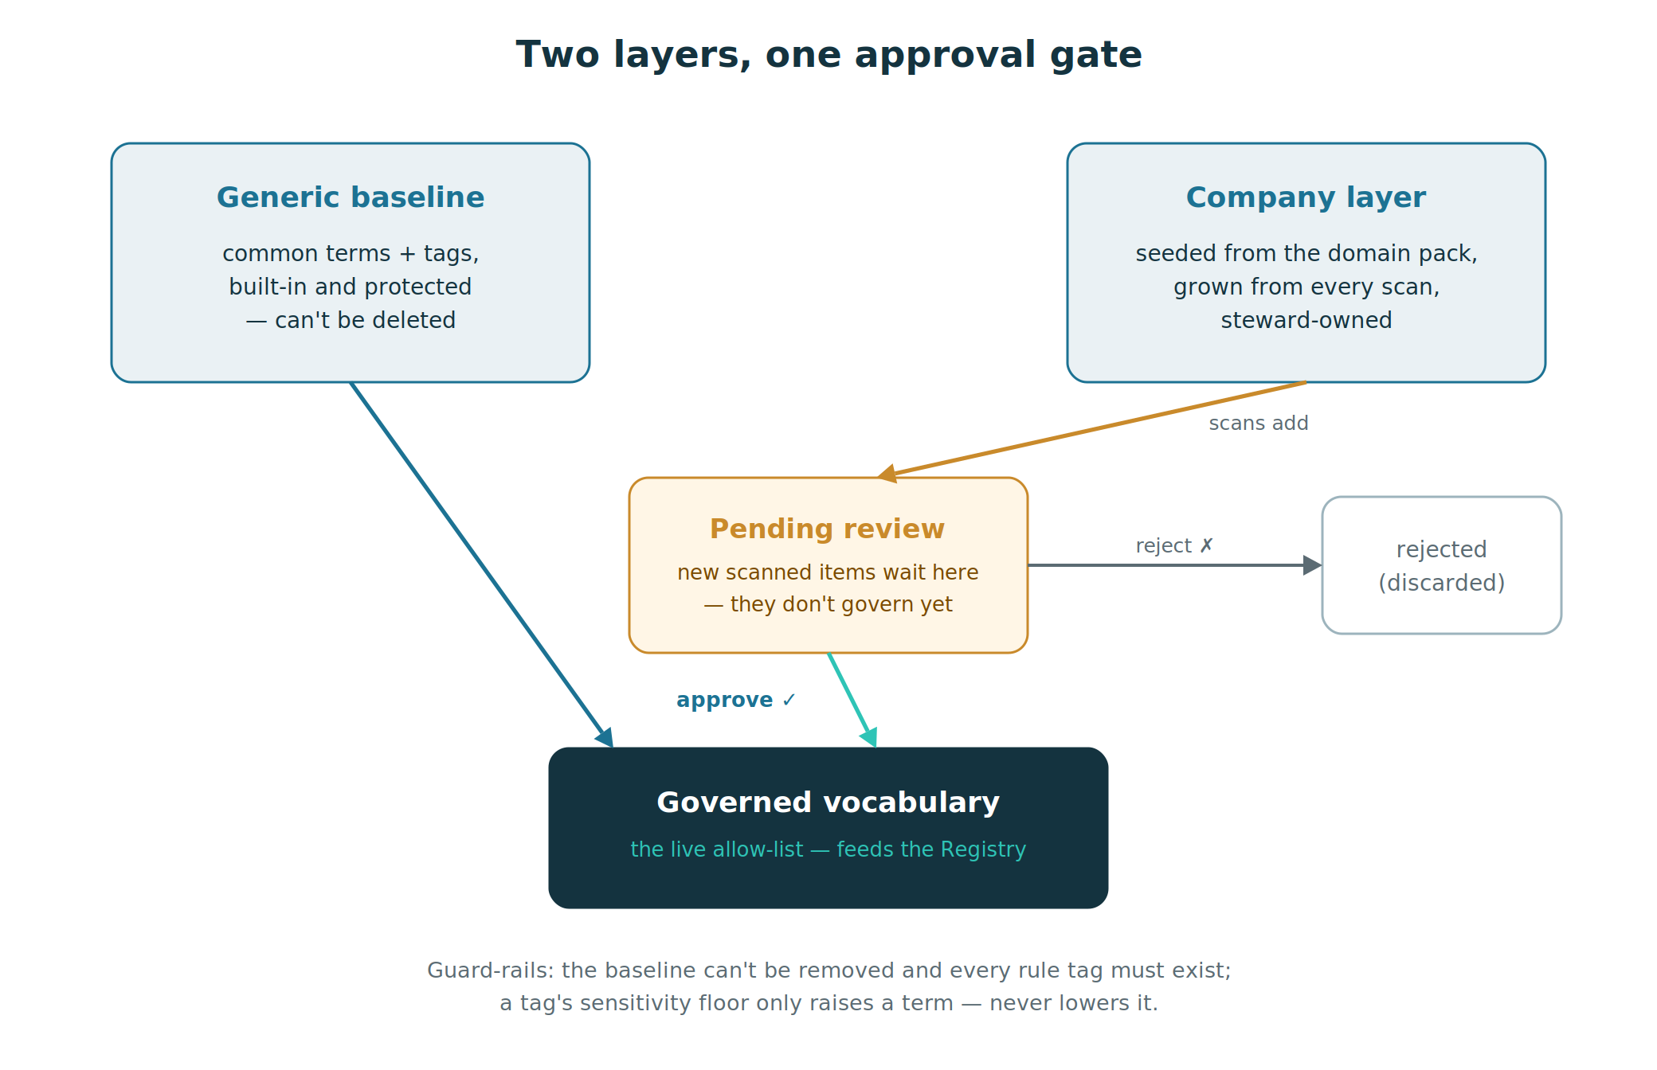
Figure. Baseline + company layer, with scan-grown items held in a pending queue until a steward approves them — the governed vocabulary grows under review, never silently.

What you do on the Dictionary page — step by step
1 · Set who you are. Enter a name in Acting as before you approve, reject or save. Every governance action is written to the audit trail with that name and a UTC timestamp, so the vocabulary carries its own provenance.
2 · Clear the pending queue. Work through Pending steward review at the top. Each scanned term and tag has a ✓ (approve) and ✗ (reject) control, with Approve all per group. Approve what belongs in the company vocabulary and reject the noise; until you do, those items are excluded from the Registry and the search facets.
3 · Curate the terms. The Terms table is the canonical business terms (baseline + company). Each row shows its Layer (generic / company / pending), Sensitivity, Aliases (divergent names that resolve to this one term, so duplicates don't fragment), its Tags, and a Used count. Add a term with the Add term row: name, sensitivity, aliases (;-separated) and tags (;-separated).
4 · Curate the tags. The Tags table is the controlled allow-list. Each tag has a Floor (the sensitivity it raises a term to), a Used count, and Example terms. Add one with Add tag (name + sensitivity floor). Keep this list tight — every tag here becomes a method the Policy Generator can emit and a facet in PDC.
5 · Add rules. A rule is a RULE PATTERN (a regex matched against a term's name) plus RULE TAGS. It auto-applies those tags to every matching term — this is how a whole domain gets tagged at once (e.g. sewer|wastewater|effluent → wastewater;operational). Rules are the scalable alternative to tagging terms one by one.
6 · Preview the search facets. The Search facet preview shows how each governed tag will look as an OpenSearch facet in PDC (a filter on attributes.tags.name), sized by reviewed usage. Use it to retire empty tags and merge near-duplicates before methods deploy — empty or fragmenting tags are cheap to fix here and expensive to fix after they're live.
7 · Check the governance audit trail. An append-only log of saves and approve/reject decisions, each with actor and timestamp. A compact summary is embedded in the Registry at export, so the governed vocabulary carries its provenance all the way to the Policy Generator. Export audit JSON for the record.
8 · Save, Reload, Export, Reseed. Save dictionary writes tag_dictionary.json; Reload re-reads it; Export JSON dumps it for inspection; and Reseed rebuilds the vocabulary from the baseline + the current domain pack — run it after you edit domain_pack.json, then re-run Suggest tags on the glossary so the new rules take effect.
Where it goes next. Once the vocabulary is clean and the pending queue is empty, it is embedded in the Registry when you generate the glossary — and that Registry is exactly what the Policy Generator reads to author Data Identification methods that stamp these same tags. See “Drift, Reconcile & the Registry” for the hand-off.

Step 3 · Govern & generate the JSONL
Goal. Assign who owns each term, bake stewardship into the export, and generate an import-ready JSONL glossary for PDC.
Governance is the difference between a word list and a glossary. On the Govern screen you build a roster of people, attach roles to terms, and then generate the JSONL that PDC imports:
- Build the roster. Add people by hand, or fetch the live roster from Keycloak so names and accounts match the target instance.
- Assign stewardship. Set steward, owner, custodian, status, rating and reviewed-date — globally for the whole glossary, or per category where ownership differs.
- Bind people to PDC. Each person resolves to a PDC account by UUID. UUIDs are per-instance, so fetch the roster from the Keycloak of the instance you’ll import into.
- Generate and import. Click Generate JSONL — the app writes one JSON line per glossary, category and term, with steward/owner UUIDs baked in. Then import it via PDC Business Glossary → Import.

What the generated JSONL looks like
One line each, in order — glossary, then categories, then terms — with the stewardship references already resolved to UUIDs:
Generated JSONL (one object per line)
{"type":"glossary","name":"Copper State", ...}
{"type":"category","name":"Member", "glossary":"Copper State", ...}
{"type":"term","name":"Member Name",
"glossary":"Copper State","category":"Member",
"steward":"<uuid>","owner":"<uuid>","status":"DRAFT", ...}

The import is whole-glossary
Import replaces, it does not merge. PDC’s Business Glossary → Import replaces the entire glossary, not a delta. To update in place on a re-run rather than create duplicates, reuse the same _ids across regenerations — the same discipline the API side relies on when it resolves term IDs (Lab B).

Why bind by UUID, not name
Per-instance IDs, resolved up front. People and terms link to PDC by per-instance UUID, never by display name. Fetching the roster from the target Keycloak guarantees the steward and owner references resolve at import — the same reason term IDs must be resolved before Apply.

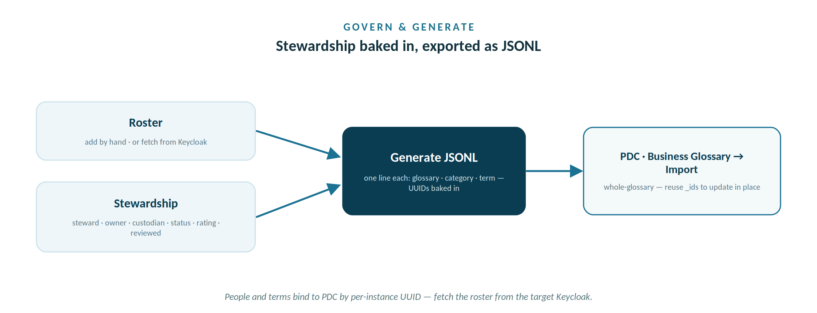
Roster and stewardship are baked into one JSONL; PDC's whole-glossary import loads it, ready for the API to attach.
With the glossary generated and imported through the PDC UI, the term↔column links can finally be written — because the API only ever updates entities that already exist. That is the back half of the workflow: authenticate, resolve the imported term IDs, and apply them to columns with a dry-run first. The Labs below walk each API call the app makes for you.

PDC Public API fundamentals

Authentication and the JWT
Every protected endpoint expects a bearer token in an Authorization: Bearer <token> header. You get that token one of two equivalent ways:
- Through the PDC API. POST credentials to the auth endpoint; the access token comes back under data.accessToken.
POST /api/public/v2/auth (application/x-www-form-urlencoded)
username=<user> password=<pwd> client_id=pdc-client
grant_type=password scope=openid profile email

200 -> { "data": { "accessToken": "eyJhbGciOi..." } }
- Straight from Keycloak. PDC fronts identity with Keycloak, so the realm token endpoint returns the same JWT under .access_token.
POST /keycloak/realms/pdc/protocol/openid-connect/token
client_id=pdc-client grant_type=password
username=<user> password=<pwd>

Token facts that matter in practice
The token is time-limited — long runs must re-authenticate when it expires (the app re-auths on a 401). The account needs the right role: admin / system_administrator works for everything; a Business Steward is enough for glossary edits and is the safer least-privilege choice. Never persist the token — keep it in memory for the run only.

The endpoint map
The public API is organised into a handful of groups. These are the ones this workshop touches:

Group | Endpoint(s) | Used for
Auth | POST /auth | Obtain the bearer token
Search | POST /search | Find a term → its id + glossary
Entities | POST /entities/filter | Find a column entity by name / fqdn / parent
Entities | PATCH /entities/{id} | Write businessTerms + features onto a column
Entities | POST /entities/filter/profiling-info | Pull PDC’s profiling stats
Jobs | POST /jobs/execute/calculate-trust-score | Compute Trust Score on the touched entities
Jobs | POST /jobs/execute/data-discovery | Profile object-store files & folders
Jobs | GET /jobs/{id}/status | Poll a running job

Versioning note (v2 vs v3)
Paths carry a version segment (/api/public/v2/…). The entity and search shapes are stable across v2/v3; the jobs surface is richest in v3 (the discrete /jobs/execute/* endpoints — e.g. data-discovery and calculate-trust-score). Your instance’s Swagger is the source of truth — confirm the version segment before scripting against it.

Lab A — Authenticate
Goal: obtain a token and confirm you are who you think you are before writing anything.

In the app
- Open the app, go to Glossary → Data Elements (links) to reveal the PDC panel.
- Fill the base URL, version, and your username / password.
- Click Get admin token. The app authenticates, fills the token field, and shows the signed-in user, whether the account carries an admin role, and the expiry countdown.

What to verify
- The admin ✓ badge (or your expected Business Steward role) is present.
- The expiry gives you enough runway for the apply run; if not, re-mint just before applying.

The call underneath
curl -sk -X POST https://<host>/api/public/v2/auth \
-H 'Content-Type: application/x-www-form-urlencoded' \
--data-urlencode username=<user> --data-urlencode password=<pwd> \
--data-urlencode client_id=pdc-client \
--data-urlencode grant_type=password \
--data-urlencode 'scope=openid profile email' | jq -r .data.accessToken

Lab B — Resolve term IDs
Goal: turn the term names in your export into the per-instance ids PDC needs. This is why the glossary must be imported first — a term has no id until it exists.

In the app
- With the glossary already imported in PDC, click Resolve & stamp IDs.
- The app searches each term and stamps its id and glossaryId into the Data Elements JSON. Unresolved names are reported — usually a sign the glossary import hasn’t run or the name differs.

The call underneath
POST /api/public/v2/search Authorization: Bearer <token>
{ "searchTerm": "Member Name",
"searchFacets": { "type": ["term"] } }

// a term hit carries its own _id (the term id) and
// rootId (the glossary it belongs to = glossaryId)
Order matters
Import → Resolve → Apply. Resolve depends on the glossary existing in PDC. Apply (next lab) depends on Resolve having stamped real ids — the app will warn and let you proceed by name, but a write with real ids is the clean path.

Lab C — Apply to PDC
Goal: write each kept term link — plus sensitivity, CDE and verified-lineage — onto its column, without clobbering anything already there. Always dry-run first.

Which terms get written — the mapping policy
Before any column is written, the app decides which kept terms should actually map to a data element — it does not link every term. Linking every column pollutes lineage, search and impact analysis, and does nothing for the Trust Score, whose glossary-term input is binary. A term is written only when it clears a relevance bar:
- Mapped automatically: Critical Data Elements, PII columns, and terms with real evidence behind them — a DDL comment, a key, or a profiling hit (High or Medium confidence).
- Held back: low-confidence terms templated from a column name alone, and conceptual or governance terms (Trust Score, Tag) that have no physical column.
- Steward override wins: a per-row Map = Yes/No on the review grid always beats the policy, so you can force-map or force-skip any term.
- Tunable: choose Selective (CDE · PII · High/Medium, the default), Strict (CDE · PII · High only), or Map everything (legacy) on the Data Elements step.
Map by business value, not volume
The Data Elements step reports a mapped vs held-back count and lists every term it withheld and why, so the selectivity is visible, not silent.
This mirrors the rule from Workshop 3: link the terms that genuinely describe a column — CDEs and PII first — and let the rest stay unmapped. Over-linking optimises a proxy (a term is technically assigned) while degrading the lineage, search and impact analysis the catalog exists to provide.

How a column write works
- Resolve the column entity. Filter entities to find the column’s _id, by fully-qualified name, by name + table, or by walking the table’s children.
- Read what’s there. The column may already carry business terms and features.
- Merge, don’t replace. Union the new term(s) with the existing ones, overlay the features.
- PATCH the superset. Send the merged attributes back.

Why the app sends the whole merged array
The PATCH contract is explicit: array fields fully replace, scalar fields overwrite, and object fields merge only the keys you send. Because businessTerms is an array, sending just the new term would drop the existing ones. So the app reads the current terms, unions them, and sends the superset — the server’s full-replace then lands on the already-merged list.
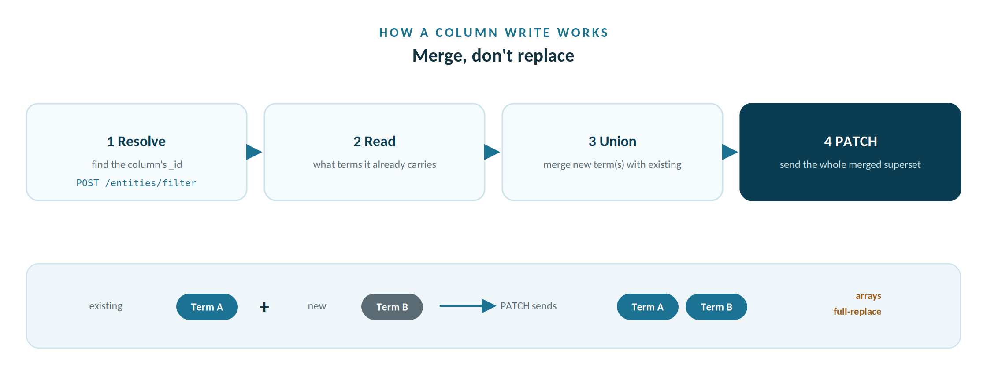
Read the current terms, union the new one, and PATCH the whole set — because arrays fully replace.

The filter (find the column)
POST /api/public/v2/entities/filter?extended=true&size=500
{ "filters": { "fqdns": ["cscu_core.members.customer_name"],
"types": ["COLUMN"] } }

// filters also accept: names, parentIds, rootIds, resourceIds,
// collectionIds, buckets, profileStatus, profiledAt
// each hit -> { _id, name, type, fqdn, parentId, rootId, attributes, ... }

The write (PATCH the column)
PATCH /api/public/v2/entities/<column _id>
{ "attributes": {
"businessTerms": [ {existing...}, {
"id": "<term id>", "glossaryId": "<glossary id>",
"name": "Member Name" } ],
"features": { "sensitivity": "HIGH",
"isCriticalDataElement": true,
"isLineageVerified": true,
"rating": { "value": 4 } } } }
Valid businessTerms properties
Each term in the array is reduced to the keys PDC accepts: id, glossaryId, name, sourceName, sourceType, confidenceScore. Any extra field — notably the app-internal glossary display name — makes PDC reject the whole PATCH with a 400. The app whitelists every term to these keys before sending, so the body shown in the dry-run preview is already clean.

In the app
- Leave Dry-run ticked and click Preview changes. The results table shows, per column: resolved entity id, the current → merged term diff, and the exact PATCH body (expandable). Nothing is written.
- When the preview looks right, untick Dry-run and click Apply to PDC. Each column reports applied / not-found / error.
Dry-run is the safety rail
Treat the dry-run as mandatory the first time you point the app at a new instance. The preview is your chance to catch a wrong fqdn shape or an unexpected entity type before any write happens.

Lab D — Calculate Trust Score
KEY POINT — THIS COMPUTES A TABLE / FILE TRUST SCORE, NOT A COLUMN ONE
PDC scores tables and files, never columns. A column never receives a Trust Score, so this job does not produce one per column.
Trust Score takes a Data Quality input; the Glossary Generator calculates its own. Lab C derived a per-column qualityScore (0–100) from the scan — based on completeness, uniqueness (only where the column is meant to be unique) and validity — plus a 1–5 rating, and PATCHed both onto the column’s features.
PDC rolls those up to the table, then this job runs at table / file scope. The app averages each column’s qualityScore and rating onto its table (files carry their own), so the job’s scope is the TABLE / FILE ids, not column ids.
So the per-column number is a quality/readiness signal a steward can override — a seed derived from the scan that a steward reviews and overrides, not PDC’s Trust Score. The Trust Score is the table rollup it feeds.

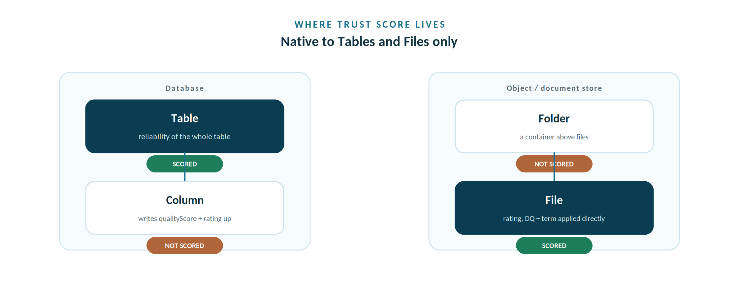
Trust Score is native to Tables and Files; Columns and Folders feed them but are never scored.

Where Trust Score lives — and how the app feeds each entity
Trust Score is native to two entity types only — tables and files. A column sits inside a table and a folder sits above files, so the scored peers are Table and File; Column and Folder never carry a score. The app’s Apply mirrors this exactly:
Entity | Scored? | How the app feeds it | What it carries
Table | Yes | Rolls each column’s mean qualityScore + rating up here, then Calculate Trust Score (Steward links the table term by hand) | Reliability of the whole table
File | Yes | Applies rating, DQ and term directly to the file; Calculate Trust Score runs here too | Reliability of a document
Column | No | Writes qualityScore + rating here from the scan | Inputs to the table score — governance & discovery, not a score
Folder | No | Skipped — not a Trust Score target | A container above files (like a schema)

The app creates the table terms; the Steward links them. The app writes one table-level term per table into the generated glossary (Member Record, Water System Record, …) so they are ready to use, but it does not link them — the Data Steward links each term to its table by hand to give that table’s Trust Score its assigned-term input. This stays a deliberate Steward task until Pentaho confirms the direction of Data Quality. The same table-level term step is taught in Workshop 3 (Move B); follow it here against the terms the app already created.
Goal: ask PDC to compute the Trust Score for the TABLES behind the columns you touched — it is a table / file rollup, never a per-column score — then poll until it finishes.
Recall the four trust inputs from the profiling workshop: a linked glossary term, Data Lineage marked Verified, a user rating, and the Data Quality metric. Lab C wrote Data Quality and a Rating onto each column; PDC averages those up to the table, and the Trust Score is computed there.

The job + the poll
POST /api/public/v3/jobs/execute/calculate-trust-score Authorization: Bearer <token>
{ "scope": [ "<table id>", "<table id>" ] }
// -> { data: { _id: "<job id>", workerName, activity } }

// then poll:
GET /api/public/v2/jobs/<job id>/status
-> { "status": "COMPLETED", "activity": ..., "duration": ... }

On the trust-score availability nuance
A PDC user-doc still says Trust Score is available for Tables and Files only and “not available in public API’s”, yet the Swagger (v1–v3) exposes a discrete endpoint for it: CALCULATE_TRUST_SCORE — its own jobs endpoint (its worker activity sits alongside METADATA_INGEST, DATA_PROFILE, DATA_DISCOVERY, PII detection and more). Because the user-doc and the Swagger disagree, the app submits it behind a toggle and reports exactly what your instance returns, so you can confirm the behaviour on your box.

In the app
- On a non-dry-run apply, tick Calculate Trust Score after apply. The app rolls each column’s qualityScore and rating up to its table, then submits the job on the TABLE ids and shows the polled status.

Lab E — Compare with PDC profiling
Goal: lay PDC’s own profiling numbers next to the app’s discovery, column by column.

The call underneath
POST /api/public/v2/entities/filter/profiling-info?sampleLimit=20
{ "filters": { "parentIds": ["<table id>"], "types":["COLUMN"] } }

// each item -> profilingInfo.stats:
// cardinality, density, selectivity, uniqueness, nulls, blanks,
// zeros, min/max/avg value & length, lexicalMin / lexicalMax

In the app
- On the discovery panel, fill the PDC connection row and click Compare with PDC profiling. Each cell shows app / PDC — completeness vs density, distinct vs cardinality, uniqueness vs uniqueness.
Reading the comparison
Close agreement validates the app’s heuristics; large gaps usually mean PDC profiled a different sample or the column hasn’t been profiled in PDC yet. Columns PDC hasn’t profiled show as not in PDC — run a Data Profiling job in PDC (Process → Data Profiling on the table) and compare again. For object-store files, Lab F triggers profiling for you.

Lab F — Profile documents in PDC
Goal: have PDC profile the object-store files you just applied to, so documents that show Profiled Status: SKIPPED gain PDC’s own Data Quality — the fourth Trust-Score input.
Does the profiler also apply to a database source?
Yes — but through a different front-end. A database column is profiled when you scan the database: the app samples that column’s live values and computes completeness, uniqueness and validity, the same Data-Quality metric a file gets. An object-store file has no live table to sample, so the app reads the file’s content (CSV / JSON / XML / text) to compute the same three dimensions. So both sources land a qualityScore; only the way it is measured differs. On the PDC side the split is the same: this lab’s Data Discovery job profiles files, object stores and document stores; a database is profiled by PDC’s structured Data Profiling (Process → Data Profiling on the table), not by Data Discovery.

The call underneath
POST /api/public/v3/jobs/execute/data-discovery Authorization: Bearer <token>
{ "scope": [ "<folder / file entity id>", ... ],
"configs": { "buildSamples": true, "headerExists": true,
"ingestProperties": true, "computeChecksum": true,
"withProfile": true } } // withProfile is v3-only

// returns { data: { _id: "<job id>", workerName, activity } }, then poll:
GET /api/public/v3/jobs/<job id>/status
-> { "status": "COMPLETED", "activity": ..., "duration": ... }

In the app
- Open Step 4 — Profile documents in PDC on the Apply page, after a non-dry-run apply.
- Click Run Data Discovery on documents. The app resolves the document folders to entity ids and submits the job — a folder cascades to the files inside it.
- Check job status polls until COMPLETED — or watch the Workers page in PDC. Profiling runs on a Remote Worker chosen by data-source affinity.
- Re-run Lab E to see each file’s new PDC Data Quality next to the app’s.

Alternative input — harvesting from PDC
The primary path is the full four-step workflow — connect and scan, review and prune, govern and generate, then resolve and apply over the API (everything above). Harvesting is the alternative for when you can’t scan the source yourself — it builds the glossary from what PDC has already cataloged. When the data source was ingested, PDC scanned it — so its entities already carry the schema, the data types, the keys, and, where stewards have done the work, the descriptions, sensitivity and trust scores. Reading them needs no direct database connection and no database password. Harvesting loads the glossary directly — there are no scan or Discover options, so prefer the Connect path when you want profiling and control. It reads table columns for a database, and files for an object or document store.
There is no “list all data sources” call
The public API’s data-sources group is retrieve-by-id only (POST /data-sources/by-ids, GET /data-sources/{id}); there is no GET that lists every source. A GET /api/public/v2/data-sources returns a “Route not found” 404 by design. So the app discovers the harvestable roots from the catalog itself, using the same entities/filter endpoint Resolve and Apply already use.

Discover the sources
Filter for the container entities — schemas and data sources — and offer them as the pick-list. Each hit carries the fqdn the harvest then scopes to.
POST /api/public/v2/entities/filter?extended=true Authorization: Bearer <token>
{ "filters": { "types": ["SCHEMA","DATA_SOURCE","RESOURCE"] } }

// each hit -> { _id, name, type, fqdn, fqdnDisplay }

Harvest the columns
Pull the COLUMN entities for the chosen root and reshape them into the same structure a local scan produces. PDC’s own column metadata supplies the data type, keys and nullability; the steward’s description becomes the definition and is treated as a high-confidence comment.
POST /api/public/v2/entities/filter?extended=true Authorization: Bearer <token>
{ "filters": { "types": ["COLUMN"] } } // scoped client-side to the chosen fqdn

// from each COLUMN entity the app reads:
// metadata.column.dataType / isPrimaryKey / isForeignKey / isNullable
// attributes.info.description -> definition (high confidence)
// attributes.features.sensitivity / trustScore
// attributes.businessTerms[] -> already-governed flag

Read before you write
Because the harvest reads attributes.features and attributes.businessTerms, every column PDC already governs is flagged in the grid (in PDC, with its current sensitivity, trust score and linked terms). The generator suggests but never silently overwrites a steward’s work — the same merge discipline Apply uses, surfaced earlier in the pipeline.
Before importing, the app can also ask PDC whether a glossary of that name already exists (a /search lookup), so you update in place rather than create a duplicate.
The base URL is the server root
Give the app the PDC server root — https://host — not the Keycloak realm URL. The app appends /keycloak/realms/<realm>/… and /api/public/v{n}/… itself, so a base that already contains them builds a doubled path that 404s. Pasting the full Keycloak URL is tolerated — the app strips it back to the root and recovers the realm.

API reference card
Every call this workshop makes, in one place. All require the bearer token except auth.

Purpose | Method & path | Body / key fields
Get token | POST /api/public/v2/auth | form: username, password, client_id, grant_type, scope
Find term | POST /api/public/v2/search | { searchTerm, searchFacets:{ type:["term"] } }
Find column | POST /api/public/v2/entities/filter | { filters:{ fqdns | names | parentIds | types } }
Write column | PATCH /api/public/v2/entities/{id} | { attributes:{ businessTerms[], features{} } }
PDC profiling | POST /api/public/v2/entities/filter/profiling-info | { filters:{…} } ?sampleLimit=N
Trust Score job | POST /api/public/v3/jobs/execute/calculate-trust-score | { scope:[ ids ] }
Profile files | POST /api/public/v3/jobs/execute/data-discovery | { scope:[ ids ], configs:{ buildSamples, withProfile } }
Poll a job | GET /api/public/v2/jobs/{id}/status | → { status, activity, duration }
Harvest sources | POST /api/public/v2/entities/filter | { filters:{ types:["SCHEMA"|"COLUMN"] } }
Glossary exists? | POST /api/public/v2/search | { searchTerm } → a GLOSSARY hit
Source by id | GET /api/public/v3/data-sources/{id} | (no list-all; retrieve by id)

Production notes & caveats
Token lifetime
Tokens expire. Authenticate once per run and re-auth on a 401 rather than caching a token across sessions. Never write it to disk.
Least privilege
Admin works, but the rights actually needed are glossary read, entity edit and job execute. A Business Steward / governance role is plenty and safer.
Version drift
Confirm the path version (v2/v3) against your instance Swagger before scripting; the jobs catalog in particular is richest in v3.
Dry-run discipline
Always preview against a new instance. Arrays full-replace on PATCH — the dry-run is what proves the merge is producing a superset, not a replacement.
Idempotency
Re-applying is safe because the app merges by term id/name; the same link won’t duplicate. Trust-score and profiling jobs can be re-run freely.
Base URL is the server root
Point the app at the PDC server root (https://host), not the Keycloak realm URL. The app appends the /keycloak/realms/<realm>/… and /api/public/v{n}/… paths itself; a base that already contains them builds a doubled URL that 404s. A full Keycloak URL is tolerated — it is stripped back to the root and the realm recovered.

The import boundary
Nothing here creates a glossary. If the glossary changes, re-import it (whole-glossary, non-incremental) before resolving and applying again.

End of workshop. You’ve taken the glossary from a local suggestion to a fully governed, trust-scored, profiled set of columns in PDC — every step after the import driven by the public API.

Appendix A — The API behind the app (Swagger reference)
How to read this. The app is a thin client over the PDC public API. Every button maps to one or more of the calls below, taken straight from your instance’s OpenAPI (Swagger) document (openapi 3.0.3) at /api/public/v{1,2,3}/. The shapes are stable across versions; v2/v3 switch entity paging to a cursor and add a few filter keys. Bodies are abbreviated to the fields the app actually sends or reads.

A1 · Authenticate — POST /api/public/v{n}/auth
What the app does. Posts form-encoded credentials, reads data.accessToken, and sends it as Authorization: Bearer on every later call.
# request (application/x-www-form-urlencoded)
POST /api/public/v2/auth
username=<user> password=<pwd>
client_id=pdc-client grant_type=password
scope=openid profile email

# 200 response
{ "message": "OK",
"data": { "accessToken": "eyJhbGciOiJIUzI1NiIsInR..." } }

# 401 -> { "status": 401, "message": "Unauthorized" }

A2 · Resolve a column or term — POST /api/public/v{n}/entities/filter
What the app does. The workhorse lookup. Filter by fqdns / names / types; each hit returns its _id, type, fqdn, parentId, rootId and full attributes. Apply uses it to resolve a column id; Resolve uses it (names + types:[“term”]) to read a term’s _id (term id) and rootId (its glossary).
# request ?extended=true&size=500
POST /api/public/v2/entities/filter
{ "filters": {
"fqdns": ["cscu_core.members.customer_name"],
"types": ["COLUMN"] } }
# filters also accept: names, parentIds, rootIds, resourceIds,
# collectionIds, buckets, profileStatus[COMPLETED|SKIPPED|FAILED],
# profiledAt{min,max} (v3 also: tags, terms, termIds)

# 200 response
{ "status": 200,
"data": [ {
"_id": "5f3a...e21", "name": "customer_name", "type": "COLUMN",
"fqdn": "cscu_core.members.customer_name",
"parentId": "...", "rootId": "...",
"metadata": { "file": { "path": "...", "bucket": "...",
"extension": "csv", "type": "FILE" } },
"attributes": {
"features": { "sensitivity": "HIGH", "qualityScore": 92,
"rating": { "value": 4 }, "isLineageVerified": true,
"isCriticalDataElement": true,
"trustScore": { "value": 78, "type": "MANUAL" } },
"businessTerms": [ { "id": "...", "glossaryId": "...",
"name": "Member Name", "confidenceScore": 1 } ] } } ],
"cursorInfo": { "cursor": null, "size": 1, "totalItems": 1 } }
# v1 returns pageInfo{currentPage,perPage,totalCount,pageCount}.

A3 · Faceted search — POST /api/public/v{n}/search/facets
What the app does. Free-text search that returns faceted counts (by type, sensitivity, business term, trust band, bucket…). The documented Search endpoint is /search/facets — it returns counts, not entity hits, so to fetch a term’s exact id the app uses A2. The facets power a governance-coverage view.
# request
POST /api/public/v2/search/facets
{ "searchTerm": "member",
"searchFacets": { "type": ["term"], "sensitivity": ["HIGH"] } }
# searchFacets keys: index, type, rootIds, businessTerms, fileFormats,
# sensitivity, domain, qualityScore, trustScore, columnKeys, tags,
# buckets, parentIds, profiledAt, modifiedAt, accessedAt

# 200 response
{ "status": 200,
"data": [ { "key": "type",
"options": [ { "name": "term", "count": 58 },
{ "name": "COLUMN", "count": 240 } ] },
{ "key": "sensitivity",
"options": [ { "name": "HIGH", "count": 31 } ] } ] }

A4 · Write metadata — PATCH /api/public/v{n}/entities/{id}
What the app does. Merge-and-write. It reads the entity (A2), unions businessTerms, overlays features, and PATCHes the superset — arrays full-replace, so the whole merged list is sent. Only the six businessTerms keys are accepted; any extra key (e.g. the app’s glossary display name) makes PDC reject the PATCH with a 400.
# request
PATCH /api/public/v2/entities/5f3a...e21
{ "attributes": {
"businessTerms": [
{ "id": "...", "glossaryId": "...", "name": "Member Name" } ],
"features": {
"sensitivity": "HIGH",
"isCriticalDataElement": true,
"isLineageVerified": true,
"rating": { "value": 4 },
"qualityScore": 92 } } }
# valid businessTerms keys: id, glossaryId, name,
# sourceName, sourceType, confidenceScore (others -> 400)

A5 · Trust Score job — POST /api/public/v{n}/jobs/execute/calculate-trust-score
What the app does. Submits the touched entity ids and polls A7 until the worker finishes.
# request
POST /api/public/v3/jobs/execute/calculate-trust-score
{ "scope": [ "<entity id>", "<entity id>" ] }

# 200 response
{ "status": "OK", "message": "...",
"data": { "_id": "<job id>", "workerName": "...",
"activity": "..." } }

A6 · Data Discovery (profiling) job — POST /api/public/v{n}/jobs/execute/data-discovery
What the app does. Profiles object-store files/folders (Lab F). scope is a list of entity ids (a folder cascades to its files); configs choose what runs. withProfile is a v3-only switch that also profiles object/document stores.
# request
POST /api/public/v3/jobs/execute/data-discovery
{ "scope": [ "<folder / file id>" ],
"configs": {
"computeChecksum": true, # duplicate detection
"ingestProperties": true, # PDF / Office properties
"buildSamples": true, # extract samples -> profiling
"headerExists": true, # first row is the header
"contentScanType": "SCAN_ONLY",
"withProfile": true } } # v3 only: profile object stores
# more configs: summarizeDocuments, addressDetection, businessTerms,
# dictionaryIds, dataPatternIds, extensions, supportedMaxFileSize,
# includePatterns, excludePatterns, dataProfiledSinceDays ...

# 200 -> { "data": { "_id": "<job id>",
# "workerName": "...", "activity": "..." } }

A7 · Poll a job — GET /api/public/v{n}/jobs/{id}/status
What the app does. Polls until status is COMPLETED (or FAILED). Shared by Trust Score (A5) and Data Discovery (A6).
# request
GET /api/public/v3/jobs/<job id>/status

# 200 response
{ "workerId": "...", "workerName": "...",
"activity": "...", "status": "COMPLETED",
"duration": 12.4,
"scope": { "dataSources": [...], "scope": [...] } }

Read your own Swagger
Every shape above comes from your instance’s live OpenAPI document. Open /api/public/v3/ (or v2 / v1) in a browser for the Swagger UI, or fetch its JSON to script against the exact version your box runs. The app pins a version per call and re-auths on a 401 — so the only contract it depends on is the one published here.

Drift, Reconcile & the Registry (1.6.19)
Version 1.6.19 introduces a single Registry that unifies the three things a steward used to set by hand, in separate places: the business term, the governed tags, and the sensitivity level. One canonical entry per concept carries all three, and both the glossary term and the Data Identification method are generated from that same entry. Because they share one source, the glossary tag and the method tag cannot drift apart by construction.

One entry, three governed outputs
Each Registry entry carries a glossary term id, a governed tag set (an allow-list), a sensitivity floor, and — for pattern methods — a category. The Glossary Generator writes the term from this entry; the Policy Generator app stamps the Data Identification method's tags from the very same entry. Sync therefore becomes a build-time invariant rather than a reconciliation chore: there is only one writer of governed tags and sensitivity, so the two sides are identical whenever they are generated.

Deterministic sensitivity
Sensitivity is decided rules-first against a codified taxonomy, not guessed by a model. A person identifier — a member, member, or patient id — is HIGH and tagged PII, while a bare surrogate or foreign key is LOW. The sensitivity is an ordinal floor: rules can raise a classification, and the optional LLM runs only on columns no rule matched and can never lower a rule hit. Regulated fields no longer depend on a small model's judgement. Tags are drawn from a controlled allow-list derived from the Registry, which ends the free-generated tag repetition seen previously.

Policy Generator (the app, formerly Method Advisor / Metadata Advisor / Classification Registry)
The Policy Generator app emits the two Data Identification method kinds — DataPattern and Dictionary — that bind back to the glossary and stamp their tags from the Registry. A dictionary method binds by dictionaryTermId (a real glossary term UUID); a pattern method binds by its categories name. Both carry their tags in the method's applyTags action, generated from the concept's Registry entry.

Why drift is visible only after reconciliation
This is the ordering that matters, and it is the reason drift is a post-reconciliation capability. A dictionary method can only be matched back to a concept by its dictionaryTermId — and that id does not exist until the reviewed glossary has been imported into PDC, which mints the ids, and those ids have been read back and reconciled into the Registry. The loop is:
scan & classify → review (merge / disambiguate / keep) → export glossary → import into PDC (PDC mints term ids) → reconcile ids into the Registry → emit & deploy methods → drift check
Until the reconcile step writes the minted ids into the Registry, dictionary methods have no id to match and read as UNKNOWN; their tag drift cannot be assessed. Pattern methods bind by category name, so pattern drift can be observed a step earlier — but the complete drift picture still follows reconciliation. In short: review the term, round-trip it through PDC, reconcile the id, and only then does drift become visible.
The drift linter then reads a deployed method back and reports OK / DRIFT / UNLINKED / ORPHAN per method; reconcile rolls a catalog scan and the deployed methods into per-concept verdicts of CLASSIFIED / UNKNOWN / MISSING / DRIFT / UNLINKED.

Persistence, References & Architecture Diagrams (1.6.19)

A persistent Registry
The Registry is now persistent state, saved alongside the glossary. On save, the app writes the working Registry — reconciled term ids, category bindings, learned concepts, the governed tag and sensitivity vocabulary, the detection rules, and the verified reference map — to a JSON file (for example registry.<glossary>.json in the /data directory). On open, that snapshot is reloaded and becomes the working Registry. This matters because the reconcile handshake is stateful: a dictionary method binds to a concept by its glossary term id, so if those minted ids were lost on restart, drift could no longer be assessed in the next session. The saved Registry is a governance artifact tied to that glossary and that PDC instance.

Descriptions: prose from the model, links from a verified map
Description enrichment deliberately separates two jobs, because a small local model will hallucinate regulation names, section numbers, and — most dangerously — live URLs, and a governance term that cites a wrong or invented regulation is worse than one that cites nothing. The LLM is asked only to write one or two plain sentences describing the concept, and is explicitly instructed not to produce citations or links. The links themselves come only from a curated, human-verified reference map carried in the domain pack, keyed by concept or tag. The composer joins the model's prose with the verified links. This is the same principle as the controlled tag allow-list: the model proposes within a controlled vocabulary and never mints authoritative facts.
For the Arizona water example, the pack ships verified links to the EPA Safe Drinking Water Act and National Primary Drinking Water Regulations, and to the Arizona ADEQ Safe Drinking Water program and Arizona Administrative Code Title 18, Chapter 4 — each stamped with the date it was verified so it can be re-checked. These are one example; a pack for any other sector carries its own verified references.

Building the Registry from scans
The Registry can be grown from the data-source scans rather than authored entirely by hand, but as reviewed accretion, not blind inference. Novel or industry-specific columns that match no core rule are proposed as candidate concepts with suggested tags and sensitivity, and a steward confirms them before they persist — the generic PII/PCI/PHI floors always remain authoritative, so inference can never downgrade a regulated field. Once curated for the first client in a sector, the accreted concepts export as a reusable domain pack, so the next client in that sector gets those industry tags suggested automatically.

Architecture diagrams at a glance
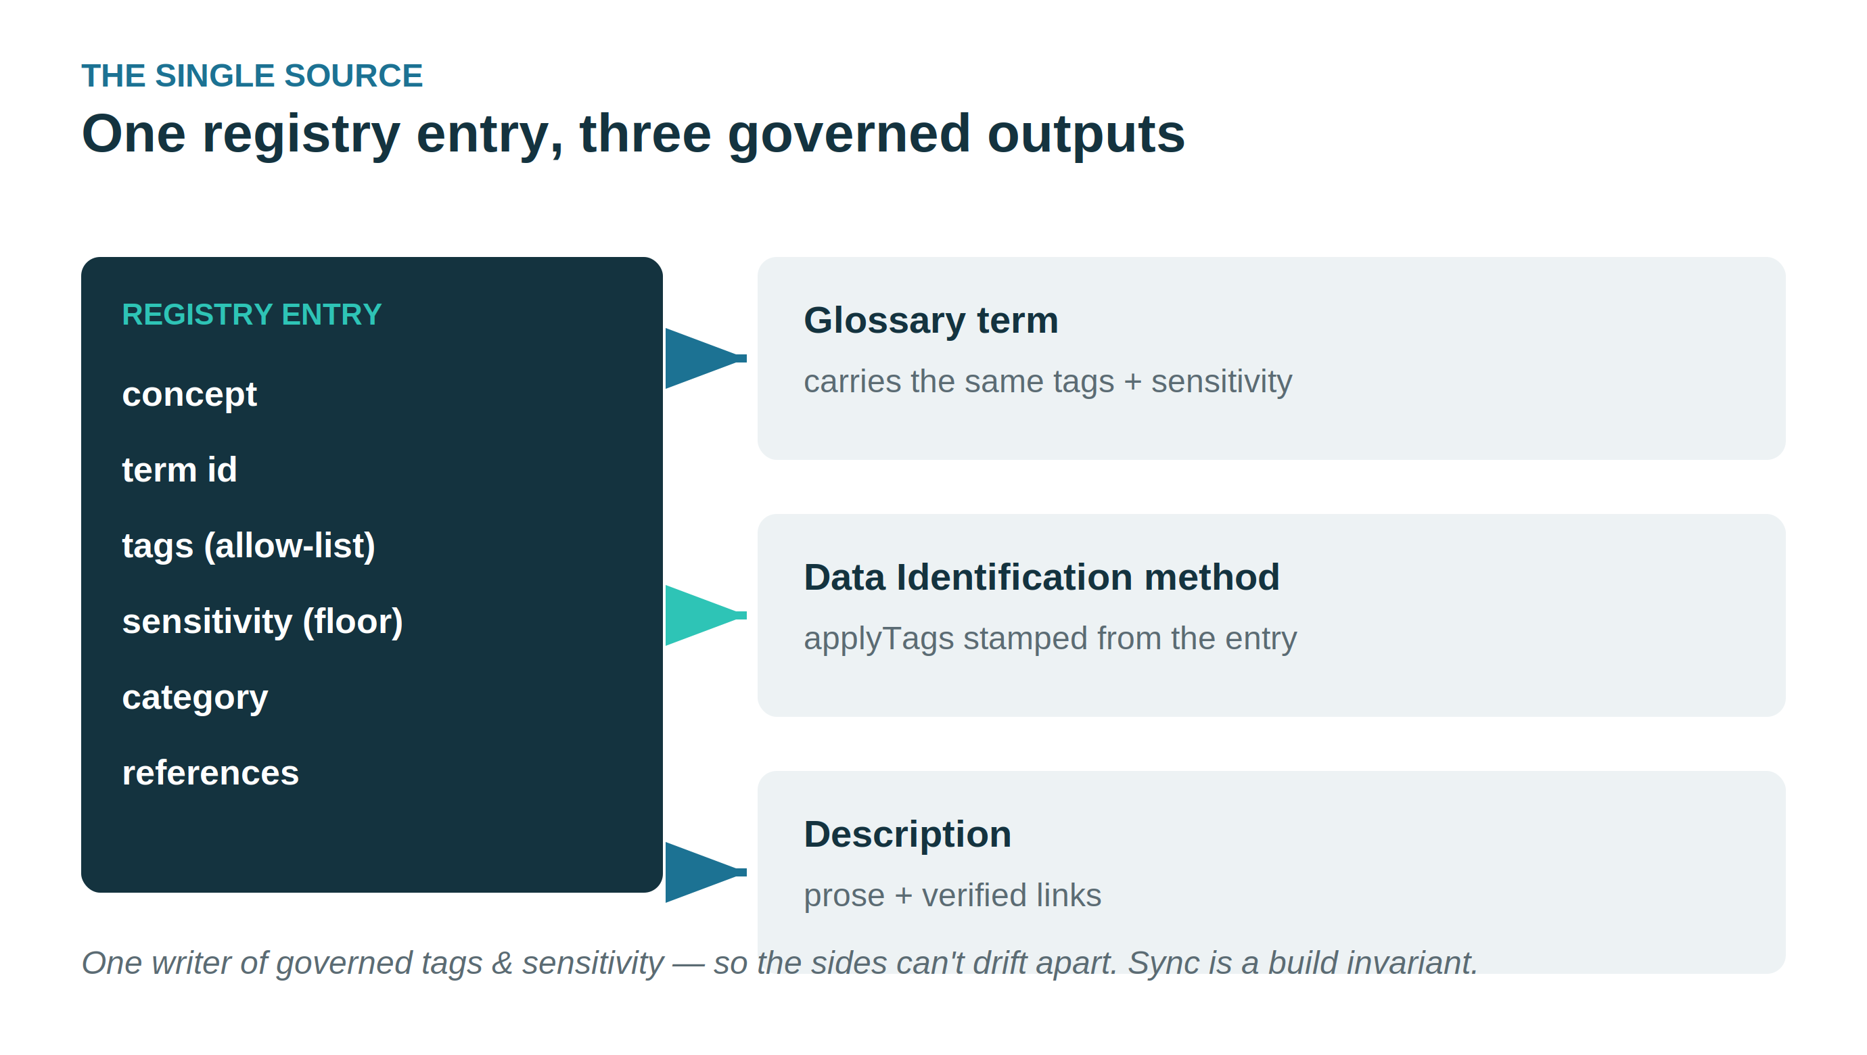
Figure 1. One Registry entry drives the glossary term, the Data Identification method's tags, and the description — one writer, so the sides cannot drift apart.
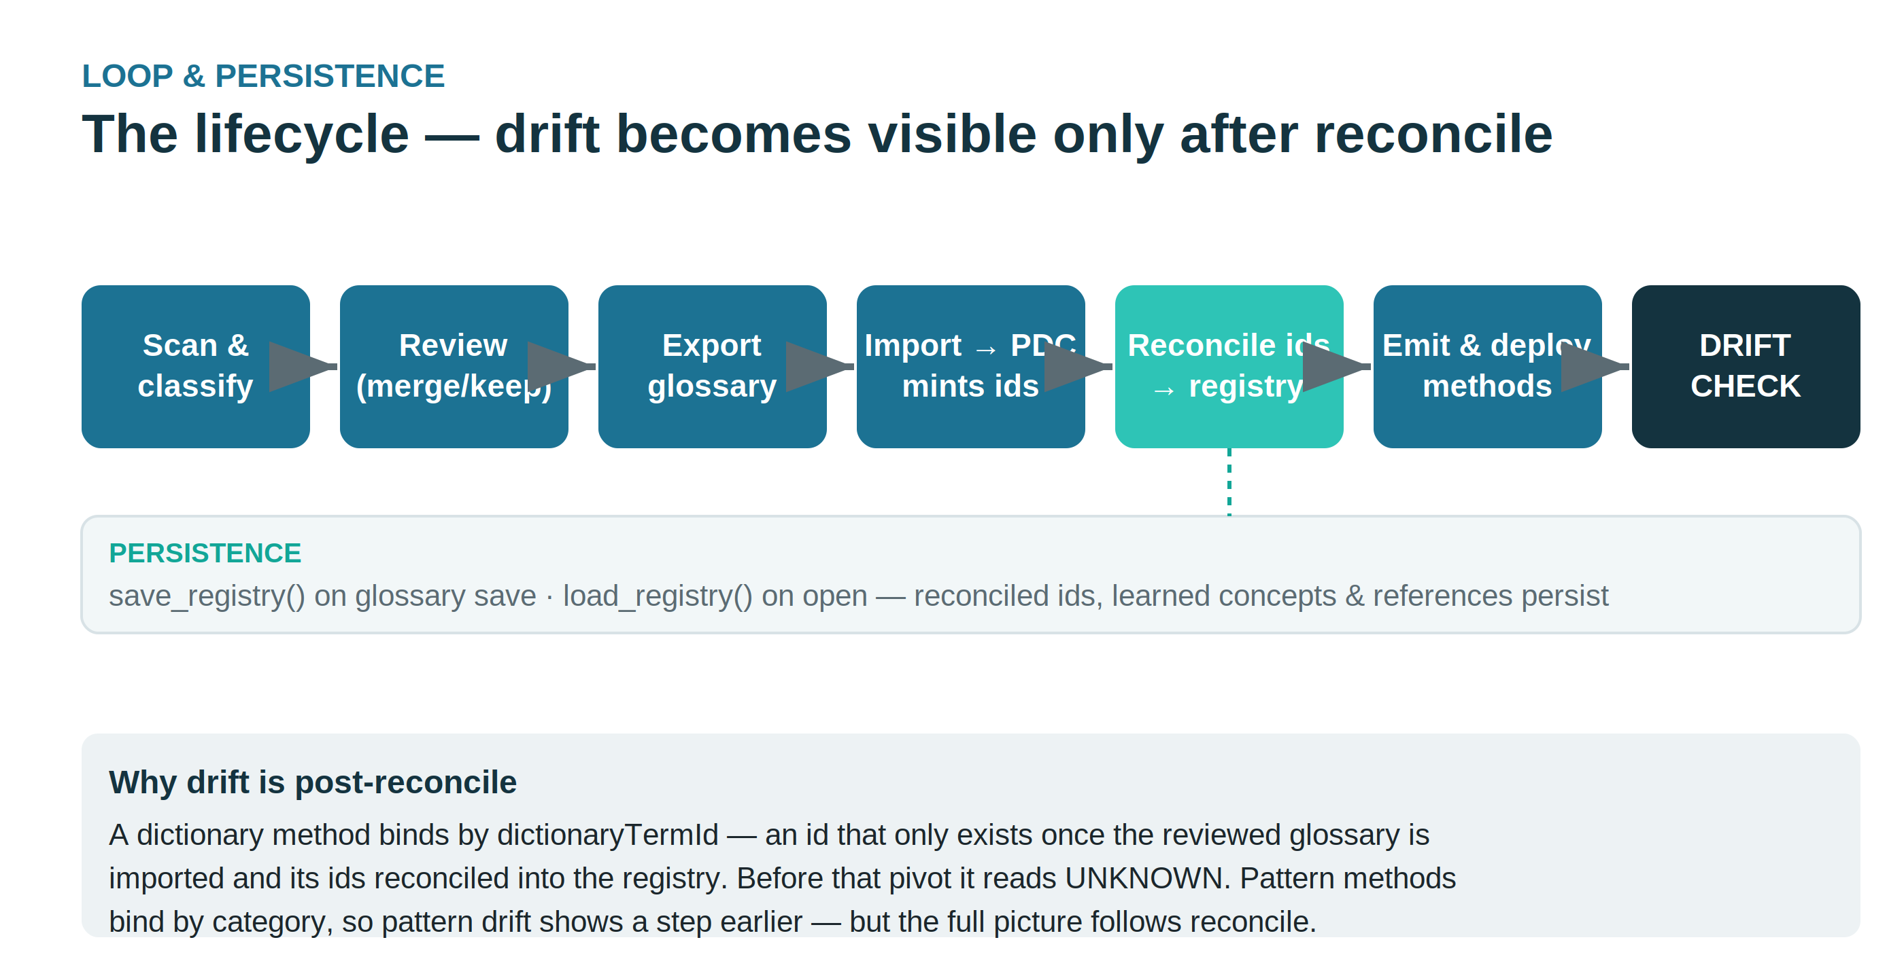
Figure 2. The lifecycle. Drift becomes assessable only after minted term ids are reconciled into the persisted Registry; before that pivot, dictionary methods read UNKNOWN.
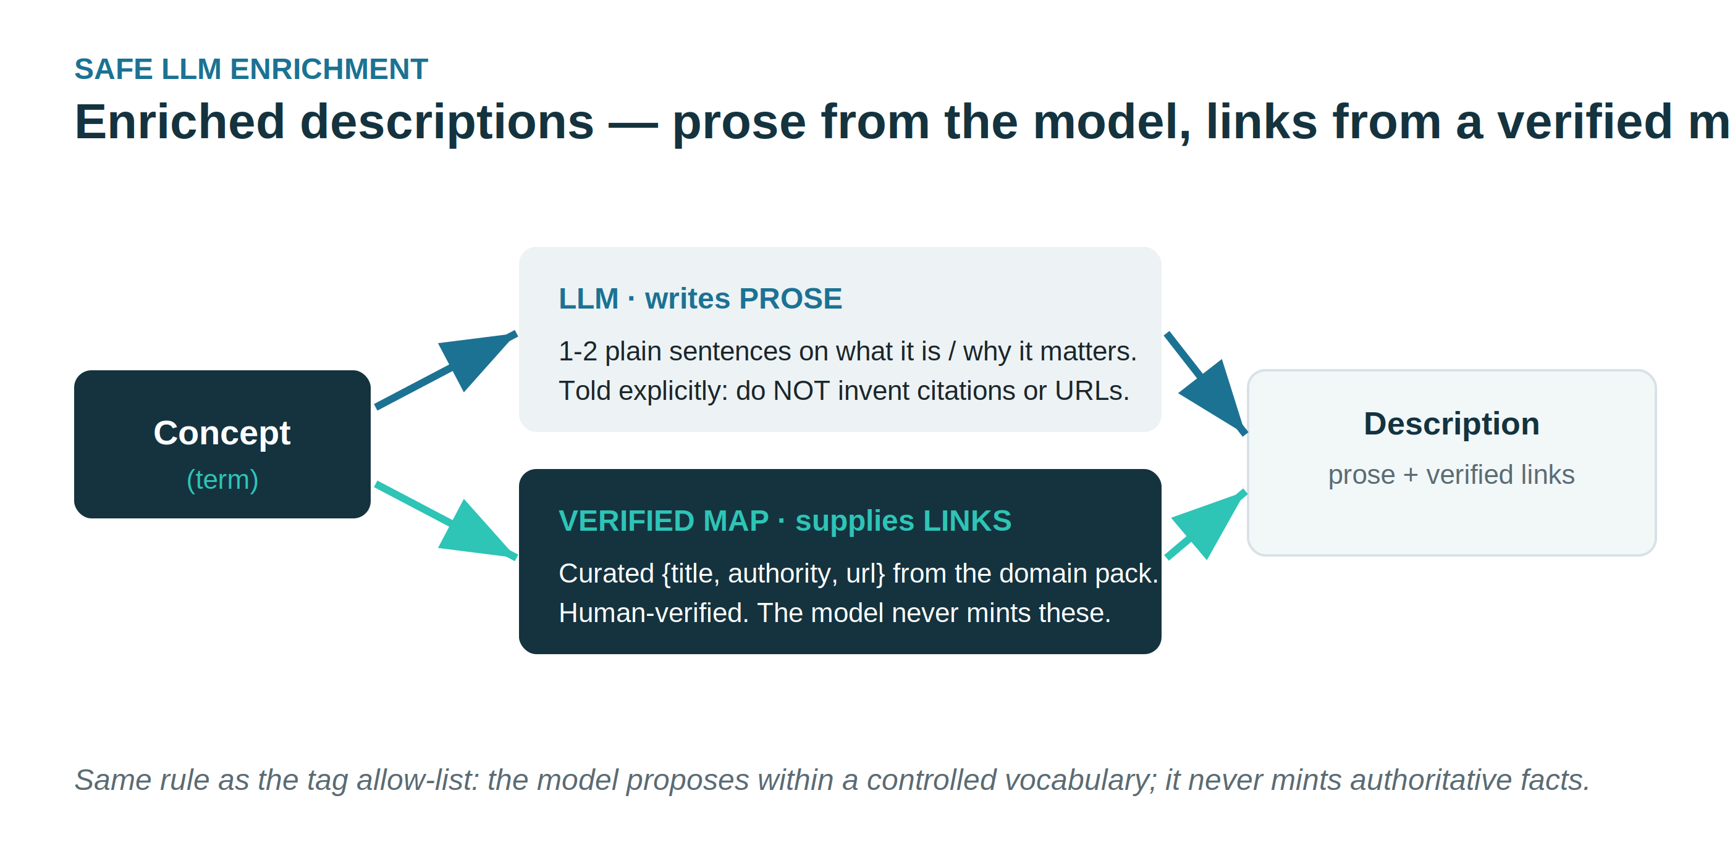
Figure 3. Safe enrichment. The model writes prose; compliance links come only from the verified reference map.
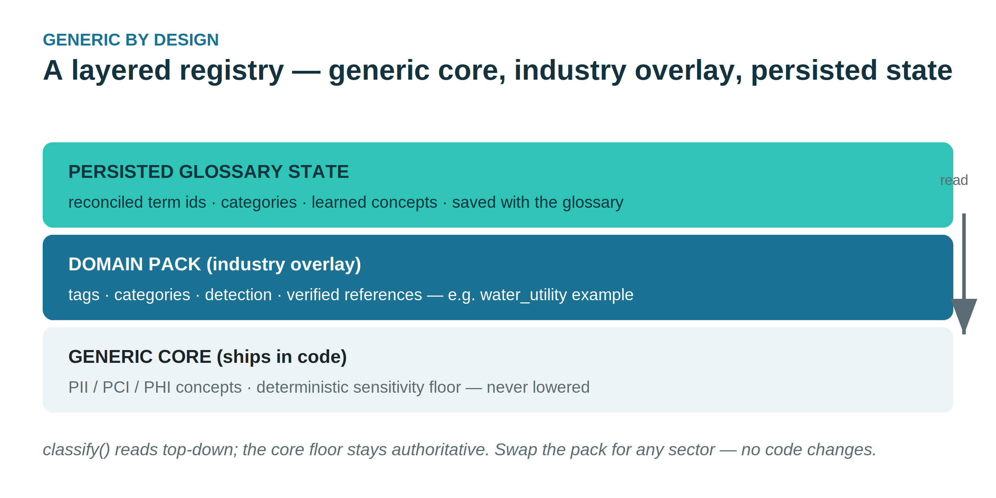
Figure 4. A layered Registry: generic core (authoritative floor), industry domain pack (swappable overlay), and persisted glossary state.

Recent capabilities (releases 1.6.5 – 1.6.19)
Since this workshop was first written, the app gained a Connect & bulk-load path, meaningful controlled tagging, a persisted Term & tag dictionary, and a governed hand-off to the Policy Generator. This section brings the workshop current; the steps above still apply.
Release | What changed | Why it matters
1.6.5 | Inline duplicate-cluster review layout | Merge/keep decisions happen where you see the duplicates
1.6.6–7 | Bulk loader: create → metadata ingest → poll | Register many sources in PDC from one CSV
1.6.7 | Export saved connections to a loader CSV | Build connections by hand, then bulk-load them
1.6.8 | Meaningful controlled tags; table terms locked | Tags say what a term is; the table term can't be dropped
1.6.9–10 | Two-layer Term & tag dictionary; guard-rails | Generic baseline + editable company layer; edits can't drift
1.6.11 | Steward approval gate; sensitivity lift | New vocabulary is reviewed before it governs; floors raise sensitivity
1.6.19 | Scan-time alias resolution; Dictionary page | Divergent names collapse to one term; vocabulary has its own home

The through-line
One governed vocabulary drives everything. Scans suggest terms and tags → the Term & tag dictionary governs them → the Registry embeds that governed vocabulary → the Policy Generator builds Data Identification methods from it. Both the glossary and the methods draw from the same allow-list, so their tags stay consistent — the one thing PDC does not enforce on its own.

Connect & bulk-load

Bulk data-source loader
The Connections page has a Bulk-load data sources into PDC panel. From a CSV, for each row the app creates the data source, then triggers a metadata ingest scoped to it and polls the job — the Connect + Ingest steps that precede profiling, identification and the glossary.
kind is one of postgres, mysql, minio/s3, or azure_blob. Resource names must start with a letter and use only letters, digits and underscores — no spaces.
The ingest job that matters (a fixed footgun)
PDC has two ingest jobs. A new source is ingested with POST /jobs/execute/metadata/ingest — the “Ingest Schemas or Scan” job, which takes the data-source config body scoped by resourceId.
Not metadata/re-ingest: that is a later refresh job whose scope must be entity UUIDs. A freshly created source's id isn't a UUID, so re-ingest returns 400 /scope/0 must match format "uuid".

Export your saved connections
Build connections by hand in the New connection form, then click Export existing. The app writes those saved connections to a loader-ready CSV. Because the app already holds their credentials, this CSV includes secrets and reloads straight into the loader — treat the file as sensitive.

Meaningful tagging & table terms
Tags are no longer just the category slug. They are derived from the term/column name and category through a controlled rule set and layered on the PII / CDE / key / sensitivity signals — e.g. Account Number → financial; sensitive; identifier; member; maskable; CDE; pH Level → water-quality; compliance. Every emitted tag stays inside the controlled vocabulary, so tags can't drift into free text.
A table-level record term (name ends in “Record”, no source column) is now locked and badged in the Review grid — it can't be dropped, even at low confidence or via bulk actions. And applying an LLM-suggested name renames every instance of that term at once, so duplicates stay one mergeable term.

The Term & tag dictionary
The governed vocabulary is a persisted, per-company artifact, edited on its own Dictionary page. It has two layers:
Layer | What it holds | Editable?
Generic (baseline) | Common terms and tags with common sensitivity — Member ID, Account Number, Email, SSN, Amount, plus baseline tags with sensitivity floors | Protected — can't be removed
Company | Terms and tags specific to this deployment, seeded from the domain pack and grown from scans | Yes — steward-owned

Grown from scans, gated by a steward
Every scan accretes the tags and terms it used into the company layer. New company items arrive as pending — suggested in the grid but they do not govern until a steward approves them (Dictionary → Pending steward review). Only the generic baseline and approved company items are governed.

Guard-rails (because drift is a PDC limitation)
Saving the dictionary is validated and repaired rather than applied blindly:
• the generic baseline can't be removed (it's restored),
• every rule/term tag must exist in the vocabulary (auto-added),
• sensitivity is validated, invalid regexes flagged, alias collisions reported,
• all repairs come back as warnings shown in the panel.

Aliases and the sensitivity lift
Aliases resolve divergent names to one canonical term. This runs at scan time: a cust_id column and a customer_account_number column both become Member ID, so they collapse into one mergeable term.
Sensitivity lift: a term's sensitivity is raised — never lowered — to the highest floor implied by its tags' floors and its canonical term's dictionary sensitivity. Ordinal, so the dictionary can only tighten a classification (a column tagged PII lifts to HIGH).

Registry & the Policy Generator hand-off
At export (Generate JSONL), the app authors the Registry — one concept per kept term — and embeds the governed vocabulary into it (tag allow-list, sensitivity floors, canonical terms with aliases). A concept whose tags fall outside the governed list is flagged (off_vocabulary_tags).
Where it says “ready for the Policy Generator”
After Generate, the Handoff to the Policy Generator card on the Govern page shows glossary saved, JSONL generated, and Registry written: registries/registry.<id>.json. Point the Policy Generator at it. Term ids fill in after you import the glossary and run Resolve Term IDs.

Build the policy from the Term, and pick up its tags
Should the Policy Generator build methods from the Term (carrying that term's governed tags), or from the tags? With this registry they are the same outcome — for a reason worth stating.
The Term is the canonical anchor: it has an identity, links to the glossary, and carries a fixed governed tag set. Tags are attributes of that term. So authoring term-first — one method per concept, emitting that concept's tags — guarantees consistency. A tag-first approach yields the same methods only because the registry already binds tags to terms, and it has no stable anchor to resolve or merge against. So: build from the Term, match the tags. Tag consistency isn't a competing goal — it's a consequence of term-anchored authoring against one governed vocabulary.

Where these live in the app
• Connections — the bulk loader and saved-connection export.
• Glossary — review terms and their tags together; the action bar is grouped Prune · Duplicates · Tags.
• Dictionary — govern the company vocabulary: terms, tags, rules, pending approvals, sensitivity floors, export.
• Govern — set stewardship, Generate JSONL, and see the Registry hand-off card.

