PENTAHO DATA CATALOG 11.0.0
Business Analyst Happy Path — Lab Environment Setup Guide
Shared demo lab — one PostgreSQL + one MinIO · four scenarios: CSCU · RETAIL · HEALTH · MFG
The single, consolidated guide for installing and configuring the lab: get the repository, set up the network once, stand up the shared stack, load a training scenario, configure and run the Glossary Generator, and connect both data sources to Pentaho Data Catalog before Workshop 1. The same steps serve all four scenarios; CSCU is used as the worked example throughout.

Overview
This guide prepares the lab environment for the Business Analyst course. The lab is a single, shared Docker stack: one PostgreSQL 16 container (demo-postgres) and one MinIO object store (demo-minio). Each training scenario loads into its own database and its own bucket, so the four course scenarios — CSCU (Copper State Credit Union, financial), RETAIL (Canyon Trail Outfitters), HEALTH (Lakeshore Health Partners) and MFG (Cascade Precision Components) — coexist side by side with no port conflicts. A provided Makefile brings the stack up, and a loader script creates, populates and verifies each scenario on demand.
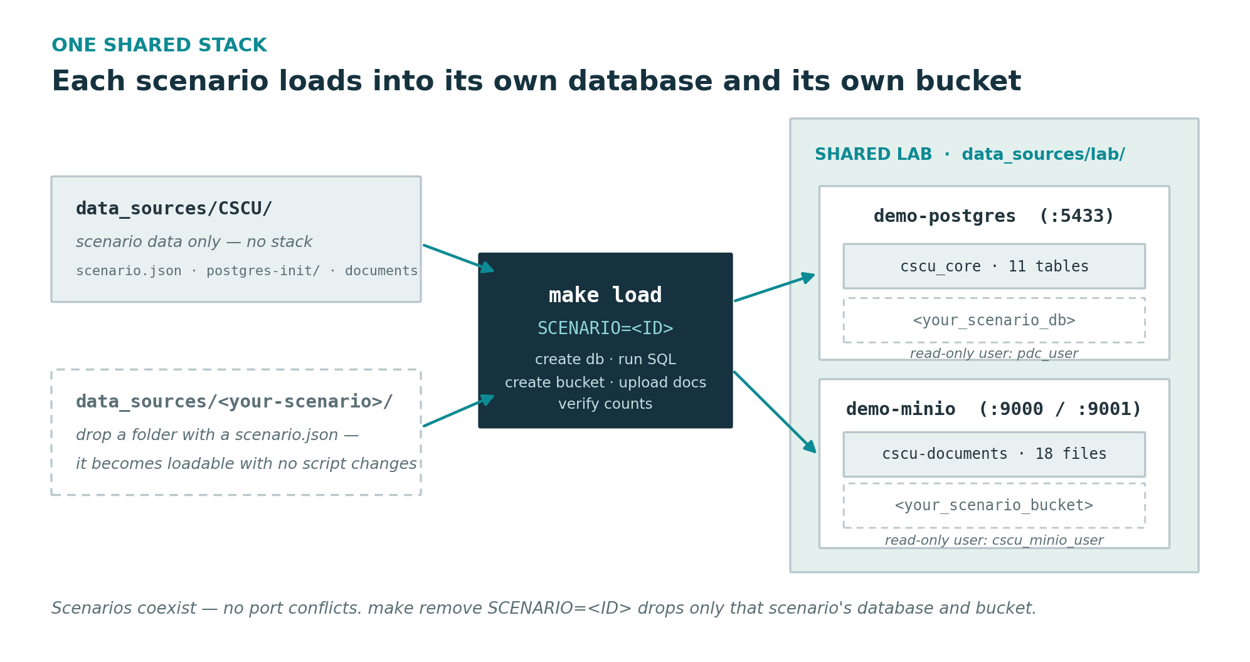

What you will build
- A PostgreSQL 16 container (demo-postgres) hosting one database per scenario (11 tables each), published on host port 5433.
- A MinIO object store (demo-minio) hosting one bucket per scenario (18 files each) — S3 API on port 9000, web console on 9001.
- Read-only catalog users PDC connects with: pdc_user for every database, plus a per-scenario MinIO user for each bucket.
- Two verified PDC data sources per loaded scenario — a database and a document store.
Scenario | Database | Bucket | MinIO user
CSCU | cscu_core | cscu-documents | cscu_minio_user
RETAIL | cto_retail | cto-documents | cto_minio_user
HEALTH | lhp_clinical | lhp-documents | lhp_minio_user
MFG | cpc_mfg | cpc-documents | cpc_minio_user

Prerequisites
- Docker Engine (or Docker Desktop) 24+ installed and running, with the Compose plugin (docker compose).
- GNU make and git (both pre-installed on the Ubuntu 24.04 lab VM).
- Access to a Pentaho Data Catalog 11.0.0 instance with a Data Steward or IT Administrator login. In the standard lab, PDC runs in the same Ubuntu VM (static IP 192.168.1.200) and is served at https://pentaho.io.
- Roughly 2 GB of free disk, and host ports 5433 (PostgreSQL — 5432 already belongs to PDC's own database on the VM), 9000 and 9001 (MinIO) free.
- On the Windows 11 host (where the Glossary Generator runs in the standard lab): Python 3.9+ and PowerShell. Optional: a local Ollama on port 11434 for LLM-enriched definitions — the app is fully functional without it.

Part A — Get the repository
The lab ships inside the PDC-Glossary-Generator git repository, together with the scenario data, the domain pack, the Glossary Generator app and the courseware. Clone it once on the Docker host (the Ubuntu VM):
git clone https://github.com/jporeilly/PDC-Glossary-Generator.git PDC-Demo
cd PDC-Demo/data_sources/lab
Already cloned? Pull the latest lab and courseware updates instead:
cd PDC-Demo
git pull
In the standard lab the Glossary Generator runs on the Windows 11 host, so clone the same repository there too (PowerShell):
git clone https://github.com/jporeilly/PDC-Glossary-Generator.git C:\Projects\PDC-Demo
cd C:\Projects\PDC-Demo

Where things live in the repository
- data_sources/lab/ — this shared stack: docker-compose.yml, Makefile, .env.example and the scenario loader.
- data_sources/<ID>/ — one data folder per scenario (CSCU, RETAIL, HEALTH, MFG): the sample SQL, the documents, the installable domain pack and the PDC bulk-load CSV.
- courseware/<ID>/ — the matching workshop set (guides and assets) per scenario.

Part B — One-time network setup (host and VM)
The standard topology: the Glossary Generator runs on the Windows 11 bare-metal host, while PDC and the shared lab stack run inside an Ubuntu 24.04 VM with the static IP 192.168.1.200, PDC served at https://pentaho.io. Do these four steps once per machine pair.

Give the VM a static IP
Use a bridged network adapter and assign the VM 192.168.1.200, so the Windows host and the VM sit on the same LAN segment and can reach each other directly.

Open the VM firewall (if ufw is enabled)
sudo ufw allow 5433/tcp # demo-lab PostgreSQL (app + PDC)
sudo ufw allow 9000/tcp # MinIO S3 API (app + PDC)
sudo ufw allow 9001/tcp # MinIO console (optional, browser only)
sudo ufw allow 443/tcp # PDC (https://pentaho.io)

Map pentaho.io on the Windows host
pentaho.io is a lab hostname, not public DNS — map it to the VM in the hosts file. In an elevated PowerShell:
Add-Content C:\Windows\System32\drivers\etc\hosts "192.168.1.200 pentaho.io"
On the VM itself, /etc/hosts must map pentaho.io to 192.168.1.200 as well — NOT to 127.0.0.1. A loopback mapping strands the whole PDC stack; see troubleshooting item G2.

Verify reachability from Windows
Test-NetConnection 192.168.1.200 -Port 5433 # PostgreSQL
curl.exe http://192.168.1.200:9000/minio/health/live -i # MinIO -> 200
curl.exe -k https://pentaho.io/ -I # PDC UI

Part C — Stand up the lab and load the scenario

Step 1: Configure and start the shared stack
cp .env.example .env
make up
make up runs a preflight check (Docker present and running, Compose plugin available), starts both containers, and waits until PostgreSQL and MinIO are genuinely ready before returning.

Step 2: Load the scenario
make load SCENARIO=CSCU # and/or RETAIL, HEALTH, MFG
For the selected scenario the loader:
- creates the scenario's database (e.g. cscu_core) and runs its SQL in order — schema, tables, sample data, then the read-only pdc_user grants;
- creates the scenario's bucket (e.g. cscu-documents), its read-only MinIO user and a bucket-scoped read-only policy;
- uploads the scenario's documents;
- verifies the table count and the uploaded object count, stopping with a clear message on the first failed check.
Loading is idempotent: an existing database is left untouched. To rebuild a scenario from scratch, run make remove SCENARIO=<ID> first.

Success looks like this
Each load ends with a summary line naming the database, schema and bucket it created and verified. Reprint the PDC connection details — with a LOADED / not loaded state per scenario — at any time with:
make console

Part D — Verify and manage the lab
Command | What it does
make up | Start both services and wait until each is ready
make load SCENARIO=<ID> | Load a scenario (database + bucket + documents, verified)
make remove SCENARIO=<ID> | Drop that scenario's database and bucket
make status | Containers, databases and buckets at a glance
make console | PDC connection details per scenario, with loaded state
make logs | Tail the logs from both containers
make clean | Stop and remove the containers but keep the data
make destroy | Remove the containers and erase all scenario data

One-time cleanup: leftovers from the old AWC stack
If this VM previously ran the retired AWC-era lab, Docker still holds its artifacts: an awc-net network (Compose stack awc, 172.18.0.0/16) and possibly old containers with a restart policy attached to it. Nothing in the current repository references them. Remove any attached containers first, then the network:
docker network inspect awc-net --format '{{range .Containers}}{{.Name}} {{end}}'
docker ps -a | grep -iE 'awc|az-water' # any old AWC containers
docker rm -f <old-container> ... # remove attached leftovers first
docker network rm awc-net

A note on changing credentials
Both PostgreSQL and MinIO bake their initial users into their data volumes on first start. If you edit credentials in .env after the first run, they will not take effect until you rebuild: make destroy, then make up and make load again.

Part E — Configure and run the Glossary Generator
The app itself stays scenario-generic; a scenario installer copies the selected scenario's runtime configuration into it. In the standard lab the app runs on the Windows 11 host (so it can use the host's local GPU Ollama); running it on the VM works identically with the .sh variants.

Install the scenario into the app
From the repository root, run the interactive installer and pick the scenario (or pass it directly):
.\install-scenario.ps1 # Windows host (or: -Scenario CSCU)
./install-scenario.sh # on the VM / Linux
The installer copies into glossary_generator/, backing up anything it replaces with a .backup-<timestamp> suffix:
- domain_pack.json — the scenario vocabulary, auto-loaded by the app (it lives beside the app code; the domain_packs/ folder is only the format reference, not an install target).
- people.json — the steward roster seed the Govern page matches expertise against.
- datasources.csv — the scenario's two PDC connections, ready for the bulk-load panel (Part F).
- GLOSSARY_COMPANY in .env — the company name shown in the app.
- tag_dictionary.json is backed up and removed, so the governed vocabulary reseeds from the new pack on next start.
One scenario at a time — rerun the installer to switch (everything is backed up), or run reset-scenario.ps1 / reset-scenario.sh to return the app to its clean, generic state (--all also clears connections, settings and saved glossaries).

Run the app
.\run.ps1 # Windows host -> http://127.0.0.1:5000
./run.sh # on the VM / Linux
The launcher pre-flights Python, the app files, port 5000 and Ollama, creates a virtualenv and installs dependencies on first run. Ollama is optional: when reachable on 127.0.0.1:11434 (the standard host runs qwen2.5:14b-instruct on local GPUs) the app can LLM-enrich definitions; without it, heuristic definitions remain — fully offline-safe.

Keeping the app up to date (git pull + restart)
The app evolves continuously in the GitHub repo; a checkout never updates itself. If a documented feature or fix isn't visible, first compare the version pill in the app's sidebar (e.g. v1.8.4) against the newest entry in docs/CHANGELOG.md — if the pill is older, the checkout serving your browser is behind. Update it:
cd ~/PDC-Demo && git pull # on the VM (Windows host: git pull in the repo)
pkill -f 'python.*app.py' 2>/dev/null # stop the running app (or Ctrl+C its terminal)
cd glossary_generator && ./run.sh # relaunch (Windows: . un.ps1)
Then hard-refresh the browser (Ctrl+F5) — the page HTML caches, so a plain reload can keep showing the old UI. Updating is always safe for your work: every state file (connections, saved glossaries, dictionary, roster, settings, audit) is git-ignored, so git pull never touches it, and the dictionary self-heals its format on upgrade. Watch out for having TWO checkouts (Windows host and VM) — features land where you pull, and the browser only sees the checkout whose app it is talking to.

Running the app on the VM but Ollama on the Windows host?
From inside the VM, localhost:11434 is the VM's own (CPU) Ollama, not the host's GPUs. Point the app's Settings -> OLLAMA URL at the Windows host's LAN IP instead — after two one-time steps on the host, because Ollama binds to loopback by default:
setx OLLAMA_HOST 0.0.0.0 # then quit + restart Ollama from the tray
New-NetFirewallRule -DisplayName "Ollama (lab VM)" -Direction Inbound `
-Protocol TCP -LocalPort 11434 -RemoteAddress 192.168.1.200 -Action Allow
Pick the RIGHT host IP: use the adapter on the same LAN segment as the bridged VM (e.g. Ethernet, 192.168.1.x) — NOT a VMware VMnet1/VMnet8 host-only address (192.168.32.x / 192.168.187.x), which the bridged VM cannot reach and which times out. ipconfig on the host shows which adapters are live.
Verify from the VM (should list the pulled models), then set the URL in Settings and Test connection — no re-pull needed, the models stay on the host. Bump the Settings TIMEOUT to 60-120s: a cold model load can exceed the 30s default and makes first calls fail silently.
curl http://<host-ip>:11434/api/tags

Confirm the scenario landed
- The header shows the scenario's company name (from GLOSSARY_COMPANY).
- Dictionary page — the governed vocabulary has reseeded from the new pack (if you switched scenarios while the app was running, use Reseed).

What persists between runs
The app is deliberately file-based: all state lives in git-ignored JSON files beside the app code, written as you work and reloaded on the next start. Stopping the app and re-running it loses nothing that has been saved:
State | File | Survives a restart?
Saved connections | connections.json | Yes — including credentials; treat a connections export as sensitive
Saved glossaries (Review rows) | glossaries.json | Yes — every named Save, with its timestamp
Term & Tag dictionary | tag_dictionary.json | Yes — seeded once from the pack, then persisted; edits and approvals accumulate
Steward roster | people.json | Yes
Settings | settings.json | Yes
Audit trail | audit_log.json | Yes
Exported Registries | registries/ | Yes — one registry per exported glossary
Scenario config | domain_pack.json, .env | Yes

Two things do NOT persist, both deliberate:
- The in-progress Review grid lives in the browser session; the server only holds it once you click Save (that is what writes glossaries.json). Save the glossary before closing the app or the tab — unsaved edits are the one thing you can lose.
- PDC bearer tokens are held in memory only, never written to disk — you re-authenticate (Get token) each session.
Two related behaviours: reset-scenario exists precisely to undo this persistence (default clears the scenario files; --all also wipes connections, settings, glossaries, audit and registries — always leaving .backup-<timestamp> copies). And rerunning install-scenario removes tag_dictionary.json (backed up) to force a reseed from the new pack — so do not casually re-install over a dictionary you have hand-curated; the backup makes it recoverable, but the live dictionary starts fresh.

Part F — Connect Pentaho Data Catalog
The fastest path is the app's bulk loader: Connections -> Bulk-load data sources -> choose glossary_generator/datasources.csv (installed in Part E) -> Base URL https://pentaho.io with Verify TLS off -> Get token as the scenario's Data Storage Administrator -> Dry run, then Run. It creates both sources, runs their test-connection jobs and ingests the database schema; the object store still needs one manual Scan Files click in PDC afterwards. The tables below carry the same values for the manual path and for verification.
Always use the VM's IP address (192.168.1.200) for the data-source connections; reserve pentaho.io for PDC's own HTTPS URL. Container names such as demo-postgres resolve only inside the VM's Docker network, and the IP endpoint also forces the S3 path-style addressing that MinIO requires. These are the exact values printed by make console, and the same ones pre-filled in each scenario's bulk-load CSV (e.g. data_sources/CSCU/cscu-datasources.csv). The tables below show the CSCU scenario as the worked example — the other scenarios follow the same pattern with their own names.
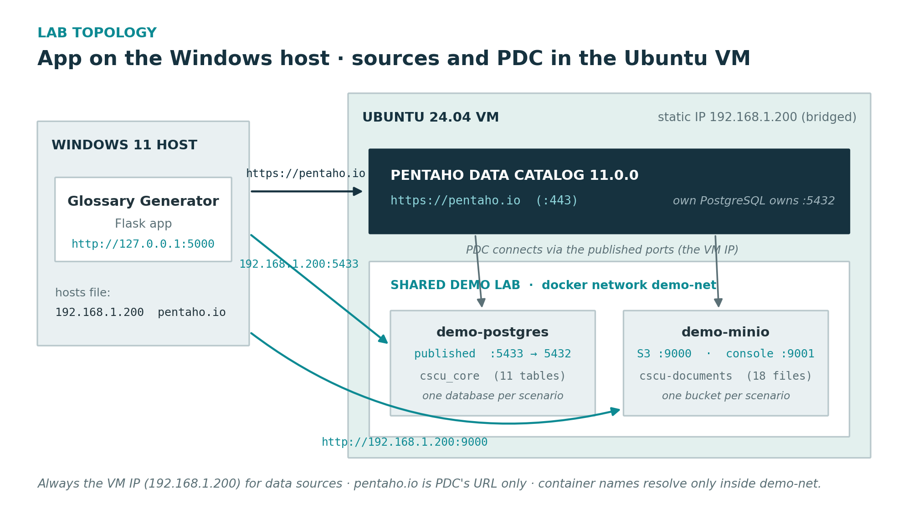

The database source
Field | Value
Data Source Name | CopperState_Core_Banking
Data Source Type | PostgreSQL
Configuration Method | Credentials
Driver Class Name | org.postgresql.Driver
Host | 192.168.1.200
Port | 5433
Database Name | cscu_core
Schemas | cscu_core
User Name | pdc_user
Password | catalog123!

The object-store source
Field | Value
Data Source Name | CopperState_Documents
Data Source Type | S3-compatible / object store (AWS S3)
Endpoint | http://192.168.1.200:9000
Access Key | cscu_minio_user
Secret Key | minio_secret_123!
Bucket | cscu-documents
Path-Style Access | Enabled (required for MinIO)

The other scenarios — the same pattern
RETAIL, HEALTH and MFG connect identically — only the database, bucket and resource names change; the host, port, endpoint and pdc_user stay the same:
Scenario | Database source / database | Object-store source / bucket
RETAIL | CanyonTrail_Retail_Ops / cto_retail | CanyonTrail_Documents / cto-documents
HEALTH | Lakeshore_Clinical / lhp_clinical | Lakeshore_Documents / lhp-documents
MFG | Cascade_Manufacturing / cpc_mfg | Cascade_Documents / cpc-documents

Any additional scenario dropped under data_sources/<ID>/ (with a scenario.json) plugs in the same way with no script changes.

Final checks
- Database: Test Connection succeeds, Metadata Ingest lists the cscu_core schema, and the 11 tables appear in the Data Canvas.
- Object store: Test Connection succeeds and Scan Files loads the bucket's folders into the Data Canvas.
- Alternative: the Glossary Generator's bulk loader registers both sources from the scenario's CSV in one pass (the object store still needs the manual Scan Files click afterwards).

Part H — (Optional) Capture PDC email with MailHog
Pentaho Data Catalog sends email for password-reset links, @-mention notifications in comments, and change, approval and error alerts — all driven by a single SMTP configuration. In a lab with no real mail server, MailHog gives learners somewhere to see those messages: it accepts any SMTP mail with no authentication and no TLS, and shows it in a web inbox. This step is optional — the Business Analyst Happy Path does not require email — but it makes the notification and workflow steps demonstrable.
MailHog attaches to the PDC application's Docker network — the pdc.sh deployment, Compose project pdc, where Keycloak and the notification services run — not to this data-source stack. demo-postgres and demo-minio are a separate Compose project and play no part here.

Run MailHog on the PDC network
On the VM, find the PDC application network (its Compose project is pdc, so the network is usually pdc_default):
docker network ls | grep -i pdc
Start MailHog attached to that network, publishing only the web UI to the host:
docker run -d --name mailhog --network pdc_default --restart unless-stopped -p 8025:8025 mailhog/mailhog
Only the web UI (port 8025) is published to the host; the SMTP port (1025) stays internal, reachable by PDC containers as mailhog:1025. Open the inbox at http://192.168.1.200:8025.

Point PDC at MailHog
PDC reads two environment files: vendor/.env.default holds the full configuration (and ships a real Office 365 SMTP default), while conf/.env holds only per-machine overrides and takes precedence on any shared key. Override the mail server by adding a KEYCLOAK_SMTP line to conf/.env — this leaves the shipped vendor file untouched and survives reinstalls. The single KEYCLOAK_SMTP value drives all PDC email: password resets, @-mention notifications, and approval and error alerts.
Add this line to conf/.env (MailHog needs no user, password or TLS):
KEYCLOAK_SMTP='{"host":"mailhog","port":"1025","auth":"false","ssl":"","starttls":"false","from":"pdc-demo@pdc-demo.local","fromDisplayName":"PDC Demo","replyTo":"","replyToDisplayName":"","envelopeFrom":"","user":"","password":""}'
KEYCLOAK_SMTP is applied when Keycloak provisions its realm, so on a fresh build — or after a reset that wipes the Keycloak volume — it takes effect automatically on start-up:
cd /opt/pentaho/pdc-docker-deployment && ./pdc.sh up

Changing the mail server on a running instance
To change the SMTP settings on an already-provisioned instance without a rebuild, push them through the IAM API instead. First get a token from the master realm, then PUT the pdc tenant:
curl -sk 'https://pentaho.io/keycloak/realms/master/protocol/openid-connect/token' -d client_id=admin-cli -d grant_type=password -d username=admin -d password=<keycloak-admin-pass>
curl -sk -X PUT 'https://pentaho.io/css-admin-api/api/v1/tenants/pdc' -H 'Authorization: Bearer <TOKEN>' -H 'Content-Type: application/json' -d '{"realm":"pdc","smtpServer":{"host":"mailhog","port":"1025","auth":"false","ssl":"","starttls":"false","from":"pdc-demo@pdc-demo.local","fromDisplayName":"PDC Demo"}}'

Verify
Trigger an email — use Forgot password on the login page, or @-mention a user in a comment — and confirm the message lands in the MailHog inbox at http://192.168.1.200:8025. Every message PDC sends is captured there and nothing leaves the VM.

Notes
- MailHog does not do STARTTLS or authentication; the block above sets both off, which is correct. If mail does not arrive, confirm those flags rather than adding credentials.
- MailHog is a standalone container with no volumes, so make destroy and the PDC reset do not affect it. If a rebuild recreates the pdc_default network, reattach with: docker network connect pdc_default mailhog.
- The shipped vendor/.env.default carries a real Office 365 SMTP default; the conf/.env override replaces it without editing the vendor file, so reinstalls and upgrades stay clean.
- MailHog is unmaintained but works. For a maintained drop-in with the same 1025/8025 ports, substitute the axllent/mailpit image.

Part I — (Optional) Offline licensing
By default PDC verifies its license against an external Pentaho (FlexNet) license server on start-up. For an air-gapped or fully self-contained lab, offline licensing activates the licensed features from a license file with no outbound connectivity. It is two steps: enable offline mode in conf/.env, then upload the license file through the Swagger UI.

Enable offline mode
The shipped vendor/.env.default sets LICENSING_OFFLINE_INSTALL=false, so PDC tries to reach the external license server. Override it in conf/.env (where it survives rebuilds, alongside your other per-machine values):
LICENSING_OFFLINE_INSTALL=true
The flag is read at start-up, so apply it with a restart. PDC then skips the external license server and waits for an uploaded license file; licensed features stay unavailable until one is uploaded. LICENSING_SERVER_URL can be left empty — offline mode ignores it.
cd /opt/pentaho/pdc-docker-deployment && ./pdc.sh up

Upload the license file (Swagger)
Obtain the offline license file (license.bin) from Pentaho support, then use the PDC API Swagger UI to upload it:
- Open the Swagger UI at https://pentaho.io/api/public/swagger/.
- Click Authorize (top right). The dialog expects a raw JWT, so mint one from the shell and paste it in (no Bearer prefix), then Authorize and Close:
curl -sk -X POST 'https://pentaho.io/keycloak/realms/pdc/protocol/openid-connect/token' -d client_id=pdc-client -d grant_type=password -d username=admin -d password=<keycloak-admin-pass> | sed -n 's/.*"access_token":"\([^"]*\)".*/\1/p'
- Expand Licensing -> POST uploadLicense, click Try it out, set deviceId to pdc-demo, choose your license.bin in fileData, then Execute.
- A successful response is 200 with "success": true and a featuresCount. PDC stores the license in its internal database and activates the entitlements immediately. Verify the licensed features in the PDC user interface.

Notes
- deviceId can be any valid identifier — pdc-demo is fine, and re-uploading the same license.bin later works regardless of the value.
- The license lives in PDC's internal database, not on disk, so a volume-wipe reset erases it. Re-upload after each rebuild. The conf/.env flag survives the reset, so only the upload repeats.
- The upload endpoint is /api/public/v2/licensing/uploadLicense on this build; earlier builds use v1 and v3 renames it to /api/public/v3/licensing/upload. The Swagger page shows which your instance exposes.

Part G — Rebuild troubleshooting
A full volume-wipe rebuild of the PDC application tier (via pdc.sh / the reset script) can hit a predictable set of issues, because wiping volumes regenerates the TLS certificates and re-runs the container init chain. This section documents the four seen during the 11.0.0 rollout, in the order they surface. The pdc-reset.sh script automates G1 and the app-tier recovery in G2; G2's host mapping and the browser certificate steps in G3 are host-level and done by hand.

G1 — opensearch-cluster-init exits 1 (security index missing)
Symptom: pdc.sh up ends with service "opensearch-cluster-init" didn't complete successfully: exit 1. The opensearch node log repeats: Failure no such index [.opendistro_security].
Cause: On a fresh opensearch volume the node's transport truststore (extra.crt) is regenerated with only the node CA (CN=pdc-demo). The admin certificate (admin.crt, self-signed CN=admin) is not in it, so securityadmin's mutual-TLS handshake is rejected (certificate_unknown) and the .opendistro_security index is never written. The cluster-init readiness probe then times out and exits 1.
Fix: Trust the admin cert on the node, restart it, then run securityadmin against the REST port 9200 (not transport 9300 — that returns "This is not an HTTP port" on this build).
node=$(docker ps --format '{{.Names}}' | grep opensearch | grep -vE 'init|volume' | head -1)
docker exec -u 0 "$node" sh -c '
if [ $(grep -c "BEGIN CERT" /opt/bitnami/opensearch/config/extra.crt) -lt 2 ]; then
cat /opt/bitnami/opensearch/config/admin.crt >> /opt/bitnami/opensearch/config/extra.crt
fi'
docker restart "$node"; sleep 40
docker exec "$node" bash -c '
cd /opt/bitnami/opensearch/plugins/opensearch-security/tools && \
./securityadmin.sh -cd /opt/bitnami/opensearch/config/opensearch-security/ \
-icl -nhnv -cacert /opt/bitnami/opensearch/config/extra.crt \
-cert /opt/bitnami/opensearch/config/admin.crt -key /opt/bitnami/opensearch/config/admin.key \
-h localhost -p 9200'
Verify: An unauthenticated request flips from "OpenSearch Security not initialized" to a 401 — that is success.
docker exec "$node" curl -s http://localhost:9200/_cluster/health

G2 — Whole app tier stuck in Created / site-wide 404
Symptom: pentaho.io returns 404 for every path, including /api/public/swagger/. ./pdc.sh ps shows fe, public-api, glossary, mds, applications and others stuck in Created, and um-css-admin-api-init exits 1 with its log looping http_code=000 against https://pentaho.io/keycloak/realms/master.
Cause: Two possible causes, check both.
- If opensearch-cluster-init failed (G1), the dependent init chain fails and the whole tier stays in Created. Fix G1 first, then re-run ./pdc.sh up.
- More subtly: /etc/hosts maps pentaho.io to 127.0.0.1 (loopback). Inside a container 127.0.0.1 is the container itself, so any service that reaches another via the pentaho.io URL — Keycloak, Mongo/FerretDB, OpenSearch, Kafka, all built from GLOBAL_SERVER_HOST_NAME=pentaho.io — hits its own loopback and gets http_code=000. This strands the entire stack. (This mapping was introduced during the version upgrade.)
Fix: Point pentaho.io at the VM's LAN IP, then recreate the containers so they pick up the corrected mapping.
sudo sed -i 's/^127\.0\.0\.1\s\+pentaho\.io/192.168.1.200 pentaho.io/' /etc/hosts
grep pentaho.io /etc/hosts # should now read: 192.168.1.200 pentaho.io
cd /opt/pentaho/pdc-docker-deployment && ./pdc.sh stop && ./pdc.sh up
Verify: From inside a container the name resolves to the LAN IP, the init returns 200, and fe/public-api reach Up:
docker exec "$node" getent hosts pentaho.io # expect 192.168.1.200, not 127.0.0.1
Note: after fixing OpenSearch in G1 you must re-run ./pdc.sh up to start the services stranded in Created — fixing OpenSearch alone does not restart them. The reset script does this automatically and waits for fe and public-api before finishing.

G3 — Browser: "Your connection is not private" (ERR_CERT_AUTHORITY_INVALID)
Symptom: Chrome blocks pentaho.io with NET::ERR_CERT_AUTHORITY_INVALID and, because pentaho.io is under HSTS, offers no "Proceed anyway" link.
Cause: PDC's TLS certificate is self-signed and is regenerated on every rebuild, so the browser does not trust the issuing CA.
Fix (fast): Click anywhere on the error page and type thisisunsafe (there is no input box — type it blind with the page focused). Chrome accepts it as the HSTS override and loads the site. This is per-certificate, so repeat it after a rebuild regenerates the cert.
Fix (persistent): Import the current server certificate into the OS trust store; recent Chrome reads it via "use imported local certificates from your operating system" (there is no longer an Authorities -> Import tab).
openssl s_client -connect pentaho.io:443 -servername pentaho.io </dev/null 2>/dev/null \
| openssl x509 -outform PEM > /tmp/pentaho.crt
sudo cp /tmp/pentaho.crt /usr/local/share/ca-certificates/pentaho.crt && sudo update-ca-certificates
Gotcha — stale certificates: Because the cert regenerates each rebuild, old trusted certs accumulate in two separate stores: the OS store (/usr/local/share/ca-certificates) and Chrome's NSS database (~/.pki/nssdb). update-ca-certificates only manages the OS store, so a stale entry (for example a CN=awc-pdc leftover) can survive there. Find and remove them by subject/nickname:
for f in /usr/local/share/ca-certificates/*.crt; do echo "$f -> $(openssl x509 -in \"$f\" -noout -subject)"; done
certutil -d sql:$HOME/.pki/nssdb -L # list Chrome NSS entries
certutil -d sql:$HOME/.pki/nssdb -D -n "<nickname>" # delete a stale one
In a rebuild-heavy lab the thisisunsafe bypass is the lower-effort default, since any imported certificate goes stale the next time the stack is wiped.

G4 — Licensed features unavailable after a rebuild
Symptom: After a volume wipe, licensed features are greyed out even though offline mode is configured.
Cause: The offline license is stored in PDC's internal database, which is wiped with the volumes. The LICENSING_OFFLINE_INSTALL=true flag survives (it lives in conf/.env), but the uploaded license does not.
Fix: Re-upload the license file after each rebuild — the full procedure is in Part I. In short: authenticate to get a bearer token, then POST the .bin to /api/public/v2/licensing/uploadLicense with deviceId=pdc-demo. The reset script can do this automatically when LICENSE_BIN and the admin password are supplied.
All scenario data is fictional and generated for training. Lab credentials are training values; change them for anything beyond the lab.

