Remote Lab Access

Lab-Environment

Introduction

Welcome to the Hitachi Vantara Global Learning for Europe, Middle East and Africa. Our Courses combine the most appropriate education delivery methods with specialist instructors and emphasis on practical exercises.

Citrix Remote Access

For our customers and trainers, we provide access to our Lab-Environment using the Microsoft RDP Client as published application in Citrix.

In order to gain access to the Lab-Environment, the "Citrix

Online Plug-in" must be installed on your workstation.

As with most installations, administrative privileges on the computer are necessary to install the client software.

Managed workstations may require desktop support

personnel to install the client software or to prepare a firewall.

Technical Support

If you have problems with our service, please contact us: For problems with Citrix:

Europe: +44-1753-618500

International: +1-408-327-4000

US: 866-437-9467

Location

European Education Centre & Hitachi Vantara

Hitachi Vantara GmbH Im Steingrund 10

63303 Dreieich Buchschlag

Germany

Gunnar Opp [gunnar.opp@HitachiVantara.com](mailto:gunnar.opp@HitachiVantara.com)

Patrick Schlicher [patrick.schlicher@HitachiVantara.com](mailto:patrick.schlicher@HitachiVantara.com)



URL: [https://citrix.hds.com](https://citrix.hds.com/)

Citrix User Accounts

username password

|  |  |  |
| --- | --- | --- |
| eecstudent17 eecstudent18 eecstudent19 eecstudent20 eecstudent21 eecstudent22 eecstudent23 eecstudent24 eecstudent25 eecstudent26 eecstudent27 eecstudent28 eecstudent29 | $PMf=eqWVScE17 |  |
| fwZqUm=$rSYW18 |  |
| EA!$vjYCPAjJ19 |  |
| ApEjf+$aFXex20 |  |
| bN[c.XbA@ibcH21](mailto:XbA@ibcH21) |  |
| imtMMHt[=Fh@T](mailto:Fh@T22)22 |  |
| FWTg=wub;fbo23 |  |
| [ca!Urww@nsBR24](mailto:ca!Urww@nsBR24) |  |
| Ym+$aEShTvLg25 |  |
| =Y$qBPgXvhvA26 |  |
| BCF!bK$FREiT27 |  |
| vLp-$KWnujST28 |  |
| hjXE.+XTcwbT29 |  |
|  |  |

[**Hitachi Vantara**](https://www.hitachivantara.com/)

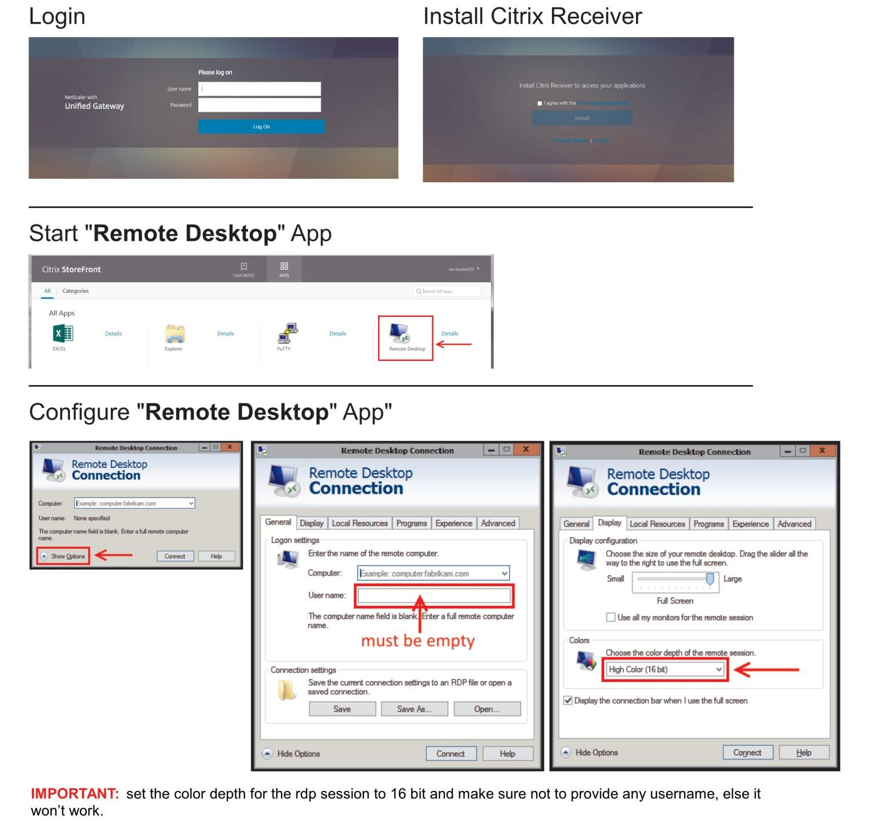

[**Hitachi Vantara**](https://www.hitachivantara.com/)

Lab 1

ip description user password

|  |  |  |  |  |
| --- | --- | --- | --- | --- |
| 10.70.37.110  10.70.37.111  10.70.37.112  10.70.37.113 | Ubuntu Server (SSH) | pentaho | passw0rd |  |
| Windows Server (RDP) 1 | pentaho | passw0rd |  |
| Windows Server (RDP) 2 | pentaho | passw0rd |  |
| Windows Server (RDP) 3 | pentaho | passw0rd |  |

Lab 2

Ip description user password

|  |  |  |  |  |
| --- | --- | --- | --- | --- |
| 10.70.37.114  10.70.37.115  10.70.37.116  10.70.37.117 | Ubuntu Server (SSH) | pentaho | passw0rd |  |
| Windows Server (RDP) 1 | pentaho | passw0rd |  |
| Windows Server (RDP) 2 | pentaho | passw0rd |  |
| Windows Server (RDP) 3 | pentaho | passw0rd |  |

Lab 3

Ip description user password

|  |  |  |  |  |
| --- | --- | --- | --- | --- |
| 10.70.37.118  10.70.37.119  10.70.37.120  10.70.37.121 | Ubuntu Server (SSH) | pentaho | passw0rd |  |
| Windows Server (RDP) 1 | pentaho | passw0rd |  |
| Windows Server (RDP) 2 | pentaho | passw0rd |  |
| Windows Server (RDP) 3 | pentaho | passw0rd |  |

Lab 4

Ip description user password

|  |  |  |  |  |
| --- | --- | --- | --- | --- |
| 10.70.37.122  10.70.37.123  10.70.37.124  10.70.37.125 | Ubuntu Server (SSH) | pentaho | passw0rd |  |
| Windows Server (RDP) 1 | pentaho | passw0rd |  |
| Windows Server (RDP) 2 | pentaho | passw0rd |  |
| Windows Server (RDP) 3 | pentaho | passw0rd |  |

Instructions for RDP

Enter your assigned Windows Server IP into the box with the label “Computer” (i.e. 10.70.37.111)

Click the button "Connect"

Use Username and Password from the table

[**Hitachi Vantara**](https://www.hitachivantara.com/)