KIM KIDS • LESSON 1
The World God Made

Draw your favorite thing God made in the box.

Say it with me:
It was very good. — Genesis 1:31
My name: ______________________________

KIM KIDS • LESSON 2
Noah Trusts God

Color the rainbow. It reminds us God keeps His promises.

Say it with me:
Noah obeyed God. — Genesis 6:22
My name: ______________________________

KIM KIDS • LESSON 3
God's Promise to Abraham

Color the stars. God promised Abraham a family this big!

Say it with me:
Abraham believed God. — Genesis 15:6
My name: ______________________________

KIM KIDS • LESSON 4
Joseph Forgives

Color Joseph's special colorful coat.

Say it with me:
God meant it for good. — Genesis 50:20
My name: ______________________________

KIM KIDS • LESSON 5
Baby Moses

Color the basket that kept baby Moses safe on the river.
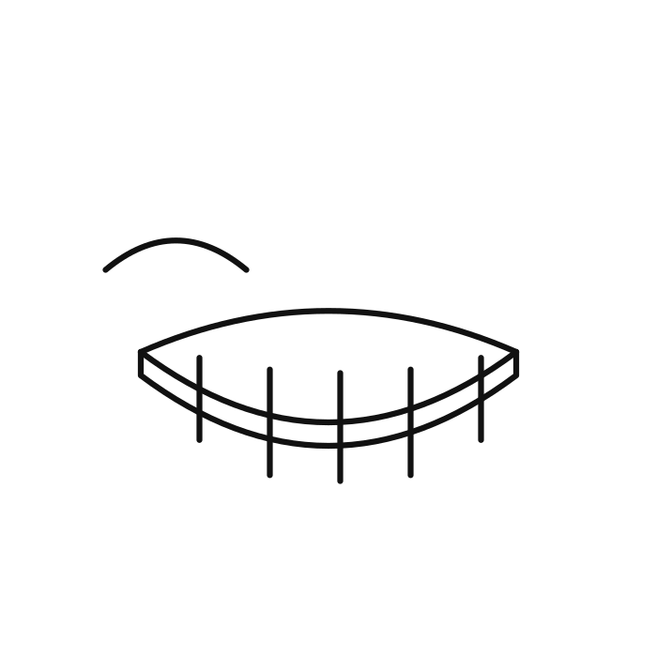
Say it with me:
God is my strength. — Exodus 15:2
My name: ______________________________

KIM KIDS • LESSON 6
God Rescues His People

Color the path God made through the sea.

Say it with me:
The Lord will fight for you. — Exodus 14:14
My name: ______________________________

KIM KIDS • LESSON 7
David and Goliath

Color David's five smooth stones.

Say it with me:
The battle is the Lord's. — 1 Samuel 17:47
My name: ______________________________

KIM KIDS • LESSON 8
Daniel and the Lions

Color the lion. God kept Daniel safe!

Say it with me:
God shut the lions' mouths. — Daniel 6:22
My name: ______________________________

KIM KIDS • LESSON 9
Jesus Is Born

Color the star that led the wise men to Jesus.

Say it with me:
A Savior has been born. — Luke 2:11
My name: ______________________________

KIM KIDS • LESSON 10
Jesus Calms the Storm

Color the boat Jesus calmed on the water.

Say it with me:
Even the waves obey Him. — Mark 4:41
My name: ______________________________

KIM KIDS • LESSON 11
The Lost Sheep

Color the little lost sheep the shepherd found.

Say it with me:
I found my lost sheep! — Luke 15:6
My name: ______________________________

KIM KIDS • LESSON 12
Jesus Is Alive!

Color the empty tomb. Jesus is alive!
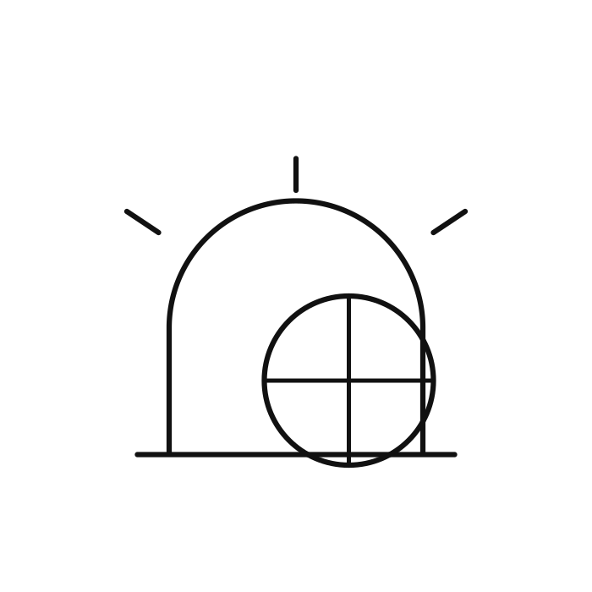
Say it with me:
He has risen! — Matthew 28:6
My name: ______________________________

