**Introduction**

The Seattle housing market has been extremely competitive for some time now, largely driven by high paying jobs from tech giants like Microsoft and Amazon. The prospect of buying a home in this environment can be quite daunting. Many people who move to Seattle initially live close to downtown in neighborhoods like Capitol Hill or Belltown and it is here that we grow to love our city. For many of us though, when it comes time to contemplate home ownership, we quickly realize that home ownership in those same trendy neighborhoods is out of reach for most. The central problem of this capstone project is to find Seattle neighborhoods with lower average home costs that are the most similar to desired and expensive neighborhoods like Capitol Hill or Belltown.

**Data**

The data used for this project will come from several different sources. Housing price data will come from Zillow (<https://www.zillow.com/research/data/>). Two different datasets will be pulled from Zillow, one that includes all home types and one which only includes single family homes. Seattle neighborhood latitude and longitude data will come from the city of Seattle’s open data program. The specific dataset used will be the Seattle Cultural Space Inventory (<https://data.seattle.gov/Community/Seattle-Cultural-Space-Inventory/vsxr-aydq>) as it conveniently contains both neighborhood and location data. However, this data will also require considerable cleaning as it contains multiple entries per neighborhood and additional unnecessary data. There will also be multiple latitude and longitude entries so a strategy for picking these will also be required. This location data will be used in combination with the Foursquare API to pull relevant location data (venues, etc.…) for each of the neighborhoods.

Example of Zillow data:

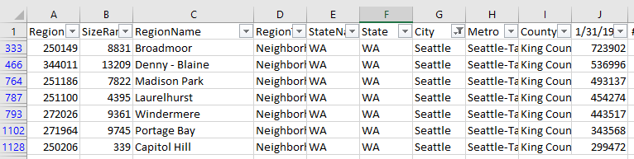

Example of Seattle Cultural Space Inventory data:

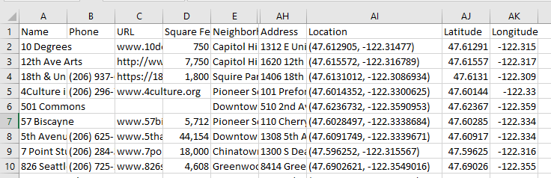

Example of cleaned Foursquare API data from a previous project:

