- Methods
  - Participants
Resting-state functional magnetic resonance imaging (rs-fMRI) data from four sites of the public ADHD-200 repository were used: NYU, Peking, NeuroIMAGE, and OHSU. This retrospective, cross-sectional comparative study used the participant as the unit of analysis. Only participants with a passing first-rater resting-state quality-control indicator (QC_Rest_1 = 1) were retained. Table 1 summarizes the final sample and site-specific acquisition characteristics. Sites differed in sample size, class balance, repetition time (TR), and series length; such acquisition and sampling differences can introduce site-related variability in multi-site functional connectivity estimates (Bellec et al., 2017; Yu et al., 2018). Analyses were therefore conducted separately by site to preserve site-specific performance estimates and avoid an aggregate dominated by site composition.
Site | Participants | Control | ADHD | TR | Volumes | Window | Step | Windows
NYU | 177 | 87 | 90 | 2.00 s | 172 | 120 s | 12 s | 19
Peking | 183 | 109 | 74 | 2.00 s | 232 | 120 s | 12 s | 29
NeuroIMAGE | 39 | 22 | 17 | 1.96 s | 257 | 120 s | ≈11.8 s | 33
OHSU | 66 | 38 | 28 | 2.50 s | 74 | 120 s | 12.5 s | 6
Table 1. Final sample composition, acquisition parameters, and effective windowing by site. TR = repetition time. Volumes correspond to the time series after removal of the first four volumes. Window length and step are reported in seconds; the number of windows depends on TR and series length.

  - Preprocessing
Preprocessing was carried out with the ATHENA pipeline (Bellec et al., 2017), applied identically at the four sites. T1-weighted anatomical images were reoriented to the right-posterior-inferior (RPI) orientation and skull-stripped. They were then segmented into gray matter, white matter, and cerebrospinal fluid and registered to the Montreal Neurological Institute standard space (MNI152) at 1 × 1 × 1 mm resolution using successive linear and non-linear transformations.
The first four functional volumes were removed to compensate for scanner instability, and motion and slice-timing corrections were applied. After functional-to-anatomical registration, the functional images were normalized to MNI152 space at 4 × 4 × 4 mm resolution. White matter, cerebrospinal fluid, and global signals, together with the six motion parameters, were regressed out. Band-pass filtering at 0.009–0.08 Hz retained fluctuations within that frequency range while attenuating slower drifts and higher-frequency noise, and was followed by spatial smoothing with a 6-mm full width at half maximum (FWHM) kernel.

  - BOLD Signal Extraction and Functional Connectivity Construction
The blood-oxygen-level-dependent (BOLD) signal was extracted from the filtered and smoothed functional derivative using the AAL116 atlas by averaging voxel time series within each region. For each analysis, the 116 regional time series were restricted to the prespecified panel under evaluation (12, 18, 39, or 116 ROIs) before connectivity estimation. Dynamic functional connectivity was estimated using sliding windows. Within each window, Pearson correlations were computed for all pairs of regions; each participant was represented by an ordered series of symmetric connectivity matrices. Correlations were not Fisher z-transformed.
The reference rectangular window was nominally 120 s long, slightly exceeding the approximately 111-s period corresponding to the 0.009-Hz lower passband cutoff; this choice was motivated by evidence that windows shorter than the longest retained wavelength can induce spurious correlation fluctuations (Leonardi and Van De Ville, 2015). Across sites, each window contained approximately 48–61 time points, and the nominal 12-s step produced approximately 90% overlap. Table 1 reports the site-specific effective values and number of windows.

  - Functional Networks Involved in ADHD
The reduced panels include regions assigned to five functional systems implicated in ADHD: the default mode network (DMN), executive control network (ECN), salience network (SN), dorsal attention network (DAN), and frontostriatal-thalamic circuit (FST) (Damiani et al., 2021; Francx et al., 2015; Hale et al., 2014; Singh et al., 2024). These systems support self-referential, executive, salience, attentional, and motor processes relevant to ADHD (Blomberg et al., 2022; Koirala et al., 2024; Parlatini et al., 2023; Reimann et al., 2024; Sutcubasi et al., 2020). Network assignments were used to organize the fixed ROI panels and were not interpreted as region-level diagnostic biomarkers.

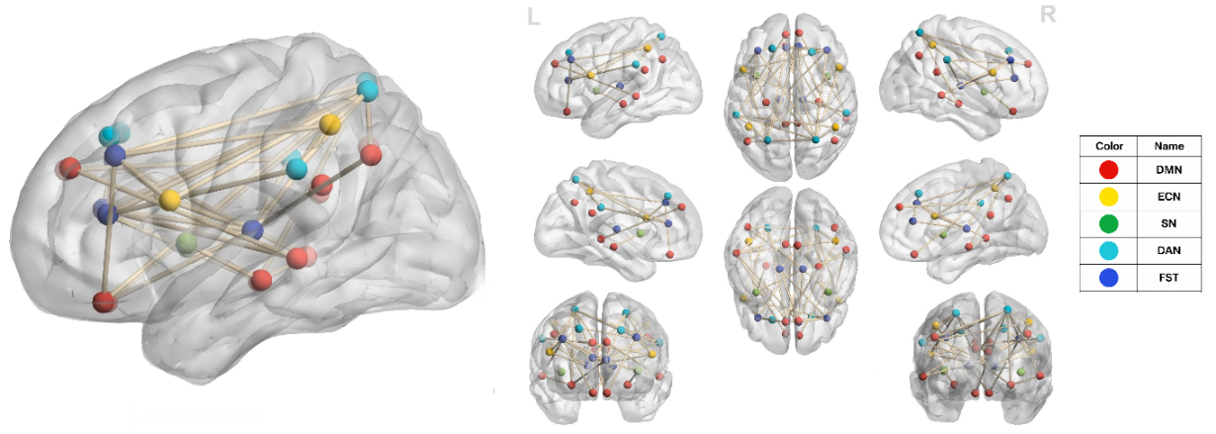
Figure 1. Functional networks used to organize the reduced ROI panels: DMN, ECN, SN, DAN, and FST.

Starting from the AAL116 atlas (Tzourio-Mazoyer et al., 2002), four fixed panels (116, 39, 18, and 12 ROIs) derived by progressive ablation during earlier NYU development were evaluated. Panel definitions were fixed before the multi-site evaluation, and no ROI selection was repeated within cross-validation folds. The 12-ROI panel is nested within the 18-ROI panel; the 39-ROI panel shares six regions with the 12-ROI panel and eight with the 18-ROI panel and is not a superset of either. Table 2 lists the 12-ROI panel.
ROI (AAL116) | Anatomical region | Main function | Network
Frontal_Sup_L | Left superior prefrontal cortex | Sustained attention and executive control | ECN-DMN
Insula_R | Right insula | Emotional integration, interoception, and attention | SN
Cingulum_Ant_L | Left anterior cingulate | Cognitive control and emotional regulation | SN
Cingulum_Ant_R | Right anterior cingulate | Cognitive control and error monitoring | SN
Precuneus_L | Left precuneus | Relaxation and autobiographical memory | DAN-DMN
Precuneus_R | Right precuneus | Introspection and self-reference | DAN-DMN
Caudate_L | Left caudate nucleus | Motor control, reward, and learning | FST
Caudate_R | Right caudate nucleus | Motor control, reward, and motivation | FST
Putamen_L | Left putamen | Motor function and movement planning | FST
Putamen_R | Right putamen | Motor function and habit processing | FST
Thalamus_L | Left thalamus | Sensory integration and motor coordination | FST
Thalamus_R | Right thalamus | Sensory integration and attention | FST
Table 2. Composition of the 12-ROI panel, including anatomical region, main function, and associated functional network.

  - BrainNetCNN

  - Experimental and Evaluation Setup
Experimental Design
The ROI panels and reference BrainNetCNN configuration were selected during NYU development and then fixed for the multi-site evaluation. Accordingly, NYU is a re-evaluation of the development site rather than an independent validation; Peking, NeuroIMAGE, and OHSU were not used for panel or hyperparameter development.
Table 3 reports the reference BrainNetCNN configuration used across ROI panels and across the representation and windowing sensitivity conditions. Because window counts and model dimensions varied across sites and panels, ROI comparisons represent complete pipelines rather than anatomical coverage alone.
Parameter | Value | Parameter | Value
Edge-to-edge filters | 4 | Learning rate | 1 × 10⁻⁴
Edge-to-node filters | 8 | Batch size | 32
Node-to-graph filters | 8 | Maximum epochs | 300
Final dropout | 0.7 | Patience | 25
Intermediate dropout | 0.6 | Early-stopping monitor | val_loss
LeakyReLU negative slope | 0.33 | min_delta | 1 × 10⁻⁵
L2 regularization | 0.05 | Inner validation fraction | 0.15
Optimizer | Adam | Seed | 42
Loss function | Binary cross-entropy | Numerical precision | FP32
Table 3. Reference BrainNetCNN training configuration used unchanged across sites, ROI panels, and representation and windowing sensitivity conditions.

The LSTM used 128 hidden units, no dropout, and one unidirectional layer, and was trained with the same learning rate, batch size, epoch ceiling, patience, and seed as the reference BrainNetCNN. A gated recurrent unit (GRU) with the same training configuration was evaluated as a second recurrent architecture; its unit count (151) was chosen so that its parameter count (99,359) matched the LSTM's (99,969) to within 1%, avoiding a capacity confound between the two recurrent architectures. A DeepSets model — an order-invariant pooling architecture that reduces to a multilayer perceptron over the connectivity vector when a single window is supplied — was evaluated under both static and windowed connectivity, using the same training configuration. The logistic-regression baseline used L2 regularization with C fixed at 1.0. Features were standardized using a scaler fitted only to the training data in each fold; the epoch- and gradient-based parameters in Table 3 did not apply.
The analysis comprised three components. First, out-of-fold performance was summarized separately for the four fixed ROI panels at each site. Second, the primary paired contrast compared the 116-ROI atlas with the 12-ROI panel; the 18-versus-12 and 39-versus-12 ROI contrasts were secondary. Third, sensitivity analyses evaluated connectivity representation, model architecture, window configuration, and learning algorithm. ROI-panel, representation, and logistic-regression conditions were evaluated at all four sites. Architecture and windowing analyses were restricted to NYU and Peking, the two largest sites and those with the narrowest primary-comparison intervals, to focus the exploratory comparisons where precision was greatest. The representation and architecture comparisons were each triangulated across an additional architecture — DeepSets for representation, evaluated at all four sites, and GRU for architecture, evaluated at NYU and Peking — and the learning-algorithm comparison was extended with DeepSets as a second, non-recurrent algorithm at all four sites.
Representation sensitivity compared static with windowed connectivity, both as a complete BrainNetCNN configuration change and, to isolate the representation effect within a fixed architecture, as a within-architecture static-versus-windowed contrast for DeepSets and for LSTM. Architecture sensitivity compared an LSTM with 128 hidden units, and a GRU with 151 hidden units, against BrainNetCNN. Windowing sensitivity compared a 140-s window with a 12-s step, a 120-s window with a 24-s step, and a 60-s window with a 12-s step, against the 120-s window, 12-s step reference; the 60-s window was also evaluated for GRU, relative to that architecture's own 120-s, 12-s configuration. Learning-algorithm sensitivity compared L2-regularized logistic regression, and a DeepSets model at matched static representation, with BrainNetCNN.
Some comparisons changed more than one component. For the 12-ROI panel, logistic regression was compared with static BrainNetCNN, so the representation was matched. For the 18-, 39-, and 116-ROI panels, the comparator was the corresponding windowed BrainNetCNN run; both representation and algorithm therefore changed, so these contrasts did not isolate the algorithm. The within-architecture representation contrasts for DeepSets and LSTM instead held architecture and all training hyperparameters fixed, isolating the representation effect more directly than the complete-configuration BrainNetCNN contrast reported above; the same logic applied to the GRU windowing contrast, which held architecture fixed relative to that architecture's own 120-s reference. The DeepSets-versus-BrainNetCNN algorithm comparison held representation fixed at the static 12-ROI panel, analogous to the logistic-regression comparison at that panel.
Evaluation Setup
The same evaluation and data-partitioning protocol was applied across all runs. Performance was estimated using 10-fold stratified cross-validation repeated five times. A 15% subset of each outer-training set was reserved for early stopping. All windows from each participant remained in the same partition, preventing participant-level leakage. Within each site, all panels and sensitivity conditions used identical participant partitions, enabling paired participant-level comparisons. Class weighting differed across sites: Peking used weights inversely proportional to class frequency, computed only from the fitting data in each fold, whereas no class weighting was applied at NYU, NeuroIMAGE, or OHSU. This site-specific choice was held constant across conditions within each site.
  - Statistical Analysis
The primary metric is the AUC of the out-of-fold predictions, aggregated by repetition: within each of the five repetitions, the predictions of the ten outer folds are pooled, the AUC is computed over all participants at the site, and the five results are averaged. Aggregation by repetition was used to avoid the discreteness and high variability of fold-level AUC estimates in the small outer test folds, which contained between three and nineteen participants. The secondary metrics are balanced accuracy, macro F1, sensitivity, and specificity; simple accuracy is retained only as an audit metric. Secondary threshold-dependent metrics were computed at a fixed probability threshold of 0.5.
AUC was chosen as the primary metric because it evaluates ranking performance across decision thresholds and is less directly affected by class prevalence than accuracy.
Uncertainty was quantified by bootstrap resampling of participants with replacement, stratified by class to preserve the proportion of cases and controls at each site. Within each comparison, the same resampled participants were used for both conditions and across all five repetitions, yielding a paired difference. Interval limits were the 2.5th and 97.5th percentiles of the distribution obtained from 10,000 class-stratified participant-level resamples, generated using the NumPy PCG64 generator with seed 42 and reset for each comparison.
Bootstrap intervals quantify participant-sampling variability conditional on the stored repeated-cross-validation predictions; they do not include model retraining or new data partitions. The estimand is therefore the repeated-cross-validation procedure rather than a single fitted model. Sensitivity intervals are pointwise and unadjusted for multiplicity. The analysis was estimation-based: no non-inferiority margin was specified, and two-sided differences with their uncertainty were reported. Because folds and repetitions share participants and training data, they were not treated as independent replicates for analysis of variance or post hoc testing.
  - Ethical Considerations
This study used anonymized data from the public ADHD-200 repository (ADHD-200 Consortium, 2011), access to which is subject to registration and the ADHD-200/INDI terms of use. The data were originally collected under protocols approved by the ethics committees of the participating institutions; informed consent was obtained from participants or their legal guardians at each of the four sites. This secondary analysis of retrospective, de-identified data required no new interaction with participants or additional consent procedures, and no attempt was made to re-identify participants.

- Results
  - Performance of the Ablation-Derived ROI Panels
Table 4 reports out-of-fold AUC and four secondary metrics for the sixteen site-by-panel combinations evaluated with the fixed, ablation-derived panels.
Site | ROIs | n | AUC [95% CI] | Balanced accuracy | Macro F1 | Sensitivity | Specificity
NYU | 12 | 177 | 59.0 [53.8, 64.3] | 57.4 ± 2.8 | 57.3 ± 2.8 | 54.7 ± 5.6 | 60.2 ± 5.6
 | 18 | 177 | 60.0 [54.7, 65.3] | 56.7 ± 3.5 | 56.6 ± 3.5 | 58.0 ± 2.7 | 55.4 ± 8.8
 | 39 | 177 | 52.8 [47.4, 58.2] | 52.3 ± 2.1 | 52.1 ± 2.2 | 48.4 ± 5.3 | 56.1 ± 5.9
 | 116 | 177 | 53.9 [48.8, 59.0] | 53.1 ± 1.9 | 53.0 ± 1.8 | 54.0 ± 4.9 | 52.2 ± 3.3
Peking | 12 | 183 | 56.4 [50.7, 62.1] | 54.1 ± 5.2 | 53.9 ± 5.2 | 46.8 ± 9.1 | 61.5 ± 6.3
 | 18 | 183 | 56.8 [50.6, 62.8] | 54.0 ± 2.6 | 53.9 ± 2.5 | 46.5 ± 5.5 | 61.5 ± 4.0
 | 39 | 183 | 62.2 [56.5, 67.7] | 60.3 ± 2.9 | 60.1 ± 3.2 | 55.7 ± 3.2 | 65.0 ± 7.8
 | 116 | 183 | 60.3 [54.4, 66.1] | 58.1 ± 3.5 | 57.9 ± 3.8 | 53.2 ± 4.4 | 62.9 ± 8.1
NeuroIMAGE | 12 | 39 | 47.4 [37.3, 57.3] | 44.3 ± 4.3 | 43.4 ± 4.2 | 34.1 ± 15.2 | 54.5 ± 13.3
 | 18 | 39 | 62.0 [51.6, 72.0] | 57.6 ± 4.5 | 57.2 ± 4.1 | 55.3 ± 12.2 | 60.0 ± 9.9
 | 39 | 39 | 50.7 [41.8, 60.0] | 53.7 ± 5.9 | 53.5 ± 5.8 | 44.7 ± 6.7 | 62.7 ± 11.8
 | 116 | 39 | 51.9 [41.5, 62.6] | 50.3 ± 6.8 | 50.0 ± 6.9 | 38.8 ± 7.9 | 61.8 ± 10.9
OHSU | 12 | 66 | 54.9 [47.1, 62.4] | 53.6 ± 4.8 | 53.3 ± 4.6 | 47.1 ± 12.2 | 60.0 ± 5.1
 | 18 | 66 | 52.2 [44.4, 60.1] | 51.1 ± 3.7 | 50.5 ± 3.5 | 42.1 ± 12.7 | 60.0 ± 10.4
 | 39 | 66 | 50.1 [40.5, 59.7] | 47.0 ± 4.8 | 46.7 ± 4.5 | 42.9 ± 10.1 | 51.1 ± 7.3
 | 116 | 66 | 55.8 [47.8, 63.8] | 54.2 ± 4.7 | 53.7 ± 5.2 | 53.6 ± 7.1 | 54.7 ± 10.4
Table 4. Out-of-fold performance by site and ROI panel, expressed as percentages. AUC is reported with its two-sided 95% confidence interval, based on 10,000 class-stratified participant-level bootstrap resamples; secondary metrics are reported as mean ± standard deviation across the five repetitions.
Out-of-fold discrimination was limited across the four sites and ROI panels, with AUC estimates ranging from 47.4% to 62.2%. The highest point estimate was observed for the 18-ROI panel in NYU and NeuroIMAGE, the 39-ROI panel in Peking, and the 116-ROI panel in OHSU. The 12-ROI panel did not have the highest point estimate at any site, although its estimate was close in NYU (59.0 compared with 60.0) and Peking (56.4 compared with 56.8). These values are descriptive point estimates and do not establish superiority.
In nine of the sixteen combinations, the 95% confidence interval included an AUC of 0.5: the four OHSU combinations, three NeuroIMAGE combinations, and the 39- and 116-ROI combinations in NYU. Thus, the available precision did not distinguish these estimates from chance-level discrimination. Peking is the only site whose four intervals exclude 0.5. Figure 2 plots the sixteen AUC estimates with their intervals.

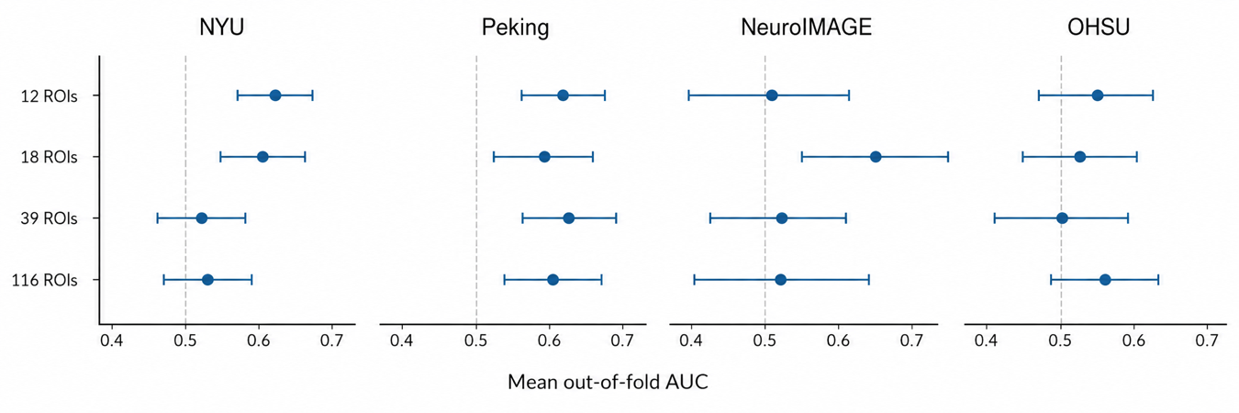
Figure 2. Mean out-of-fold AUC by ROI count and site. Rows correspond to the 12-, 18-, 39-, and 116-ROI panels. Points show the mean of the five repeat-level out-of-fold AUC values, and horizontal bars show two-sided 95% participant-bootstrap confidence intervals. The vertical dashed line indicates chance-level discrimination (AUC = 0.50).
  - Paired ROI-Panel Comparisons
The primary comparison contrasted the full 116-ROI atlas with the 12-ROI panel. The estimated AUC difference (116-ROI panel − 12-ROI panel) was −5.1 percentage points in NYU, +4.0 in Peking, +4.5 in NeuroIMAGE, and +0.9 in OHSU. All four confidence intervals included zero: [−11.1, +0.7] in NYU, [−2.5, +10.5] in Peking, [−10.3, +20.0] in NeuroIMAGE, and [−8.3, +9.9] in OHSU. Point estimates varied in magnitude and sign across sites, and the intervals did not support a consistent direction.
Because NYU was the development site for the panel and training configuration, its favorable 12-ROI estimate represents an internal re-evaluation rather than independent validation.
Comparisons with the two intermediate panels showed a similarly mixed pattern. In NYU, the 39-ROI panel had an AUC 6.2 percentage points lower than the 12-ROI panel, with an interval that excluded zero, whereas the 18-ROI panel yielded a similar estimate. In NeuroIMAGE, the 18-ROI panel had an AUC 14.6 percentage points higher than the 12-ROI panel, also with an interval that excluded zero.
  - Sensitivity Analyses
Figure 3 summarizes the ROI-panel, representation, architecture, and windowing contrasts relative to the 12-ROI windowed BrainNetCNN reference, together with the within-architecture representation contrasts for DeepSets and LSTM and the additional GRU architecture and windowing conditions. Table 5 additionally reports the logistic-regression and DeepSets algorithm contrasts. Sensitivity intervals are pointwise and unadjusted for multiplicity.
Replacing the windowed series with a single static connectivity matrix reduced AUC by 4.1 percentage points in NYU, 3.5 in Peking, and 3.4 in OHSU, and increased it by 5.4 percentage points in NeuroIMAGE. All four intervals included zero, with the NYU upper limit close to zero. Because representation and model capacity both changed, this contrast does not isolate the effect of static versus windowed connectivity. Holding architecture fixed instead, the within-architecture contrasts were similarly inconclusive: for DeepSets, static representation was 1.1 percentage points higher than windowed in NYU and 0.6 higher in Peking, both intervals including zero [−1.6, +3.9] and [−1.9, +2.9]; for LSTM, static representation was 1.9 percentage points higher in NYU and 0.5 lower in Peking, again with intervals including zero [−1.0, +4.9] and [−3.6, +2.7]. Across all three architectures tested, no comparison showed a consistent advantage of windowed over static connectivity.
The recurrent-network comparison differed between the two sites tested. For NYU, the AUC of LSTM (128 hidden units) was 6.5 percentage points lower than that of BrainNetCNN, with an interval that excluded zero [−10.9, −2.0]. For Peking, the AUC of LSTM (128 hidden units) was 0.1 percentage point lower than that of BrainNetCNN, with a wide interval that included zero [−4.7, +4.4]. Because capacity and regularization also differed, this was a configuration-level rather than architecture-isolated contrast. A second recurrent architecture, GRU with 151 units — chosen to match the LSTM's parameter count — showed a larger deficit in NYU (7.1 percentage points lower than BrainNetCNN, [−11.9, −2.3]) and a comparable deficit in Peking (1.8 percentage points lower, [−6.3, +2.8]) to the LSTM. The two recurrent architectures therefore did not differ materially from each other, and neither outperformed BrainNetCNN at either site.
The windowing contrasts were larger in NYU than in Peking. For NYU, the AUC of the 140-s window, 12-s step condition was 3.3 percentage points lower than that of the 120-s window, 12-s step reference, with an upper confidence limit close to zero [−6.5, +0.1]. The AUC of the 120-s window, 24-s step condition was 4.7 percentage points lower, with an interval that excluded zero [−8.6, −0.8]. For Peking, both differences were less than 1 percentage point in magnitude, with intervals that included zero. Each contrast changed one configured windowing parameter while holding the other fixed. However, window length or step also altered overlap, window count, and potentially effective model capacity; these were therefore complete-condition contrasts. A shorter 60-s window with a 12-s step was also evaluated for BrainNetCNN, giving a further AUC reduction of 4.6 percentage points in NYU, with an interval that excluded zero [−8.8, −0.6], and a 1.2 percentage-point increase in Peking, with an interval that included zero [−2.9, +5.3]. The same 60-s window evaluated for GRU, relative to that architecture's own 120-s reference, reduced AUC by 1.2 percentage points in NYU [−4.3, +1.8] and by 3.5 percentage points in Peking, with an interval that excluded zero [−6.7, −0.2]. As with the 140-s and 120-s/24-s conditions, these were complete-condition contrasts rather than isolated window-length effects.
When representation was matched (12-ROI panel, static), the logistic-regression baseline had a higher AUC point estimate than the corresponding BrainNetCNN configuration at three of the four sites: +2.5 percentage points in NYU, +6.3 in Peking, and +10.4 in NeuroIMAGE; the difference was −1.9 in OHSU. All four confidence intervals included zero. At the 18-, 39-, and 116-ROI panels, the comparator was instead the windowed BrainNetCNN run for the same panel, so both representation and algorithm differed. Fifteen of the sixteen logistic-regression intervals included zero. The exception was the 39-ROI comparison in OHSU, where logistic regression was 13.8 percentage points lower than the corresponding BrainNetCNN run [−23.3, −4.7]. A second algorithm comparison at the same matched static representation, DeepSets against BrainNetCNN, showed a mixed pattern: DeepSets was 1.9 percentage points lower in NYU, 3.8 higher in Peking, 4.2 lower in NeuroIMAGE, and 2.6 higher in OHSU, with all four intervals including zero. As with the logistic-regression comparison, neither algorithm showed a consistent advantage over BrainNetCNN at matched representation.
Dimension | Condition | NYU | Peking | NeuroIMAGE | OHSU
ROI count | 18 ROIs | +1.0 [−3.7, +5.6] | +0.4 [−4.5, +5.4] | +14.6 [+3.8, +25.8] | −2.7 [−12.2, +6.6]
 | 39 ROIs | −6.2 [−12.3, −0.3] | +5.8 [−1.1, +12.9] | +3.4 [−9.3, +15.8] | −4.8 [−13.4, +4.1]
 | 116 ROIs (primary) | −5.1 [−11.1, +0.7] | +4.0 [−2.5, +10.5] | +4.5 [−10.3, +20.0] | +0.9 [−8.3, +9.9]
Connectivity | Static FC | −4.1 [−8.2, +0.2] | −3.5 [−8.3, +1.3] | +5.4 [−6.3, +17.4] | −3.4 [−10.9, +4.1]
 | Static FC (DeepSets) | +1.1 [−1.6, +3.9] | +0.6 [−1.9, +2.9] | — | —
 | Static FC (LSTM) | +1.9 [−1.0, +4.9] | −0.5 [−3.6, +2.7] | — | —
Architecture | LSTM (128 units) | −6.5 [−10.9, −2.0] | −0.1 [−4.7, +4.4] | — | —
 | GRU (151 units) | −7.1 [−11.9, −2.3] | −1.8 [−6.3, +2.8] | — | —
Window / step (s) | 140 / 12 | −3.3 [−6.5, +0.1] | −0.4 [−3.2, +2.4] | — | —
 | 120 / 24 | −4.7 [−8.6, −0.8] | −0.8 [−4.6, +3.0] | — | —
 | 60 / 12 | −4.6 [−8.8, −0.6] | +1.2 [−2.9, +5.3] | — | —
 | 60 / 12 (GRU) | −1.2 [−4.3, +1.8] | −3.5 [−6.7, −0.2] | — | —
Algorithm comparison | Logistic regression, 12 ROIs (static comparator) | +2.5 [−4.7, +9.5] | +6.3 [−1.1, +13.9] | +10.4 [−5.3, +25.9] | −1.9 [−13.5, +10.4]
 | DeepSets, 12 ROIs (static comparator) | −1.9 [−6.6, +2.8] | +3.8 [−0.9, +8.6] | −4.2 [−16.0, +7.3] | +2.6 [−5.3, +10.6]
 | 18 ROIs (windowed comparator) | −3.9 [−11.0, +3.0] | −6.3 [−13.8, +1.3] | −5.5 [−19.9, +8.9] | +10.6 [−0.7, +21.6]
 | 39 ROIs (windowed comparator) | +0.1 [−6.2, +6.5] | +0.2 [−6.2, +6.5] | +0.4 [−14.2, +14.8] | −13.8 [−23.3, −4.7]
 | 116 ROIs (windowed comparator) | +2.4 [−3.8, +8.6] | −1.1 [−7.4, +5.3] | +3.0 [−10.7, +17.2] | −1.2 [−10.6, +8.1]
Table 5. Paired differences in mean out-of-fold AUC, in percentage points, with two-sided 95% participant-bootstrap confidence intervals. For ROI count, architecture, and the BrainNetCNN connectivity and windowing rows, Δ = condition − the 12-ROI windowed BrainNetCNN reference. The DeepSets and LSTM connectivity rows and the GRU windowing row instead hold architecture fixed: Δ = static − windowed connectivity (DeepSets, LSTM) or Δ = 60-s − 120-s window (GRU), within that architecture. For logistic regression and DeepSets, Δ = the listed algorithm − its matched BrainNetCNN comparator at the same representation. For 18, 39, and 116 ROIs, the logistic-regression comparator is windowed, so both representation and algorithm differ. Dashes indicate conditions not evaluated.
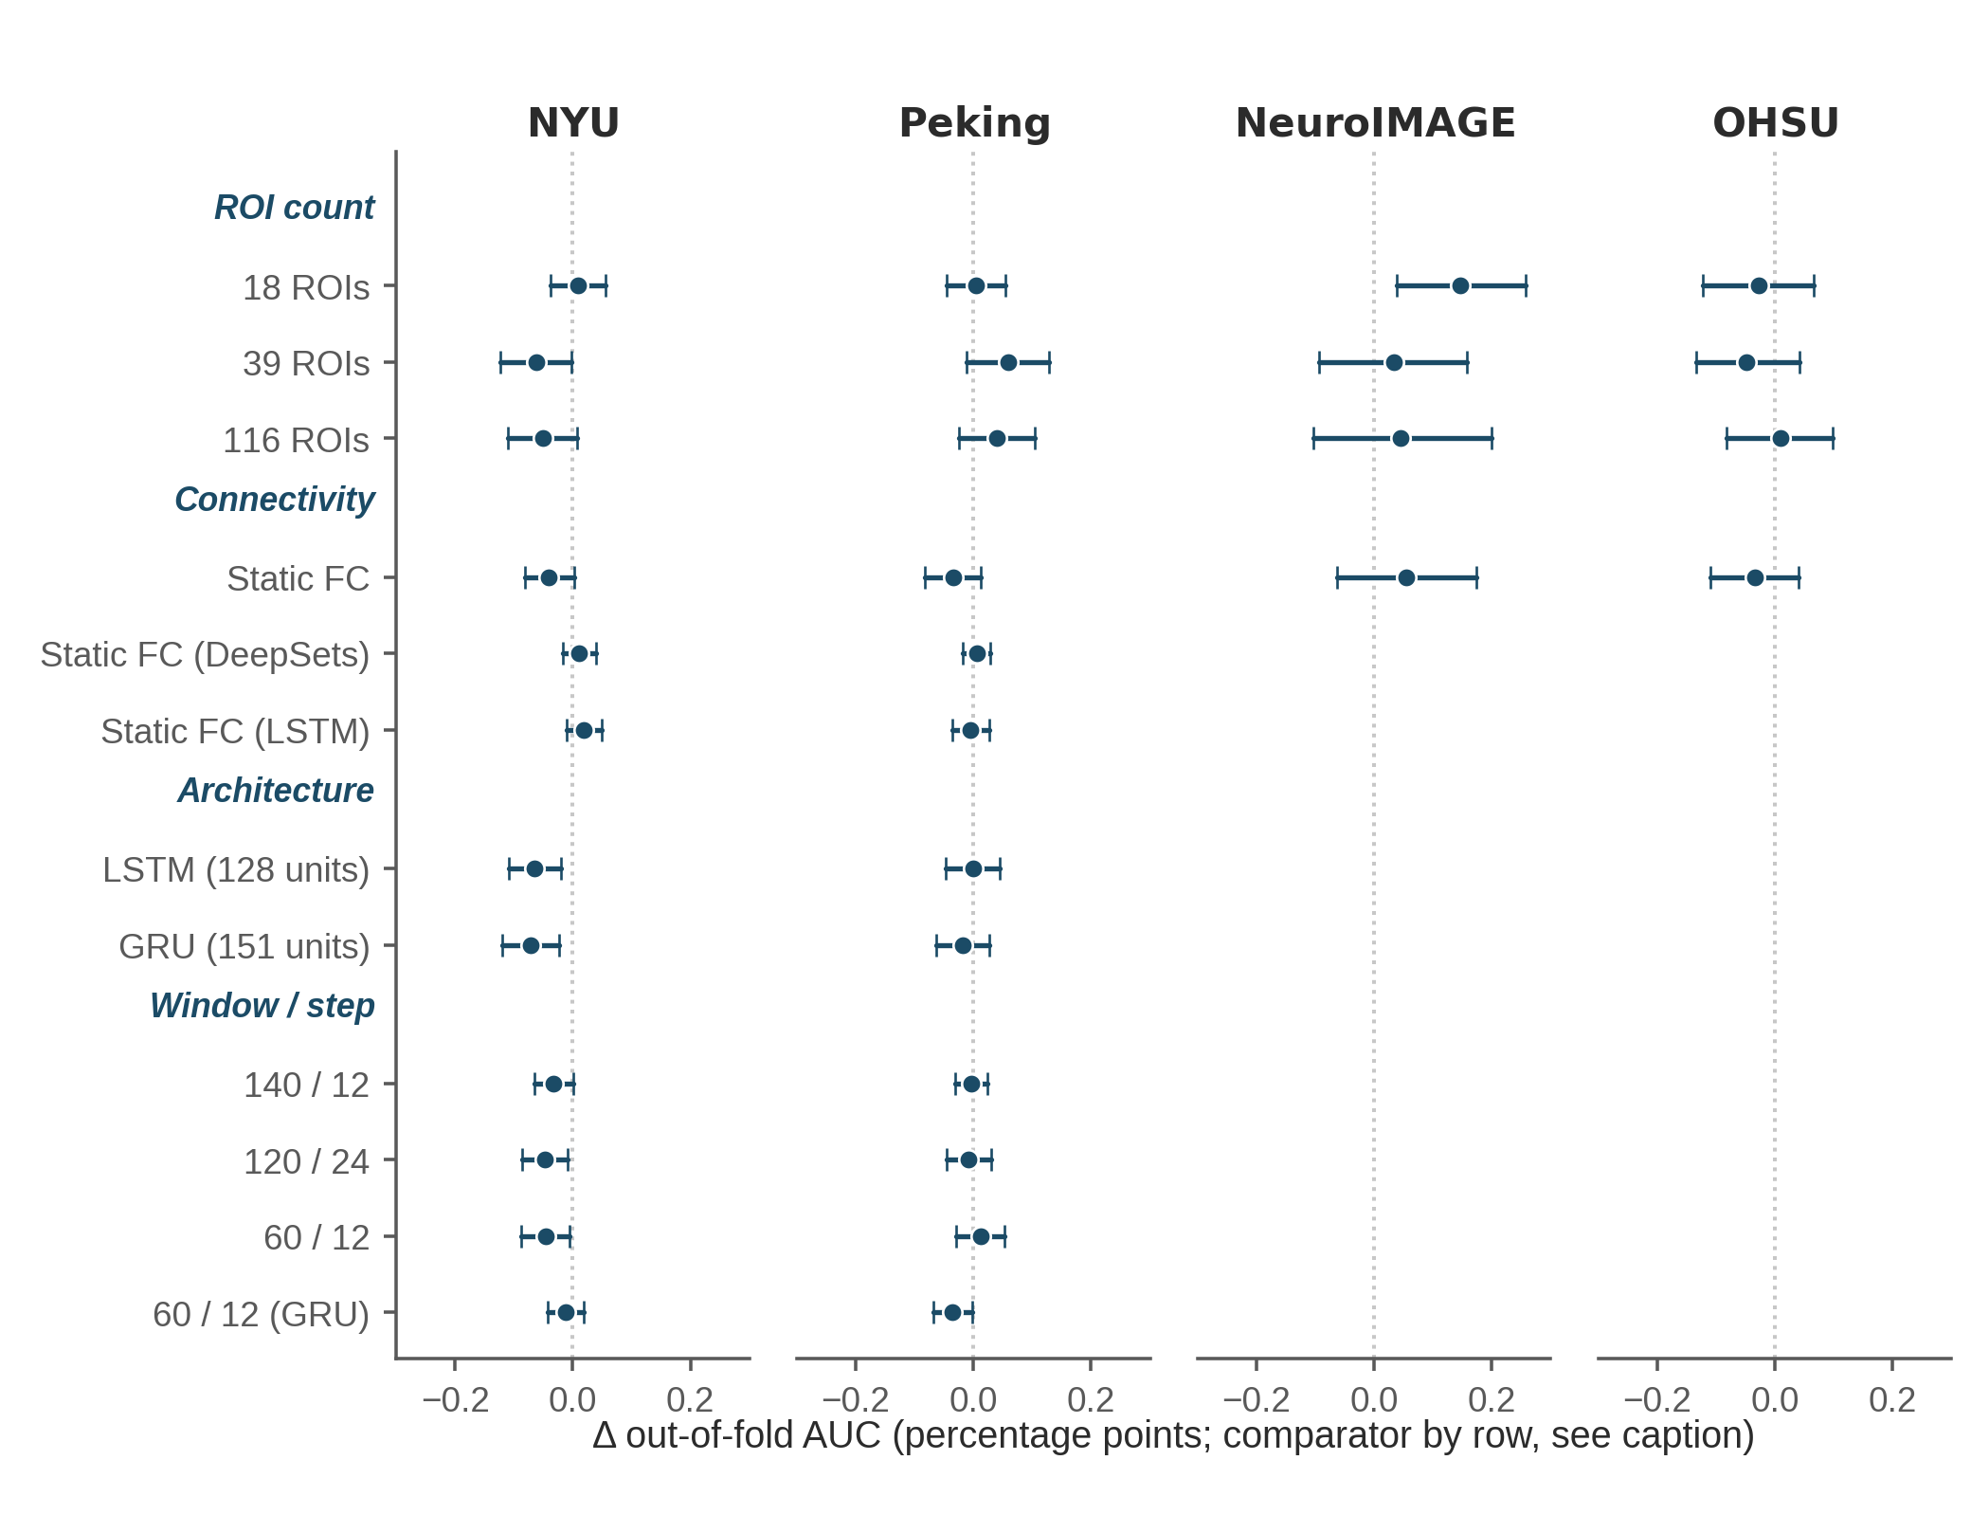
Figure 3. Sensitivity analyses relative to the 12-ROI windowed BrainNetCNN reference, except for the DeepSets and LSTM connectivity rows and the GRU windowing row, which instead hold architecture fixed and compare static against windowed connectivity, or a 60-s against a 120-s window, within that architecture (see Table 5 note). Points show paired differences in mean out-of-fold AUC, and horizontal bars show two-sided 95% participant-bootstrap confidence intervals. Positive values favor the listed condition. Windowing labels report window length / step, in seconds. LSTM, GRU, DeepSets-windowed, and the 60-s windowing contrasts were evaluated only in NYU and Peking; DeepSets-static was evaluated at all four sites.
  - Convergence and Model Behavior
Across sites, training cross-entropy decreased while inner-validation loss decreased more slowly, with no clear late upturn. For the 12- and 18-ROI panels, training loss remained above validation loss throughout training, consistent with dropout being active only during fitting. For the 39- and 116-ROI panels, this relationship reversed after roughly the first third of training: training accuracy continued climbing while inner-validation accuracy remained flat, indicating that the additional loss reduction reflected memorization rather than improved generalization. The gap between outer-training and out-of-fold AUC generally increased with panel size and was largest at the 116-ROI panel at all sites, although it was not monotonic in NeuroIMAGE. Figure 4 shows the corresponding out-of-fold ROC curves by site and ROI panel, based on the same out-of-fold predictions summarized in Table 4. Because a small gap can also reflect limited performance in both partitions, it was interpreted only alongside out-of-fold performance.
For the reference 12-ROI windowed BrainNetCNN configuration, early stopping was rarely triggered: depending on the site, between 44 and 50 of the 50 folds reached the maximum of 300 epochs, and the epoch ceiling, rather than the patience criterion of 25 epochs, governed training duration. This pattern was not uniform across configurations: at the 116-ROI panel, only 19 to 28 of 50 folds reached the ceiling, and for the LSTM architecture early stopping triggered in every fold.

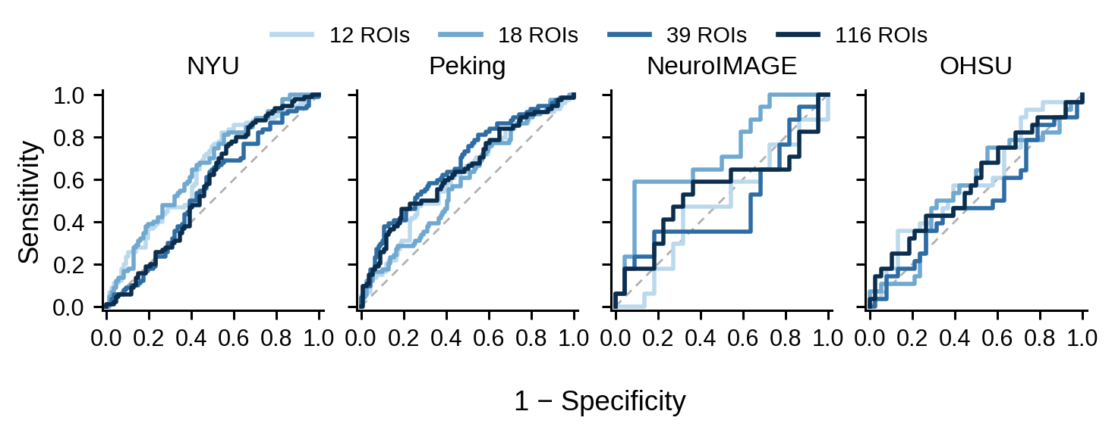
Figure 4. Out-of-fold ROC curves by site and ROI panel. Each curve uses the mean predicted probability across the five repetitions for each participant, based on the same out-of-fold predictions summarized in Table 4. The diagonal dashed line indicates chance-level discrimination (AUC = 0.50).
References
ADHD-200 Consortium. (2011). The ADHD-200 Consortium: A model to advance the translational potential of neuroimaging in clinical neuroscience. Frontiers in Systems Neuroscience, 6, Article 62. https://doi.org/10.3389/fnsys.2012.00062
Bellec, P., Chu, C., Chouinard-Decorte, F., Benhajali, Y., Margulies, D. S., & Craddock, R. C. (2017). The Neuro Bureau ADHD-200 Preprocessed repository. NeuroImage, 144(Part B), 275–286. https://doi.org/10.1016/j.neuroimage.2016.06.034
Blomberg, R., Signoret, C., Danielsson, H., Perini, I., Rönnberg, J., & Johansson Capusan, A. (2022). Aberrant resting-state connectivity of auditory, ventral attention/salience and default-mode networks in adults with attention deficit hyperactivity disorder. Frontiers in Neuroscience, 16, Article 972730. https://doi.org/10.3389/fnins.2022.972730
Damiani, S., Tarchi, L., Scalabrini, A., Marini, S., Provenzani, U., Rocchetti, M., Oliva, F., & Politi, P. (2021). Beneath the surface: hyper-connectivity between caudate and salience regions in ADHD fMRI at rest. European Child & Adolescent Psychiatry, 30(4), 619–631. https://doi.org/10.1007/s00787-020-01545-0
Francx, W., Oldehinkel, M., Oosterlaan, J., Heslenfeld, D., Hartman, C. A., Hoekstra, P. J., Franke, B., Beckmann, C. F., Buitelaar, J. K., & Mennes, M. (2015). The executive control network and symptomatic improvement in attention-deficit/hyperactivity disorder. Cortex, 73, 62–72. https://doi.org/10.1016/j.cortex.2015.08.012
Hale, T. S., et al. (2014). [Reference pending bibliographic verification against an authoritative source -- not resolved as of this revision; see delivery report, Sec. 11.]
Koirala, S., Grimsrud, G., Mooney, M. A., Larsen, B., Feczko, E., Elison, J. T., Nelson, S. M., Nigg, J. T., Tervo-Clemmens, B., & Fair, D. A. (2024). Neurobiology of attention-deficit hyperactivity disorder: historical challenges and emerging frontiers. Nature Reviews Neuroscience, 25, 759–775. https://doi.org/10.1038/s41583-024-00869-z
Leonardi, N., & Van De Ville, D. (2015). On spurious and real fluctuations of dynamic functional connectivity during rest. NeuroImage, 104, 430–436. https://doi.org/10.1016/j.neuroimage.2014.09.007
Parlatini, V., Itahashi, T., Lee, Y., Liu, S., Nguyen, T. T., Aoki, Y. Y., et al. (2023). White matter alterations in attention-deficit/hyperactivity disorder (ADHD): a systematic review of 129 diffusion imaging studies with meta-analysis. Molecular Psychiatry, 28, 4098–4123. https://doi.org/10.1038/s41380-023-02173-1
Reimann, G. M., et al. (2024). [Reference pending bibliographic verification against an authoritative source -- not resolved as of this revision; see delivery report, Sec. 11.]
Singh, et al. (2024). [Reference pending bibliographic verification against an authoritative source -- not resolved as of this revision; see delivery report, Sec. 11.]
Sutcubasi, B., Metin, B., Kurban, M. K., Metin, Z. E., Beser, B., & Sonuga-Barke, E. (2020). Resting-state network dysconnectivity in ADHD: a system-neuroscience-based meta-analysis. World Journal of Biological Psychiatry, 21(9), 662–672. https://doi.org/10.1080/15622975.2020.1775889
Tzourio-Mazoyer, N., Landeau, B., Papathanassiou, D., Crivello, F., Etard, O., Delcroix, N., Mazoyer, B., & Joliot, M. (2002). Automated anatomical labeling of activations in SPM using a macroscopic anatomical parcellation of the MNI MRI single-subject brain. NeuroImage, 15(1), 273–289. https://doi.org/10.1006/nimg.2001.0978
Yu, M., Linn, K. A., Cook, P. A., Phillips, M. L., McInnis, M., Fava, M., Trivedi, M. H., Weissman, M. M., Shinohara, R. T., & Sheline, Y. I. (2018). Statistical harmonization corrects site effects in functional connectivity measurements from multi-site fMRI data. Human Brain Mapping, 39(11), 4213–4227. https://doi.org/10.1002/hbm.24241

