ADHD classification from dynamic functional connectivity: a multi-site evaluation of anatomical ROI groups
Working version — Sections 2 (Method) and 3 (Results). The Abstract, Introduction, Discussion, Conclusions, and Highlights will be written at a later stage.

2. Method

2.1 Participants
Resting-state functional magnetic resonance imaging (rs-fMRI) images from four sites of the public ADHD-200 repository were used: NYU, Peking, NeuroIMAGE, and OHSU. The study followed an empirical-analytical design of comparative scope and cross-sectional nature, based on retrospective data. Each image underwent an initial quality control check based on the QC_Rest_1 indicator, used to assess the validity of resting-state acquisitions; this procedure identified records with motion artifacts or capture failures.
Table 1 shows the composition of the resulting analytic sample. The four sites differ in sample size, class balance, and acquisition parameters, in particular in repetition time (TR) and in the length of the time series. Differences of scanner and protocol of this kind introduce non-biological variability in connectivity estimates, which limits statistical power and can produce spurious findings; removing it requires harmonization procedures that carry assumptions of their own and that remain an active methodological problem (Yu et al., 2018; Hu et al., 2023). In ADHD-200 the difficulty is compounded because site is confounded with class balance and with the acquisition protocol itself, so a pooled estimate would mix the effect of the ROI group with the effect of the site. The four sites were therefore analyzed separately and were not combined into a common effect.
Site | Subjects | Control | ADHD | TR | Volumes
NYU | 177 | 87 | 90 | 2.00 s | 172
Peking | 183 | 109 | 74 | 2.00 s | 232
NeuroIMAGE | 39 | 22 | 17 | 1.96 s | 257
OHSU | 66 | 38 | 28 | 2.50 s | 74
Table 1. Composition of the analytic sample and acquisition parameters by site. TR = repetition time. Volumes correspond to the time series after removal of the first four volumes during preprocessing.

2.2 Preprocessing
Preprocessing was carried out with the ATHENA pipeline (Bellec et al., 2017), applied identically at the four sites. T1-weighted anatomical images were reoriented to the right-posterior-inferior (RPI) orientation system and skull-stripped. They were then segmented into gray matter, white matter, and cerebrospinal fluid, and registered to the Montreal Neurological Institute standard space (MNI152) at 1 × 1 × 1 mm resolution through successive linear and non-linear transformations. The smoothed gray matter density maps produced at this step were not used in the analysis reported here.
In the functional images, the first four volumes were removed to compensate for scanner instability, and motion and slice-timing corrections were applied. After functional-to-anatomical registration, the functional images were normalized to MNI152 space at 4 × 4 × 4 mm resolution. Non-neural signals were regressed out: white matter, cerebrospinal fluid, global signal, and the six motion parameters. A 0.009–0.08 Hz band-pass filter was applied to remove low-frequency components and physiological noise, followed by 6 mm full width at half maximum (FWHM) spatial smoothing to improve the signal-to-noise ratio.

2.3 BOLD Signal Extraction and Functional Connectivity Construction
The blood-oxygen-level-dependent (BOLD) signal was extracted from the filtered and smoothed functional derivative with the AAL116 atlas, averaging the time series of the voxels of each region. The 116 regional time series obtained in this way were then restricted to each of the ROI groups described in Section 2.4. Dynamic functional connectivity was estimated with sliding windows: within each window the Pearson correlation matrix between all regions of the group in use was computed, so that every subject is represented by an ordered series of connectivity matrices covering the scan.
Window length was set to 120 s and step to 12 s. Table 2 gives their translation into volumes, which depends on the TR of each site. The 120 s window was chosen above the time scale set by the lower cutoff of the filter. The ATHENA band-pass starts at 0.009 Hz, a period of approximately 111 s, and shorter windows can yield more variable connectivity estimates without being formally invalid (Leonardi & Van De Ville, 2015). The resulting overlap of 90% makes adjacent windows highly similar, which limits the dynamic information available; Section 2.6 describes the conditions that vary these two parameters.
Site | Window | Step | Overlap | Windows per subject
NYU | 60 TR = 120 s | 6 TR = 12 s | 90% | 19
Peking | 60 TR = 120 s | 6 TR = 12 s | 90% | 29
NeuroIMAGE | 61 TR ≈ 120 s | 6 TR ≈ 11.8 s | ≈90% | 33
OHSU | 48 TR = 120 s | 5 TR = 12.5 s | ≈90% | 6
Table 2. Effective windowing by site in the reference configuration. The number of windows per subject differs across sites because the repetition time and the length of the series differ.

2.4 Functional Networks Involved in ADHD
ADHD is associated with altered dynamic interaction among higher-order brain networks (Singh et al., 2024). The resulting between-network disconnection pattern affects the integration of information, the regulation of attention, response inhibition, and the modulation of motor activity (Blomberg et al., 2022). Figure 1 shows the five networks on which this study draws: the default mode network (DMN), the executive control network (ECN), the salience network (SN), the dorsal attention network (DAN), and the frontostriatal-thalamic circuit (FST) (Damiani et al., 2021; Francx et al., 2015; Hale et al., 2014). Together they support self-reference, inhibitory control, stimulus prioritization, attentional regulation, and motor modulation, the processes most often altered in ADHD (Koirala et al., 2024; Parlatini et al., 2023; Reimann et al., 2024; Sutcubasi et al., 2020).
Four anatomical groups of 12, 18, 39, and 116 regions of interest (ROIs) were defined on the AAL116 atlas (Tzourio-Mazoyer et al., 2002). Because the disorder is heterogeneous and not all structures within a network show the same degree of dysfunction (Schleim, 2022), the reduced groups retain a subset of each network rather than the whole. The 12-ROI group is nested within the 18-ROI group, which adds six regions. The 39-ROI group was built from a broader review of the networks involved: it shares six regions with the first and eight with the second, so it is not a superset of either. The 116-ROI group is the full atlas and serves as a maximum-dimensionality reference. Table 3 lists the composition of the 12-ROI group.
[ Figure 1 — placeholder combining the anatomical projections of the five functional networks and the location of the twelve regions of the compact group. ]
Figure 1. Functional networks implicated in ADHD and anatomical location of the 12-ROI group, in sagittal, axial, and coronal projections.
ROI (AAL116) | Anatomical region | Main function | Network
Frontal_Sup_L | Left superior prefrontal cortex | Sustained attention and executive control | ECN-DMN
Insula_R | Right insula | Emotional integration, interoception, and attention | SN
Cingulum_Ant_L | Left anterior cingulate | Cognitive control and emotional regulation | SN
Cingulum_Ant_R | Right anterior cingulate | Cognitive control and error monitoring | SN
Precuneus_L | Left precuneus | Relaxation and autobiographical memory | DAN-DMN
Precuneus_R | Right precuneus | Introspection and self-reference | DAN-DMN
Caudate_L | Left caudate nucleus | Motor control, reward, and learning | FST
Caudate_R | Right caudate nucleus | Motor control, reward, and motivation | FST
Putamen_L | Left putamen | Motor function and movement planning | FST
Putamen_R | Right putamen | Motor function and habit processing | FST
Thalamus_L | Left thalamus | Sensory integration and motor coordination | FST
Thalamus_R | Right thalamus | Sensory integration and attention | FST
Table 3. Composition of the 12-ROI group, with its anatomical correspondence and associated functional network. The equivalent table for the 18- and 39-ROI groups is provided in the supplementary material.

2.5 Deep Learning Architectures
[ Section reserved. To be written at a later stage. It must state how each architecture consumes the ordered series of connectivity matrices of Section 2.3: the reference model receives the matrices as simultaneous inputs, without recurrence, attention, or memory across them, so its input should not be described as a sequence processed over time. ]

2.6 Experimental and Evaluation Setup
The protocol in this section applies to every run of the study: the same partitioning scheme, training configuration, and seed were used for each site, ROI group, and sensitivity condition. Performance was estimated by repeated stratified cross-validation, with an outer loop of 10 folds by 5 repetitions and an inner partition of 15% of the training set reserved for early stopping. All windows of a subject remained in the same partition, so no observation from an evaluated subject took part in training the model that classified it. Within each site, the four ROI groups and all sensitivity conditions share the same seed and partition fingerprint, which allows subject-wise paired comparisons. Because the ROI groups were defined a priori, no region-selection step is repeated within folds.
Class weighting differs across sites: Peking uses weights inversely proportional to class frequency, computed only on the fitting data of each fold, whereas NYU, NeuroIMAGE, and OHSU do not apply it. The difference was held constant within each site, and it is a further reason why the four site-specific procedures cannot be treated as interchangeable (Section 2.1).
Table 4 lists the training configuration, held identical for every condition. Two quantities still vary between runs, and neither is a free choice: the number of windows per subject, set by the TR and the series length of each site, and the number of model parameters, set by the ROI group and that number of windows. The parameter count ranges from 1,841 to 4,433 with 12 regions and from 16,817 to 41,873 with 116, roughly nine times more; Table S2 gives the sixteen values. Fixing the hyperparameters therefore does not fix the number of parameters, so a comparison between ROI groups compares complete pipelines rather than the anatomical group alone.
Parameter | Value | Parameter | Value
Edge-to-edge filters | 4 | Learning rate | 1 × 10⁻⁴
Edge-to-node filters | 8 | Batch size | 32
Node-to-graph / dense units | 8 | Maximum epochs | 300
Final dropout | 0.7 | Patience | 25
Intermediate dropout | 0.6 | Early-stopping monitor | val_loss
LeakyReLU negative slope | 0.33 | min_delta | 1 × 10⁻⁵
L2 regularization | 0.05 | Inner validation fraction | 0.15
Optimizer | Adam | Seed | 42
Loss function | Binary cross-entropy | Numerical precision | FP32
Table 4. Training configuration, held identical across the four sites, the four ROI groups, and all sensitivity conditions.
Exposure to hyperparameter tuning. The configuration was fixed before the comparative runs, but it was selected in an earlier development phase with access to results, on NYU with the 12-ROI group; Table S2 lists the ten configurations compared. NYU performance may therefore carry optimistic bias of unknown magnitude. The other three sites were evaluated with the frozen configuration, which reduces the bias without removing it: their performance is also estimated by internal cross-validation and not in an independent cohort.
Four design choices were varied to test the robustness of the estimates. The reference against which each is measured is the 12-ROI group with windowed connectivity of 120 s and a 12 s step, and every condition keeps the subjects, partitions, seed, class weighting, and training configuration of that within-site reference. None of the conditions was defined after seeing intermediate results.
The first dimension is the dimensionality of the anatomical group, contrasting 18, 39, and 116 ROIs against 12 at the four sites. Because the groups are defined a priori, varying the number of regions is a sensitivity analysis of input dimensionality and not a region-discovery procedure.
The second dimension is the signal representation, replacing the windowed series of matrices with a single Pearson correlation matrix computed over the complete series, referred to as static connectivity. This does not isolate the dynamic component alone: with 1,361 parameters the static condition also has the lowest capacity of the study, so the comparison spans two complete pipelines. The difference in capacity is reported and not artificially equalized, because equalizing it would introduce a different model and a new configuration search.
The third dimension is the architecture: a 128-unit long short-term memory (LSTM) recurrent network, evaluated under the same protocol as the reference architecture. With 66 input edges that network has approximately 99,969 parameters and no regularization, against 3,089 and 4,049 parameters in NYU and Peking with dropout and L2 regularization, so the comparison documents the practical effect of the choice within this study and does not compare mechanisms on equal terms.
The fourth dimension is windowing, varying one feature at a time relative to the reference, as Table 5 sets out. Condition A lengthens the window to 140 s while keeping the step. Condition B doubles the step to 24 s while keeping the length. Changing the step also changes the number of windows and hence the capacity of the model, so the effect of overlap is not causally isolated.
Condition | Window | Step | Windows NYU / Peking | Parameters NYU / Peking
Reference | 120 s | 12 s | 19 / 29 | 3,089 / 4,049
A — length | 140 s | 12 s | 18 / 28 | 2,993 / 3,953
B — step | 120 s | 24 s | 10 / 15 | 2,225 / 2,705
Table 5. Windowing sensitivity conditions. Parameter counts were obtained by instantiating the architecture with the number of windows corresponding to each site.
The dimensionality and representation comparisons were run at the four sites. The architecture and windowing comparisons were restricted to NYU and Peking, which give the narrowest primary comparison intervals, 0.118 and 0.129 wide against 0.182 in OHSU and 0.303 in NeuroIMAGE. OHSU is in any case unsuitable for the windowing conditions: its 74 volumes yield 6 windows in the reference configuration and would leave 4 under condition A and 3 under condition B, too few for the manipulation to be separable from the loss of windowing itself. This restriction on which sites to evaluate was decided before running the architecture and windowing conditions, on the basis of the precision already available from the primary comparison.
The fifth dimension is the choice of algorithm, replacing the reference architecture with an L2-regularized logistic regression fit on the vectorized upper triangle of the connectivity matrix. The regularization strength was fixed at C = 1.0 before training, so no hyperparameter search was performed; standardization was refit within each fold, never on the full sample. The model was evaluated under the same partitions, seed, and per-site class weighting as the rest of the study. At 12 ROIs the comparator is the static BrainNetCNN run of the second dimension, so representation is held constant and only the algorithm changes. No static BrainNetCNN run exists at 18, 39, or 116 ROIs, so at those sizes the comparator is the windowed run of the corresponding ROI group, and representation and algorithm change together; these twelve comparisons carry the same representation confound already declared for the second dimension.
The five dimensions above define the scope of the evaluation. Alternative sequence architectures, learning curves by sample size, and atlases other than AAL116 lie outside it and are taken up in the Discussion.

2.7 Statistical Analysis
The primary metric is the AUC of the out-of-fold predictions, aggregated by repetition: within each of the five repetitions the predictions of the ten outer folds are pooled, the AUC is computed over all subjects of the site, and the five results are averaged. Aggregating by repetition rather than by fold is what makes the estimate stable, since an individual fold holds between three and eighteen subjects. The secondary metrics are balanced accuracy, macro F1, sensitivity, and specificity; simple accuracy is retained only as an audit metric.
AUC was chosen as the primary metric for two reasons. It summarizes the receiver operating characteristic curve over all decision thresholds, so it does not require committing to an operating point that this study has no clinical basis for choosing. And it is not distorted by the class balance of each site, which ranges from 87:90 in NYU to 109:74 in Peking; reviews of single-subject prediction of brain disorders in neuroimaging identify overall accuracy reported without regard to unequal class sizes as a recurrent source of uninformative results (Arbabshirani et al., 2017).
Uncertainty was quantified by bootstrap resampling of subjects with replacement, stratified by class to preserve the proportion of cases and controls at each site. Within each comparison the same resampled subjects are applied to both conditions and to the five repetitions, which makes the difference paired. The interval limits are the 2.5 and 97.5 percentiles of the resampling distribution, obtained with the NumPy PCG64 generator under seed 42, reset at each site. The number of resamples was fixed before any result was available: 10,000 for the primary comparison and 2,000 for each of the remaining sensitivity comparisons, ten from the representation, architecture, and windowing dimensions and sixteen from the linear-baseline dimension of Section 2.6.
Intervals are read as ranges of compatible values and not as tests. At the sample sizes common in neuroimaging, cross-validation yields intervals on the order of ten percentage points (Varoquaux, 2018), so the ordering of two configurations can reverse through sampling variability alone.
Scope of the estimates. The intervals are conditional on the existing predictions, models, and partitions, so they cover the variability of subject sampling but not that of retraining or of new partitions, and the estimand is the repeated cross-validation pipeline as a whole rather than a single final model. No non-inferiority margin was prespecified, so the analysis locates differences and their precision without issuing verdicts of equivalence, non-inferiority, or superiority. No analysis of variance or post-hoc test is reported, because folds and repetitions share subjects and training data and are not the independent replicates such tests assume.

2.8 Ethical Considerations
This study used anonymized data from the public ADHD-200 repository (ADHD-200 Consortium, 2011), access to which is subject to registration and to the ADHD-200/INDI terms of use. The data were originally collected under protocols approved by the ethics committees of the participating institutions and with informed consent from participants or their legal guardians. As a secondary analysis of retrospective, de-identified data, it required no new interaction with the subjects and no additional consent procedures, and no attempt was made to re-identify participants.

3. Results

3.1 Performance by ROI group and site
Table 6 shows the out-of-fold performance of the sixteen site-by-group combinations: the AUC with its confidence interval and the four secondary metrics defined in Section 2.7. Each value pools the predictions of the ten outer folds within each repetition and averages the five repetitions. The metrics of the outer training partition and the gaps between partitions are given in Table S1, as a diagnostic of the mismatch between fit and generalization rather than a performance result.
Site | ROIs | n | AUC [95% CI] | Balanced accuracy | Macro F1 | Sensitivity | Specificity
NYU | 12 | 177 | 59.0 [53.8, 64.3] | 57.4 ± 2.8 | 57.3 ± 2.8 | 54.7 ± 5.6 | 60.2 ± 5.6
 | 18 | 177 | 60.0 [54.7, 65.3] | 56.7 ± 3.5 | 56.6 ± 3.5 | 58.0 ± 2.7 | 55.4 ± 8.8
 | 39 | 177 | 52.8 [47.4, 58.2] | 52.3 ± 2.1 | 52.1 ± 2.2 | 48.4 ± 5.3 | 56.1 ± 5.9
 | 116 | 177 | 53.9 [48.8, 59.0] | 53.1 ± 1.9 | 53.0 ± 1.8 | 54.0 ± 4.9 | 52.2 ± 3.3
Peking | 12 | 183 | 56.4 [50.7, 62.1] | 54.1 ± 5.2 | 53.9 ± 5.2 | 46.8 ± 9.1 | 61.5 ± 6.3
 | 18 | 183 | 56.8 [50.6, 62.8] | 54.0 ± 2.6 | 53.9 ± 2.5 | 46.5 ± 5.5 | 61.5 ± 4.0
 | 39 | 183 | 62.2 [56.5, 67.7] | 60.3 ± 2.9 | 60.1 ± 3.2 | 55.7 ± 3.2 | 65.0 ± 7.8
 | 116 | 183 | 60.3 [54.4, 66.1] | 58.1 ± 3.5 | 57.9 ± 3.8 | 53.2 ± 4.4 | 62.9 ± 8.1
NeuroIMAGE | 12 | 39 | 47.4 [37.3, 57.3] | 44.3 ± 4.3 | 43.4 ± 4.2 | 34.1 ± 15.2 | 54.5 ± 13.3
 | 18 | 39 | 62.0 [51.6, 72.0] | 57.6 ± 4.5 | 57.2 ± 4.1 | 55.3 ± 12.2 | 60.0 ± 9.9
 | 39 | 39 | 50.7 [41.8, 60.0] | 53.7 ± 5.9 | 53.5 ± 5.8 | 44.7 ± 6.7 | 62.7 ± 11.8
 | 116 | 39 | 51.9 [41.5, 62.6] | 50.3 ± 6.8 | 50.0 ± 6.9 | 38.8 ± 7.9 | 61.8 ± 10.9
OHSU | 12 | 66 | 54.9 [47.1, 62.4] | 53.6 ± 4.8 | 53.3 ± 4.6 | 47.1 ± 12.2 | 60.0 ± 5.1
 | 18 | 66 | 52.2 [44.4, 60.1] | 51.1 ± 3.7 | 50.5 ± 3.5 | 42.1 ± 12.7 | 60.0 ± 10.4
 | 39 | 66 | 50.1 [40.5, 59.7] | 47.0 ± 4.8 | 46.7 ± 4.5 | 42.9 ± 10.1 | 51.1 ± 7.3
 | 116 | 66 | 55.8 [47.8, 63.8] | 54.2 ± 4.7 | 53.7 ± 5.2 | 53.6 ± 7.1 | 54.7 ± 10.4
Table 6. Out-of-fold performance by site and ROI group, expressed as percentages. AUC is reported with its two-sided 95% confidence interval, obtained by class-stratified bootstrap resampling of subjects with 10,000 resamples; the secondary metrics are given as mean ± standard deviation over the 5 repetitions. The metrics of the outer training partition, the gaps between the two partitions, and simple accuracy, retained as an audit metric, are provided in the supplementary material.
Validation performance was modest at the four sites and across the four ROI groups, with AUC values between 47.4% and 62.2%. The highest point estimate corresponds to the 18-ROI group in NYU and NeuroIMAGE, to the 39-ROI group in Peking, and to the 116-ROI group in OHSU. The 12-ROI group does not reach the maximum at any site, although it is close in NYU (59.0 against 60.0) and in Peking (56.4 against 56.8). These are comparisons of point estimates and not evidence of superiority; the comparisons with their uncertainty are given in Sections 3.2 and 3.3.
The gap between the outer training partition and the out-of-fold predictions, detailed in Table S1, increases with dimensionality in NYU, Peking, and OHSU, and is largest with 116 ROIs at the four sites, between 33.9 and 40.3 AUC points. NeuroIMAGE is the exception: its gap with 12 ROIs, 30.9 points, exceeds that of 18 ROIs, 26.0 points, the only case in which the compact group falls below chance level. A smaller gap is also compatible with a model that learns little on both partitions, so it is read alongside out-of-fold performance and not as a decision criterion.
Figure 2a shows the AUC of the sixteen combinations with its confidence interval. In nine of them the interval includes the chance value of 0.5: the four OHSU combinations, three NeuroIMAGE combinations, and the 39- and 116-ROI combinations in NYU. Peking is the only site whose four intervals exclude chance.

3.2 Primary comparison between ROI groups
The prespecified comparison contrasts the 12-ROI group with the full 116-ROI atlas. The estimated difference is +5.1 AUC points in favor of the compact group in NYU, and −4.0, −0.9, and −4.5 points in Peking, OHSU, and NeuroIMAGE, respectively. The four confidence intervals include zero: [−0.7, +11.1] in NYU, [−10.5, +2.5] in Peking, [−9.9, +8.3] in OHSU, and [−20.0, +10.3] in NeuroIMAGE. The reading is therefore estimative: the point differences are small or moderate depending on the site, they change sign across sites, and the available precision does not resolve them.
NYU is the only site where the point difference favors the compact group, and it is also the site on which the configuration was tuned with that same group (Section 2.6). That coincidence requires interpreting the NYU result with additional caution, because it is compatible with selection-related optimism, although it does not on its own establish the existence or magnitude of that bias.

3.3 Sensitivity analyses
The median similarity between adjacent windows ranged from 0.962 to 0.987 in the reference runs of the four sites, which is consistent with the redundancy expected at 90% overlap. Figure 2b and Table 7 show the four sensitivity dimensions relative to the reference configuration. The sign convention is Δ = condition − reference: a negative value indicates performance below that of the reference at the same site.
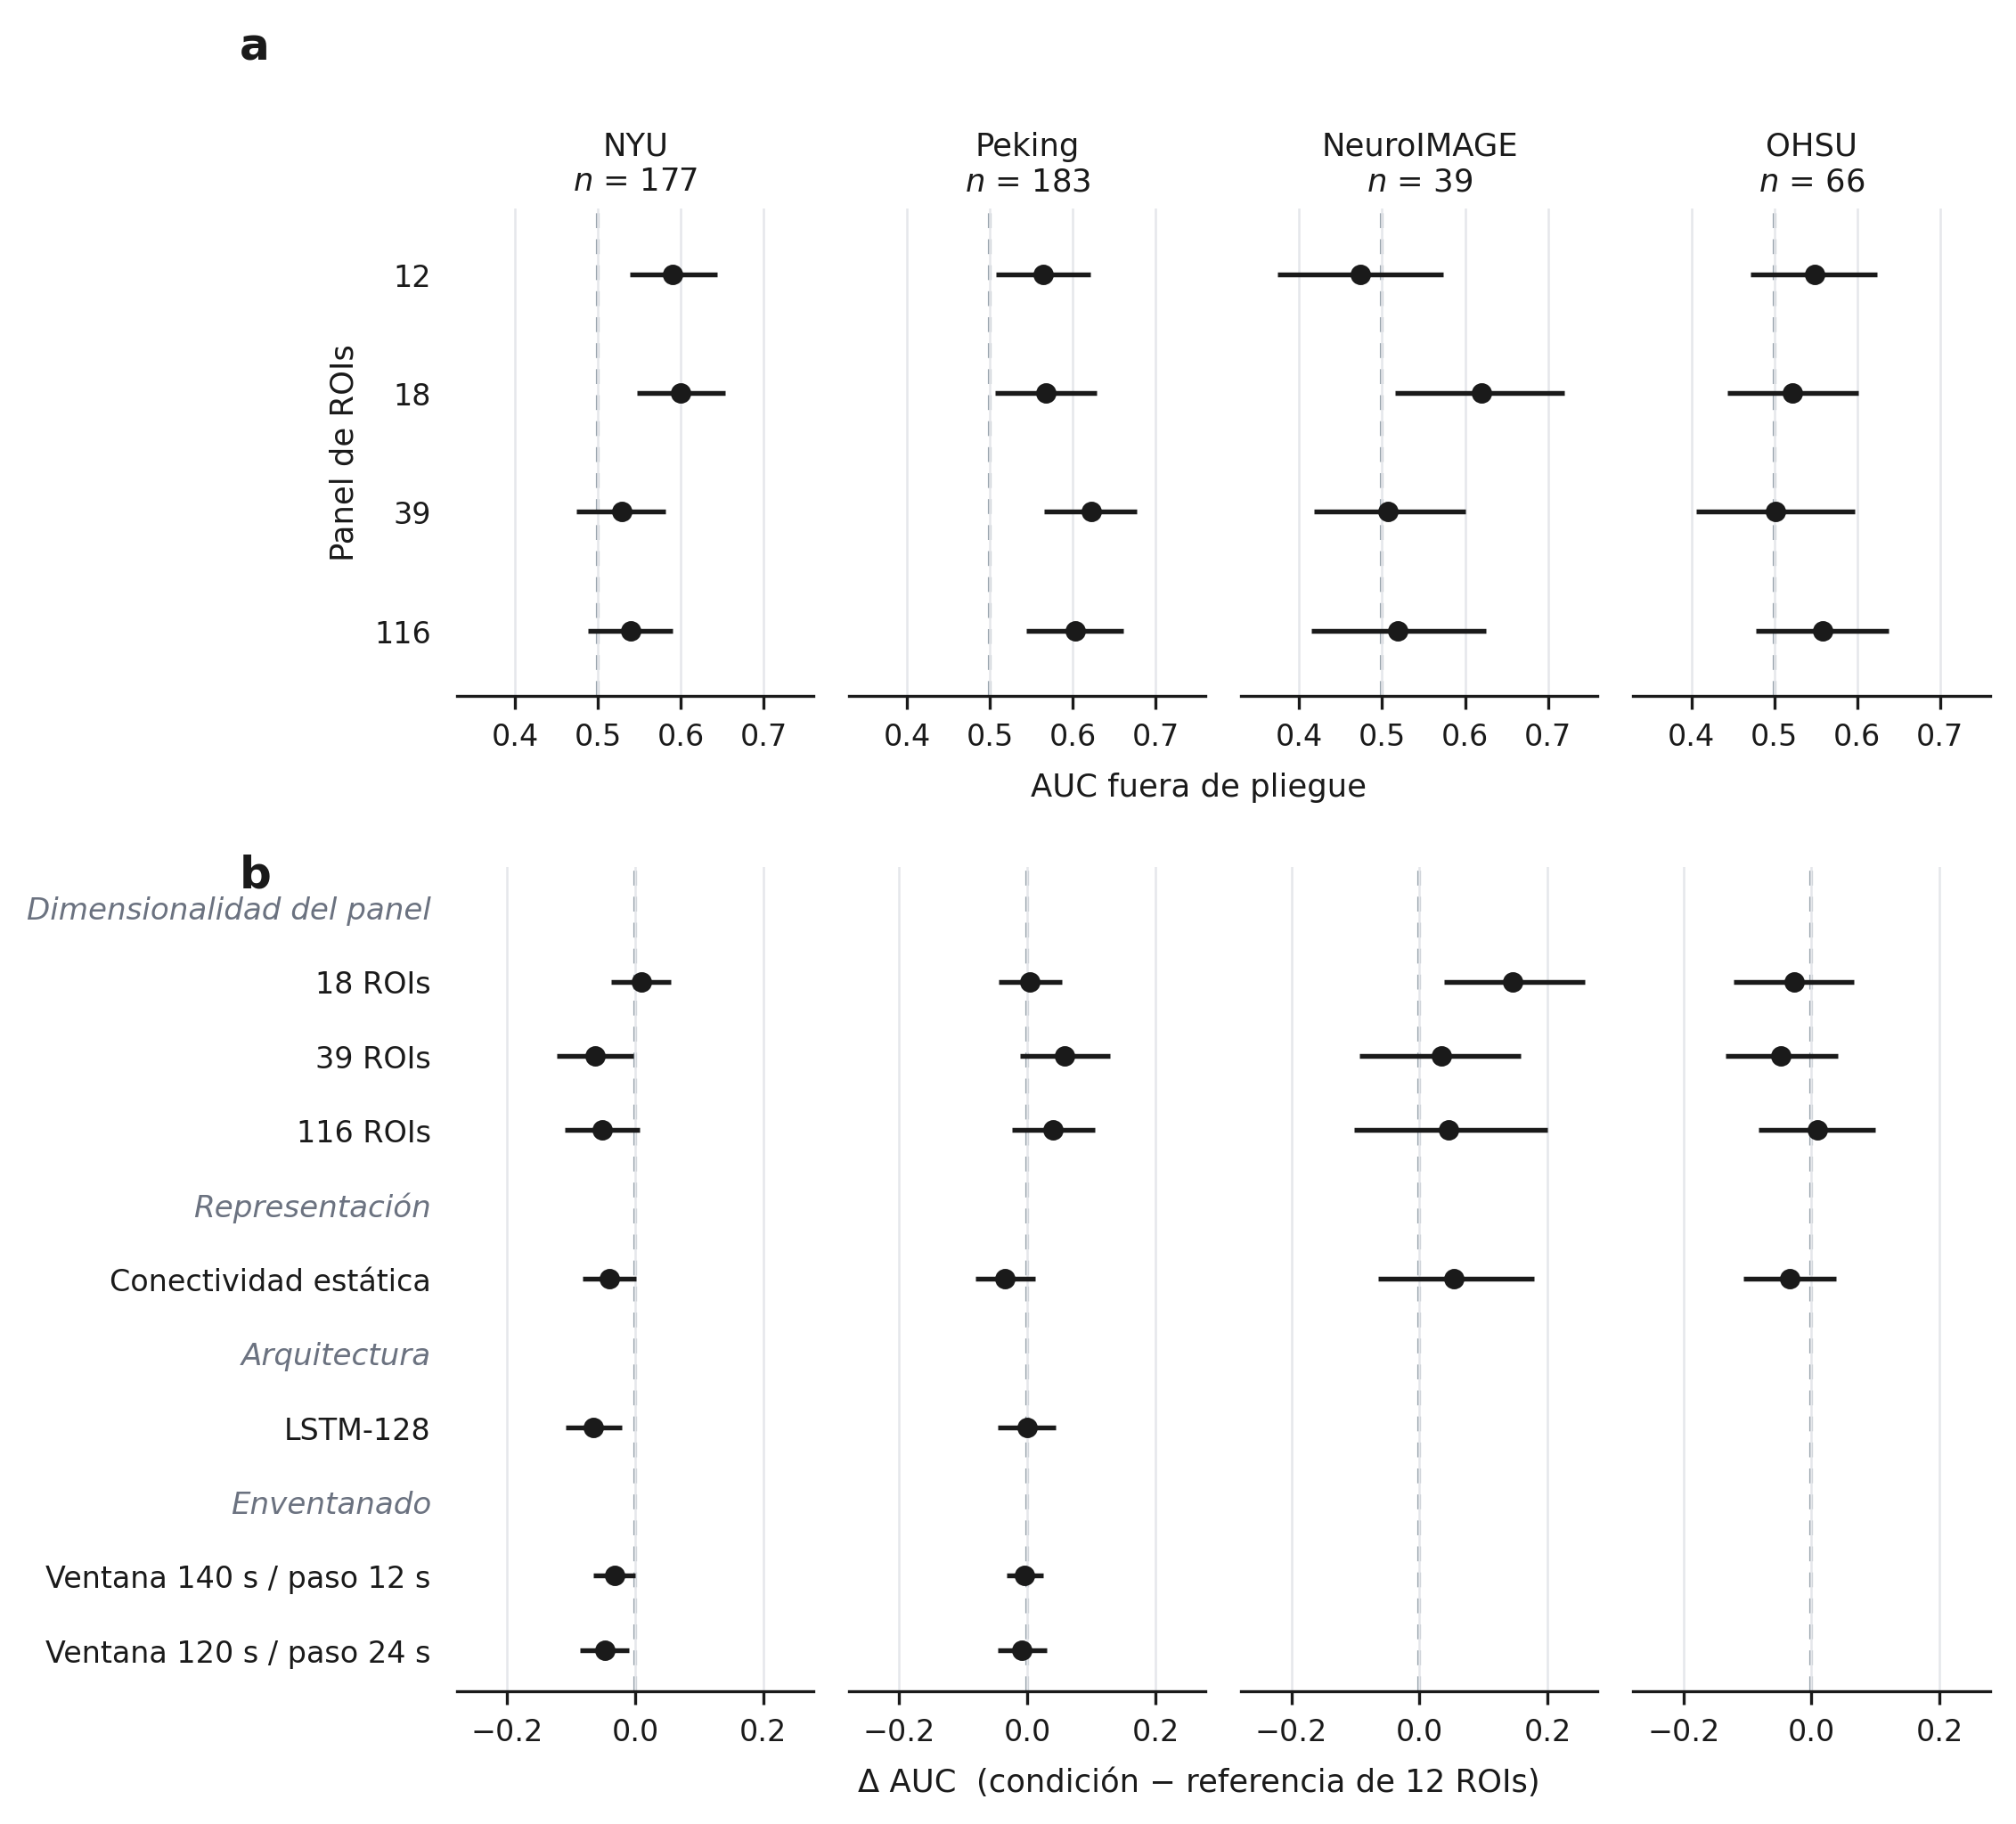
Figure 2. (a) Out-of-fold AUC of each ROI group by site, with two-sided 95% confidence intervals; the dashed line marks chance-level performance. (b) AUC difference of each sensitivity condition relative to the 12-ROI reference configuration, with its confidence interval; the dashed line marks the absence of a difference. Rows keep the same position across the four sites to allow horizontal reading; the architecture and windowing conditions were evaluated only in NYU and Peking, so their rows are empty for NeuroIMAGE and OHSU. Intervals come from a class-stratified paired bootstrap of subjects, conditional on the existing partitions: 10,000 resamples in panel (a) and in the three dimensionality rows of panel (b), and 2,000 in the remaining four rows of (b).

3.3.1 ROI group
The comparison of 116 against 12 ROIs is the primary comparison reported in Section 3.2 and is not repeated here. Of the two remaining dimensionality comparisons, neither produces a consistent pattern across sites. In NYU, enlarging the group to 39 ROIs reduces AUC by 6.2 points, with an interval that excludes zero, whereas moving to 18 ROIs leaves the estimate essentially unchanged. In Peking the direction reverses: the 39-ROI group exceeds the 12-ROI group by 5.8 points, although its interval includes zero. In NeuroIMAGE, the 18-ROI group exceeds the 12-ROI group by 14.6 points with an interval that excludes zero, and in OHSU the three differences are small with wide intervals. Only two of the twelve dimensionality comparisons have intervals that exclude zero, and they do so in opposite directions: 39 ROIs in NYU, against the larger group, and 18 ROIs in NeuroIMAGE, in favor of the larger group. Sensitivity to the dimensionality of the ROI group is therefore site-dependent.

3.3.2 Signal representation
Replacing the windowed series of connectivity matrices with a single static matrix reduces AUC by 4.1 points in NYU, 3.5 in Peking, and 3.4 in OHSU, and increases it by 5.4 points in NeuroIMAGE. All four intervals include zero, although the NYU interval borders it. The direction favors the windowed representation at three of the four sites, but the magnitude is small and the precision insufficient to resolve it. As stated in Section 2.6, the comparison also involves models of different capacity, so the observed difference is not attributable to the dynamic component of the representation alone.

3.3.3 Model architecture
Re-evaluating the recurrent network under the corrected protocol gives results of very different magnitude at the two sites. In NYU, LSTM-128 falls 6.5 AUC points below the reference architecture, with an interval that excludes zero, [−10.9, −2.1]; in Peking the difference is one tenth of a point and its interval spans zero widely, [−4.7, +4.5]. The two models differ in capacity, regularization, and mechanism, and the reference configuration was tuned on NYU, so the comparison documents a practical effect within this study and does not establish general superiority of either mechanism.

3.3.4 Window length and step
The two windowing conditions show the same asymmetric pattern. In NYU, lengthening the window to 140 s reduces AUC by 3.3 points and doubling the step to 24 s reduces it by 4.7, with intervals that exclude zero by narrow margins; in Peking both differences are below one point and their intervals include zero. Within the range evaluated the conclusions do not depend critically on these parameters. The longer-step condition also reduces the number of windows and the capacity of the model, so its effect is not attributed to overlap alone.
Dimension | Condition | NYU | Peking | NeuroIMAGE | OHSU
ROI group | 18 ROIs | +1.0 [−3.7, +5.6] | +0.4 [−4.5, +5.4] | +14.6 [+3.8, +25.8] | −2.7 [−12.2, +6.6]
 | 39 ROIs | −6.2 [−12.3, −0.3] | +5.8 [−1.1, +12.9] | +3.4 [−9.3, +15.8] | −4.8 [−13.4, +4.1]
 | 116 ROIs (primary) | −5.1 [−11.1, +0.7] | +4.0 [−2.5, +10.5] | +4.5 [−10.3, +20.0] | +0.9 [−8.3, +9.9]
Signal representation | Static connectivity | −4.1 [−8.2, +0.1] | −3.5 [−8.1, +1.2] | +5.4 [−6.4, +17.9] | −3.4 [−10.6, +3.9]
Model architecture | LSTM-128 | −6.5 [−10.9, −2.1] | −0.1 [−4.7, +4.5] | — | —
Windowing | Window 140 s / step 12 s | −3.3 [−6.5, −0.1] | −0.4 [−3.3, +2.5] | — | —
 | Window 120 s / step 24 s | −4.7 [−8.7, −1.0] | −0.8 [−4.6, +3.1] | — | —
Table 7. AUC difference, in percentage points, of each sensitivity condition relative to the 12-ROI reference configuration at the same site, with two-sided 95% confidence intervals. Δ = condition − reference. The 116-ROI row is the primary comparison of Section 3.2, shown here with the sign convention of this table. Dashes indicate conditions not evaluated at that site under the precision restriction described in Section 2.6. The dimensionality comparisons were estimated with 10,000 resamples and the remaining comparisons with 2,000.

3.3.5 Linear baseline
Section 2.6 describes a fifth sensitivity dimension that replaces the reference architecture with an L2-regularized logistic regression, fit on the vectorized upper triangle of the connectivity matrix with a penalty strength fixed before training. At 12 ROIs the comparator is the static BrainNetCNN run used in Section 3.3.2, so representation is held constant and only the algorithm changes. At 18, 39, and 116 ROIs no static BrainNetCNN run exists, so the comparator is instead the windowed run of the corresponding ROI group, and representation and algorithm change together.
Across the sixteen site-by-ROI-group comparisons, only one interval excludes zero: a 13.8-point disadvantage for the baseline in OHSU at 39 ROIs, one of the twelve comparisons that carry the representation confound. At 12 ROIs, where representation is matched, the point difference favors the linear baseline at three of the four sites and is negative only in OHSU, with all four intervals including zero. The twelve confounded comparisons show no consistent direction by site or by ROI group. Table 8 gives all sixteen comparisons.
Dimension | Condition | NYU | Peking | NeuroIMAGE | OHSU
Linear baseline (logistic regression) | 12 ROIs (vs. static) | +2.5 [−4.6, +9.5] | +6.3 [−1.1, +14.1] | +10.4 [−5.0, +25.6] | −1.9 [−13.7, +10.1]
 | 18 ROIs (vs. windowed)† | −3.9 [−11.1, +3.0] | −6.3 [−13.5, +1.8] | −5.5 [−20.0, +8.1] | +10.6 [−1.0, +21.7]
 | 39 ROIs (vs. windowed)† | +0.1 [−6.3, +6.4] | +0.2 [−6.6, +6.5] | +0.4 [−13.5, +15.2] | −13.8 [−23.3, −4.3]
 | 116 ROIs (vs. windowed)† | +2.4 [−3.8, +9.1] | −1.1 [−7.2, +5.0] | +3.0 [−10.4, +17.6] | −1.2 [−10.2, +8.5]
Table 8. AUC difference, in percentage points, of the logistic-regression baseline relative to its matched BrainNetCNN comparator, by ROI group and site, with two-sided 95% bootstrap confidence intervals (2,000 resamples). Δ = baseline − comparator. † marks the twelve comparisons at 18, 39, and 116 ROIs, where no static BrainNetCNN run exists and the comparator is the windowed run of the same ROI group instead: representation and algorithm change together, the same confound declared for the second dimension of Section 2.6.

3.4 Convergence and model behavior
Figure 3 documents the training behavior and the discriminative capacity of the reference configuration at the four sites. The cross-entropy curves show a slow, sustained decrease on the fitting subset and an essentially flat trajectory on the inner validation partition, without the upturn characteristic of late overfitting. Training cross-entropy lies above inner validation cross-entropy throughout, which does not indicate an absence of overfitting: the training metric is recorded with dropout active, whereas the validation metric is evaluated in inference mode.
The AUC gaps of Table S1, between 9 and 40 points, are the relevant measure of the mismatch. They are not directly comparable with the curves: the curves describe the fitting subset during training, whereas the table evaluates the complete outer partition, fit plus inner validation, in inference mode.
The accuracy curves remain close to chance level at the four sites, with wide interquartile bands in NeuroIMAGE and OHSU, consistent with their sample sizes. Early stopping was rarely triggered: depending on the site, between 44 and 50 of the 50 folds exhausted the maximum of 300 epochs, and the best observed epoch coincided with the last one in the same range of folds. The epoch ceiling, not the patience of 25, therefore governed training duration in most fits. This is reported as a limitation of the protocol and was not corrected with new runs.
The out-of-fold ROC curves are shown per repetition, so that the five predictions of each subject are not treated as independent observations. At the four sites they lie close to the diagonal. Separation from chance is visible in NYU and Peking and smaller in NeuroIMAGE and OHSU, where the intervals of Table 6 are also the widest in the study: the estimate is imprecise rather than necessarily null. The confusion matrices at a fixed threshold of 0.5 are provided in the supplementary material.
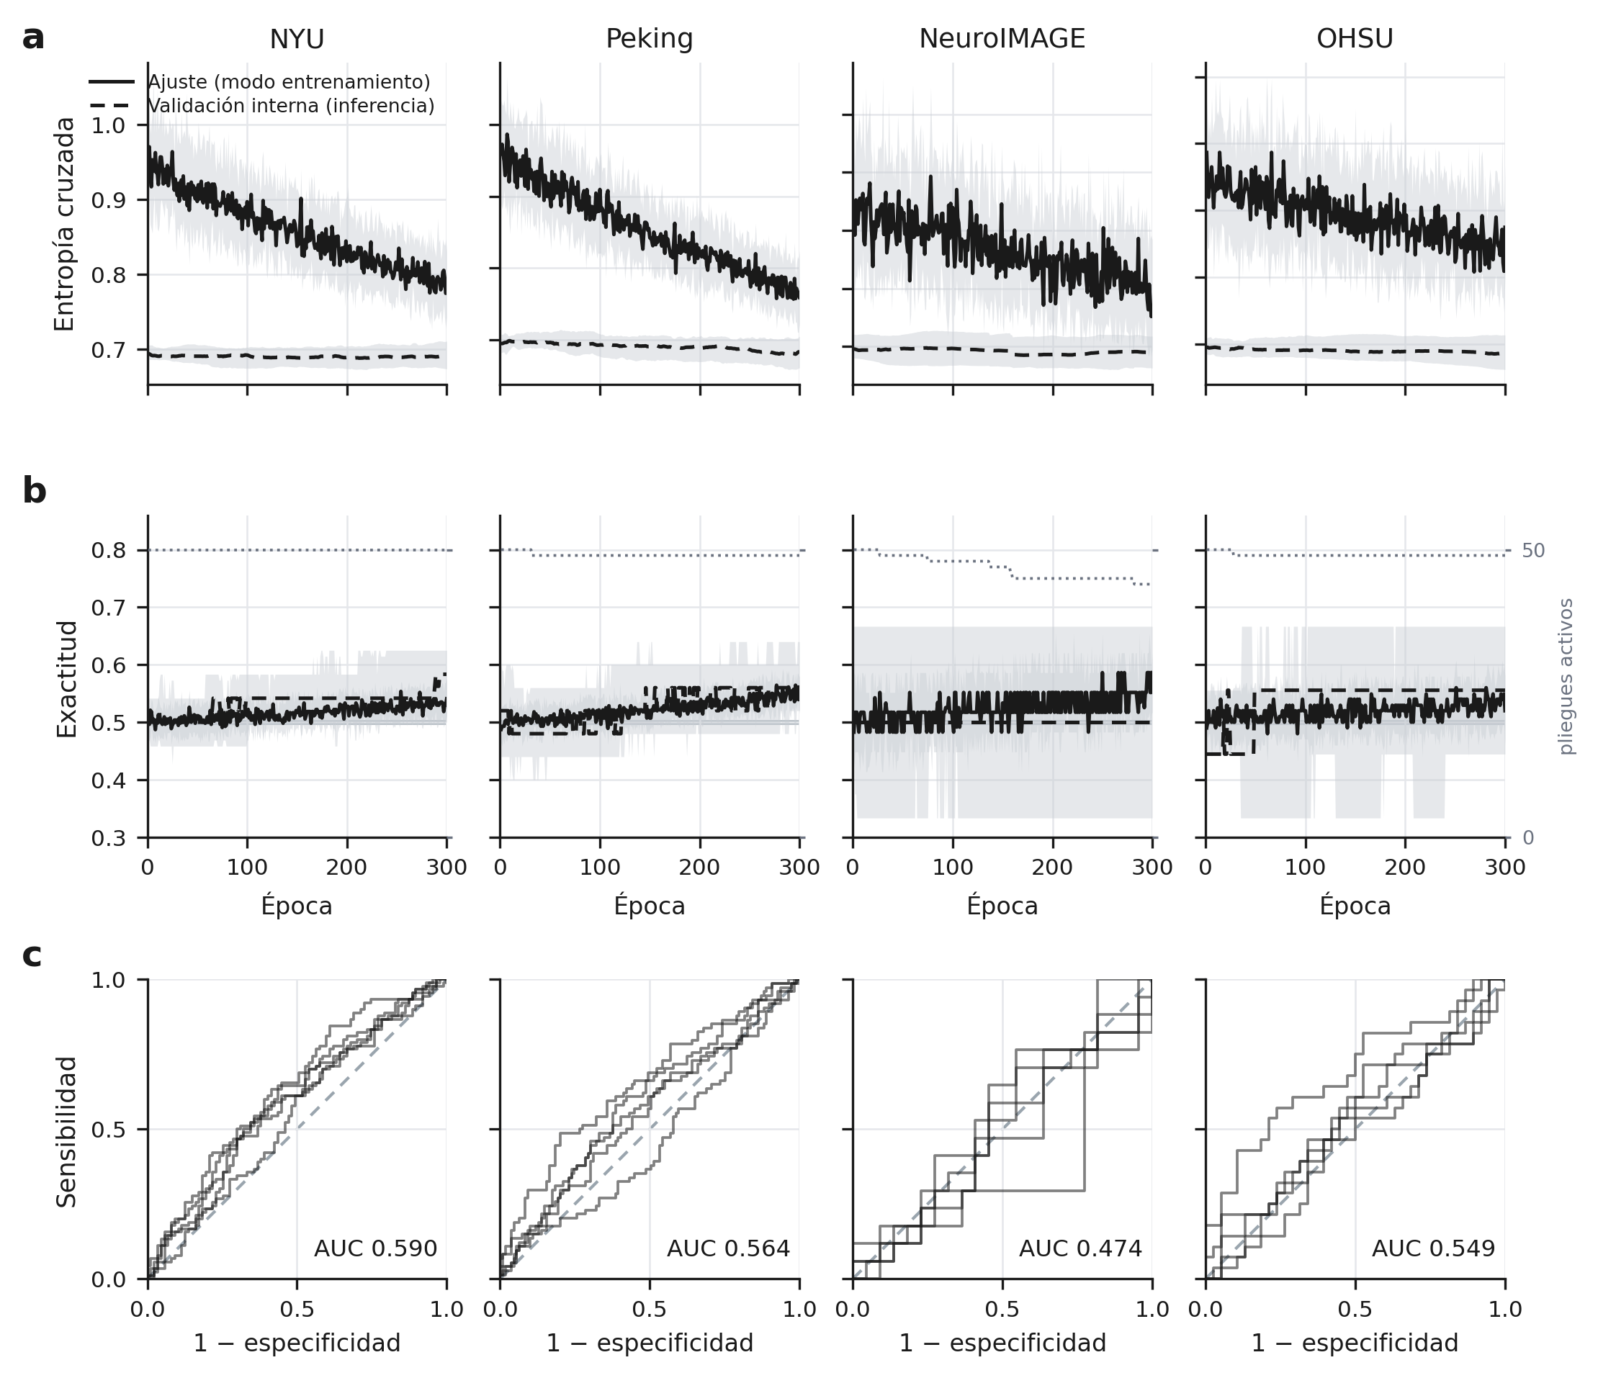
Figure 3. Model behavior in the 12-ROI reference configuration, by site. (a) Cross-entropy and (b) accuracy per epoch. The solid line corresponds to the fitting subset, recorded in training mode with dropout and batch normalization active; the dashed line corresponds to the inner validation partition, evaluated in inference mode. The two series are not directly comparable with each other because of that difference in mode. The shaded band indicates the interquartile range over the 50 folds, the solid gray line in (b) marks chance level, and the dotted line in (b), read on the right-hand axis, indicates how many folds remain active at each epoch. (c) Out-of-fold ROC curves, one for each of the five repetitions, against the diagonal of no discrimination; the figure in each panel is the mean AUC of the five repetitions, matching the validation row of Table 6.

