- Methods
  - Participants
Resting-state functional magnetic resonance imaging (rs-fMRI) data from four sites of the public ADHD-200 repository were used: NYU, Peking, NeuroIMAGE, and OHSU. This retrospective, cross-sectional comparative study used the participant as the unit of analysis. Only participants with a passing first-rater resting-state quality-control indicator (QC_Rest_1 = 1) were retained. Sites differed in sample size, class balance, repetition time (TR), and series length (Table 1); such acquisition and sampling differences can introduce site-related variability in multi-site functional connectivity estimates (Bellec et al., 2017; Yu et al., 2018). Analyses were therefore conducted separately by site to preserve site-specific performance estimates and avoid an aggregate dominated by site composition.
Site | Participants | Control | ADHD | TR | Volumes | Window | Step | Windows
NYU | 177 | 87 | 90 | 2.00 s | 172 | 120 s | 12 s | 19
Peking | 183 | 109 | 74 | 2.00 s | 232 | 120 s | 12 s | 29
NeuroIMAGE | 39 | 22 | 17 | 1.96 s | 257 | 120 s | ≈11.8 s | 33
OHSU | 66 | 38 | 28 | 2.50 s | 74 | 120 s | 12.5 s | 6
Table 1. Final sample composition, acquisition parameters, and effective windowing by site. TR = repetition time. Volumes correspond to the time series after removal of the first four volumes. Window length and step are reported in seconds; the number of windows depends on TR and series length.

  - Preprocessing
Preprocessing was carried out with the ATHENA pipeline (Bellec et al., 2017), applied identically at the four sites. T1-weighted anatomical images were reoriented to the right-posterior-inferior (RPI) orientation and skull-stripped. They were then segmented into gray matter, white matter, and cerebrospinal fluid and registered to the Montreal Neurological Institute standard space (MNI152) at 1 × 1 × 1 mm resolution using successive linear and non-linear transformations.
The first four functional volumes were removed to compensate for scanner instability, and motion and slice-timing corrections were applied. After functional-to-anatomical registration, the functional images were normalized to MNI152 space at 4 × 4 × 4 mm resolution. White matter, cerebrospinal fluid, and global signals, together with the six motion parameters, were regressed out. Band-pass filtering at 0.009–0.08 Hz retained fluctuations within that frequency range while attenuating slower drifts and higher-frequency noise, and was followed by spatial smoothing with a 6-mm full width at half maximum (FWHM) kernel.

  - BOLD Signal Extraction and Functional Connectivity Construction
The blood-oxygen-level-dependent (BOLD) signal was extracted from the filtered and smoothed functional derivative using the Automated Anatomical Labeling 116-region atlas (AAL116) by averaging voxel time series within each region. For each analysis, the 116 regional time series were restricted to the prespecified panel under evaluation (12, 18, 39, or 116 regions of interest [ROIs]) before connectivity estimation. Dynamic functional connectivity was estimated using sliding windows. Within each window, Pearson correlations were computed for all pairs of regions; each participant was represented by an ordered series of symmetric connectivity matrices. For the static-connectivity conditions, Pearson correlations were instead computed over the complete postprocessed regional time series, yielding one connectivity matrix per participant.
The reference rectangular window was nominally 120 s long, slightly exceeding the approximately 111-s period corresponding to the 0.009-Hz lower passband cutoff; this choice was motivated by evidence that windows shorter than the longest retained wavelength can induce spurious correlation fluctuations (Leonardi and Van De Ville, 2015). Across sites, each window contained approximately 48–61 time points, and the nominal 12-s step produced approximately 90% overlap.

  - Functional Networks Involved in ADHD
The reduced panels include regions assigned to five functional systems implicated in ADHD: the default mode network (DMN), executive control network (ECN), salience network (SN), dorsal attention network (DAN), and frontostriatal-thalamic circuit (FST) (Damiani et al., 2021; Francx et al., 2015; Hale et al., 2014). These systems support self-referential, executive, salience, attentional, and motor processes relevant to ADHD (Blomberg et al., 2022; Koirala et al., 2024; Parlatini et al., 2023; Sutcubasi et al., 2020). Network assignments were used to organize the fixed ROI panels and were not interpreted as region-level diagnostic biomarkers.

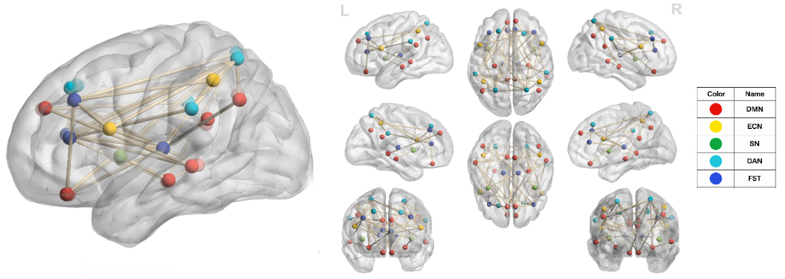
Figure 1. Functional networks used to organize the reduced ROI panels: DMN, ECN, SN, DAN, and FST.

Starting from the AAL116 atlas (Tzourio-Mazoyer et al., 2002), four fixed panels (116, 39, 18, and 12 ROIs) were prespecified regarding the functional networks implicated in ADHD (Figure 1). Panel definitions were fixed before the multi-site evaluation; the panels were not selected using performance at any site, and no ROI selection was repeated within cross-validation folds. The 12-ROI panel (Table 2) is nested within the 18-ROI panel; the 39-ROI panel shares six regions with the 12-ROI panel and eight with the 18-ROI panel and is not a superset of either.
ROI (AAL116) | Anatomical region | Main function | Network
Frontal_Sup_L | Left superior prefrontal cortex | Sustained attention and executive control | ECN-DMN
Insula_R | Right insula | Emotional integration, interoception, and attention | SN
Cingulum_Ant_L | Left anterior cingulate | Cognitive control and emotional regulation | SN
Cingulum_Ant_R | Right anterior cingulate | Cognitive control and error monitoring | SN
Precuneus_L | Left precuneus | Relaxation and autobiographical memory | DAN-DMN
Precuneus_R | Right precuneus | Introspection and self-reference | DAN-DMN
Caudate_L | Left caudate nucleus | Motor control, reward, and learning | FST
Caudate_R | Right caudate nucleus | Motor control, reward, and motivation | FST
Putamen_L | Left putamen | Motor function and movement planning | FST
Putamen_R | Right putamen | Motor function and habit processing | FST
Thalamus_L | Left thalamus | Sensory integration and motor coordination | FST
Thalamus_R | Right thalamus | Sensory integration and attention | FST
Table 2. Composition of the 12-ROI panel, including anatomical region, main function, and associated functional network.

  - BrainNetCNN

  - Experimental and Evaluation Setup
Experimental Design
The reference BrainNetCNN configuration was developed and fixed using NYU before the multi-site evaluation. Accordingly, NYU is a re-evaluation of the development site for the model configuration rather than an independent validation; Peking, NeuroIMAGE, and OHSU were not used for hyperparameter development.
The prespecified BrainNetCNN training and regularization specification reported in Table 3 was used without dimensionality-specific retuning across ROI panels and the representation and windowing sensitivity conditions. The same specification was applied to the static-connectivity leave-one-site-out (LOSO) conditions without LOSO-stage retuning; for LOSO, five initialization seeds (42–46) were run instead of the single reference seed shown in Table 3. Because window counts and model dimensions varied across sites and panels, ROI comparisons represent complete pipelines rather than anatomical coverage alone.
Parameter | Value | Parameter | Value
Edge-to-edge filters | 4 | Learning rate | 1 × 10⁻⁴
Edge-to-node filters | 8 | Batch size | 32
Node-to-graph filters | 8 | Maximum epochs | 300
Final dropout | 0.7 | Patience | 25
Intermediate dropout | 0.6 | Early-stopping monitor | val_loss
LeakyReLU negative slope | 0.33 | min_delta | 1 × 10⁻⁵
L2 regularization | 0.05 | Inner validation fraction | 0.15
Optimizer | Adam | Seed | 42
Loss function | Binary cross-entropy | Numerical precision | FP32
Table 3. Prespecified BrainNetCNN training and regularization specification used without dimensionality-specific retuning across sites, ROI panels, and representation and windowing sensitivity conditions. The same specification was applied without LOSO-stage retuning to the static-connectivity LOSO conditions; for LOSO, five initialization seeds (42–46) were run instead of the single reference seed shown.

The long short-term memory (LSTM) model had 128 hidden units, no dropout, and one unidirectional layer; it used the reference BrainNetCNN learning rate, batch size, epoch ceiling, patience, and seed. The gated recurrent unit (GRU) used the same training configuration and 151 units, yielding 99,359 parameters versus the LSTM's 99,969, a match within 1% that avoided a capacity confound between the recurrent architectures. DeepSets, an order-invariant pooling architecture that reduces to a multilayer perceptron over the connectivity vector when supplied one window, was evaluated with static and windowed connectivity under the same training configuration. L2-regularized logistic regression used C = 1.0 and features standardized by a scaler fitted only to each fold's training data; epoch- and gradient-based Table 3 parameters did not apply.
The within-site analysis comprised three components. First, out-of-fold performance was summarized separately for the four fixed ROI panels at each site. Second, the primary paired contrast compared the 116-ROI atlas with the 12-ROI panel; the 18-versus-12 and 39-versus-12 ROI contrasts were secondary. Third, sensitivity analyses evaluated connectivity representation, model architecture, window configuration, and learning algorithm. ROI-panel, representation, and logistic-regression conditions were evaluated at all four sites. Architecture and windowing analyses were exploratory and were subsequently restricted to NYU and Peking, the two largest sites, which also provided the most precise primary-comparison estimates. The representation comparison also included DeepSets at all four sites, and the architecture comparison included GRU at NYU and Peking. The learning-algorithm comparison additionally included DeepSets as a second non-recurrent algorithm at all four sites.
Sensitivity analyses compared: (1) static with windowed connectivity both as a complete BrainNetCNN configuration change and as within-architecture contrasts for DeepSets and LSTM; (2) LSTM (128 units) and GRU (151 units) with BrainNetCNN; (3) 140-s/12-s, 120-s/24-s, and 60-s/12-s window settings with the 120-s/12-s reference; and (4) BrainNetCNN with L2-regularized logistic regression and with DeepSets at matched static representation. The 60-s window was also compared with GRU's own 120-s/12-s configuration.
At 12 ROIs, the logistic-regression and DeepSets algorithm contrasts used matched static BrainNetCNN comparators. At 18, 39, and 116 ROIs, logistic regression was compared with windowed BrainNetCNN, so representation and algorithm both changed. The DeepSets and LSTM static-versus-windowed contrasts held architecture and all training hyperparameters fixed; the GRU windowing contrast held architecture fixed relative to its own 120-s reference.
Within-Site Evaluation
All runs used 10-fold stratified cross-validation repeated five times, reserving 15% of each outer-training set for early stopping. All windows from a participant remained in one partition, and identical participant partitions were used across panels and sensitivity conditions within each site to enable paired comparisons. Peking used inverse-frequency class weights computed only from each fold's fitting data; NYU, NeuroIMAGE, and OHSU used none. This site-specific policy was documented before the corresponding runs, held constant across conditions, and addressed Peking's class imbalance.
Cross-Site Transportability Evaluation across the Observed Sites (Leave-One-Site-Out)
A separate leave-one-site-out (LOSO) analysis assessed transportability across the four observed acquisition sites. Each rotation held out one site and trained the models on the other three. Within the pooled source sites, a 15% subset stratified by site × diagnosis with random_state=42 was reserved for inner validation; the same fit/inner-validation/test split was used across ROI dimensionalities, model families, and BrainNetCNN seeds.
LOSO used static Pearson functional connectivity at 12 and 116 ROIs (66 and 6,670 upper-triangular edges), without Fisher z-transformation, post hoc harmonization, or class, site, or sample weighting. BrainNetCNN used the frozen Table 3 specification, five initialization seeds (42–46) per condition, and the inner-validation split for early stopping. The deterministic logistic-regression comparator was fitted once to the fit subset, with no tuning or early stopping, L2 regularization at C = 1.0, and a scaler fitted only on the same subset.
The held-out site was excluded from scaling, fitting, inner validation, early stopping, and LOSO-stage selection or tuning, although this did not remove NYU's historical exposure. During NYU 12-ROI windowed-connectivity development, the L2 penalty and intermediate dropout rate were retained over tested alternatives based on out-of-fold performance. The resulting specification was applied without retuning to static-connectivity LOSO.
The absence of post hoc harmonization describes the evaluated procedure and does not demonstrate the absence of site effects. LOSO assesses transportability only across the four observed sites, not in an independent future cohort.
  - Statistical Analysis
The primary within-site metric was the area under the receiver operating characteristic curve (AUC) of out-of-fold predictions aggregated by repetition: predictions from the ten outer folds were pooled within each repetition, AUC was calculated over all participants at the site, and the five AUCs were averaged. Aggregation by repetition was used to avoid the discreteness and high variability of fold-level estimates from outer test folds of 3–19 participants. AUC was chosen because it evaluates ranking across thresholds and is less directly affected by class prevalence than accuracy. Secondary metrics were balanced accuracy, macro F1, sensitivity, and specificity at a fixed probability threshold of 0.5; simple accuracy was retained only for audit.
Uncertainty was estimated by resampling participants with replacement, stratified by class to preserve site-specific case-control proportions. Within each comparison, the same resampled participants were used for both conditions and all five repetitions. Two-sided 95% interval limits were the 2.5th and 97.5th percentiles of 10,000 resamples generated with NumPy PCG64, seed 42, reset for each comparison.
These intervals quantify participant-sampling variability conditional on stored repeated-cross-validation predictions, without model retraining or new partitions; the within-site AUC therefore summarizes the repeated-cross-validation procedure rather than a single fitted model. Sensitivity intervals were pointwise and unadjusted for multiplicity. No non-inferiority margin was specified; two-sided differences and uncertainty were reported. Because folds and repetitions shared participants and training data, they were not treated as independent replicates for analysis of variance or post hoc testing.
For each LOSO rotation, the estimand was held-out-site AUC for the frozen procedure trained on the other three sites. BrainNetCNN averaged five seed-specific AUCs; logistic regression used one deterministic fit, and between-seed dispersion was summarized separately. Secondary metrics and the 0.5 threshold matched the within-site analysis. Class-stratified resampling of participants with replacement within the held-out site quantified sampling variability conditional on frozen predictions and a fixed source-site composition, without model retraining or changes to the data partitions. Interval limits were the 2.5th and 97.5th percentiles of 10,000 NumPy PCG64 resamples (seed 42) and were pointwise and unadjusted for multiplicity. Resamples were shared across conditions and contrasts within each held-out site, with the generator reset by site rather than by comparison to preserve pairing. The prespecified contrasts were BNN116−BNN12, Logistic12−BNN12, and Logistic116−BNN116 (BNN, BrainNetCNN).
Training and inner-validation loss and accuracy trajectories, the outer-training versus out-of-fold AUC gap, and the number of folds reaching the 300-epoch ceiling were examined descriptively. These diagnostics were not treated as formal hypothesis tests.
  - Ethical Considerations
This study used anonymized data from the public ADHD-200 repository (ADHD-200 Consortium, 2011), access to which is subject to registration and the ADHD-200/INDI terms of use. The data were originally collected under protocols approved by the ethics committees of the participating institutions; informed consent was obtained from participants or their legal guardians at each of the four sites. This secondary analysis of retrospective, de-identified data required no new interaction with participants or additional consent procedures, and no attempt was made to re-identify participants.

- Results
  - Performance of the Prespecified ROI Panels
Site | ROIs | n | AUC [95% CI] | Balanced accuracy | Macro F1 | Sensitivity | Specificity
NYU | 12 | 177 | 59.0 [53.8, 64.3] | 57.4 ± 2.8 | 57.3 ± 2.8 | 54.7 ± 5.6 | 60.2 ± 5.6
 | 18 | 177 | 60.0 [54.7, 65.3] | 56.7 ± 3.5 | 56.6 ± 3.5 | 58.0 ± 2.7 | 55.4 ± 8.8
 | 39 | 177 | 52.8 [47.4, 58.2] | 52.3 ± 2.1 | 52.1 ± 2.2 | 48.4 ± 5.3 | 56.1 ± 5.9
 | 116 | 177 | 53.9 [48.8, 59.0] | 53.1 ± 1.9 | 53.0 ± 1.8 | 54.0 ± 4.9 | 52.2 ± 3.3
Peking | 12 | 183 | 56.4 [50.7, 62.1] | 54.1 ± 5.2 | 53.9 ± 5.2 | 46.8 ± 9.1 | 61.5 ± 6.3
 | 18 | 183 | 56.8 [50.6, 62.8] | 54.0 ± 2.6 | 53.9 ± 2.5 | 46.5 ± 5.5 | 61.5 ± 4.0
 | 39 | 183 | 62.2 [56.5, 67.7] | 60.3 ± 2.9 | 60.1 ± 3.2 | 55.7 ± 3.2 | 65.0 ± 7.8
 | 116 | 183 | 60.3 [54.4, 66.1] | 58.1 ± 3.5 | 57.9 ± 3.8 | 53.2 ± 4.4 | 62.9 ± 8.1
NeuroIMAGE | 12 | 39 | 47.4 [37.3, 57.3] | 44.3 ± 4.3 | 43.4 ± 4.2 | 34.1 ± 15.2 | 54.5 ± 13.3
 | 18 | 39 | 62.0 [51.6, 72.0] | 57.6 ± 4.5 | 57.2 ± 4.1 | 55.3 ± 12.2 | 60.0 ± 9.9
 | 39 | 39 | 50.7 [41.8, 60.0] | 53.7 ± 5.9 | 53.5 ± 5.8 | 44.7 ± 6.7 | 62.7 ± 11.8
 | 116 | 39 | 51.9 [41.5, 62.6] | 50.3 ± 6.8 | 50.0 ± 6.9 | 38.8 ± 7.9 | 61.8 ± 10.9
OHSU | 12 | 66 | 54.9 [47.1, 62.4] | 53.6 ± 4.8 | 53.3 ± 4.6 | 47.1 ± 12.2 | 60.0 ± 5.1
 | 18 | 66 | 52.2 [44.4, 60.1] | 51.1 ± 3.7 | 50.5 ± 3.5 | 42.1 ± 12.7 | 60.0 ± 10.4
 | 39 | 66 | 50.1 [40.5, 59.7] | 47.0 ± 4.8 | 46.7 ± 4.5 | 42.9 ± 10.1 | 51.1 ± 7.3
 | 116 | 66 | 55.8 [47.8, 63.8] | 54.2 ± 4.7 | 53.7 ± 5.2 | 53.6 ± 7.1 | 54.7 ± 10.4
Table 4. Out-of-fold performance by site and ROI panel, expressed as percentages. AUC is reported with its two-sided 95% confidence interval, based on 10,000 class-stratified participant-level bootstrap resamples; secondary metrics are reported as mean ± standard deviation across the five repetitions.
Out-of-fold discrimination was limited (Table 4), with AUC ranging from 47.4% to 62.2% across sites and ROI panels. The highest point estimate occurred at 18 ROIs in NYU and NeuroIMAGE, 39 ROIs in Peking, and 116 ROIs in OHSU. The 12-ROI panel was not highest at any site but was close to the maximum in NYU (59.0 compared with 60.0) and Peking (56.4 compared with 56.8). These descriptive point estimates do not establish superiority.
Nine of sixteen 95% confidence intervals included AUC = 0.5: all four OHSU conditions, three NeuroIMAGE conditions, and the 39- and 116-ROI conditions in NYU. Available precision did not distinguish these estimates from chance-level discrimination. Peking alone had four intervals excluding 0.5 (Figure 2).

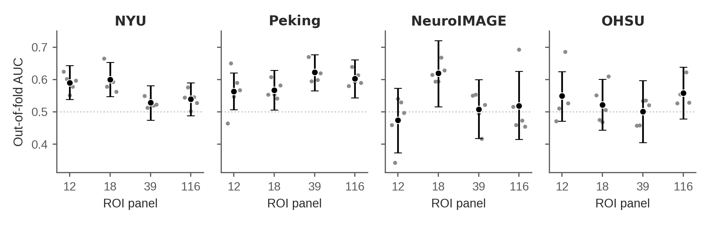
Figure 2. Mean out-of-fold AUC by ROI count and site. The x-axis shows the 12-, 18-, 39-, and 116-ROI panels. Black points show the mean of the five repeat-level out-of-fold AUC values, with vertical bars showing two-sided 95% participant-bootstrap confidence intervals; gray points show the five individual repeat-level AUC values. The horizontal dashed line indicates chance-level discrimination (AUC = 0.50).
  - Paired ROI-Panel Comparisons
For the primary 116-minus-12 ROI comparison, AUC differences were −5.1 percentage points in NYU, +4.0 in Peking, +4.5 in NeuroIMAGE, and +0.9 in OHSU. All confidence intervals included zero: [−11.1, +0.7], [−2.5, +10.5], [−10.3, +20.0], and [−8.3, +9.9], respectively. Point estimates varied in magnitude and direction across sites, and the intervals did not support a consistent direction.
Because the BrainNetCNN configuration was developed at NYU, its favorable 12-ROI estimate is an internal re-evaluation rather than independent validation.
Intermediate-panel comparisons were also mixed. Relative to 12 ROIs, the 39-ROI AUC in NYU was 6.2 percentage points lower, with an interval excluding zero, whereas the 18-ROI estimate was similar. In NeuroIMAGE, the 18-ROI AUC was 14.6 percentage points higher, also with an interval excluding zero.
  - Sensitivity Analyses
Static BrainNetCNN connectivity changed AUC by −4.1 percentage points in NYU, −3.5 in Peking, −3.4 in OHSU, and +5.4 in NeuroIMAGE; all intervals included zero. Because representation and model capacity both changed, this complete-configuration contrast did not isolate representation. Within fixed architectures, static-versus-windowed AUC differences were +1.1 percentage points in NYU and 0.0 in Peking for DeepSets and +1.9 in NYU and −1.4 in Peking for LSTM; all intervals included zero. Across the three architectures, no comparison showed a consistent advantage of windowed over static connectivity (Figure 3; Table 5).
Relative to BrainNetCNN, LSTM AUC differences were −6.5 percentage points in NYU [−10.9, −2.0] and −0.1 in Peking [−4.7, +4.4]. Because capacity and regularization also differed, these were configuration-level rather than architecture-isolated contrasts. Parameter-matched GRU showed corresponding deficits of −7.1 [−11.9, −2.3] and −0.6 [−5.1, +3.8]. LSTM and GRU therefore had similar point-estimate deficits at each site, but no direct LSTM-versus-GRU contrast was performed. Neither recurrent architecture showed an AUC advantage over BrainNetCNN at either site.
The 140-s/12-s and 120-s/24-s conditions had larger AUC deficits in NYU (−3.3 percentage points [−6.5, +0.1] and −4.7 [−8.6, −0.8]) than in Peking, where both differences were below 1 percentage point in magnitude and intervals included zero. Although each contrast changed one configured parameter, window length or step also changed overlap, window count, and potentially effective capacity; these were complete-condition contrasts.
For the 60-s/12-s window, BrainNetCNN AUC changed by −4.6 percentage points in NYU [−8.8, −0.6] and +1.3 in Peking [−2.8, +5.5]. Relative to GRU's 120-s reference, the corresponding differences were −1.2 [−4.3, +1.8] and −5.2 [−8.6, −1.8]. These were likewise complete-condition rather than isolated window-length effects.
At matched static 12-ROI representation, logistic regression differed from BrainNetCNN by +2.5 percentage points in NYU, +6.3 in Peking, +10.4 in NeuroIMAGE, and −1.9 in OHSU; all intervals included zero. At 18, 39, and 116 ROIs, logistic regression was compared with windowed BrainNetCNN, so representation and algorithm both differed. Fifteen of sixteen intervals included zero; the exception was 39 ROIs in OHSU (−13.8 [−23.3, −4.7]). The matched static DeepSets comparison was also mixed (−1.9, +1.8, −4.2, and +2.6 percentage points in NYU, Peking, NeuroIMAGE, and OHSU, respectively), with all intervals including zero. Neither algorithm showed a consistent advantage over BrainNetCNN at matched representation.
Dimension | Condition | NYU | Peking | NeuroIMAGE | OHSU
ROI count | 18 ROIs | +1.0 [−3.7, +5.6] | +0.4 [−4.5, +5.4] | +14.6 [+3.8, +25.8] | −2.7 [−12.2, +6.6]
 | 39 ROIs | −6.2 [−12.3, −0.3] | +5.8 [−1.1, +12.9] | +3.4 [−9.3, +15.8] | −4.8 [−13.4, +4.1]
 | 116 ROIs (primary) | −5.1 [−11.1, +0.7] | +4.0 [−2.5, +10.5] | +4.5 [−10.3, +20.0] | +0.9 [−8.3, +9.9]
Connectivity | Static FC | −4.1 [−8.2, +0.2] | −3.5 [−8.3, +1.3] | +5.4 [−6.3, +17.4] | −3.4 [−10.9, +4.1]
 | Static FC (DeepSets) | +1.1 [−1.6, +3.9] | +0.0 [−2.3, +2.4] | — | —
 | Static FC (LSTM) | +1.9 [−1.0, +4.9] | −1.4 [−4.7, +1.9] | — | —
Architecture | LSTM (128 units) | −6.5 [−10.9, −2.0] | −0.1 [−4.7, +4.4] | — | —
 | GRU (151 units) | −7.1 [−11.9, −2.3] | −0.6 [−5.1, +3.8] | — | —
Window / step (s) | 140 / 12 | −3.3 [−6.5, +0.1] | −0.4 [−3.2, +2.4] | — | —
 | 120 / 24 | −4.7 [−8.6, −0.8] | −0.8 [−4.6, +3.0] | — | —
 | 60 / 12 | −4.6 [−8.8, −0.6] | +1.3 [−2.8, +5.5] | — | —
 | 60 / 12 (GRU) | −1.2 [−4.3, +1.8] | −5.2 [−8.6, −1.8] | — | —
Algorithm comparison | Logistic regression, 12 ROIs (static comparator) | +2.5 [−4.7, +9.5] | +6.3 [−1.1, +13.9] | +10.4 [−5.3, +25.9] | −1.9 [−13.5, +10.4]
 | DeepSets, 12 ROIs (static comparator) | −1.9 [−6.6, +2.8] | +1.8 [−3.3, +6.7] | −4.2 [−16.0, +7.3] | +2.6 [−5.3, +10.6]
 | 18 ROIs (windowed comparator) | −3.9 [−11.0, +3.0] | −6.3 [−13.8, +1.3] | −5.5 [−19.9, +8.9] | +10.6 [−0.7, +21.6]
 | 39 ROIs (windowed comparator) | +0.1 [−6.2, +6.5] | +0.2 [−6.2, +6.5] | +0.4 [−14.2, +14.8] | −13.8 [−23.3, −4.7]
 | 116 ROIs (windowed comparator) | +2.4 [−3.8, +8.6] | −1.1 [−7.4, +5.3] | +3.0 [−10.7, +17.2] | −1.2 [−10.6, +8.1]
Table 5. Paired differences in mean out-of-fold AUC, in percentage points, with two-sided 95% participant-bootstrap confidence intervals. For ROI count, architecture, and the BrainNetCNN connectivity and windowing rows, Δ = condition − the 12-ROI windowed BrainNetCNN reference. The DeepSets and LSTM connectivity rows and the GRU windowing row instead hold architecture fixed: Δ = static − windowed connectivity (DeepSets, LSTM) or Δ = 60-s − 120-s window (GRU), within that architecture. For logistic regression and DeepSets, Δ = the listed algorithm − its matched BrainNetCNN comparator at the same representation. For 18, 39, and 116 ROIs, the logistic-regression comparator is windowed, so both representation and algorithm differ. Dashes indicate conditions not evaluated. FC denotes functional connectivity.
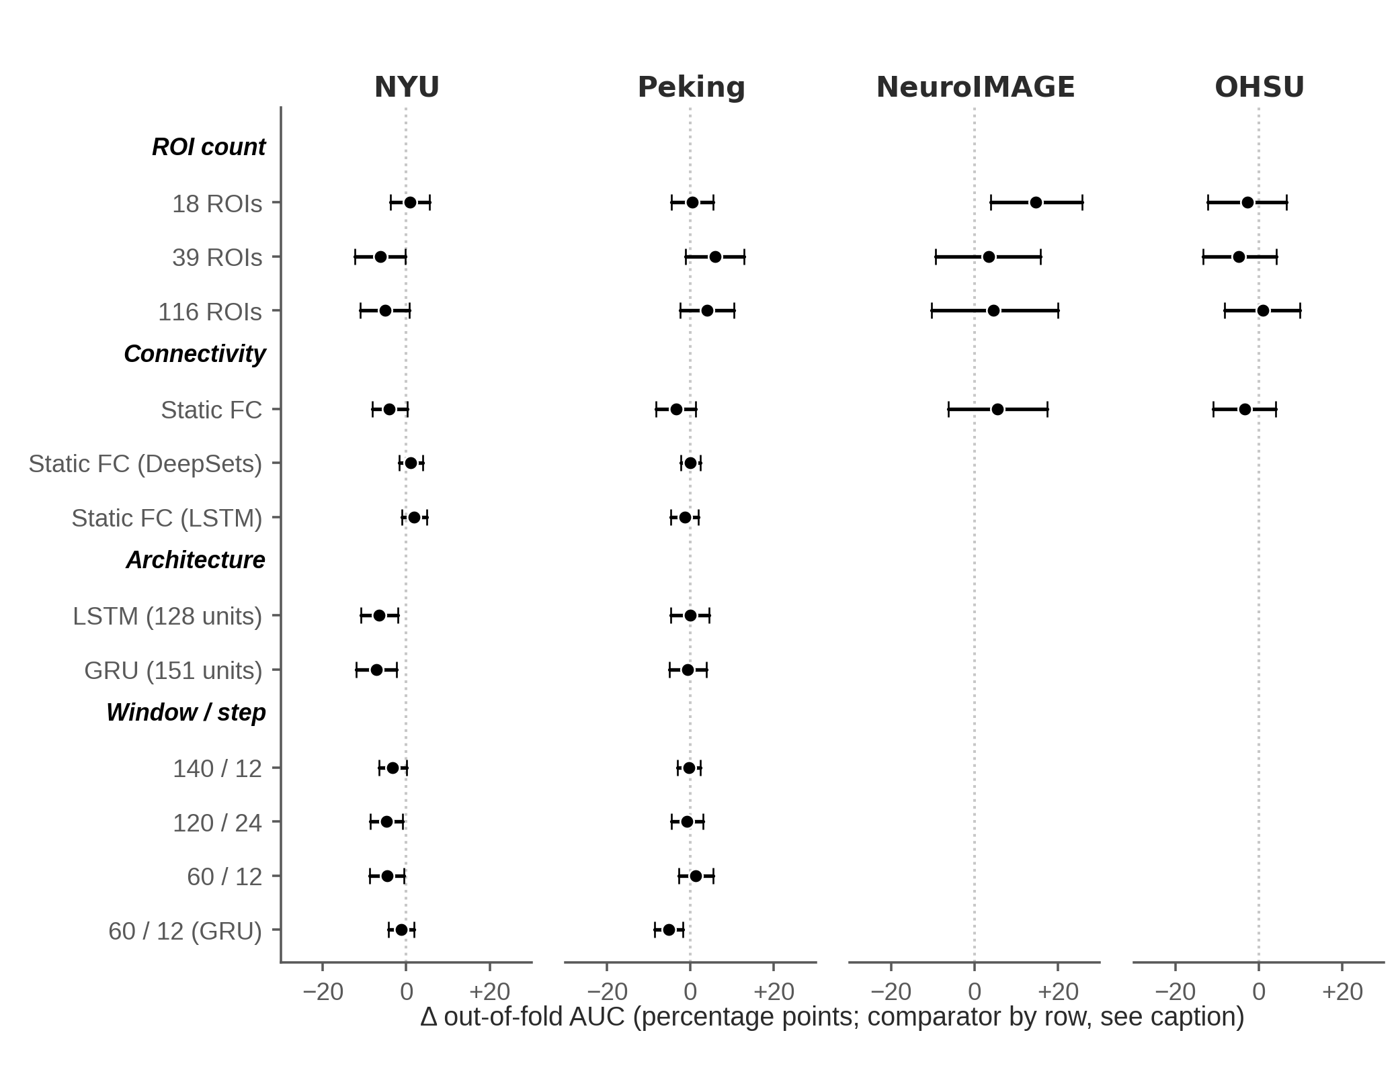
Figure 3. Sensitivity analyses relative to the 12-ROI windowed BrainNetCNN reference. The DeepSets and LSTM connectivity rows and the GRU windowing row are exceptions because they hold architecture fixed: the DeepSets and LSTM rows compare static with windowed connectivity, and the GRU row compares a 60-s window with a 120-s window (see Table 5 note). Points show paired differences in mean out-of-fold AUC, and horizontal bars show two-sided 95% participant-bootstrap confidence intervals. Positive values favor the listed condition. Windowing labels report window length/step in seconds. The plotted LSTM and GRU architecture contrasts, the DeepSets static-versus-windowed contrast, and the 60-s windowing contrasts were evaluated only at NYU and Peking. The separate static DeepSets-versus-BrainNetCNN algorithm comparison evaluated at all four sites is reported in Table 5.
  - Convergence and Model Behavior
Across sites, training cross-entropy decreased while inner-validation loss decreased more slowly, without a clear late upturn. Training loss exceeded validation loss throughout fitting at 12 and 18 ROIs, consistent with dropout being active only during fitting. At 39 and 116 ROIs, training accuracy continued rising after roughly the first third of training while inner-validation accuracy remained comparatively flat, consistent with increasing overfitting. The outer-training versus out-of-fold AUC gap generally increased with panel size and was largest at 116 ROIs at all sites, although not monotonically in NeuroIMAGE. Because a small gap can also reflect limited performance in both partitions, it was interpreted only alongside out-of-fold performance (Figure 4).
Early stopping was rare for the reference 12-ROI windowed BrainNetCNN: 44–50 of 50 folds reached 300 epochs, so the ceiling rather than the 25-epoch patience criterion governed duration. At 116 ROIs, 19–43 folds reached the ceiling by site, whereas early stopping occurred in every LSTM fold.

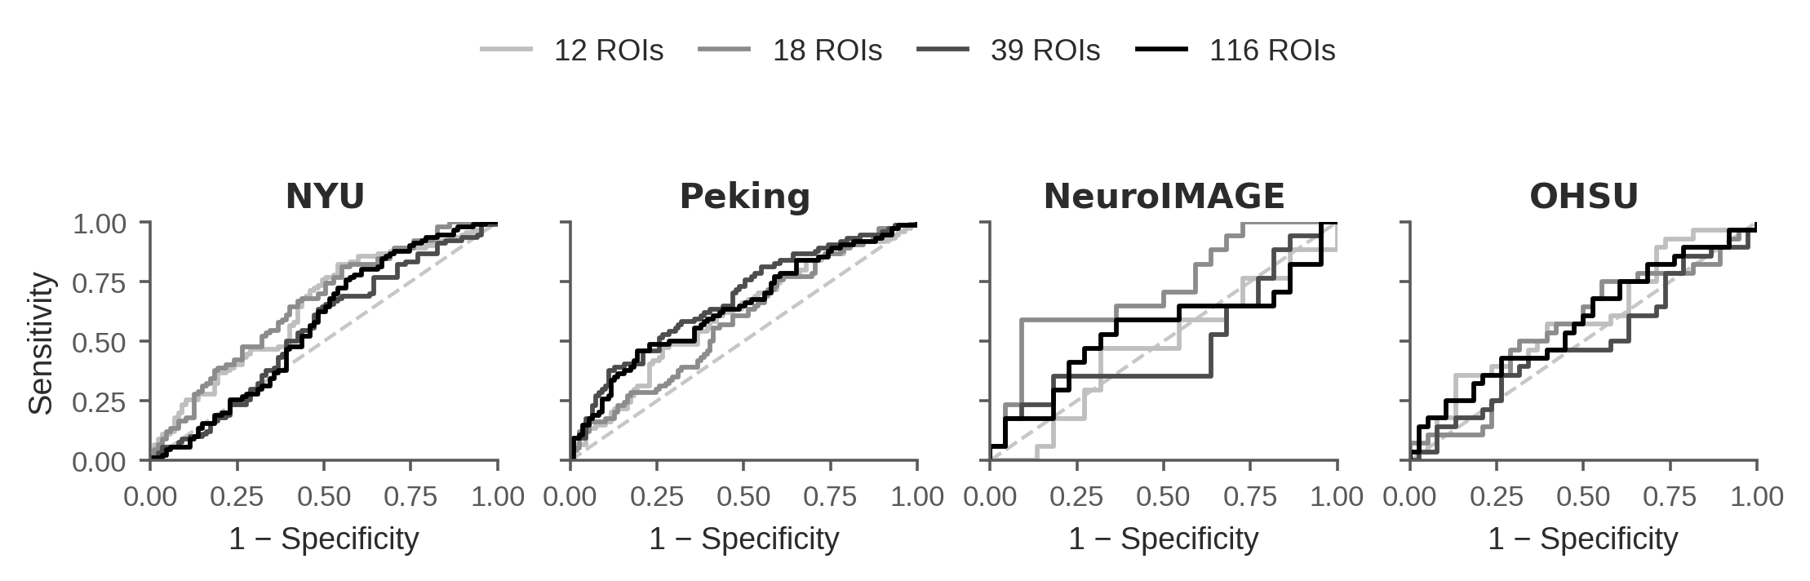
Figure 4. Out-of-fold ROC curves by site and ROI panel. Each curve uses the mean predicted probability across the five repetitions for each participant, based on the same out-of-fold predictions summarized in Table 4. The diagonal dashed line indicates chance-level discrimination (AUC = 0.50).
  - Site-Held-Out Performance under Leave-One-Site-Out Evaluation
Held-out sample sizes in Table 6 ranged from 39 in NeuroIMAGE to 183 in Peking, with corresponding variation in confidence-interval width. Across 16 held-out-site/model/ROI conditions, AUC ranged from 44.4% to 63.9%. Fourteen pointwise 95% intervals included AUC = 0.50; only 12-ROI BrainNetCNN in NYU and OHSU had intervals entirely above 0.50. These crossings were interpreted descriptively, not as 16 hypothesis tests.
Held-out site | BNN-12 AUC [95% CI] | LOSO Logistic-12 | BNN-116 | LOSO Logistic-116
NYU (held-out n=177) | 57.6 [50.9, 64.2] | 56.0 [47.2, 64.6] | 54.5 [48.1, 60.8] | 55.7 [47.0, 63.9]
Peking (held-out n=183) | 56.2 [48.6, 63.5] | 52.8 [44.1, 61.5] | 51.8 [45.8, 57.9] | 54.3 [45.3, 62.9]
NeuroIMAGE (held-out n=39) | 63.3 [47.8, 77.3] | 63.9 [45.7, 80.5] | 50.1 [38.8, 61.4] | 57.2 [38.8, 74.6]
OHSU (held-out n=66) | 63.1 [50.4, 75.3] | 53.3 [39.2, 67.1] | 49.6 [39.3, 60.1] | 44.4 [30.2, 58.9]
Table 6. Leave-one-site-out AUC by held-out site, ROI dimensionality, and model across the four observed acquisition sites. Held-out sample sizes are shown in the site labels. Values are AUC × 100 [95% CI]. BNN denotes BrainNetCNN. Confidence intervals were obtained from 10,000 class-stratified participant-bootstrap resamples within each held-out site and are pointwise, unadjusted, and conditional on the fixed source-site composition and frozen LOSO predictions for that rotation. BrainNetCNN point estimates are means of five seed-specific AUCs; logistic-regression estimates are from a single deterministic fit. No pooled estimate across sites was calculated. For BrainNetCNN, NYU had historical exposure during configuration development and its held-out-site result is therefore not development-independent (see Methods). LOSO partition sizes are detailed in Supplementary Table S_LOSO_Design.
The estimated BrainNetCNN 116-minus-12 ROI AUC differences were −3.0, −4.4, −13.3, and −13.5 percentage points in NYU, Peking, NeuroIMAGE, and OHSU, respectively; all paired 95% intervals included zero (Supplementary Table S_LOSO_Contrasts). Thus, the intervals did not establish an advantage of either dimensionality. Because the 12- and 116-ROI BrainNetCNN models used the same specification without dimensionality-specific retuning, this was not a comparison of separately optimized models.
The LOSO logistic-regression-versus-BrainNetCNN contrasts varied in direction across held-out sites at both ROI dimensionalities, and all eight corresponding 95% confidence intervals included zero (Supplementary Table S_LOSO_Contrasts). The LOSO results therefore did not support a consistent AUC advantage for either model family across the four observed sites.
Because the within-site and LOSO analyses differ in target estimand and connectivity representation and, for Peking, in class-weighting policy, their site-specific interval patterns were not interpreted as direct changes in performance.
References
ADHD-200 Consortium. (2011). The ADHD-200 Consortium: A model to advance the translational potential of neuroimaging in clinical neuroscience. Frontiers in Systems Neuroscience, 6, Article 62. https://doi.org/10.3389/fnsys.2012.00062
Bellec, P., Chu, C., Chouinard-Decorte, F., Benhajali, Y., Margulies, D. S., & Craddock, R. C. (2017). The Neuro Bureau ADHD-200 Preprocessed repository. NeuroImage, 144(Part B), 275–286. https://doi.org/10.1016/j.neuroimage.2016.06.034
Blomberg, R., Signoret, C., Danielsson, H., Perini, I., Rönnberg, J., & Johansson Capusan, A. (2022). Aberrant resting-state connectivity of auditory, ventral attention/salience and default-mode networks in adults with attention deficit hyperactivity disorder. Frontiers in Neuroscience, 16, Article 972730. https://doi.org/10.3389/fnins.2022.972730
Damiani, S., Tarchi, L., Scalabrini, A., Marini, S., Provenzani, U., Rocchetti, M., Oliva, F., & Politi, P. (2021). Beneath the surface: hyper-connectivity between caudate and salience regions in ADHD fMRI at rest. European Child & Adolescent Psychiatry, 30(4), 619–631. https://doi.org/10.1007/s00787-020-01545-0
Francx, W., Oldehinkel, M., Oosterlaan, J., Heslenfeld, D., Hartman, C. A., Hoekstra, P. J., Franke, B., Beckmann, C. F., Buitelaar, J. K., & Mennes, M. (2015). The executive control network and symptomatic improvement in attention-deficit/hyperactivity disorder. Cortex, 73, 62–72. https://doi.org/10.1016/j.cortex.2015.08.012
Hale, T. S., Kane, A. M., Kaminsky, O., Tung, K. L., Wiley, J. F., McGough, J. J., Loo, S. K., & Kaplan, J. T. (2014). Visual network asymmetry and default mode network function in ADHD: An fMRI study. Frontiers in Psychiatry, 5, Article 81. https://doi.org/10.3389/fpsyt.2014.00081
Koirala, S., Grimsrud, G., Mooney, M. A., Larsen, B., Feczko, E., Elison, J. T., Nelson, S. M., Nigg, J. T., Tervo-Clemmens, B., & Fair, D. A. (2024). Neurobiology of attention-deficit hyperactivity disorder: historical challenges and emerging frontiers. Nature Reviews Neuroscience, 25, 759–775. https://doi.org/10.1038/s41583-024-00869-z
Leonardi, N., & Van De Ville, D. (2015). On spurious and real fluctuations of dynamic functional connectivity during rest. NeuroImage, 104, 430–436. https://doi.org/10.1016/j.neuroimage.2014.09.007
Parlatini, V., Itahashi, T., Lee, Y., Liu, S., Nguyen, T. T., Aoki, Y. Y., et al. (2023). White matter alterations in attention-deficit/hyperactivity disorder (ADHD): a systematic review of 129 diffusion imaging studies with meta-analysis. Molecular Psychiatry, 28, 4098–4123. https://doi.org/10.1038/s41380-023-02173-1
Sutcubasi, B., Metin, B., Kurban, M. K., Metin, Z. E., Beser, B., & Sonuga-Barke, E. (2020). Resting-state network dysconnectivity in ADHD: a system-neuroscience-based meta-analysis. World Journal of Biological Psychiatry, 21(9), 662–672. https://doi.org/10.1080/15622975.2020.1775889
Tzourio-Mazoyer, N., Landeau, B., Papathanassiou, D., Crivello, F., Etard, O., Delcroix, N., Mazoyer, B., & Joliot, M. (2002). Automated anatomical labeling of activations in SPM using a macroscopic anatomical parcellation of the MNI MRI single-subject brain. NeuroImage, 15(1), 273–289. https://doi.org/10.1006/nimg.2001.0978
Yu, M., Linn, K. A., Cook, P. A., Phillips, M. L., McInnis, M., Fava, M., Trivedi, M. H., Weissman, M. M., Shinohara, R. T., & Sheline, Y. I. (2018). Statistical harmonization corrects site effects in functional connectivity measurements from multi-site fMRI data. Human Brain Mapping, 39(11), 4213–4227. https://doi.org/10.1002/hbm.24241

