Lab W01 - Preparing Your Environment
The orientation assignment had you install several applications. The lab will further prepare our environment and introduce some tools we will reference and use throughout the semester.
Part A. Connecting to Your CIS 4000 Work Repository
Windows: You have two options: Git Bash (command-line) and Git GUI. These instructions will use Git Bash because it makes the Linux command line easier to understand.

- Create a folder named ‘git’ somewhere in Windows. This is where you will store any cloned repositories. I recommend your home folder (typically C:\Users\username)
- Open Git Bash and set up a username and email in the config file.
git config --global user.name "Your Name"
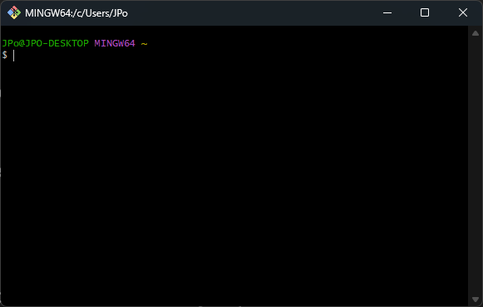
git config --global user.email your_email@example.com
- Generate an SSH Key (you can use previously generated keys).
ssh-keygen -t rsa -b 4096 -C "your_email@example.com"
- Add SSH Key to GitHub:
Copy the SSH key to your clipboard in Git Bash:
clip < ~/.ssh/id_rsa.pub
Go to GitHub online and navigate to Settings > SSH and GPG keys. Then click New SSH key, paste your key, and save. Follow that by testing the connection in Git Bash
ssh -T git@github.com
If successful, you will see a confirmation message.
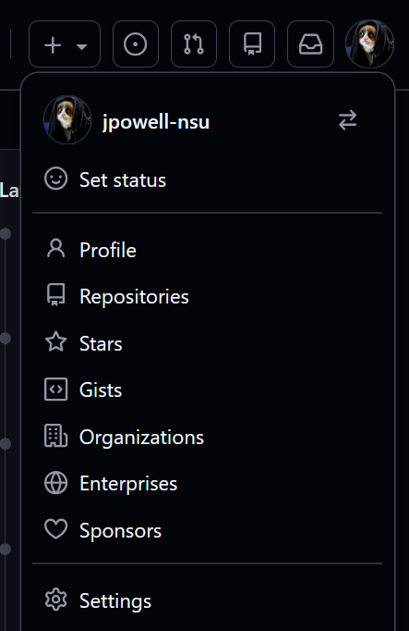
- Clone your cis4000work repository.
Go to your repository in GitHub and get the HTTP or SSH URL from the Code drop-down menu.
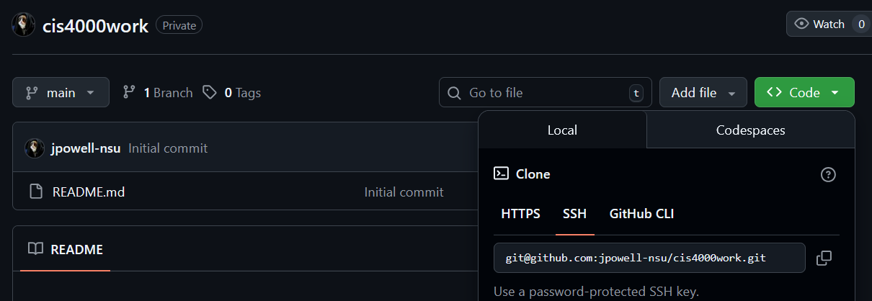
Next, issue the command in Git Bash
git clone https://github.com/username/repository.git git/cis4000work
If everything works, the cloned repository will be in your git/cis4000work folder.
- Next, try to commit a file.
In your cis4000work folder in Windows, create a simple text file called test.sql with the contents “SELECT hello FROM world;” (the query will not do anything; we just need content).
Now stage and commit it in Git Bash
go into the like ~/git/cis4000work (main): cd git/cis4000work
stages the files : git add .
set up the commit: git commit -m “chore(test)”
push the commit: git push origin main
Double-check it by going to github.com and looking in your repository for the file.
Linux: Git is very similar in Linux. This time, we will clone the repository, edit the file, commit the changes, then return to Windows and update the cloned repository.
- Start Xubuntu in your VM (or use your own Linux/macOS) and open a terminal. If you did not finish the installation from the orientation, you need to (see https://www.theodinproject.com/lessons/foundations-setting-up-git), including setting up an SSH key.
- Once it is set up, do the following at the command line.
In your home direct: mkdir git
Change into the directory: cd git
Clone it using SSH URL: git clone https://github.com/username/repository.git git/cis4000work
- In the cis4000work folder, edit the SQL file to add a second line: “SELECT hello FROM xubuntu;”
- Now stage and commit as we did in Git Bash.
go into ~/git/cis4000work: cd git/cis4000work
stages the files: git add .
set up the commit: git commit -m “chore(test)”
push the commit: git push origin main
Double-check it by going to github.com and looking in your repository for the file.
- Now, we need to return Windows and Git Bash to update the clone. In Git Bash, make sure you are in the cis4000work folder: ~/git/cis4000work (main). You may have to cd into it when you open the Git Bash terminal. Then issue the following:
git pull
You should see it update the repository, and you can view the changes by opening the SQL file.
Overall, this is a simple process, but you must pay attention to details and may need to adapt. You can add files and folders to your cloned repository and similarly commit them. There are a lot of things to know about GitHub, and it is so common in the industry that you may be asked about it in an interview. I recommend spending some time learning it in more detail.
Submission: Enter “done” in Moodle submission textbox when you complete the assignment.

