Examples on how to write out the solution to various sorting algorithms.

Bubble sort: -34 13 16 -22 17 47 26 25 -1 37 32

Pass 1:
-34 13 16 -22 17 47 26 25 -1 37 32
-34 13 -22 16 17 47 26 25 -1 37 32
-34 13 -22 16 17 26 47 25 -1 37 32
-34 13 -22 16 17 26 25 47 -1 37 32
-34 13 -22 16 17 26 25 -1 47 37 32
-34 13 -22 16 17 26 25 -1 37 47 32
-34 13 -22 16 17 26 25 -1 37 32 47

Pass 2:
-34 13 -22 16 17 26 25 -1 37 32 47
-34 -22 13 16 17 26 25 -1 37 32 47
-34 -22 13 16 17 25 26 -1 37 32 47
-34 -22 13 16 17 25 -1 26 37 32 47
-34 -22 13 16 17 25 -1 26 32 37 47

Pass 3:
-34 -22 13 16 17 25 -1 26 32 37 47
-34 -22 13 16 17 -1 25 26 32 37 47

Pass 4:
-34 -22 13 16 17 -1 25 26 32 37 47
-34 -22 13 16 -1 17 25 26 32 37 47

Pass 5:
-34 -22 13 16 -1 17 25 26 32 37 47
-34 -22 13 -1 16 17 25 26 32 37 47

Pass 6:
-34 -22 -1 13 16 17 25 26 32 37 47

Selection sort: -34 13 16 -22 17 47 26 25 -1 37 32

First Swap: -34 13 16 -22 17 32 26 25 -1 37 47
Second Swap: -34 13 16 -22 17 -1 26 25 32 37 47
Third Swap: -34 13 16 -22 17 -1 25 26 32 37 47
Fourth Swap: -34 13 16 -22 -1 17 25 26 32 37 47
Fifth Swap: -34 13 -1 -22 16 17 25 26 32 37 47
Sixth Swap: -34 -22 -1 13 16 17 25 26 32 37 47

Mergesort -34 13 16 -22 17 47 26 25 -1 37 32

Note: Diagramming depends on the tool you have. The one below was done in Draw.io. The important part thing is to show the splitting and merging. You can draw it out on paper or a white board.
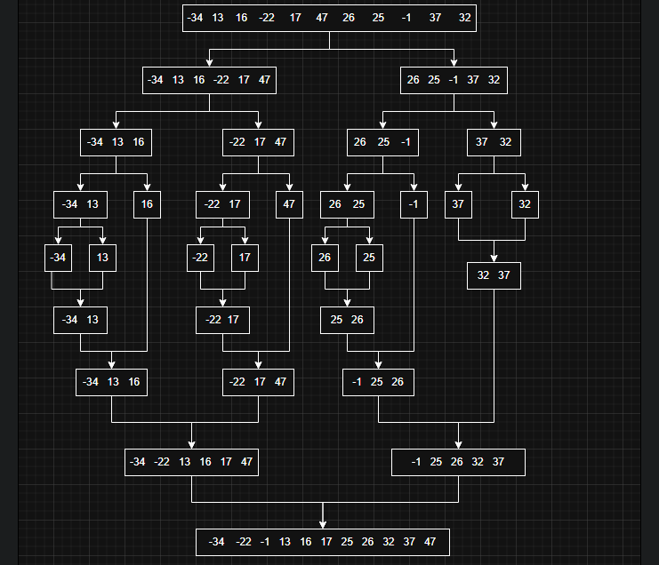
Quicksort

