CIS 4020 · DATA STRUCTURES
Queues
Extra Practice Problems

These are optional practice problems. They are not required, not collected, and not graded. They exist so you can build comfort with queues, at your own pace, before or alongside the required assignment. These were the required assignment in a previous semester, so they run the same range of difficulty as that assignment.
A general note on the “explain why this fails” problems: Not every algorithm shown in this set is actually broken. If you trace one carefully and cannot find an error, trust your work and simply write “no error,” then move on.

1. Palindrome Recognition (Stack and Queue Trace)
Select one of the strings below and trace the palindrome-recognition algorithm described in “Simple Applications of the ADT Queue” (starting on page 412, with pseudocode on page 414) for the string. Show the operation, stack, and queue contents after each operation in the table below, using a setup similar to Figure 8.2.
Choose one string.
Option 1 | Option 2 | Option 3
rmaveevamr | zgeeegz | bgrcigb
amexxema | fvzxzvf | eeeqheee
wogrkgow | xwrltrwx | sijjyyjjis

- The queue is named q, and the stack is named s; for example, q.enqueue(a) and s.push(a).
- You do not need to show the temporary variable; for example, s.pop() instead of temp = s.pop().
- You can combine two related operations on the same line.
- State “false” as the operation if the algorithm terminates with false.
- You do not need to show operations for creating the queue or stack.
- You do not need to show the operation to compare the characters.
- Add more rows if needed.
Table 1: Palindrome trace.
Operation | Stack (base on the left) | Queue (front on the left)
q.enqueue(first char), s.push(first char) | (first char) | (first char)

2. Mixed Stack and Queue Trace
Trace the following pseudocode and show the contents of the stack and queue at the end of each loop iteration. Add more rows as needed.
- Assume q is a queue for integers, and s is a stack for integers.
- q.poll() dequeues the item, q.offer(x) enqueues the item.
- s.pop() pops the item, s.push(x) pushes the item.
- The queue is already loaded as shown.
- Use (empty) to indicate if the stack or queue is empty at that point.
For i = 1 to 4 {
a <- q.poll();
s.push(a);
b <- q.poll();
s.push(b);
c <- s.pop();
q.offer(c + a);
d <- s.pop();
q.offer(d - b);
}
Table 2: Loop trace.
i | Stack (base on the left side) | Queue (front on the left side)
 | (empty) | 23 15 16 3 18
1
2
3
4

3. Droid Report Scheduling
Rebel droid units line up to report to Princess Leia. Each droid arrives at a given time, spends a set amount of time reporting, and then departs.
- Use a queue to manage the droids in order of arrival.
- At each arrival or departure event, update the queue.
- Show both the processing schedule (start and finish times) and the queue contents at each event.
- Add rows as needed.
Table 3: Arrivals.
Droid | Arrival Time | Length
A | 2 | 5
B | 4 | 3
C | 7 | 4
D | 9 | 6
E | 13 | 5
F | 14 | 7

Table 4: Processing schedule.
Droid ID | Arrival Time | Required Time | Begin Report Time | End Report Time

Table 5: Queue contents at each event.
Event Time | Queue (front on the left side)

4. Sorting Boxes with a Stack and a Queue
Spock must sort boxes by size in ascending order. Scotty loads them into a cubby hole (a stack). Spock can also use a conveyor belt (belt B, a queue) to help. His goal is to sort with the fewest operations.

Rules
- Move one box at a time.
- Stack (cubby hole): push/pop only at the top.
- Queue (belt B): offer to back, poll from front.
- Must place a box onto a stack or queue — no floor, table, or other help.
- May peek at the stack top or queue front.
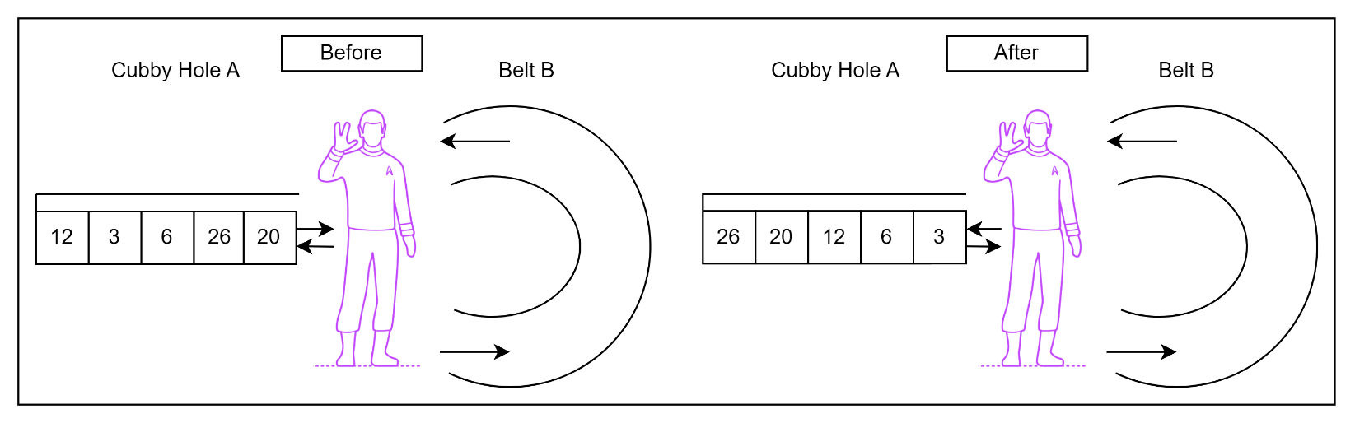
Before and after: the boxes end sorted so popping the stack yields ascending order.
Spock may move boxes between stack A and queue B in any order (A→B, B→A, A→A, B→B). Show each operation and the contents of A and B in the table below. Two operations may be shown per row (e.g., move box 4 to belt B). Add rows as needed.
Table 6: Box-sorting operations.
Operation(s) | Stack (base on the left) | Belt (front on the left)
Initial setup | 12 3 6 26 20
e.g. A.poll(), B.offer(18) | 12 3 6 26 | 20

5. Removing Duplicates
The pseudocode algorithm below is intended to remove all duplicate values from a queue and preserve the original order.
(a) Explain why this algorithm fails.
(b) Correct the pseudocode, highlighting or commenting on what changes you make.
tempQueue = new empty queue
WHILE queue is not empty:
value = DEQUEUE(queue)
isDuplicate = FALSE
// Check tempQueue for duplicates
helperQueue = new empty queue
WHILE tempQueue is not empty:
tempValue = DEQUEUE(tempQueue)
IF tempValue == value THEN
isDuplicate = TRUE
ENQUEUE(helperQueue, tempValue)
// Restore tempQueue
WHILE helperQueue is not empty:
ENQUEUE(tempQueue, DEQUEUE(helperQueue))
// Keep value if not duplicate
IF NOT isDuplicate THEN
ENQUEUE(tempQueue, value)
// Restore original queue (preserve order)
WHILE tempQueue is not empty:
ENQUEUE(queue, DEQUEUE(tempQueue))

6. Maximum Value
The pseudocode algorithm below is intended to find the maximum value and preserve the original order.
(a) Explain why this algorithm fails.
(b) Correct the pseudocode, highlighting or commenting on what changes you make.
max = -Infinity
tempQueue = new empty queue
WHILE queue is not empty:
value = DEQUEUE(queue)
IF value > max THEN
max = value
ENQUEUE(tempQueue, value)
// Restore original queue
WHILE tempQueue is not empty:
ENQUEUE(queue, DEQUEUE(tempQueue))
RETURN max

7. Interleaving Two Queues
The pseudocode algorithm below is intended to interleave two queues, A and B, and maintain their relative order, e.g., [1, 2, 3] and [4, 5, 6] become [1, 4, 2, 5, 3, 6].
(a) Explain why this algorithm fails.
(b) Correct the pseudocode, highlighting or commenting on what changes you make.
mergedQueue = new empty queue
WHILE NOT queueA.isEmpty() AND NOT queueB.isEmpty():
ENQUEUE(mergedQueue, DEQUEUE(queueA))
ENQUEUE(mergedQueue, DEQUEUE(queueB))
WHILE NOT queueA.isEmpty():
ENQUEUE(mergedQueue, DEQUEUE(queueA))
WHILE NOT queueB.isEmpty():
ENQUEUE(mergedQueue, DEQUEUE(queueB))

