CIS 4020 · DATA STRUCTURES
Stacks
Extra Practice Problems

These are optional practice problems. They are not required, not collected, and not graded. They exist so you can build comfort with stacks, at your own pace, before or alongside the required assignment. Some of these were the required assignment in a previous semester, so they run the same range of difficulty as that assignment.
A general note on the “explain why this fails” problems: Not every algorithm shown in this set is actually broken. If you trace one carefully and cannot find an error, trust your work and simply write “no error,” then move on.

1. Balanced Parentheses (Stack Trace)
Use a stack trace (see lecture and page 360) to determine if the expression's parentheses are balanced, for each expression below.
- ((a / (b + c)) / (d * (e)))
- ((a + (b * ((c - d)) * e)) - f)
- ((a / b) - 3 * 4 * c) + ((2 / d) + 7 * (e - 2)) * f

2. Infix to Postfix (Stack Trace)
For each infix expression, convert it to postfix using a stack trace (see Fig. 7-9 on page 377 and our lecture). Digits and letters are operands.
- ((a / (b + c)) / (d * (e)))
- ((a + (b * ((c - d)) * e)) - f)
- ((a / b) - 3 * 4 * c) + ((2 / d) + 7 * (e - 2)) * f

3. Push/Pop Order Puzzle
Suppose you have a stack to push and pop values 1, 2, 3, 4, 5, and 6 in ascending order. You must push the values in that order. However, once on the stack, a value can be popped and printed but never pushed back onto the stack. Given these constraints, provide the operations that produce the printed sequences seen in (a) through (c). If it cannot be done, show the push and pops until it fails.
For example, 2 4 5 6 3 1 can be done using the sequence below: push(1), push(2), pop(), push(3), push(4), pop(), push(5), pop(), push(6), pop(), pop(), pop().
Table 1: Why the example sequence works.
Stack (top on the right) | Operation
1 | push 1
1 2 | push 2
1 | pop and print 2
1 3 | push 3
1 3 4 | push 4
1 3 | pop and print 4
1 3 5 | push 5
1 3 | pop and print 5
1 3 6 | push 6
1 3 | pop and print 6
1 | pop and print 3
(empty) | pop and print 1

(a) 4 3 6 5 2 1
(b) 5 4 1 3 6 2
(c) 3 2 5 4 6 1

4. Train Car Reordering
Using the technique shown in the lecture and textbook, list the push and pop operations that would result in the after image, given the before image of train cars below. You can write the method calls like “temp = A.pop()” and “B.push(temp)”, or combine a pair like “B.push(A.pop()).” The tracks are only connected as shown, and each track is long enough to hold any necessary train cars. Minimize the number of operations needed. Two separate before/after pairs are shown.
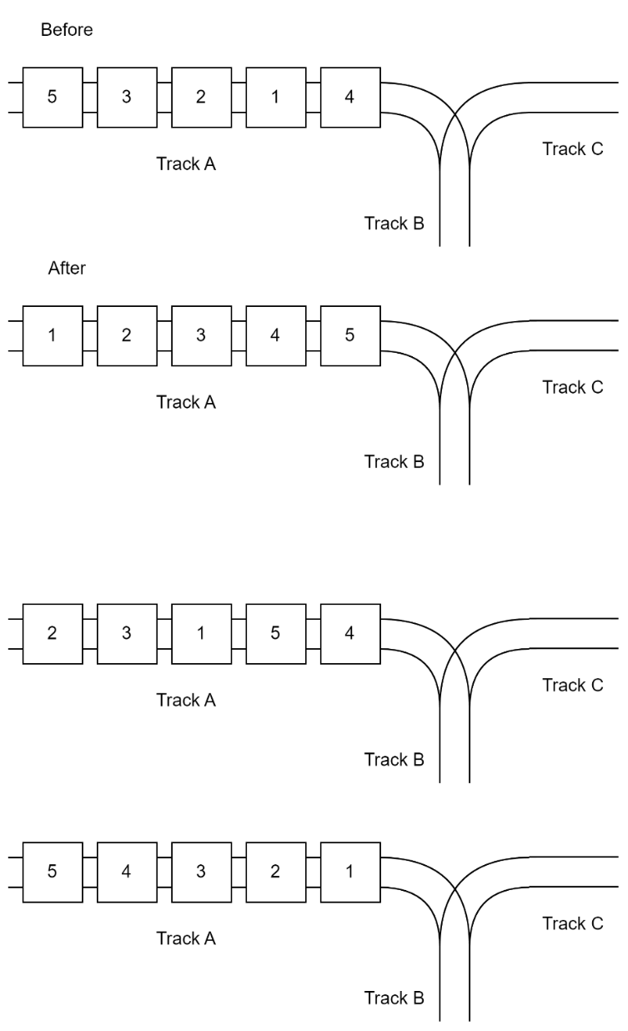
Two train car reordering puzzles: reorder Track A into the after image, using Track B as a siding.

5. Balanced Parentheses, Mixed Symbols
Pick one of the two expressions below and draw the stack trace (see lecture and page 360) to determine if the expression's parentheses are balanced. Note that the process is the same for any parentheses type.
(a) [{((x + y) * z) / w}]
(b) ((a + b) * (c - d) + {[e * f] / g)

6. Infix to Postfix, With Exponents
Convert the infix expression to postfix using a trace like Figure 7-9 on page 377 and our lecture. Show each step. Note that ^ is the exponent operator, e.g., D^E.
A * (B + C * (D ^ E - F)) + (G / (H + I * J))
Table 2: Infix-to-postfix trace. Add more rows if needed.
Ch | Stack | Postfix

7. Push/Pop Order Puzzle, Choose One
Suppose you have a stack to push and pop values 1, 2, 3, 4, 5, and 6 in ascending order. You must push the values in that order. However, once on the stack, a value can be popped and printed but never pushed back onto the stack. Given these constraints, pick either (a) or (b) and provide the operations that produce the printed sequence. If it cannot be done, show the push and pops until it fails. (See Problem 3 for an example.)
(a) 4 5 6 1 3 2
(b) 3 4 5 6 1 2

8. Train Car Reordering, Six Cars
Using the technique shown in the lecture and textbook, list the push and pop operations that would result in the after image, given the before image of train cars below. You can write the method calls like “temp = A.pop()” and “B.push(temp)”, or combine a pair like “B.push(A.pop()).” The tracks are only connected as shown, and each track is long enough to hold any necessary train cars. Minimize the number of operations needed.
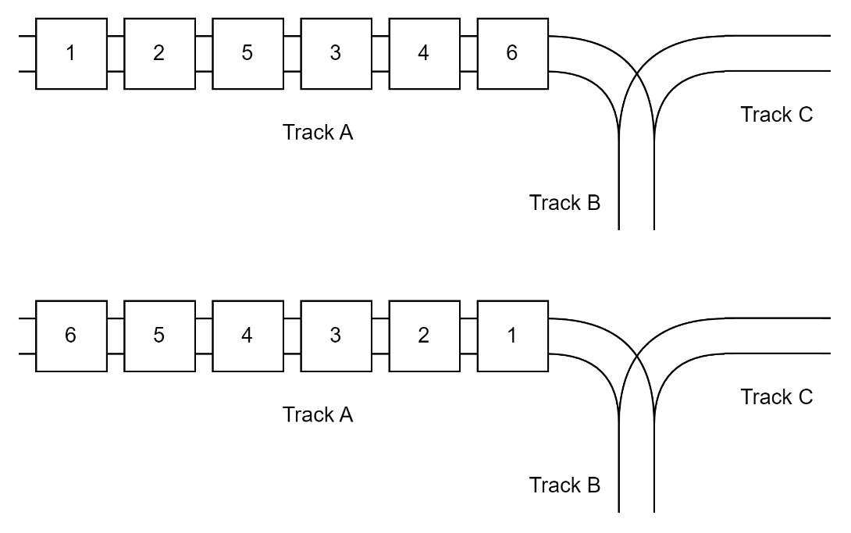
Reorder six train cars from the before image to the after image, using Track B as a siding.

9. Removing Duplicates
The pseudocode algorithm below is intended to remove all duplicate values from a stack and preserve the original order.
(a) Explain why this algorithm fails.
(b) Correct the pseudocode, highlighting or commenting on what changes you make.
tempStack = new empty stack
WHILE stack is not empty:
value = POP(stack)
isDuplicate = FALSE
// Check tempStack for duplicates
helperStack = new empty stack
WHILE tempStack is not empty:
tempValue = POP(tempStack)
IF tempValue == value THEN
isDuplicate = TRUE
PUSH(helperStack, tempValue)
// Restore tempStack
WHILE helperStack is not empty:
PUSH(tempStack, POP(helperStack))
// Keep value if not duplicate
IF NOT isDuplicate THEN
PUSH(tempStack, value)
// Restore original stack (preserve order)
WHILE tempStack is not empty:
PUSH(stack, POP(tempStack))

10. Maximum Value
The pseudocode algorithm below is intended to find the maximum value and preserve the original order.
(a) Explain why this algorithm fails.
(b) Correct the pseudocode, highlighting or commenting on what changes you make.
max = POP(stack)
tempStack = new empty stack
WHILE stack is not empty:
value = POP(stack)
IF value > max THEN
max = value
PUSH(tempStack, value)
// Restore original stack
WHILE tempStack is not empty:
PUSH(stack, POP(tempStack))
RETURN max

