Slither
Use-Case Specification: Game Prototype

Version 1.0

[Note: The following template is provided for use with the Rational Unified Process. Text enclosed in square brackets and displayed in blue italics (style=InfoBlue) is included to provide guidance to the author and should be deleted before publishing the document. A paragraph entered following this style will automatically be set to normal (style=Body Text).]
[To customize automatic fields in Microsoft Word (which display a gray background when selected), select File>Properties and replace the Title, Subject and Company fields with the appropriate information for this document. After closing the dialog, automatic fields may be updated throughout the document by selecting Edit>Select All (or Ctrl-A) and pressing F9, or simply click on the field and press F9. This must be done separately for Headers and Footers. Alt-F9 will toggle between displaying the field names and the field contents. See Word help for more information on working with fields.]

Revision History
Date | Version | Description | Author
02/27/2021 | 1.0 | Worked on this form. | Joseph Powell IV

Table of Contents
1. Use-Case Name 2
1.1 Brief Description 2
2. Flow of Events 2
2.1 Basic Flow 2
2.2 Alternative Flows 2
2.2.1 < First Alternative Flow > 2
2.2.2 < Second Alternative Flow > 2
3. Special Requirements 2
3.1 < First Special Requirement > 2
4. Preconditions 2
4.1 < Precondition One > 2
5. Postconditions 2
5.1 < Postcondition One > 2
6. Extension Points 2
6.1 <Name of Extension Point> 2

Use-Case Specification: <Use-Case Name>

[The following template is provided for a Use-Case Specification, which contains the textual properties of the use case. This document is used with a requirements management tool, such as Rational RequisitePro, for specifying and marking the requirements within the use-case properties.
The use-case diagrams can be developed in a visual modeling tool, such as Rational Rose. A use-case report, with all properties, may be generated with Rational SoDA. For more information, see the tool mentors in the Rational Unified Process.]

Use-Case Name

Brief Description
Slither is based off the late great retro sensation that took the 90s by storm. After registering and login, users are met with the famous snake that slithers around eating apples.

Flow of Events

Basic Flow
- Players must register.
- Player then must login.
- Game window appears.
- Player collects apples
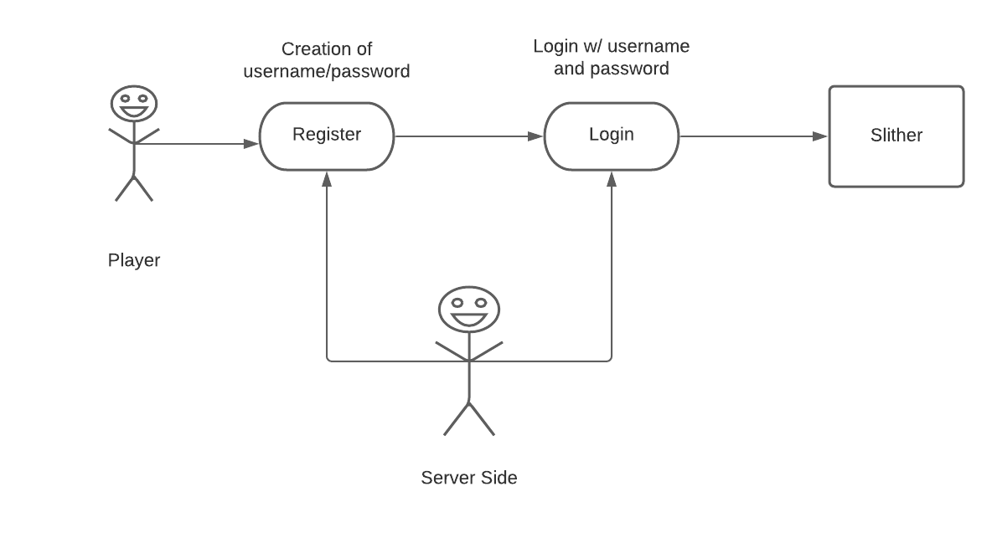

Alternative Flows

End Game
- Collecting apples increases snake’s length
- Colliding with parts of snake end game

< An Alternative Subflow >
[Alternative flows may, in turn, be divided into subsections if it improves clarity.]

< Second Alternative Flow >
[There may be, and most likely will be, a number of alternative flows in a use case. Keep each alternative flow separate to improve clarity. Using alternative flows improves the readability of the use case, as well as preventing use cases from being decomposed into hierarchies of use cases. Keep in mind that use cases are just textual descriptions, and their main purpose is to document the behavior of a system in a clear, concise, and understandable way.]

Special Requirements

None

Preconditions

Creating username/password
- Login successful

Postconditions
[A postcondition of a use case is a list of possible states the system can be in immediately after a use case has finished.]

Server acknowledge player.
- Server gives player access to game.

