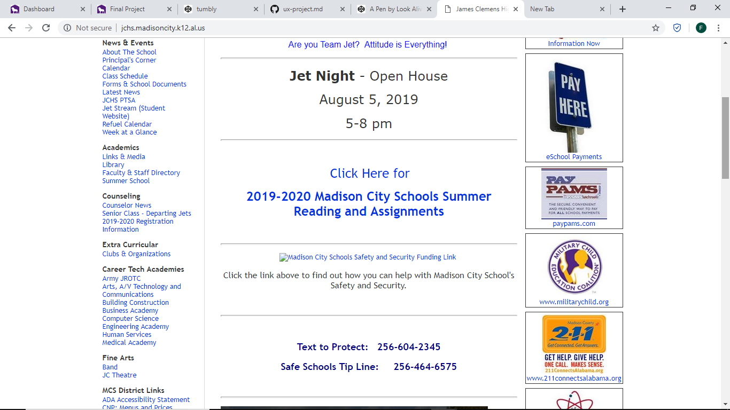

We can see here that many schools’ websites have the long navigation table on the left side, so I’ve decided to make that simpler and clean by applying a drop box for the 9 categories. 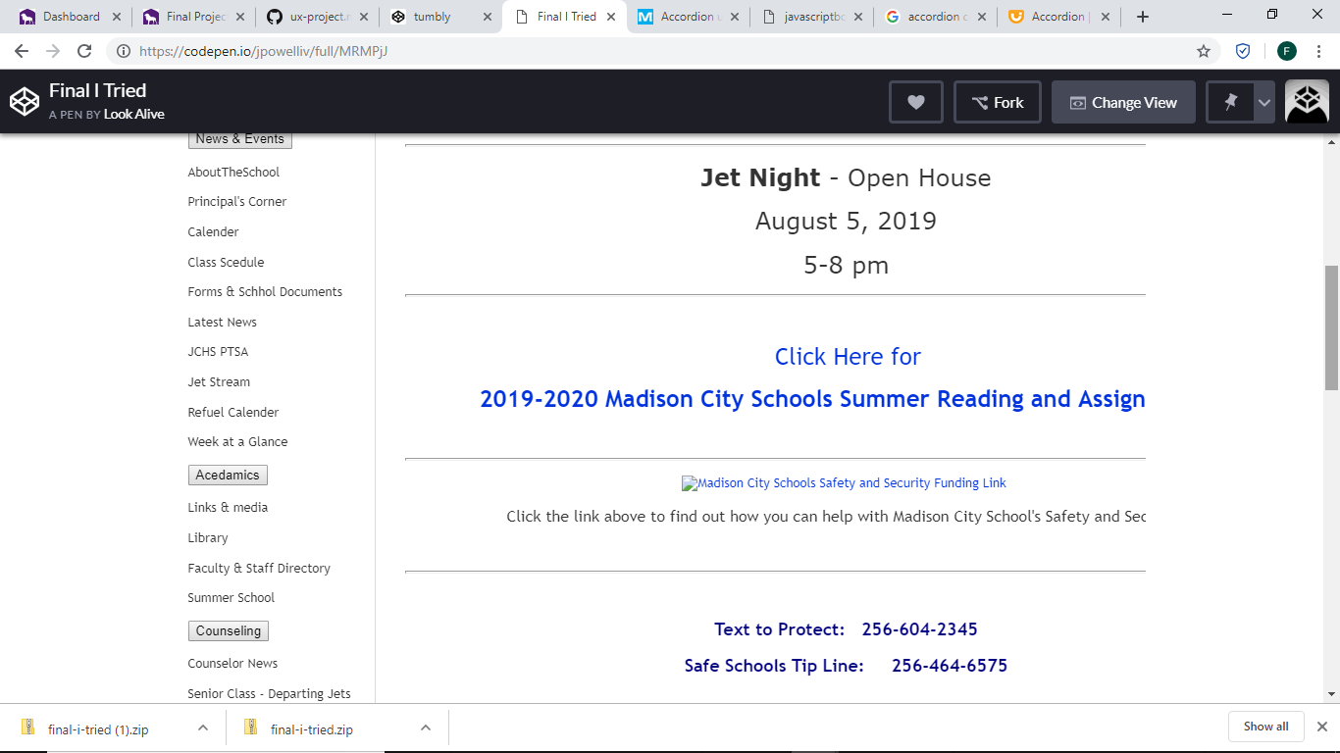

As you can see, I tried to put the left column there into an accordion style layout, but I gotten stuck and could not finish at all. I’m sorry I couldn’t figure it out and I been at drill all day since I’m getting deployed. I tried : (