Power ON Commands (Only at startup)
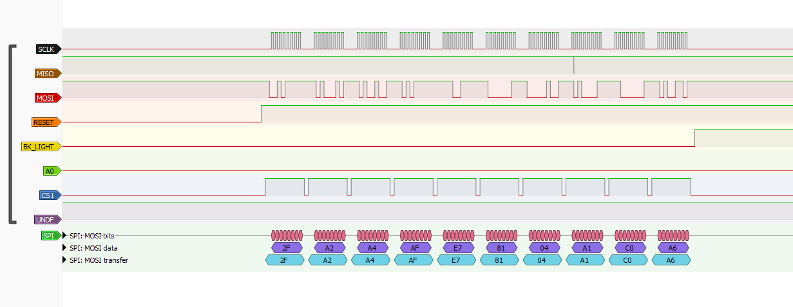
Write Image 1
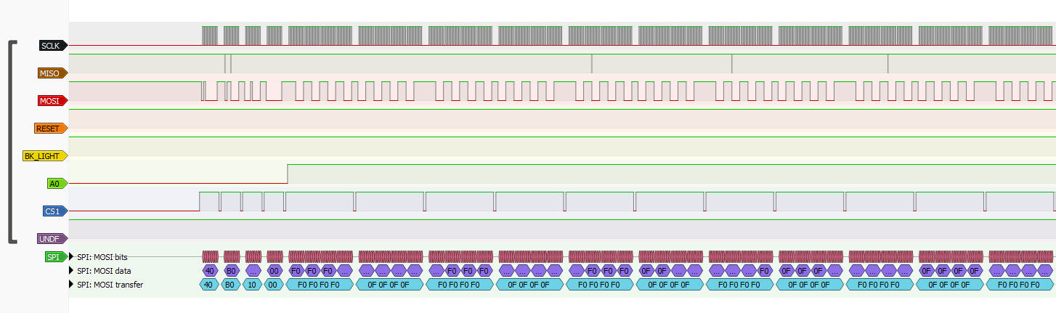
Write Image 2
