A Canted Turnstile Antenna for CubeSat Telemetry Antenna

G.N. LeBrasseur

Portland State University, OreSat

27-Sep-2016

A Canted Turnstile is a common omnidirectional antenna used for communications on spacecraft in Low Earth Orbit. NASA Goddard documented the design for spacecraft antenna systems in Sept. 1967 in publication X-712-67-441 [1]. The Canted Turnstile is constructed using four monopoles, each fed in quadrature phase, and tilted above or below the plane by some angle between 15 and 65 degrees. With respect to the plane, the radiated propagation is mostly horizontal-linear near the plane, and becomes right hand circular (RHCP) above, and left hand circular (LHCP) below the plane. For a practical implementation, this is very close to the hypothetical isotropic radiator which radiates uniformly in all directions within a sphere. For a spacecraft with unknown and varying attitude, this behavior is beneficial.

Roughly following guidance from the NASA document for spacecraft Explorer 35, a Canted Turnstile using a Shimizu [2] type 90 degree stripline hybrid coupler to feed the four monopoles was chosen. The MiniCircuits QBA-07+ 90 degree hybrid coupler [3] was found to meet the requirements for frequency, power handling, temperature range and size appropriate for a CubeSat antenna. The QBA-07+ has the four basic ports, input, 0 degree, 90 degree and isolated as described by the Shimizu design. Three couplers and one 90 degree coax phasing section was chosen to form the four quadrature signal phases. Figure 1 describes the layout of the quadrature phasing arrangement.



Figure 1. Quadrature Phasing Section

The impedance match shown as Z between the λ/4 monopole and the hybrid coupler is formed using an L-Section, and is intended to match the 50 Ω impedance of the coupler, to the typical 32 Ω impedance of a λ/4 monopole. Upon testing it was found that the impedance of the monopoles in their configuration on a CubeSat electrical mock-up was actually close to 50 Ω, so leaving the L-Section out entirely performed best. It was also found that pruning the monopole lengths slightly provided an optimum match at the 50 Ω input. The pruning resulted in the 0 and 180 degree elements to be 140 mm, or 25 mm shorter, and the 90 and 270 degree elements to be 190 mm, or 25 mm longer. Elements slightly shorter become more capacitive, and ones longer are more inductive. Figure 2 shows the impedance measured using an HP 8753E Vector Network Analyzer (VNA) at the 50 Ω input port, at the design frequency of 436.5 MHz.

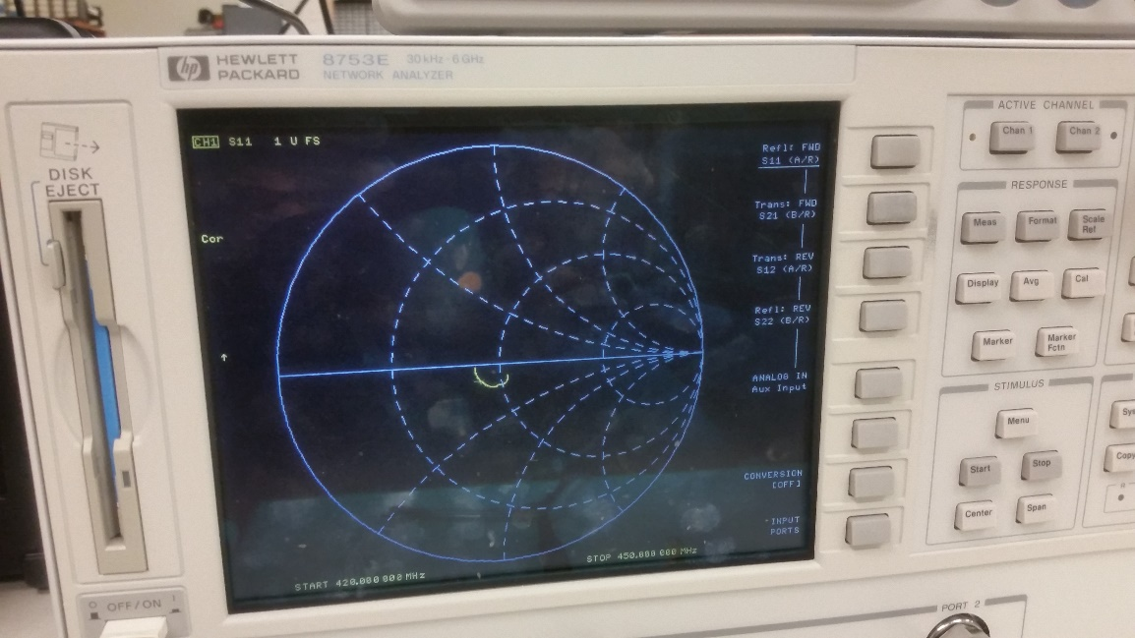

Figure 2. Impedance at 50 Ω input

The antenna was placed into an RF anechoic chamber [4] and tested for far field radiation, which resulted in propagation patterns for both the horizontal and vertical polarizations around the +Z axis, and +Y axis. The orientation of the antenna in the +Z axis is shown in Figure 3, and relative propagation measurements for the horizontal and vertical polarizations are shown in Figure 4, and Figure 5 respectively. The orientation of the antenna in the +Y axis is shown in Figure 6, and relative propagation measurements for the horizontal and vertical polarizations are shown in Figure 7, and Figure 8 respectively. The propagation patterns measured do not indicate any extreme signal drop out, however are not indicative of a perfect isotropic radiator. This is entirely expected and wholly acceptable when considering the actual propagation will be the conjunction of both horizontal and vertical propagations combined. Where both are strong in both horizontal and vertical components, the resultant polarization will become mostly circular. Where one of the propagation levels drops down, the resultant polarization will become elliptical in that sense, and in the extreme case, approach linear polarization.

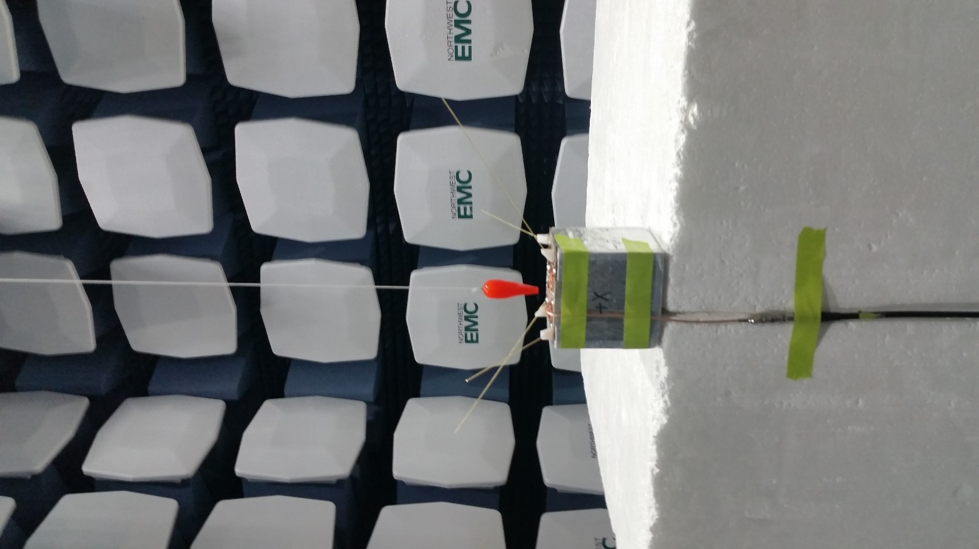

Figure 3. Orientation in the +Z axis

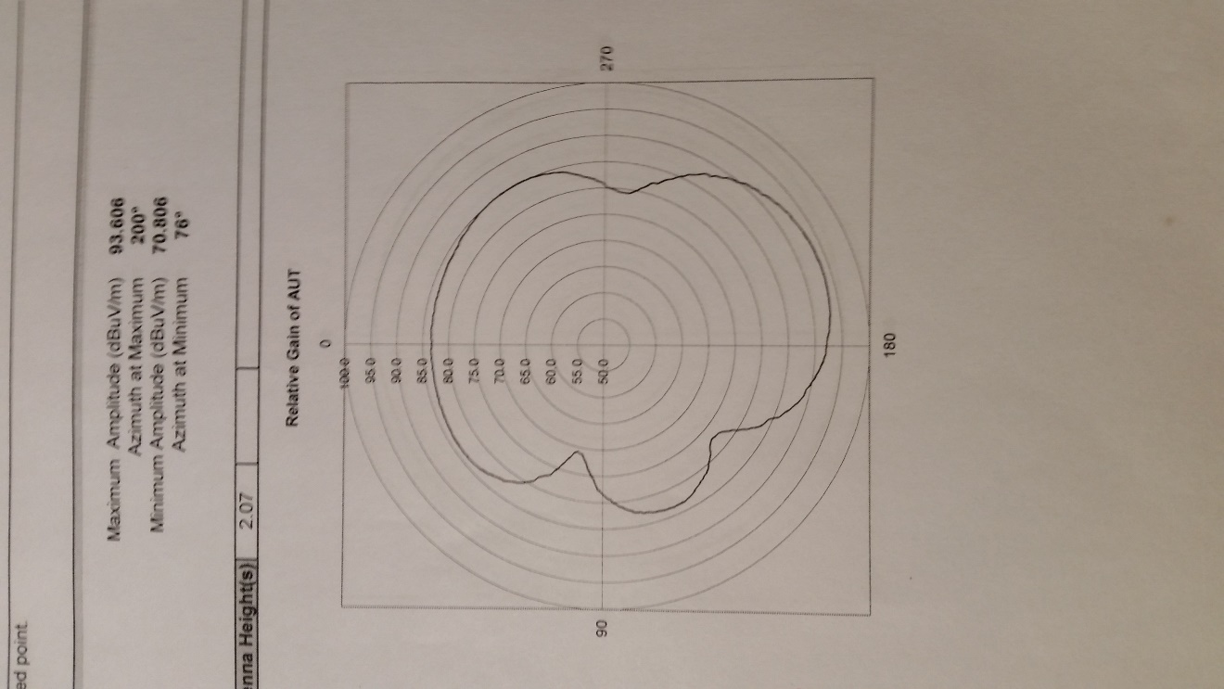 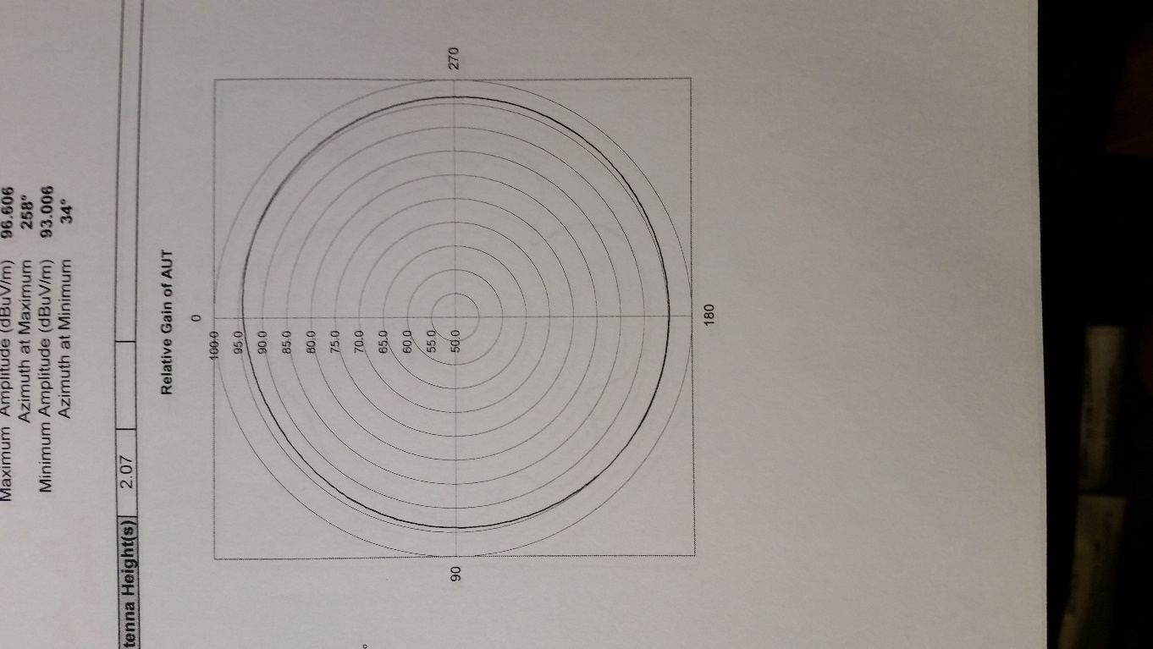

Figure 4. Horizontal Polarization Figure 5. Vertical Polarization

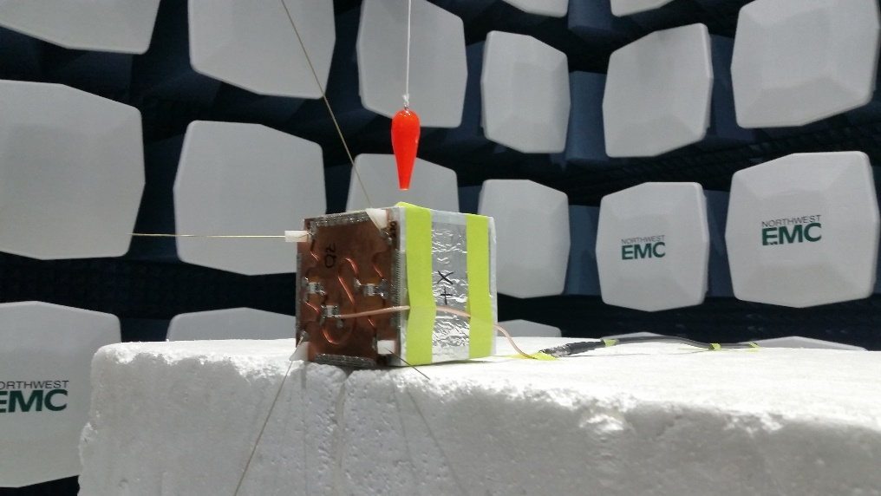

Figure 6. Orientation in the +Y axis

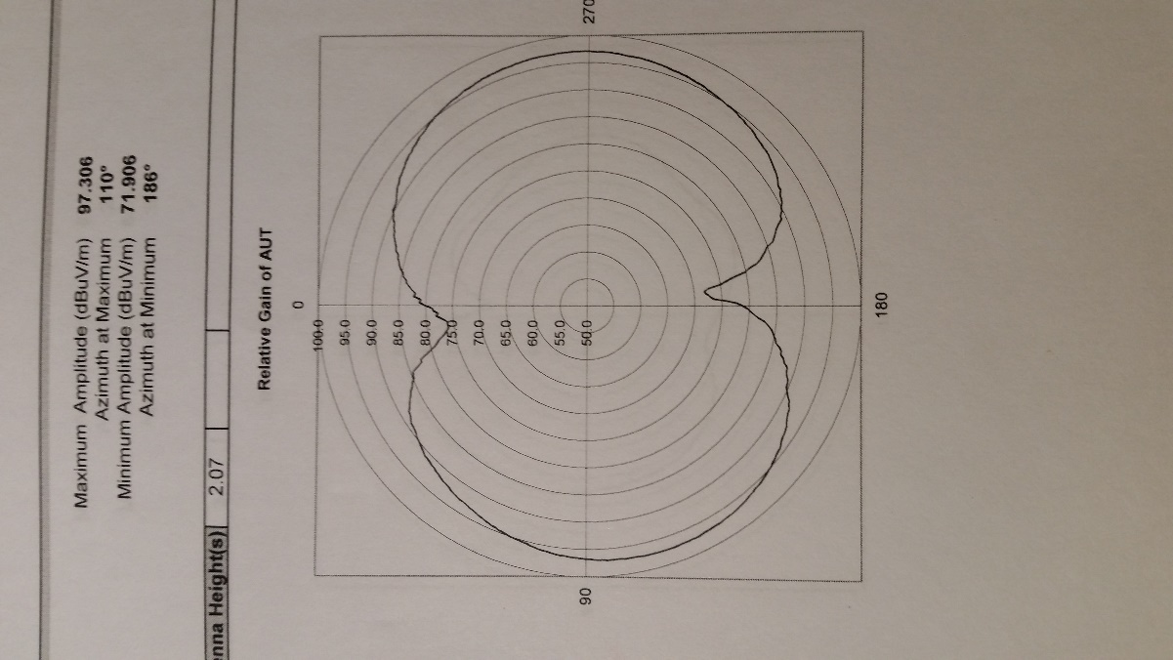 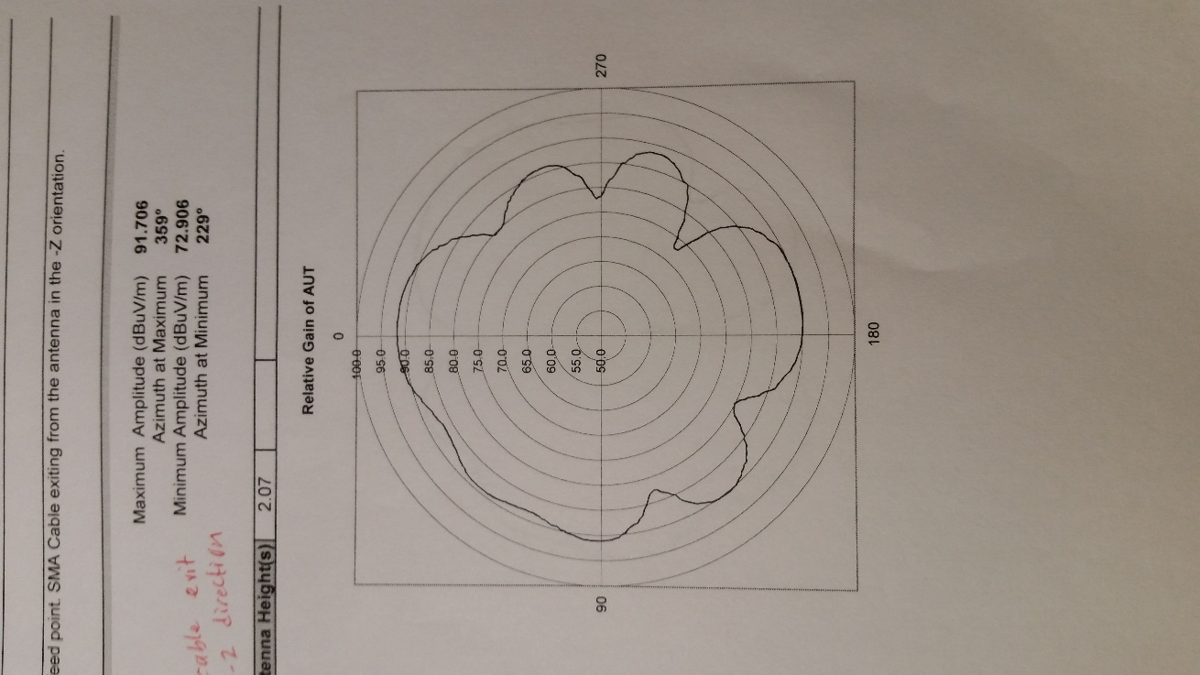

Figure 7. Horizontal Polarization Figure 8. Vertical Polarization

References

[1] Jackson, R. B., The Canted Turnstile As An Omnidirectional Spacecraft Antenna System, NASA Goddard Document X-712-67-441, Sept. 1967

[2] Shimizu, J. K., Stripline 3 dB Couplers, Stanford Research Institute.

[3] MiniCircuits QBA-07+, 2-Way 90 degree Splitter/Combiner, <http://www.minicircuits.com>

[4] Jeff Alcoke, NWEM0324, Northwest EMC, <http://www.nwemc.com>