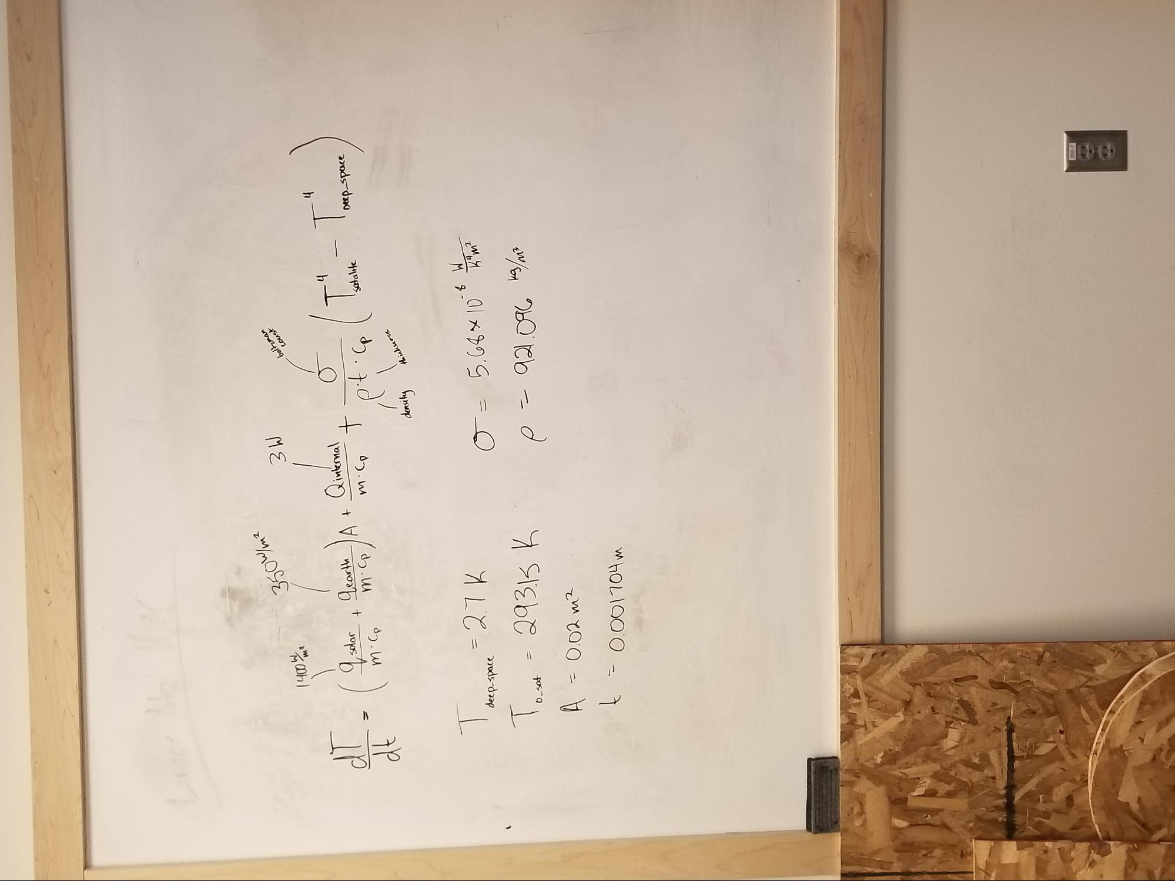

200-7

MHOL1000 - 7

Em 200 = 4 stebe - tor 1

ALE = Peds r

w/ Bob = mit . 1 * 80'S =

2

.

density

thickness

d. M

.

8

o't. lp )

. W

18. U

Satalike

Deep Space

V

teost + saps h ,

**0**

***h***

ht

coust

ME

boltzman

M/MOSE