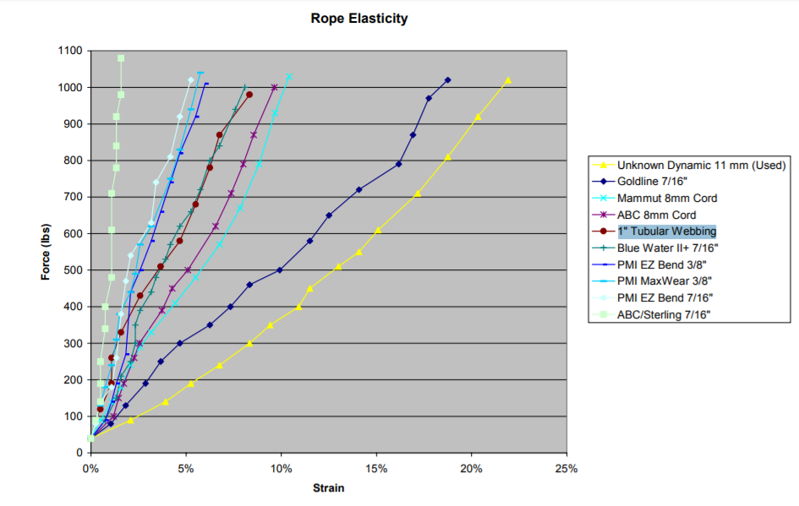

https://user.xmission.com/~tmoyer/testing/Qualifying_a_Rescue_Rope.pdf