2016-AT-06 Recursive Painting
0 ---- | I: ---- | II: ---- | III: hard | IV: medium

Answer Type: Multiple Choice

Body
Beaver and his friends have volunteered to help renovate the City Museum of Informatics. They have to paint a floor of 16 x 16 meters in one of the exhibition rooms.

The planning department has a special set of painting instructions.

The instructions are printed on sheets that reference other sheets by number. Each sheet has a scale printed at the bottom.

Here is an example for such floor plan from a previous project. It draws a beaver.
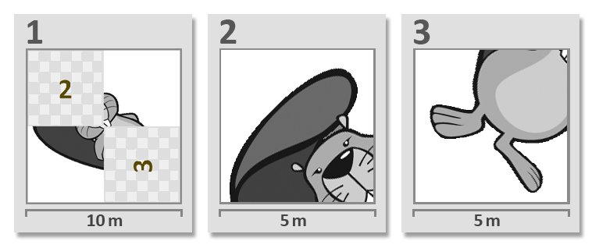
Beaver is given the plan for the new project:
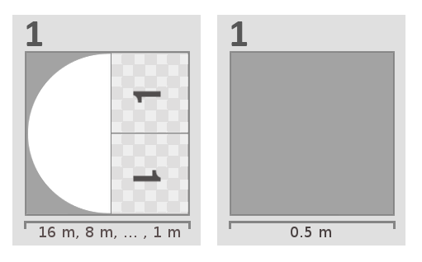
The planning sheet referenced itself and both sheets have the same number! His friend asks how this can be and beaver answers: “We can do it. The second sheet is important because it tells us when to stop.”

Question / Challenge

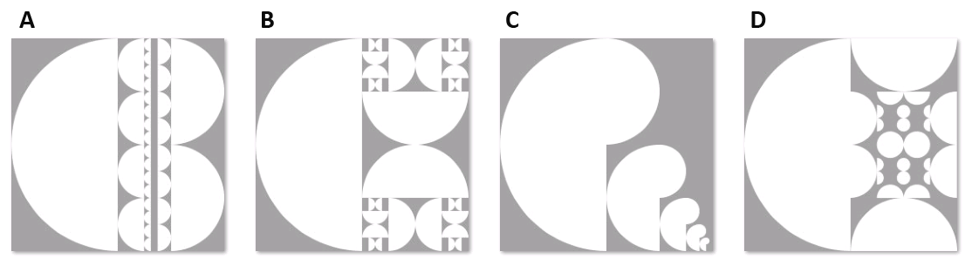
What does the painted result look like?

Answer

The correct answer is B.

Explanation

Consider the left sheet of the plan. It describes to paint the left part of the floor with a half circle with its round side facing to the left. For the right half of the floor, it describes to use again the same sheet twice, but the part that has to be painted has to be at least 1m long. Do note that the orientation of the two 1's is opposite. This indicates the sheet has to be rotated each time to the proper orientation.

Note that the two round sides of sheet “1” touch each other, that means that in the result the round sides of the half circles will always touch.

It's informatics

Self referencing instructions like this one are called recursive. Recursion is an important concept in informatics. Recursive solutions are usually shorter and more compact than their alternatives but sometimes a little bit harder to understand. Recursive patterns are frequently found in nature. Terminating conditions like the one shown in the example play an important role in recursion to avoid endless loops.

Keywords

Recursion, terminating condition, stop condition.

Websites

https://en.wikipedia.org/wiki/Recursion_(computer_science)
https://en.wikipedia.org/wiki/Recursion

Internal Use

Wording

Recursion, recursive pattern, recursive solution

Comments

Revised by
Valentina Dagiene, valentina.dagiene@mii.vu.lt, Lithuania
Nursultan Akhmetov, nursultan.akhmetov.krg@gmail.com, Kazakhstan
Eljakim Schrijvers, eljakim@bebraschallenge.org, USA
Anna Morpurgo, morpurgo@di.unimi.it, Italy

Graphics

All graphics self made (public domain).

Files

2016-AT-06.odt (this file)
example.png, questions.png, answers.png
all images also as .psd (Photoshop)

Authorship

Gerald Futschek, gerald.futschek@ifs.tuwien.ac.at, Austria
Wilfried Baumann, baumann@ocg.at, Austria

License

Copyright © 2016 Bebras – International Contest on Informatics and Computer Fluency. This work is licensed under a Creative Commons Attribution-ShareAlike 3.0 Unported License (CC BY-SA 3.0). Visit: http://creativecommons.org/licenses/by-sa/3.0/

