2023-AT-01-eng A day at the zoo
6yo–8yo:  – | 8yo–10yo:  – | 10yo–12yo:  hard | 12yo–14yo:  medium | 14yo–16yo:  easy | 16yo–19yo:  –
Answer Type: Open Integer (☐ keep order of multiple-choice/-select)
Categories (click to choose):  ☑ algorithms and programming  ☐ data structures and representations |  |  | ☐ computer processes and hardware  ☐ communication and networking  ☐ interactions, systems and society
Equivalent Tasks: None

Body
Anja spends a day in the zoo. On a flyer she discovers many different activities. Each activity has a start and an end time, and guests cannot leave in the middle of an activity.
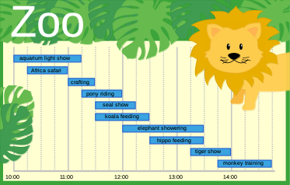
Anja wants to attend as many activities as possible, but she can only attend one activity at a time. She can’t leave in the middle of an activity, so she has to attend activities from beginning to end. Since some of the activities overlap, Anja cannot attend all activities today.

Question / Challenge
What is the maximum number of activities Anja can attend from beginning to end over the entire day?

Answer Options / Interactivity Description
Integer numbers from [0, 10]

Answer Explanation
Anja can attend a maximum of 5 activities over the entire day.
One way to solve this problem is to try all possible combinations of non-overlapping activities. Each combination of non-overlapping activities gives us a valid schedule. Then we check which schedule has the most activities (an optimal schedule). This is called an exhaustive search.
An exhaustive search can be difficult since there are too many possibilities to check. It’s also hard to make sure that you’ve checked everything.
We can make an observation to simplify the problem. If two activities overlap, then only one of the two activities can be part of an optimal schedule. If one activity takes place completely during another activity, then it is always better to take the shorter activity.
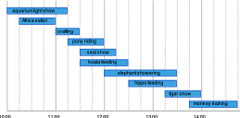
For example, the Africa safari takes place completely during the aquarium light show and it is shorter, it is better not to choose the aquarium light show, because it may overlap with a larger number of other activities.
With the same reasoning, we can do the following.
- We can exclude the koala feeding, since the seal show takes place completely during the koala feeding.
- We can exclude the elephant showering, since the hippo showering takes place completely during the elephant showering.
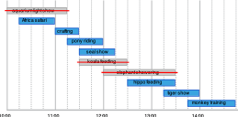
After deleting these three activities, we are left with these activities.
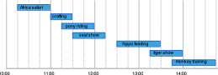
We can decompose (or break up) these activities into independent groups, which we call A, B and C. We can find the optimal schedule for the entire day by finding the optimal schedule for each group.
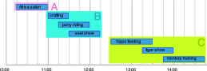
For group A, there is only one activity: the Africa safari. The optimal schedule is to attend the Africa safari.
For group B, there are three activities. Conducting an exhaustive search, there are only two valid schedules for group B.
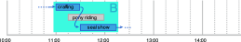
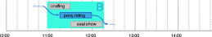
The optimal schedule is to take the crafting and seal show activities.
For group C, there are also three activities. Using a similar reasoning, the optimal schedule is to take the crafting and seal show activities.
Putting the optimal schedules together, we have the following schedule for the entire day.
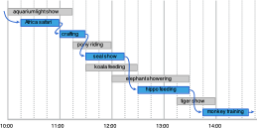
There are 5 activities in this schedule, so the answer is 5.

This is Informatics
Often in informatics, when designing an algorithm to solve a problem, the easiest algorithm to think of is an exhaustive search, as it is conceptually simple and guaranteed to give the correct answer. The main problem is that an exhaustive search can take too much time to do, either by hand or with a computer. We need to find ways to make more efficient algorithms to solve problems in a more reasonable amount of time.
In order to make an algorithm more efficient, we often have to make observations about the problem which allow us to simplify the problem. A problem where you maximize or minimize a quantity is called an optimization problem. When simplifying an optimization problem, we have to think about what decisions we can make which do not prevent us from obtaining an optimal solution. In the task, we were able to disregard the aquarium light show, koala feeding, and elephant showering activities, since we can be sure any schedule containing these activities can be potentially improved by picking a different activity instead.
Another strategy which allows us to make an algorithm more efficient is decomposing the problem into independent parts, called subproblems. Since computers are really good at doing the same task repeatedly on different inputs, it is a viable strategy to find an algorithm which can be applied to independent subproblems.
In general, the task of choosing the maximal number out of several activities in a certain period of time is called the activity selection problem or interval scheduling problem. When managing processes in a large factory or running many programs on a single computer, we might have an activity selection problem with thousands or millions of activities. In informatics, there are even more sophisticated algorithms to solve these problems without any use of exhaustive search at all.

This is Computational Thinking
In this task it is necessary to develop a strategy for finding a maximal solution. This can be done by analyzing the overlapping of the different activities and finding rules which activities must be excluded and which activities must be included in an optimal solution. This is a typical algorithmic thinking approach, when these rules are applied in a specific order.
If we look at the description of the solution we find also a decomposition of the problem in smaller parts that can be solved independently, a very effective strategy to solve problems.
Another solution approach may be to construct all possible combinations of visits of activities and select the ones with the maximum number of activities. This is also an algorithmic approach, but it involves many combinations and therefore much more algorithmic steps than the previously described approach.

Informatics Keywords and Websites
Exhaustive search (https://en.wikipedia.org/wiki/Brute-force_search)
Optimization problem (https://en.wikipedia.org/wiki/Optimization_problem)
Activity Selection Problem
Interval Scheduling Problem

Computational Thinking Keywords and Websites
Decomposition: https://en.wikipedia.org/wiki/Decomposition_(computer_science)

Wording and Phrases
EDIT HERE (delete this): list of words and phrases used to name important things mentioned in the task body (actors, activities/processes, concepts, definitions, objects, names, etc.) This is to ensure the consequent use of terminology in the task body and to facilitate translation.

Comments
Florentina Voboril, florentina.voboril@gmx.at, 2023-05-04:
According to the reviews, I implemented the following changes:
- The activities were renamed like activities. E.g. “Elephant showering” instead to only the name of an animal species.
- Added the condition that Anja chooses only those activities that she will see from their beginning to their end.
- The images were placed in the middle
- Added a keyword for CT
- The age was changed to hard for 10-12yo and medium for 12-14yo
The following ideas from the reviews might be a good idea, but were not implemented yet:
- Some activities sound as if people could stay as long as their want. If it is not clear for students that the activities have be joined from beginning to end, it might make sense to change the topic of the story to e.g. Disneyland (you cannot leafe the carousel or roller coasters) or film festival.
- It would be possible to also create an interactive task (drag and drop of blocks) to make this task also suitable for younger kids.
Aldrich Ellis Asuncion, aldrich@noi.ph, 2023-05-15:
Changelog from Bebras Task Workshop:
The task is very good we opted to add more details to the explanation of how to get to the solution. We made the following changes.
- Edited the task body and question for more natural English phrasing.
- Introduced and emphasized the concept of exhaustive search in the explanation to the answer.
- Added more diagrams to explain the solution process.
- Capitalized Africa in the task text and images.
- Rewrote the This is Informatics section to focus instead on exhaustive search, decomposition, and algorithm improvement.
EDIT ABOVE (keep this template and add above this line): author, e-mail, date (YYYY-MM-DD): Comment, including documentation of and reasons for changes, and precautions to take when further developing this task.

Graphics and Other Files
2023-AT-01-eng.odt This file.
All graphics originally by Florentina Voboril, self-made, slightly edited and adapted by Jean-Philippe Pellet
EDIT ABOVE (keep this template and add above this line): filename, author, source/self-made, license
Please indicate:
- Source of each image or of each other file to produce the task image(s):
(URL and/or author)
- License for each image.
Note: If the source of an image is unclear, it might be copyrighted and cannot be used in the task.

Authors, Contributors, and Editors (incl. Graphics)
Author Florentina Voboril, florentina.voboril@gmx.at, Austria
Author Svetlana Unkovic, svetlana.unkovic@tuwien.ac.at, Austria
Author Gerald Futschek, gerald.futschek@tuwien.ac.at, Austria
Contributor: Aldrich Ellis Catapang Asuncion, aldrich@noi.ph, Philippines
Contributor: Jean-Philippe Pellet, jean-philippe.pellet@hepl.ch, Switzerland
EDIT ABOVE (keep this template and add above this line): author / contributor / editor, e-mail, country.

License

Copyright © 2023 Bebras – International Challenge on Informatics and Computational Thinking. This work is licensed under a Creative Commons Attribution-ShareAlike 4.0 International License. https://creativecommons.org/licenses/by-sa/4.0/.

