2023-AU-01b-deu Companion Planting
6yo–8yo:  – | 8yo–10yo:  – | 10yo–12yo:  medium | 12yo–14yo:  easy | 14yo–16yo:  – | 16yo–19yo:  –
Answer Type: Interactive (Drag & Drop) (☐ keep order of multiple-choice/-select)
Categories (click to choose):  ☑ algorithms and programming  ☑ data structures and representations |  |  | ☐ computer processes and hardware  ☐ communication and networking  ☐ interactions, systems and society
Equivalent Tasks: None

Body
Lisa legt ein Gemüsebeet an. Darauf will sie fünf verschiedene Sorten Gemüse pflanzen.
Manche Gemüsesorten vertragen sich gut miteinander, andere nicht.
Das Bild zeigt, welche Gemüsesorten sich gut () und welche sich nicht vertragen ().
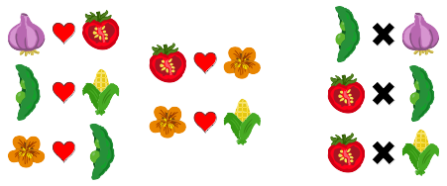
Lisa hat das Beet in sechseckige Bereiche aufgeteilt. In jeden Bereich will sie genau eine Sorte pflanzen. Dazu hat sie diese Regel: Bereiche, die direkt aneinander grenzen, dürfen keine Sorten enthalten, die sich nicht vertragen.
In drei Bereiche hat Lisa schon Knoblauch gepflanzt.

Question / Challenge
Bepflanze alle noch freien Bereiche und beachte Lisas Regel!
Ziehe die Gemüsesorten auf passende Bereiche.
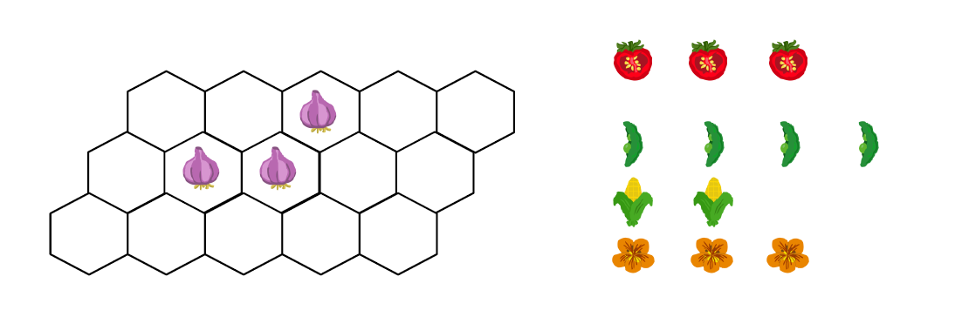

Answer Options / Interactivity Description
There are 15 total spaces (3×5), but three are pre-filled with garlic plants and cannot be altered.
- Students can drag three of each of the remaining four types of plants (Corn, Tomatoes, Beans and Nasturtiums) to fill the remaining spaces in the garden bed.
- Once all spaces are full, students click ‘Save’.

Answer Explanation
Da sich Bohnen (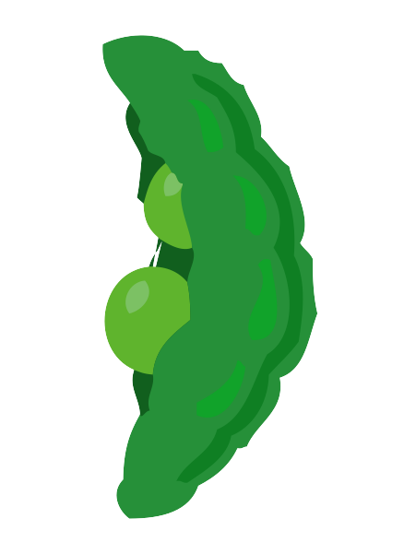) nicht mit Knoblauch vertragen, würde Lisa auf den grauen Bereichen keine Bohnen pflanzen. Es bleiben also für die Bohnen nur die übrigen Bereiche.
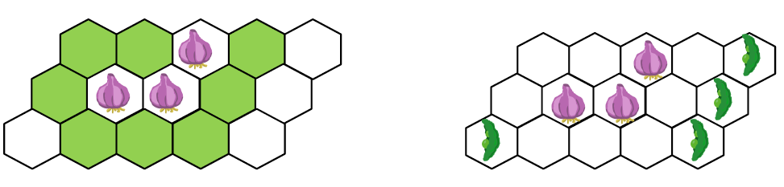
Weil Tomaten sich nicht mit Bohnen vertragen, würde Lisa nun auf den grauen Bereichen unten keine Tomaten anpflanzen, aber auf den drei übrigen Bereichen.
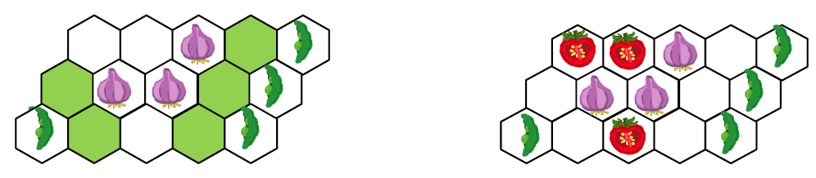
Weil sich Tomaten nicht mit Mais vertragen, würde Lisa nun auf die drei grauen Bereiche unten keinen Mais pflanzen. Auf diese Bereiche kann sie aber Brunnenkresse pflanzen, für die keine Unverträglichkeit bekannt ist. Auf die verbleibenden Bereichen würde Lisa Mais pflanzen, der sich nur mit Tomaten nicht verträgt.
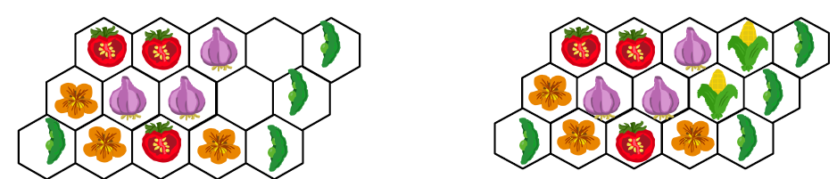

This is Informatics
Bei dieser Aufgabe lohnt es sich, genau zu überlegen, wie man vorgeht. Reines Herumprobieren wäre zu zeitaufwendig und nicht zielführend . Die Platzierung der Bohnen im ersten Schritt ist ein wichtiger Ansatzpunkt zur Lösung der Aufgabe. Bei dieser Aufgabe ist die Reihenfolge der Vorgangsweise sehr wichtig. Wir haben mit einem Schritt begonnen, von dem nach genauem Nachdenken klar war, dass er nur so erfolgen kann. Der erfolgte erste Schritt reduzierte wiederum die Möglichkeiten für die folgenden Schritte.
Beziehungen zwischen Pflanzen können wie im Diagramm unten dargestellt werden. Zwei Pflanzen sind mit einer grünen Linie verbunden, wenn sie sich gut vertragen und andernfalls mit einer gestrichelten roten Verbindung.
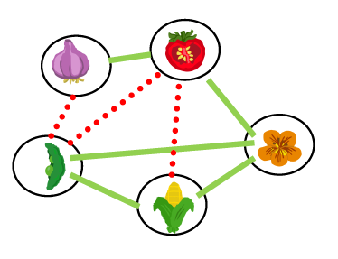
Diagramme, so wie das hier verwendete, die aus Knoten (Punkten) und Kanten (Verbindungslinien) bestehen, nennt man Graphen. Damit kann man ganz verschiedene Probleme anschaulich darstellen. In vielen Fällen dient die Übersetzung eines Problems in Graphenform nicht nur der Anschauung sondern kann einen wichtigen Beitrag zur Lösung liefern.

This is Computational Thinking
EDIT HERE (delete this): explain which computational thinking competencies are necessary to solve this task. Use about 3 to 8 sentences. Do not explain the correct answers of the task, also do not explain the computer science behind the task. You may, however, relate your explanation to the “Answer Explanation” section and the “This is Informatics” section.

Informatics Keywords and Websites
Conditionals
https://en.wikipedia.org/wiki/Conditional_(computer_programming)
Dynamic Programming
https://en.wikipedia.org/wiki/Dynamic_programming
Divide-and-Conquer Algorithm
https://en.wikipedia.org/wiki/Divide-and-conquer_algorithm
Divide-and-Conquer Vs. Dynamic Programming
https://www.interviewbit.com/blog/difference-between-divide-and-conquer-and-dynamic-programming/

Computational Thinking Keywords and Websites
EDIT HERE (delete this): give some keywords, useful to find further information on the web. The target are the teachers and interested students. // Indicate websites (in English and other languages) which offer further information on the particular domain of computational thinking mentioned in the “This is Computational Thinking” section.

Wording and Phrases
Tomato, Garlic, Carrot, Corn, Beans, Nasturtiums, Companion Gardening.

Comments
Reviews:
To add or update a review, go to https://review.bebras.org.

By: luan (svn: luan)
on 2023-04-15
Non-assigned review
It is a good idea. There are some mistakes such as:
+ The example is 3x3, not 2x3.
+ There are 6 plants but only 15 squares in the question table.
========================================
By: Bence Gaál (svn: gaal)
on 2023-04-17
Assigned review
Great and fun task! I like it!

In the example: You mentioned 2x3 table, but it is a 3x3.

For me, the colouring the table is unnecessary, and the contrast in the case of corn is not enough. Maybe a table with pictures is better

This is Computational Thinking: missing
CT keywwords are missing too.
========================================
By: Esraa almajhad (svn: majhad)
on 2023-04-17
Non-assigned review
[AGE] ok
[IDEA] i like the idea .
[TEXT] there is a mistake in the number of the garden bed (3*3)
[EXPL] I prefere explain all correct possibilities of solutions
[TiCT] missing
[AUTH] ok
[NAME] ok
========================================
By: Susanne Datzko (svn: sdatzko)
on 2023-04-19
Assigned review
[AGE] I think the task is harder than rated. I think it is "medium" for 12-14 yo. The task is relatively complex and there are many dependencies that need to be considered.
[IDEA] I like the task idea and its relation to reality.
[TEXT] However, the task needs to be better and more clearly structured. The table with the good and bad neighbors should also be presented with the graphs. It all needs to be on one page so that you don't have to have the information from the table in your head.
The question must be shorter and more clearly formulated. Parts of the question can already be explained in the body. In the example, you could also include a misplaced plant. (By the way, the field is 3x3 and not 2x3).
Nasturtiums - whats that?! - I would only call it flower. Think about not using at all the name of the plants and only work with the pictures.
[EXPL] Go probably step by step how it could be solved in a smarter way than brute force. Start with tomatos and beans probably? How many different solutions are possible?
Is there a possibility to make the relations between the different plants more visible? Graph?
Explain why the tomatos and the beans will allwasy be in the same place.
[ANSWERTYPE] I think its really appealing and motivating to solve this task with drag and drop - but it could be a time killer like this. Add some more planted fields to reduce the possibilities. Think about making another MC version with 4 different planted beds.
[TiI] Many different computer science keywords are used but none of them is really explained. Consentrate on one or 2 keywords and formulate a direct connection to the task.
[TiCT] Not filled out
[GRAPH]I like the style of the graphics. Probably make them a bit simpler and then smaller so that it fits better on one page.
========================================
By: Nora Anna Escherle (svn: escherle)
on 2023-04-21
Assigned review
[AGE] The age/difficulty level is specified and seems appropriate for the task and question.
[IDEA] Not extremely original idea but nice and relatable. It does require some computational thinking skill to be understood and solved.
[TEXT] Very long, could and should be shortened. The question and conditions are clear though.
[EXPL] The “Answer Explanation” section is available and complete. It is understandable by students of the appropriate level. There is a clear reason why the correct answer is correct.
[TiI] The “It’s informatics” section is available but does not really refer to how/ why this is informatics. It focuses on the solving process which would be more suitable in the “TiCT”-section. Connection to the “story” is well made.
[TiCT] “This is Computational Thinking” section is not available .
[GRAPH] The figures are clear and appealing. They are CC-licensed and may be re-used and modified. They are available in SVG format (i.e., as vector graphics).
[AUTH] The name(s) and mail address(es) of the author(s) are available.
[NAME] The names of the task folder and file(s) comply with the prescribed format.
[OTHER] -
========================================
EDIT ABOVE (keep this template and add above this line): author, e-mail, date (YYYY-MM-DD): Comment, including documentation of and reasons for changes, and precautions to take when further developing this task.

Graphics and Other Files
2023-AU-01b-deu.odt This file.
2023-AU-01_beans.svg, Emily Gates, self-made, CCBYSA
2023-AU-01_tomato.svg, Emily Gates, self-made, CCBYSA
2023-AU-01_corn.svg, Emily Gates, self-made, CCBYSA
2023-AU-01_carrot.svg, Emily Gates, self-made, CCBYSA
2023-AU-01_garlic.svg, Emily Gates, self-made, CCBYSA
2023-AU-01_nasturtium.svg, Emily Gates, self-made, CCBYSA
2023-AU-01_answer.svg, Emily Gates, self-made, CCBYSA
2023-AU-01_example.svg, Emily Gates, self-made, CCBYSA
2023-AU-01_question.svg, Emily Gates, self-made, CCBYSA
EDIT ABOVE (keep this template and add above this line): filename, author, source/self-made, license
Please indicate:
- Source of each image or of each other file to produce the task image(s):
(URL and/or author)
- License for each image.
Note: If the source of an image is unclear, it might be copyrighted and cannot be used in the task.

Authors, Contributors, and Editors (incl. Graphics)
Emily Gates, emily.gates@csiro.au, Australia
Mhairi King, mhairi.king@csiro.au, Australia
Estela Ramić, estelaramic@gmail.com, Bosnia and Herzegovina
Mathias Hiron, mathias.hiron@gmail.com, France
Christian Datzko, christian@bebras.services, Hungary
EDIT ABOVE (keep this template and add above this line): author / contributor / editor, e-mail, country.

License

Copyright © 2023 Bebras – International Challenge on Informatics and Computational Thinking. This work is licensed under a Creative Commons Attribution-ShareAlike 4.0 International License. https://creativecommons.org/licenses/by-sa/4.0/.

