2023-AU-05a-eng Beaver Bundles
6yo–8yo:  – | 8yo–10yo:  – | 10yo–12yo:  hard | 12yo–14yo:  medium | 14yo–16yo:  easy | 16yo–19yo:  –
Answer Type: Interactive (Drag & Drop) (☐ keep order of multiple-choice/-select)
Categories (click to choose):  ☐ algorithms and programming  ☑ data structures and representations |  |  | ☐ computer processes and hardware  ☐ communication and networking  ☐ interactions, systems and society
Equivalent Tasks: None

Body
Pieces in a toy construction set have four characteristics:
- width (values: narrow, average, or wide)
- height (values: short, average, or tall)
- number of semi-circles on top (values: zero, one or two)
- number of semi-circles cut out of the bottom (values: zero, one or two)
A beaver wants to organize the pieces into groups of three according to the following rule:
Each characteristic, when looked at one-by-one, has either the same value for each piece in the group, or a different value for each piece in the group.


For example, the group above satisfies the rule because:
- each piece in the group has the same width value
- each piece in the group has a different height value
- each piece in the group has a different number of semi-circles on top
- each piece in the group has a different number of semi-circles cut out of the bottom

Question / Challenge

How can the following nine pieces be divided into groups of three so that each group satisfies the rule?
Drag and drop the pieces to form three groups
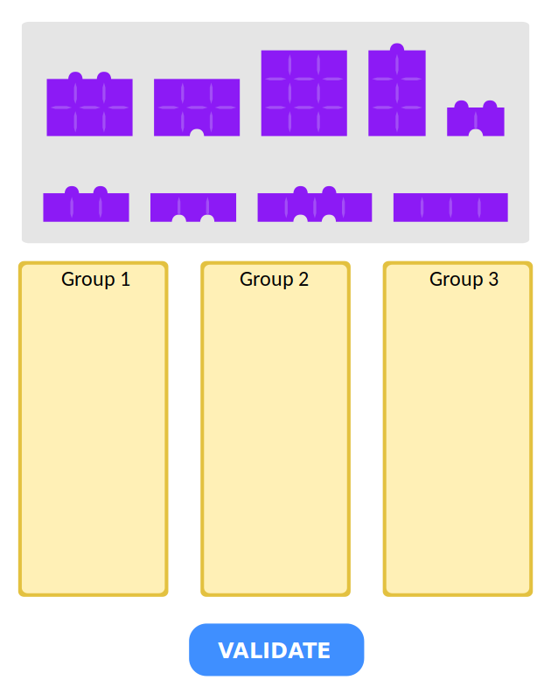

Answer Options / Interactivity Description
Some specifications in case of full feedback:
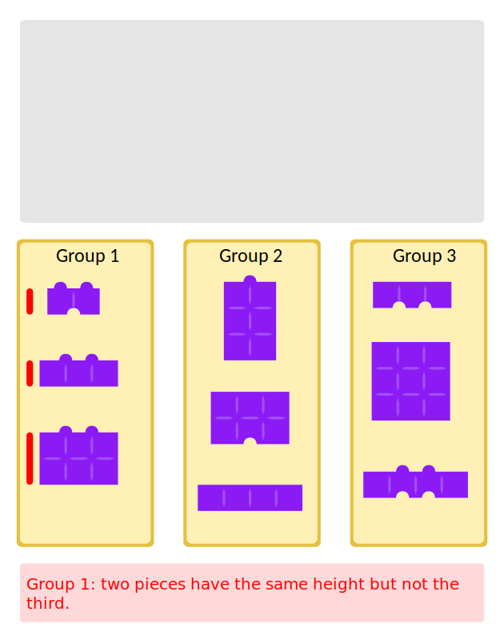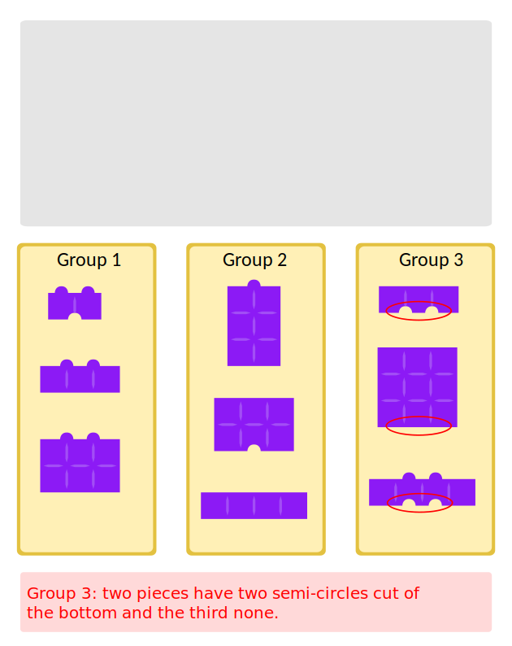

Answer Explanation
The correct answer is as follows:
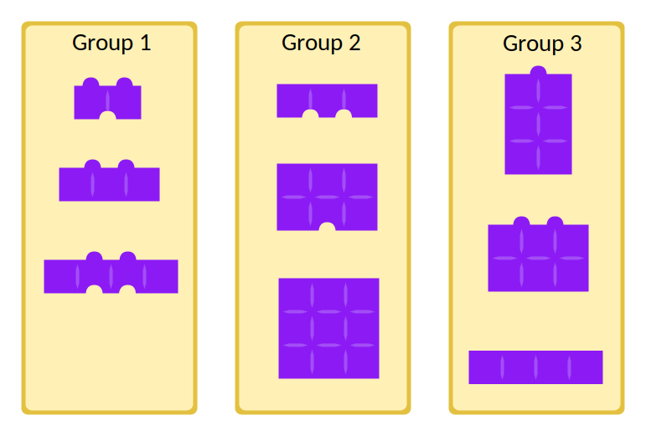

We can verify that this is correct:
- For Group 1, the width values are different, the height values are the same, and each piece has two semi-circles on top and a different number of semi-circles cut out of the bottom.
- For Group 2, the width values are the same, the height values are different, and each piece has zero semi-circles on top and a different number of semi-circles cut out of the bottom.
- For Group 3, the width values are different, the height values are different, and each piece has a different number of semi-circles on top and zero semi-circles cut out of the bottom.
There are several ways to find this correct answer and to verify that it is the only correct answer. One approach is to test all ways of dividing these pieces into three groups. That could take a long time! A different approach using careful reasoning is described next. (You might need to manipulate these pieces to convince yourself at each step.)
There are only two pieces that have the width value “wide” and two pieces that have the width value “narrow”:
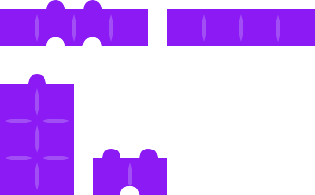
This means there must be a group where all the pieces have the width value “average”. Of the five pieces that have the width value “average”, two have two semi-circles on top and three have zero semi-circles on top.

Therefore, these three with zero semi-circles on top must form a group which is Group 2 above.
To finish, we need to divide the remaining six pieces into two groups where all the pieces in each group have different width values. We can now focus on the characteristic height. Notice that there must be a group of pieces that all have the height value “short” and a group of pieces that all have different height values. By looking at the bottom of these pieces, we can determine that Group 3 must be formed.
The remaining three pieces must form the final group which is Group 1.

This is Informatics
This task illustrates a practical example of Ramsey's Theorem, which is about finding ordered patterns within a large system or structure. The theorem states that for any given pattern or configuration, there exists a minimum size of a system or structure where the pattern is guaranteed to emerge.

The patterns can be defined in various ways, depending on the context and problem at hand. The original formulation of the theorem used colors to represent different categories, but the concept of coloring is not essential to the theorem itself. In this task, this has been adapted to shapes.

Ramsey's Theorem has far-reaching applications in mathematics (combinatorics, graph theory), computer science, and physics, among other domains. It provides insights into the existence of order and structure within seemingly chaotic systems and has implications in areas such as network analysis, optimization problems and cryptography.

This is Computational Thinking
This task illustrates a typical situation in problem solving where we use logical thinking, pattern recognition, and decomposition.
Logical inferences are used to to find a solution which follow a constrained set of rules. For example, the rule about the width can be expressed as “all pieces in the group are of equal width OR all pieces in the group are of different width”
There are many different patterns to recognize within this task. For example, you might notice that given two pieces, there is exactly one other piece that can be added to form a group satisfying the rule.
This task can also be viewed as an example of decomposition. Each group has four rules that it must satisfy in order to be part of it. The four rules can be checked independently, and the final result for each group is the combination of those four checks.

Informatics Keywords and Websites
Set Card Game - https://en.wikipedia.org/wiki/Set_(card_game)
Ramsay’s Theorem - https://www.baeldung.com/cs/ramsey-theory

Computational Thinking Keywords and Websites
Pattern Recognition - https://www.learning.com/blog/pattern-recognition-in-computational-thinking/#:~:text=Pattern%20recognition%20as%20part%20of,have%20one%20or%20multiple%20similarities.

Wording and Phrases

Comments
Adam Grodeck, adam.grodeck@csiro.au, 2023-03-30: please note that the images have been selected with a colour-blind friendly palette to ensure accessibility, given that patterns are not possible to use to distinguish the images. If changing images, will need to keep this consideration in mind!
J.P. Pretti, jpretti@uwaterloo.ca, 2023-05-15: O2 changed the images and story for these reasons:
- remove advantage for people familiar with game of Set
- remove any issues with colour-blindness altogether
- move further away from Set “just in case” because of possible copyright issues
The problem itself also changed to induce more manipulation and to move further away from Set.
EDIT ABOVE (keep this template and add above this line): author, e-mail, date (YYYY-MM-DD): Comment, including documentation of and reasons for changes, and precautions to take when further developing this task.

Graphics and Other Files
2023-AU-05a-eng.odt This file.
2023-AU-05_example.svg, Adam Grodeck, self-made, CC BY SA
2023-AU-05_question.svg, Adam Grodeck, self-made, CC BY SA
2023-AU-05_solution.svg, Adam Grodeck, self-made, CC BY SA
2023-AU-05_template.svg, Adam Grodeck, self-made, CC BY SA
EDIT ABOVE (keep this template and add above this line): filename, author, source/self-made, license
Please indicate:
- Source of each image or of each other file to produce the task image(s):
(URL and/or author)
- License for each image.
Note: If the source of an image is unclear, it might be copyrighted and cannot be used in the task.

Authors, Contributors, and Editors (incl. Graphics)
Adam Grodeck, adam.grodeck@csiro.au, Australia
Marielle Léonard, marielleleonard59@gmail.com, France: new graphics, self-made:
- 2023-AU-05_interactive_task.svg
- 2023-AU-05_example.svg
- 2023-AU-05_interactive_task_solution.svg
- 2023-AU-05_interactive_task_full_feedback_1.svg
- 2023-AU-05_interactive_task_full_feedback_2.svg

EDIT ABOVE (keep this template and add above this line): author / contributor / editor, e-mail, country.

License

Copyright © 2023 Bebras – International Challenge on Informatics and Computational Thinking. This work is licensed under a Creative Commons Attribution-ShareAlike 4.0 International License. https://creativecommons.org/licenses/by-sa/4.0/.

