2023-CH-01-eng Umbrella
6yo–8yo:  medium | 8yo–10yo:  – | 10yo–12yo:  – | 12yo–14yo:  – | 14yo–16yo:  – | 16yo–19yo:  –
Answer Type: Multiple-Choice with Images (☐ keep order of multiple-choice/-select)
Categories (click to choose):  ☐ algorithms and programming  ☑ data structures and representations |  |  | ☐ computer processes and hardware  ☐ communication and networking  ☐ interactions, systems and society
Equivalent Tasks: Actually, this year's task 2023-LT-02 "Photo" is fairly similar.

Body
This is Anna’s umbrella:
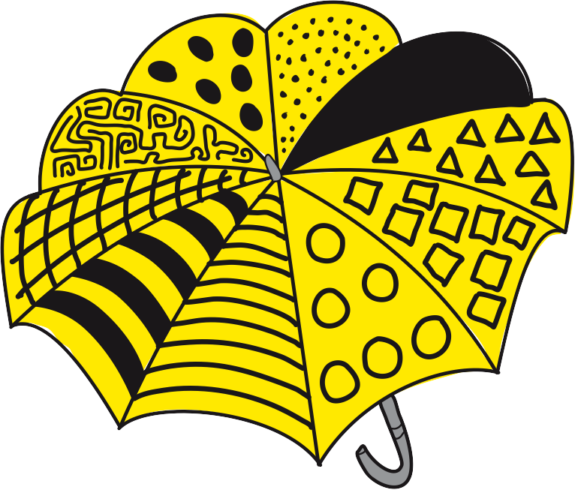

Question / Challenge
One of the four images shows Anna’s umbrella. Which one?

Answer Options / Interactivity Description
A) | B) | C) | D)
 |  |  | 

Answer Explanation
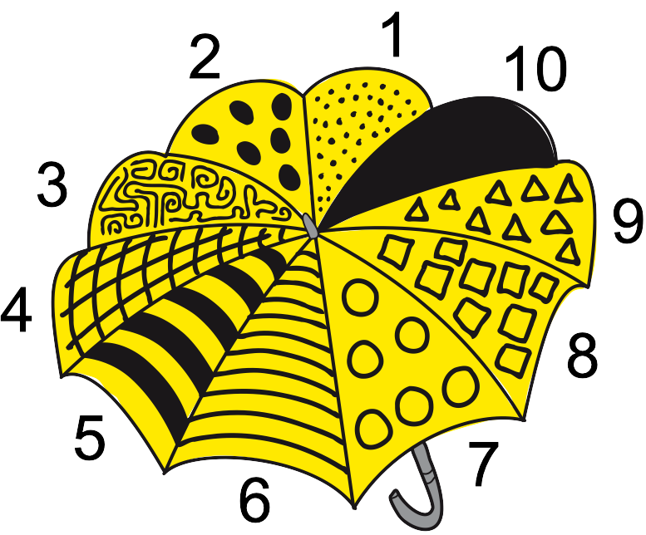
Every pattern is used only once in Anna’s umbrella. Therefore, we can compare each image with Anna’s umbrella this way:
- pick the left-most pattern from the image and find its position in Anna’s umbrella.
- check if the following patterns match Anna’s umbrella.
In each image we can see a sequence of only five patterns. So we cannot decide whether the image matches the full sequence of all ten patterns of Anna’s umbrella. However, only image C has a sequence of five patterns that fully matches Anna’s umbrella. For this reason, only umbrella C can show Anna’s umbrella. All other images show pattern sequences that only partially match that of Anna’s umbrella; so they cannot show Anna’s umbrella.
 | A | B | C | D
answer
images
Anna’s  umbrella | 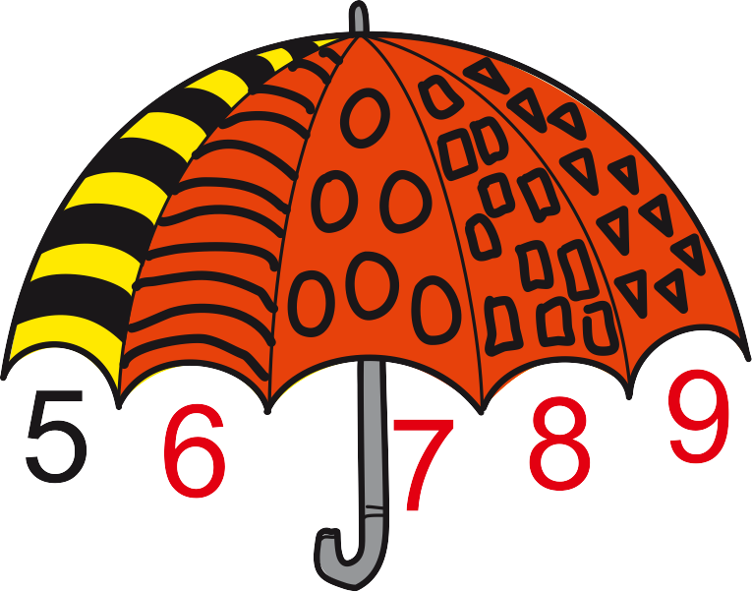 | 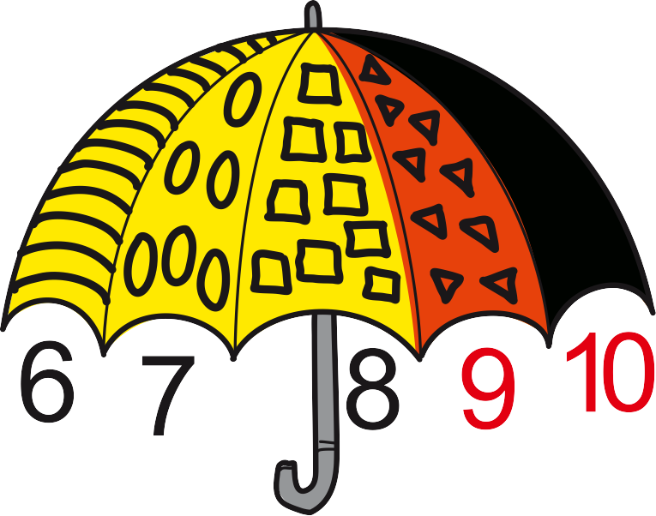 | 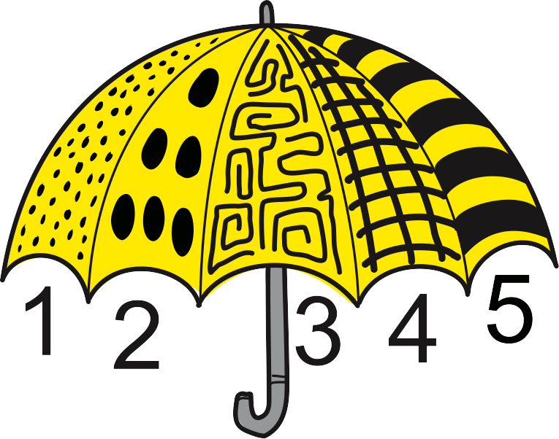 | 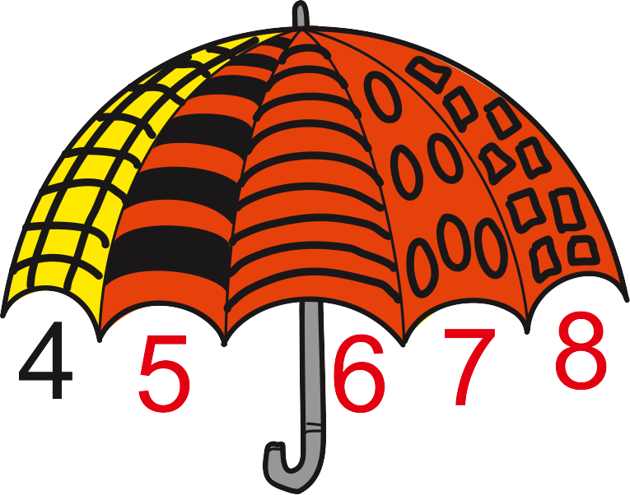

This is Informatics
In this Bebras task, we gain only partial information about the umbrella patterns shown in the answer options. Nevertheless, we can determine which image shows Anna’s umbrella: We can look at the four pattern sequences and notice that only one also occurs in Anna’s umbrella.
The same principle as for the “umbrella search” is applied when searching a text document. The computer searches with the given partial information (“search sequence” of letters) for matching sequences of letters in the document. You can observe that the longer your search sequence, the less matches you will find and the higher your chance to find the spot in the document that you are looking for. The shorter your sequence, the less accurate, but the faster your search. In computer science, search procedures (search algorithms) have been designed (and are still being improved) in order to obtain the most suitable results as quickly as possible. These algorithms are capable of searching in large amounts of data, like the internet search tools you may know.

This is Computational Thinking
The problem can be solved by using decomposition. Decomposition means breaking down a problem into smaller problems or steps. To find a matching sequence of 5 patterns you can break it down to the steps described in the answer explanation.
This task is also a very practical exercise in pattern recognition. Pattern recognition is the ability to recognize regularities, repetitions or similarities in a set of data. To find the favorite umbrella it is necessary to quickly find the matching sequences of the patterns. Later, when programming, pattern recognition allows us to use a modular approach, where have to solve a recurring sub task only once.

Informatics Keywords and Websites
Pattern, Sequence, search algorithms: https://en.wikipedia.org/wiki/Search_algorithm

Computational Thinking Keywords and Websites
pattern recognition: https://en.wikipedia.org/wiki/Pattern_recognition

Wording and Phrases
The expression «favorite umbrella» is not used in the task body but described as «umbrella that Bebras wants».

Comments
Fabian Frei, fabian.frei@inf.ethz.ch, 2023-02-19: For a more difficult version of this task, it would be possible to display not the full pattern of the desired umbrella, but only the reverse side of what is shown in C. In this case, the correct solution can be found only by excluding all wrong answers. (A partial overlap, for example with only the full black pattern, is also possible.)
Susanne Datzko, susanne.datzko@informatik-biber.ch, 2023-03-30: I added the following to the task:
- Explanation graphic
- structured the explanation into different steps
- added the fact, that the solution C could still be not the correct umbrella, because of the missing information. Added this information in the explanation and reformulated the taskbody a bit, so that it is clear, that one of the umbrella is really «the umbrella that Bebras wants».
- Moved the second part of the it is informatics to It is computational thinking. Added the connection to search algorithms in it is informatics.
==================== International Reviews =================================
Valentina Dagienė, valentina.dagiene@mif.vu.li, Lithuania, 2023-04-15:
Rating: as of now: 5.0 // potential: 6.0
I am one of the authors of this task, I thought not to review it, but I can briefly assess.
[AGE] fine
[IDEA] The idea of the task is not original, we have several "pattern recognition" tasks earlier. But there are some new elements like rotated patterns. This task requires computational thinking skills to be solved also spatial thinking is needed.
[TEXT] clear
[EXPL] Explanation is very well done.
[TiI] “It’s informatics” section is written good enough.
[TiCT] “This is Computational Thinking” section can be improved to write more about approach that we are using to solve this task.Could we talk about tinkering? Also we can mention decomposition.
[GRAPH] Well done
[AUTH] Yes
[NAME] Yes
[OTHER] I like the idea of Fabian (in "Comments" section): make more harder version by using reverse side of umbrella. Actually it can be different Bebras task.
Carlos Luna, 2023-04-22
Rating: as of now 4.0 // potential: 6.0
Interesting task, specially for the youngest ones.
[AGE} I think this task could be of interest for the second age group (8yo-10yo).
TEXT] I think there could be a little more story to the task, to make it more attractive.
[EXPL} It is a great idea to include images in the answer exlanation, as it helps better understand the idea of patterns and the comparison between the favorite umbrella's patterns anf the other ones.
Also related to this section, the final comment about option C being the correct option only if we can see the back side might be a little confusing. The idea itself is good and relevant, but I recommend rephrasing it to make it clear that since we are working with incomplete information. C is the best option, and to be 100% sure it's the right one, more information would be needed. And to get that extra information we would need to be able to look at the backside.
Alvida Lozdienė, 2023-04-15
Rating: as of now 6.0 // potential: 6.0
The task is very interesting and pedagogically correct. I suggest the authors to think about its interactivity.
For example, only the side parts of the umbrella should be presented, while the middle parts can be drag and drop by the participant from the collection of parts provided near.

Goran Sukovic, 2023-04-13
Rating: as of now 6.0 // potential: 6.0
A very nice task for the youngest group.
Extensive explanation with nice images.
There are two tiny typos in the text.
1. Missing the letter 's' in the word "pattern" in "check the order of all following pattern"
2. Choose between a colon and a dot in the text "wants: We" in the following paragraph: "Nevertheless, we can determine which umbrella our beaver wants: We can look at the four pattern sequences and notice that only one also occurs in the desired umbrella."
Consider changing the following sentence: "The same principle as for the “umbrella search” is applied when searching a text document". It's slightly misleading. The following text in the section suggests that we search for a word in a text. For example, insert the phrase "for a word in a text document" in the sentence.
Leonardo Cavalcante, 2023-04-20
Rating: as of now 5.0 // potential: 6.0
Very nice task for the youngest age groups.
The TICT section can be improved, connecting the ct skills to the context of the task.
Susanne Datzko, susanne.datzko@informatik-biber.ch, 2023-04-28:
- made the corrections mentioned by Goran – thank you!
- Reformulated the last paragraph of the answer-explanation to make it clearer (thank you Carlos)
- Improved TICTs section according to the comments. Tinkering could be an approach to solve the problem but wouldn’t lead quickly to a solution. Decomposition and pattern recognition is a better strategy to solve this task.

Wolfgang Pohl, pohl@bwinf.de, 2023-05-16 (on behalf of IBW WG L4):
We wanted an even simpler task body. Also, we found it unnatural to say “the umbrella that Bebras wants”, because you would usually not want one specific object, but any object with certain properties. Also, there is no need to have a beaver here. In the end, it simply is “Anna’s umbrella”. As a consequence, we had to adapt explanation and This is Informatics section accordingly.
Also, we found the illustration in the explanation to be confusing, with a too high level of abstraction for that age group. We present a more direct approach of comparing the answer option images with the “real” umbrella.
EDIT ABOVE (keep this template and add above this line): author, e-mail, date (YYYY-MM-DD): Comment, including documentation of and reasons for changes, and precautions to take when further developing this task.

Graphics and Other Files
2023-CH-01-eng.odt This file.
2023-CH-02-taskbody.svg, Vaidotas Kinčius (vaidotas.kincius@bebras.lt), Creative Commons Attribution-ShareAlike 4.0 (https://creativecommons.org/licenses/by-sa/4.0/)
2023-CH-02-[A-D].svg, Vaidotas Kinčius (vaidotas.kincius@bebras.lt), Creative Commons Attribution-ShareAlike 4.0 (https://creativecommons.org/licenses/by-sa/4.0/)
2023-CH-02-explanation[1].svg, originals by Vaidotas Kinčius (vaidotas.kincius@bebras.lt), modified by Susanne Datzko, susanne.datzko@informatik-biber.ch
EDIT ABOVE (keep this template and add above this line): filename, author, source/self-made, license
Please indicate:
- Source of each image or of each other file to produce the task image(s):
(URL and/or author)
- License for each image.
Note: If the source of an image is unclear, it might be copyrighted and cannot be used in the task.

Authors, Contributors, and Editors (incl. Graphics)
Angélica Herrera Loyo, ETH Zürich, Switzerland, angelica.herrera@inf.ethz.ch
Valentina Dagienė, Vilnius University, Lithuania, valentina.dagiene@mif.vu.lt
Vaidotas Kinčius, vaidotas.kincius@bebras.lt (graphics)
Contributor: Susanne Datzko, susanne.datzko@informatik-biber.ch, Switzerland
Editor: Wolfgang Pohl, pohl@bwinf.de, (Germany) at IBW 2023
EDIT ABOVE (keep this template and add above this line): author / contributor / editor, e-mail, country.

License

Copyright © 2023 Bebras – International Challenge on Informatics and Computational Thinking. This work is licensed under a Creative Commons Attribution-ShareAlike 4.0 International License. https://creativecommons.org/licenses/by-sa/4.0/.

