2023-CH-05-eng Log Storage
6yo–8yo:  – | 8yo–10yo:  hard | 10yo–12yo:  medium | 12yo–14yo:  easy | 14yo–16yo:  – | 16yo–19yo:  –
Answer Type: Click To Choose (☐ keep order of multiple-choice/-select)
Categories (click to choose):  ☐ algorithms and programming  ☑ data structures and representations |  |  | ☑ computer processes and hardware  ☐ communication and networking  ☐ interactions, systems and society
Equivalent Tasks: None

Body
Beaver Sawya cuts wood logs of various lengths and then sells them. Whenever she has finished cutting one, she puts the logs down along the 18-meter-long narrow road, one after the other as the logs cannot fit side by side.
When Sawya puts down a log, she places it in the first available spot from the left where the log fits. When she sells a given log, it is simply removed from the spot it previously occupied.
Sawya has prepared, in this order, logs of lengths 2, 5, 3, 6, and 1 (in meters). This leads to this arrangement along the road:
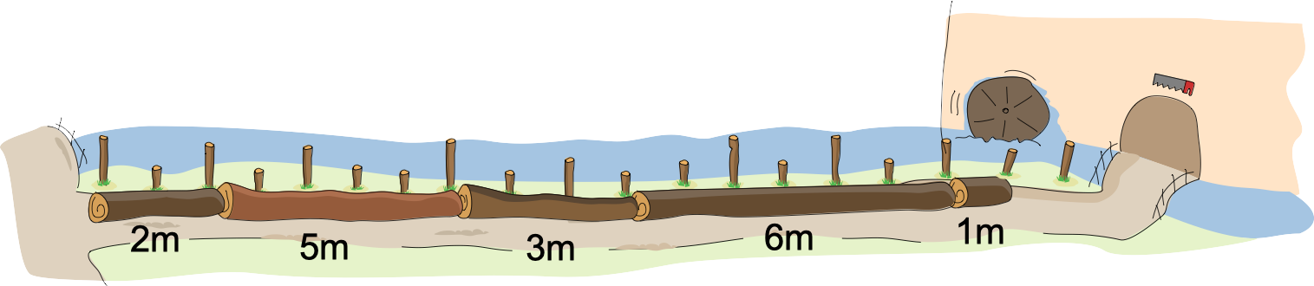
She proceeds to sell the logs with sizes 6, 2, and 5 meters. Then, she cuts a new 4-meter log. Since she places it as far left as she can, the road now looks like this:
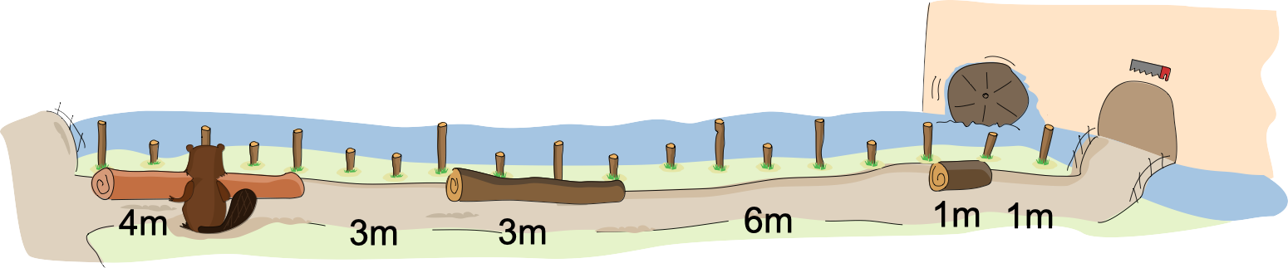

Question / Challenge
Sawya has to cut logs of lengths 1, 2, 3 and 4 meters. Which of the following orders will allow her to store them all on the road, provided she uses the same rule?

Answer Options / Interactivity Description
A)

B)

C)

D)

E)


Answer Explanation
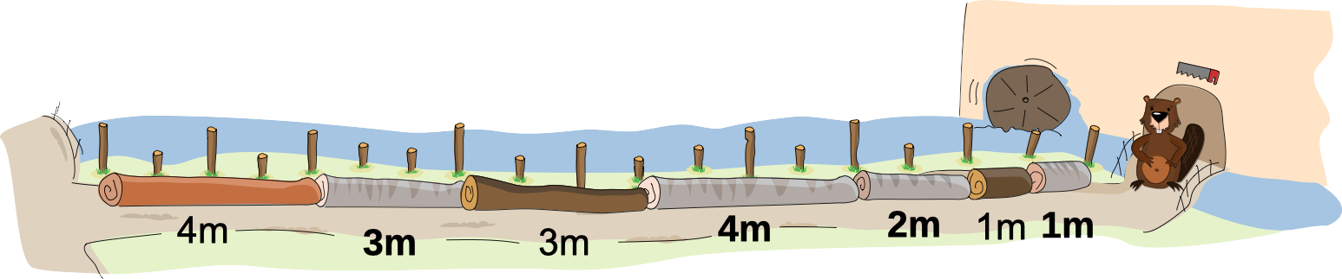
The correct answer is C) First 3 m, then 2 m, then 4 m, then 1 m.
All other answers lead to Sawya being unable to put down the last log.
The state of the road before Sawya cuts the new logs, as shown in the question, has three free spots: the leftmost spot is 3 meters long, the middle spot is 6 meters long, and the last one, on the right, is 1 meter long.
Answer C) totally fills the leftmost spot with the first log, then totally fills the middle spot with the next two logs, and the last log goes right into the rightmost spot: this works.
Answer A) totally fills the leftmost spot with the first two logs, but then puts the 3-meter-long log in the middle spot. Now the middle spot has been reduced to just 3 meters, and the last log, which is 4 meters long, fits neither there nor in the rightmost spot.
Answer B) puts the 1-meter-long log in the leftmost spot and, next, the 4-meter-log log in the middle spot. The leftmost spot can then still completely be filled with the third log, which is 2 meters long, but there is no sufficient contiguous space to put the last log.
Answer D) has a similar problem, but even earlier: the third log of 4 meters already cannot be put down. The leftmost and rightmost spots are too small anyway, and the middle spot is half occupied by the second log of 3 meters.

This is Informatics
One can see Sawya’s road as memory (RAM, stands for Random Access Memory) inside a computer, and the logs being put down and, later, sold, as computer processes requesting a certain amount of memory to run. In this example, although there is enough space to theoretically put down all the logs, the order (and the strategy) in which they come and go makes it sometimes impossible to fit them all. The same can happen in computers: depending on the order in which chunks of memory are allocated and freed, it may be impossible to allocate a new chunk of memory of a given size, even when the total free memory is greater than that size. This problem is known as memory fragmentation. Allocation strategies smarter than that of Sawya or memory models allowing, e.g., chunks to be moved help alleviate the fragmentation problem. Memory fragmentation is not only a problem with RAM: allocating space on a disk for writing files of various sizes leads to very similar problems.

This is Computational Thinking
To solve this task, one must evaluate the different proposed orders according to the described strategy, and find out which lead to a possible solution or not. While doing so, one may infer rules of thumb that can help formulate criteria for a given order (or beginning of an order) to be either promising or probably leading to a difficult situation (e.g. by creating several small memory fragments, which will later be unlikely to be used).

Informatics Keywords and Websites
• Memory management: https://en.wikipedia.org/wiki/Memory_management
• Memory fragmentation: https://en.wikipedia.org/wiki/Fragmentation_(computing)

Computational Thinking Keywords and Websites
Evaluation

Wording and Phrases
—

Comments
2023-05-17, Ralph Macarasig, ralph.macarasig@obf.ateneo.edu: Made a change in wording to make the task body clearer.
2023-05-16, Gerald Futschek, gerald.futschek@tuwien.ac.at: Henry Ong, henryo@simcc.org: We simplified the task by converting the decimal points to a whole number by simply doubling each number. The main reason is that students in grade 3 in some countries are not yet introduced to decimals. In some parts of the world, 1,5 is shown as 1.5, hence a whole number will eliminate this confusion. We rephrased some sentences to improve clarity.
2023-05-04, Jean-Philippe Pellet, jean-philippe.pellet@hepl.ch: As per what the reviewers suggested: improved TiI to quickly mention disk fragmentation as well (without going into details of how a filesystem works). Surely an interactive version would be possible: but I’d be afraid that the task gets too simple (simpler than now) when you can try it out interactively, as the “search space” remains relatively small. I also rephrased a sentence in the body following Wilfried’s suggestion.
==================== International Reviews =================================
Willem van der Vegt, 2023-04-11: Rating: as of now: 5 // potential: 6
Beautiful task and pictures.
Another part of the It's informatics could be the organization of the hard drive, where files are deleted and new are placed, and the role of the file allocation table.
An interactive solution part would be possible (put the new logs in order) or an interactive helper could be offered (play with it and deduce the proper order).
baumann wilfried, 2023-04-21: Rating: as of now: 5 // potential: 5
Nice task for this age group.
instead of "she places it as far left as she can". Maybe something like: She starts to fill the available space from the left using the first gap big enough …
gates, 2023-04-19: Rating: as of now: 4 // potential: 6
[AGE] Appropriate age levels.
[IDEA] Overall, this is a good Bebras task. The question may be more engaging/challenging in a drag and drop format, as it is fairly easy to determine the answer from the given options at present.
[TEXT] Addresses all aspects of the question in a good amount of text, in a logical fashion.
[EXPL] Thoroughly explains each of the answers, excellent.
[TiI Could use some editing for clarity, but otherwise strong.
[TiCT] Succinct.
[GRAPH] Very charming and appropriate graphics. I particularly appreciate the visual differences between several of the logs.

EDIT ABOVE (keep this template and add above this line): author, e-mail, date (YYYY-MM-DD): Comment, including documentation of and reasons for changes, and precautions to take when further developing this task.

Graphics and Other Files
2023-CH-05-eng.odt This file.
2023-CH-05-[taskbody, solution, question].svg all by Susanne Datzko, susanne.datzko@informatik-biber.ch, Switzerland
EDIT ABOVE (keep this template and add above this line): filename, author, source/self-made, license
2023-CH-05-graphics.svg, 2023-CH-05-body1.svg, 2023-CH-05-body2.svg, 2023-CH-05-answer.svg 2023-CH-05-answerA.svg, 2023-CH-05-answerB.svg, 2023-CH-05-answerC.svg, 2023-CH-05-answerD.svg, 2023-CH-05-answerE.svg – all redisagned by Darija Dasovic (darija.dasovic@ucitelji.hr, Croatia) from svg pictures made by Susanne Datzko

Authors, Contributors, and Editors (incl. Graphics)
EDIT ABOVE (keep this template and add above this line): author / contributor / editor, e-mail, country.
Jean-Philippe Pellet (main author), jean-philippe.pellet@hepl.ch, Switzerland
graphics: Susanne Datzko, susanne.datzko@informatik-biber.ch, Switzerland
Darija Dasović, darija.dasovic@ucitelji.hr, Croatia, redesigned the graphics at the workshop 05/16/2023
Editors at IBW 2023: Gerald Futschek, Henry Ong

License

Copyright © 2023 Bebras – International Challenge on Informatics and Computational Thinking. This work is licensed under a Creative Commons Attribution-ShareAlike 4.0 International License. https://creativecommons.org/licenses/by-sa/4.0/.

