2023-DE-02-eng Flowershop
6yo–8yo:  – | 8yo–10yo:  medium | 10yo–12yo:  – | 12yo–14yo:  – | 14yo–16yo:  – | 16yo–19yo:  –
Answer Type: Interactive (Other) (☐ keep order of multiple-choice/-select)
Categories (click to choose):  ☑ algorithms and programming  ☐ data structures and representations |  |  | ☐ computer processes and hardware  ☐ communication and networking  ☐ interactions, systems and society
Equivalent Tasks: None

Body
The flower shop sells bouquets that are composed in only three steps:
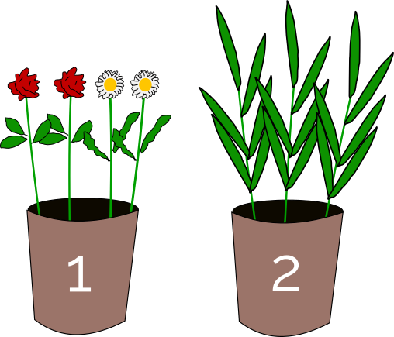
- Pick a flower from the first bucket.
- If the flower is a daisy , pick another daisy.
- Pick at least one branch from the second bucket to complete the bouquet.

Question / Challenge
Create a bouquet of exactly 4 pieces following the three steps.
(There is more than one correct solution).

Answer Options / Interactivity Description
If you click on a plant in one of the buckets, this plant is added to the bouquet. If you click on a plant in the bouquet this plant is removed from the bouquet.

Answer Explanation
There are 2 correct solutions:

In order to compose the bouquet correctly, you need to follow the three instructions:
Following the first instruction, you can pick either a daisy or a rose.
Following the second instruction, you pick either another daisy, so that you have two, or no flower, leaving you with one rose.
Following the third instruction, you add either three branches to the rose or two branches to the two daisies, in order to obtain exactly 4 pieces.

This is Informatics
The instructions to compose a bouquet are very clear and could be executed by a machine. In informatics, this is called an algorithm. In this task there are some very typical instructions that appear in many computer programs.
- The first instruction is a random choice from a collection of objects.
- The second instruction is called an if-statement. The command “pick another daisy” is only executed if a certain condition is true. This condition is “the flower is a daisy”.
- The third instruction looks simple but is a rather complex repeat-until or while repetition. Here, a certain activity, namely “pick a branch from the second bucket”, is repeated several times. The number of repetitions has to be at least 1 and stops when the bouquet has 4 pieces.
Floristry is an art and a profession. There exist different traditions with rules how to compose bouquets. This is an example that professional knowledge includes algorithms.

This is Computational Thinking
To solve this task it is necessary to understand and execute an algorithm. Further, this task illustrates that algorithms are a facet of cultural life. Evaluation is also part of the task, because at the end, you must have 4 flowers, and they cannot be two roses, or one daisy and one rose.

Informatics Keywords and Websites
Algorithm, random choice, if-statement

Computational Thinking Keywords and Websites
Algorithm thinking, evaluation

Wording and Phrases
Bouquet, branch, bucket, daisy, floristry, pick (a flower, a branch, a daisy)

Comments
Reviews:
Review 1
Stars: 4 / 5
[graphic] It has two buckets image but no bouquet.
How about there be an empty bouquet?
[question] How about asking questions according to the "body"?
For example, the question could be modified to ask about composing a bouquet that flower shop sells.
[AGE] I think it is difficult for young students (group 2) to understand the meaning of 'at least one' and solve the problem.
Review 2:
Stars: 4 / 5
[AGE] The age/difficulty level is specified and seems appropriate for the task and question.
[IDEA] Not extremely original idea but nice and relatable. It does require some computational thinking skill to be understood and solved.
[TEXT] Very clear, short and concise.
[EXPL] The “Answer Explanation” section is available and complete. It is understandable by students of the appropriate level. There is a clear reason why the correct answer is correct.
[TiI] The “It’s informatics” section is available. It is understandable by students of the appropriate level, well connected to the task, describes the background of the "story" and the connection to the informatics (computer science) of this task.
[TiCT] “This is Computational Thinking” section is not available.
[GRAPH] The figures are clear and appealing. They are CC-licensed and may be re-used and modified. They are available in SVG format (i.e., as vector graphics).
[AUTH] The name(s) and mail address(es) of the author(s) are available.
[NAME] The names of the task folder and file(s) comply with the prescribed format.
[OTHER]
Review 3:
Stars: 3 / 6
Nice and not difficult interactive task for the youngest.
The disadvantage is that the correct answer can be obtained by violating the given algorithm.
This can be fixed by arranging the selected items on the desktop from left to right in the order they were selected (for example).
Review 4:
Stars: 5 / 6
[AGE] Yes
[IDEA] Idea is known from previous year's tasks but still it is attractive for learners. For sure, it requires computational thinking skill for solving.
[TEXT] Quite well written. I suggest to name the second flower for example "rose" (naming "red flower" is not good comparing that another flower is named "daisy"). Also I am not sure that "branch" is a correct word here.
[EXPL] Is the “Answer Explanation” section available and complete? Is it understandable by students of the appropriate level? Is there a clear reason why the correct answer is correct? Is there a clear reason why the wrong answers are wrong?
[TiI] “It’s informatics” section is very well written, we can use it as an example for other tasks. Clear explanation about connection to informatics.
[TiCT] If the “This is Computational Thinking” section is not written at all. It is optional but it would be good to have at leas some sentences about solving process, what CT skills are needed, etc.
[GRAPH] All done.
[AUTH] Yes
[NAME] yes
[OTHER] I would like to suggest to make a more harder version of this task. Remove limitation of 4 pieces: then you can get 6 solutions.
Michael Weigend, mw@creative-informatics.de, 2023-03-25:
1. This task has two possible solutions.
If you want to have just one unique solution (and make the task a bit easier), you may change two things:
1) modify the third rule: “Pick one branch of the second bucket.”
2) modify the task: “Create a bouquet of exactly 3 pieces according to these rules.”
An alternative to “click on object”-interactivity would be drag&drop.
2. A multiple choice-version of this task would be this:
Which of these bouquets have been bought in the flowershop?
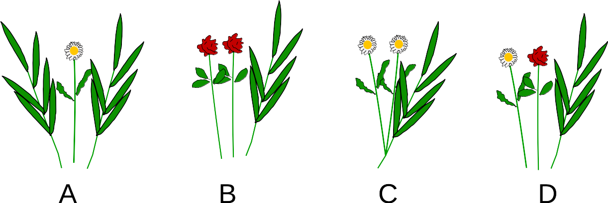

The correct answer would be C.

Michael Weigend, mw@creative-informatics.de, 2023-05-02:
Changes inspired by reviews and responses to reviews:
I changed the question. The original version said: “Create a bouquet of exactly 4 pieces according to these rules.” Now it is more according to the story (encouraged by review 1).
I added a few remarks on Computational Thinking (encouraged by reviews 2 and 4).
Review 1:” it is difficult for young students (group 2) to understand the meaning of 'at least one' and solve the problem”. Yes, this might be a difficulty. However, I think the term ‘at least 1’ is very clear and is used in children’s every-day life a lot.
I understand the criticism in review 3 this way: A contestant could start with picking at least one branch from the second bucket. This could be considered as “violating the given algorithm”. However, the task description does not explicitly demand that the statements are executed in a certain order. To keep it simple I would leave the interaction as it is.

Mao (maoyong@itccc.org.cn) - Koleszar (vkoleszar@ceibal.edu.uy) - Workshop group 5, 2023-05-16
Changes were made in the body of the task to explain that there are only 3 steps and in the question. Red flower was replaced with rose in the explanation. Also template was restored, and numbers were added to the image. CT section was completed.

Graphics and Other Files
2023-DE-02-eng.odt This file.
bouquet_4.svg, Michael Weigend, self-made
bouquets.svg, Michael Weigend, self-made
daisy.svg, Michael Weigend, self-made
flowers.svg, Michael Weigend, self-made

Authors, Contributors, and Editors (incl. Graphics)
Author: Michael Weigend, mw@creative-informatics.de, Germany
Contributors:
- Yong Mao, maoyong@itccc.org.cn, China
- Víctor Koleszar, vkoleszar@ceibal.edu.uy, Uruguay

License

Copyright © 2023 Bebras – International Challenge on Informatics and Computational Thinking. This work is licensed under a Creative Commons Attribution-ShareAlike 4.0 International License. https://creativecommons.org/licenses/by-sa/4.0/.

