2023-DE-04-eng Karla's Dream House
6yo–8yo:  – | 8yo–10yo:  medium | 10yo–12yo:  – | 12yo–14yo:  – | 14yo–16yo:  – | 16yo–19yo:  –
Answer Type: Interactive (Click-On-Object) (☐ keep order of multiple-choice/-select)
Categories (click to choose):  ☐ algorithms and programming  ☑ data structures and representations |  |  | ☐ computer processes and hardware  ☐ communication and networking  ☑ interactions, systems and society
Equivalent Tasks: None

Body
Karla has three maps that all show exactly the same area. One map shows the forests, one shows the rivers, and one shows the houses. Karla's dream house is in the forest and close to the riverbank.

Forests | Rivers | Houses
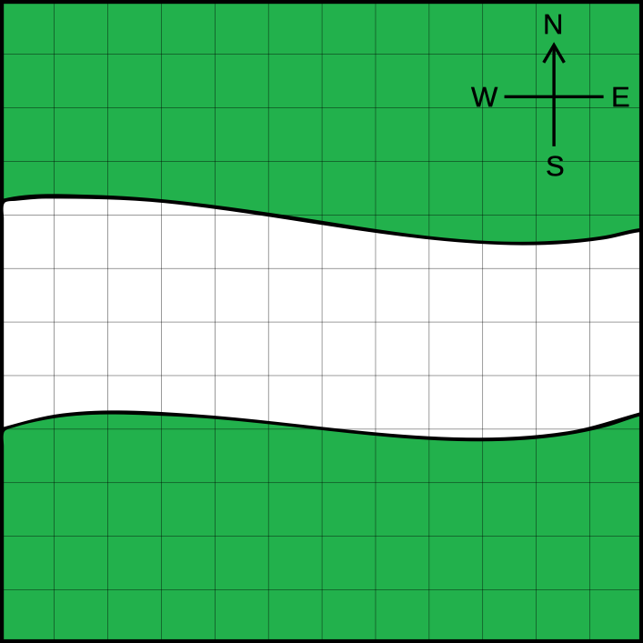 | 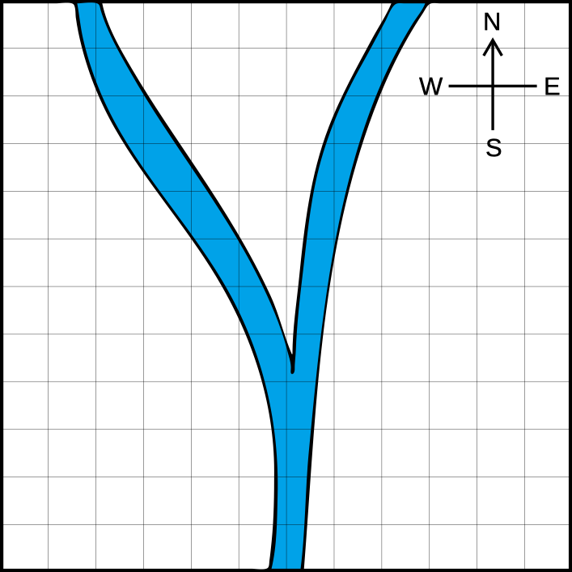 | 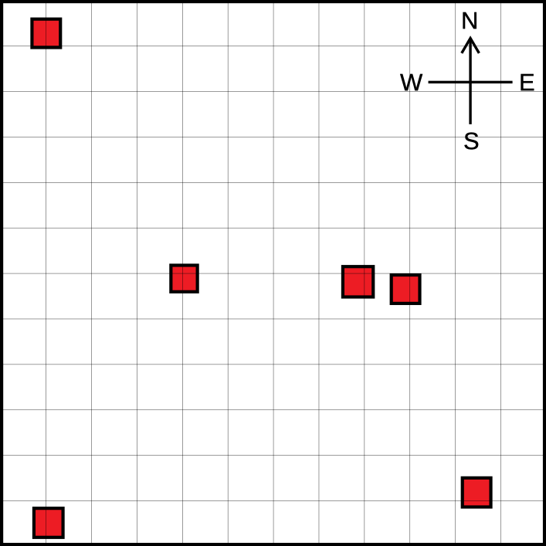

Question / Challenge
Which is Karla's dream house?

Answer Options / Interactivity Description
Karla’s dream house shall be selected by click on the rightmost map.

Answer Explanation
This is the correct answer:
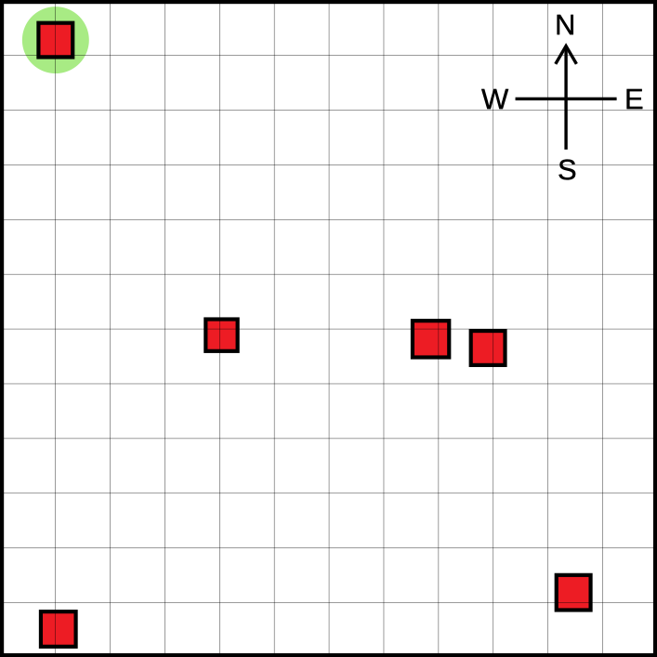
To identify Karla's dream house, the information from all three maps must be evaluated. The selected house must be located in a forest area and close to a river, which only applies to the house on the top left. This is easy to see when the maps are overlayed:
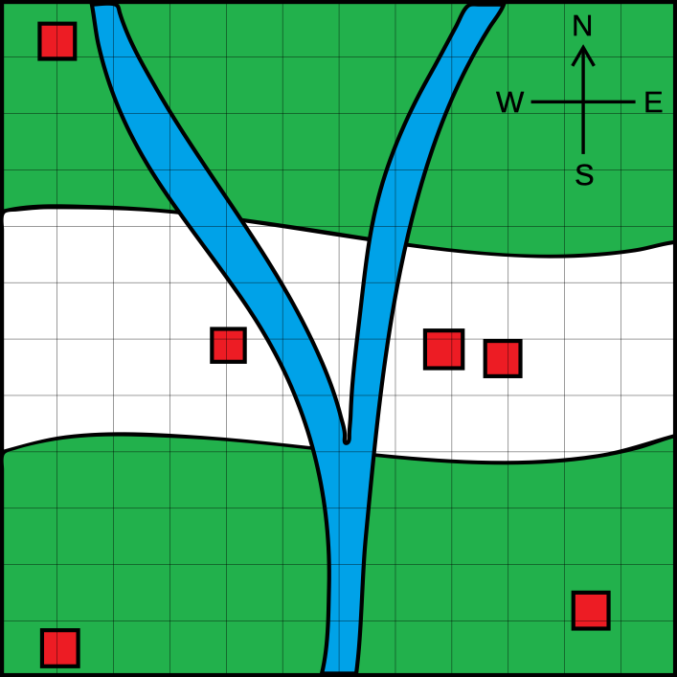

It’s Informatics
If the information about the vegetation, the rivers and the buildings were shown on a single map, then it would be easy to identify the house you are looking for.
In a geographic information system (GIS), a wide variety of spatial information is brought together and displayed on a map. A GIS thus serves to visualize and analyze geodata. With the help of a GIS, it is possible for disaster control officers to compile information for evacuation plans, for example.
The principle of multiple layers with different image information is also known from graphics programs. An important question is always which layer or which objects are displayed in the foreground. In the example, Karla's map should be the top layer, so that the houses are not hidden by the forest areas.

This is Computational Thinking
The task requires students to systematically and logically combine multiple layers of maps to find a particular place. It involves geometric data structure analysis including abstraction of the three maps representation to create a coherent and informative composite map.

Informatics Keywords and Websites
Geographic Information System (GIS)
Graphics Software, Layers, Transparency
https://en.wikipedia.org/wiki/Geographic_information_system
https://en.wikipedia.org/wiki/Layers_(digital_image_editing)

Computational Thinking Keywords and Websites
Data structure analysis
Abstraction

Wording and Phrases
Map, river map, map showing forests, map with houses
close: distance of the two objects is short.

Comments
Kirsten Schlüter, kirsten.schlueter@sonnwendjoch.de, 2023-05-01):
Review (anonymous): [TEXT] The text seems to me too implicit: in particular I miss a key piece of information about the pictures, they are maps of the same region with the same scale, this is the crucial point for the solution.
Comment (Author): It is now said that the three maps show exactly the same area.
Review (anonymous): [EXPL] It does not explain why overlapping makes sense
Comment (Author): It is reasoned that one can easily see if both conditions are true by overlaying the maps: “This is easy to see when the maps are overlayed.”
Review (anonymous): [IDEA] Good idea, while not obvious whether it is not enough to have two layers (rivers+meadows & houses) instead of three.
Comment (Author): GIS and graphics programs rely on the principle of multiple layers with different information. This way the layers can be updated or edited individually. To introduce the concept from the beginning, I decided to use three maps, not only two.
Review (anonymous): It's a novel idea. However, the description and constraints of the task appear unclear or insufficient. And there is a lack of consideration for color blindness. TCT is missing.
Comment (Author): For more clarity, I added the information that the maps show exactly the same area. Additionally, I have labeled the maps. To account for colorblindness, I replaced “light green” and “dark green” with “light color” and “dark color”.
Comment (Editors in work group L8): The group suggested adding a grid and a compass to all pictures, so that it is very clear that the pictures represent map layers. We also removed the Meadows as they did not bring any information but introduced potential confusion. Word close was added to Wording and Phrases section. We also added It’s Computational Thinking section and keywords.
EDIT ABOVE (keep this template and add above this line): author, e-mail, date (YYYY-MM-DD): Comment, including documentation of and reasons for changes, and precautions to take when further developing this task.

Graphics and Other Files
2023-DE-04-eng.odt This file.
Map_Forest.svg, Kirsten Schlüter, selfmade
Map_Rivers.svg, Kirsten Schlüter, selfmade
Map_Houses.svg, Kirsten Schlüter, selfmade
Maps_Overlay.svg, Kirsten Schlüter, selfmade
Solution.svg, Kirsten Schlüter, selfmade
EDIT ABOVE (keep this template and add above this line): filename, author, source/self-made, license
Please indicate:
- Source of each image or of each other file to produce the task image(s):
(URL and/or author)
- License for each image.
Note: If the source of an image is unclear, it might be copyrighted and cannot be used in the task.

Authors, Contributors, and Editors (incl. Graphics)
Author Kirsten Schlüter, kirsten.schlueter@sonnwendjoch.de, Germany
Editor Marika Parviainen, mhparv@utu.fi, Finland
Editor Yoshiaki Matsuzawa, matsuzawa@si.aoyama.ac.jp, Japan
Editor: Hyun-seok Jeon, melongist@gmail.com, South Korea
Editor: Marios Omar Choudary, marios.choudary@gmail.com, Pakistan
EDIT ABOVE (keep this template and add above this line): author / contributor / editor, e-mail, country.

License

Copyright © 2023 Bebras – International Challenge on Informatics and Computational Thinking. This work is licensed under a Creative Commons Attribution-ShareAlike 4.0 International License. https://creativecommons.org/licenses/by-sa/4.0/.

