2023-IR-02-eng Job_Assignment
6yo–8yo:  – | 8yo–10yo:  – | 10yo–12yo:  – | 12yo–14yo:  medium | 14yo–16yo:  – | 16yo–19yo:  –
Answer Type: Multiple-Choice (☐ keep order of multiple-choice/-select)
Categories (click to choose):  ☑ algorithms and programming  ☑ data structures and representations |  |  | ☐ computer processes and hardware  ☐ communication and networking  ☐ interactions, systems and society
Equivalent Tasks: None

Body
Rose, Mary, Elif, Omran, Yunas, Bahar and Nahid have applied for open positions in a factory departments including accounting, warehouse, call center, and packing.
Each individual is only qualified for jobs shown in the figure.
One person must be hired to work in each position and each person can hold at most one of the jobs.

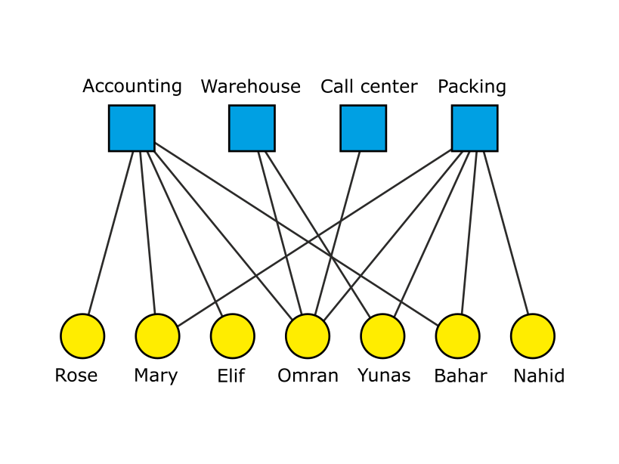
Question / Challenge
Which of the following is definitely true?

Answer Options / Interactivity Description
a) Nahid will be hired for packing.
b) Yunas will be hired for the warehouse.
c) Omran will be hired for packing.
d) If Mary is hired for packing, Bahar will be hired for accounting.
e) Elif will be hired for accounting.

Answer Explanation
Choice (b) is true.
It is enough to note that if a certain job has only one applicant, that applicant must be hired in that job, even if he/she has applied for other jobs as well.

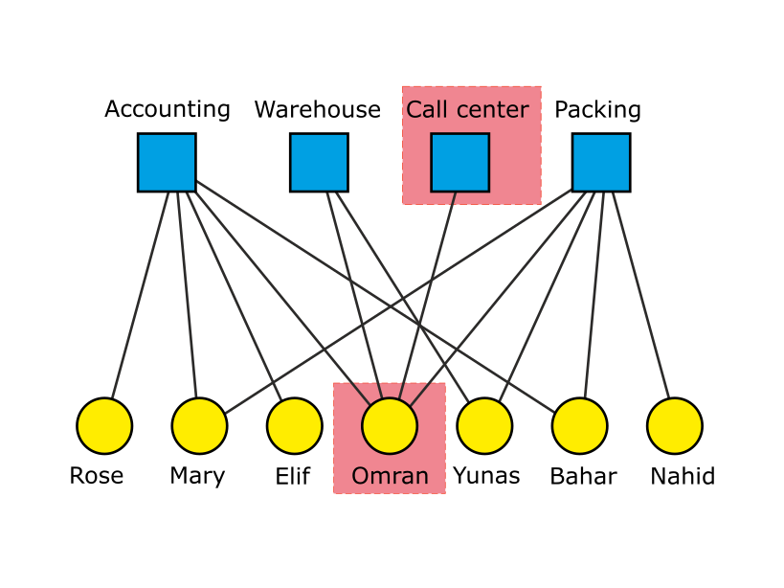
Thus, at first glance Omran must be hired in the Call center.
Therefore choice (c) is false.

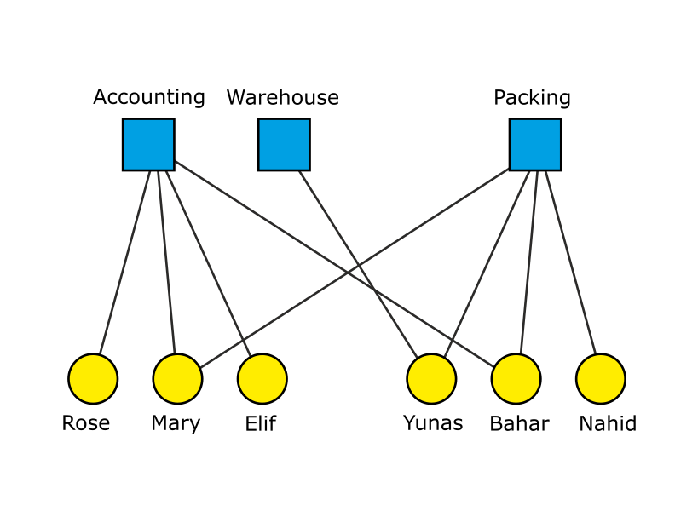
Now we remove Omran and Call center and their
lines from the figure, because the call center job is
filled and Omran can only have one job.

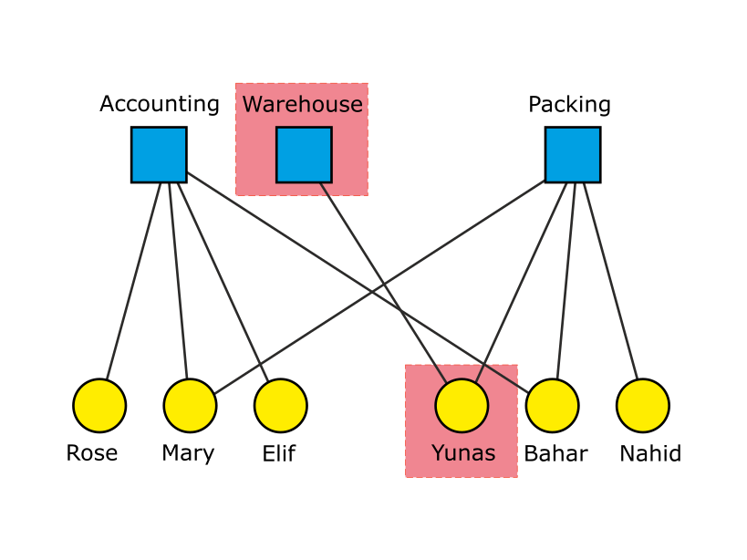
By repeating this logic Yunas will be hired for the
Warehouse and the choice (b) is true.

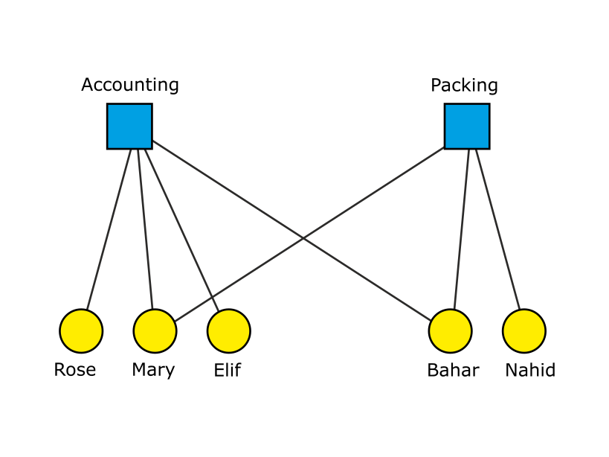
By removing Yunas and the Warehouse and
their lines from the figure, we can clearly see a
solution that violates choices (a) and (d) and (e).

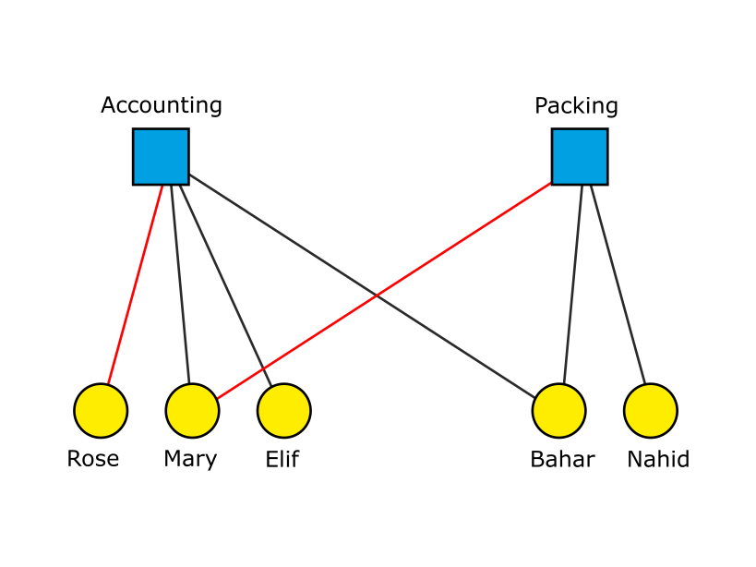
For example, Mary and Rose might be hired
in Packing and Accounting respectively.

This is Informatics
We used a bipartite graph to represent the data structure of jobs and applicants. This is a constraint satisfaction problem where assigning values to variables eliminates other options and could be represented using traditional set notation, e.g. Warehouse = {Omran, Yunas} before applying arc consistency logic to assign jobs. Constraint satisfaction problems are common in many real world resource allocation problems and in puzzles (such as Sudoku).
The story behind this task is using bipartite graphs for job assignment. Bipartite graphs are an interesting representation of a graph using two categories of vertices which allow a polynomial time algorithm to solve the vertex matching problem.

This is Computational Thinking
We used decomposition by looking at each job alone and independent of other jobs.
We used logic where we said that “if a certain job has only one applicant, that applicant must be hired in that job, even if he/she has applied for other jobs as well”, then we found an algorithm to solve this task, therefore this is Computational Thinking.

Informatics Keywords and Websites
Job assignment, Bipartite graph, Graph.
https://en.wikipedia.org/wiki/Bipartite_graph
https://www.coursera.org/lecture/graphs/job-assignment-h3kGu

Computational Thinking Keywords and Websites
Logic, Decomposition.

Wording and Phrases
accounting, warehouse, call center, packing, hire, job, qualified

Comments
Jalil Nedaeepour, nedaeepour@gmail.com, (2023-03-29): The Idea of this task proposal is from my previous studies about graphs and their applications.

Jalil Nedaeepour, nedaeepour@gmail.com, (2023-05-05): I have implemented most of the suggestions of the reviewers.

James Atlas, james.atlas@canterbury.ac.nz, 2023-05-16 and Özgür Özdemir, ozguregitim@gmail.com: working group L5. Edited graphics to make the vertex and font sizes larger. Simplified language in rules. Corrected rules to be “one will be hired…” Changed difficulty to medium for 12-14. Changed Ali to Elif so that each vertex has a unique first character label. Changed answer option e to use Elif so that answers do not use the same person more than once. Fixed template. Rewrote informatics section to add constraint satisfaction. Added words to wording and phrases.
EDIT ABOVE (keep this template and add above this line): author, e-mail, date (YYYY-MM-DD): Comment, including documentation of and reasons for changes, and precautions to take when further developing this task.

Graphics and Other Files
2023-IR-02-eng.odt This file.
Job_Assignment_0.svg, Jalil Nedaeepour, selfmade.
Job_Assignment_1.svg, Jalil Nedaeepour, selfmade.
Job_Assignment_2.svg, Jalil Nedaeepour, selfmade.
Job_Assignment_3.svg, Jalil Nedaeepour, selfmade.
Job_Assignment_4.svg, Jalil Nedaeepour, selfmade.
Job_Assignment_5.svg, Jalil Nedaeepour, selfmade.

EDIT ABOVE (keep this template and add above this line): filename, author, source/self-made, license
Please indicate:
- Source of each image or of each other file to produce the task image(s):
(URL and/or author)
- License for each image.
Note: If the source of an image is unclear, it might be copyrighted and cannot be used in the task.

Authors, Contributors, and Editors (incl. Graphics)
Jalil Nedaeepour, nedaeepour@gmail.com, Iran.
James Atlas, james.atlas@canterbury.ac.nz, New Zealand, 2023-05-16
Özgür Özdemir, ozguregitim@gmail.com, Turkey, 2023-05-16
EDIT ABOVE (keep this template and add above this line): author / contributor / editor, e-mail, country.

License

Copyright © 2023 Bebras – International Challenge on Informatics and Computational Thinking. This work is licensed under a Creative Commons Attribution-ShareAlike 4.0 International License. https://creativecommons.org/licenses/by-sa/4.0/.

