2023-LT-01-eng Sort the beavers by hats
6yo–8yo:  medium | 8yo–10yo:  – | 10yo–12yo:  – | 12yo–14yo:  – | 14yo–16yo:  – | 16yo–19yo:  –
Answer Type: Interactive (Drag & Drop) (☐ keep order of multiple-choice/-select)
Categories (click to choose):  ☑ algorithms and programming  ☑ data structures and representations |  |  | ☐ computer processes and hardware  ☐ communication and networking  ☐ interactions, systems and society
Equivalent Tasks:

Body
Sort the beavers in ascending order according to their hats’ heights.
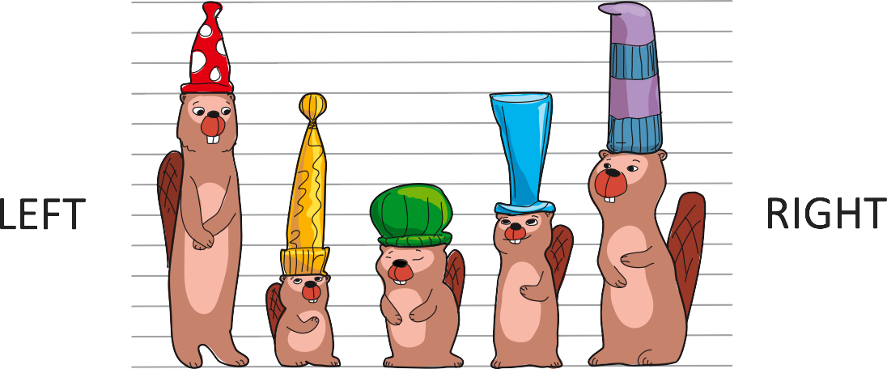

Question / Challenge
Move the beavers by dragging them. The beavers to the right must have taller hats than those to their left.

Answer Options / Interactivity Description
Interactive case: The possibility to drag each beaver to another place in the row. The beavers between slide one position in direction to the emptied place.
In case of multiple-choice

Question / Challenge
In what sequence will the beavers stand if they are arranged in a way that beavers to the right have taller hats than beavers to the left?
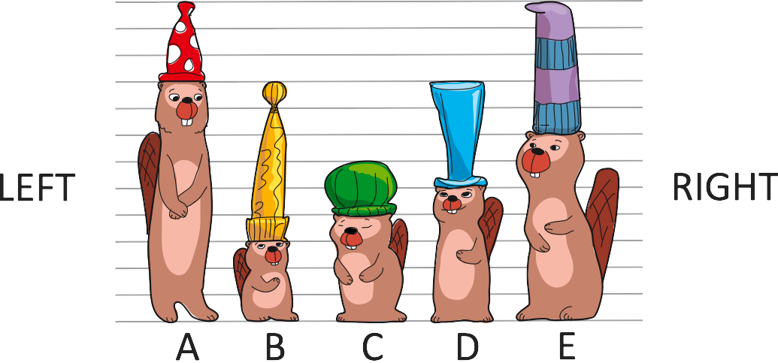
A) C A D E B
B) B E D A C
C) C A E D B
D) E B D A C

Answer Explanation
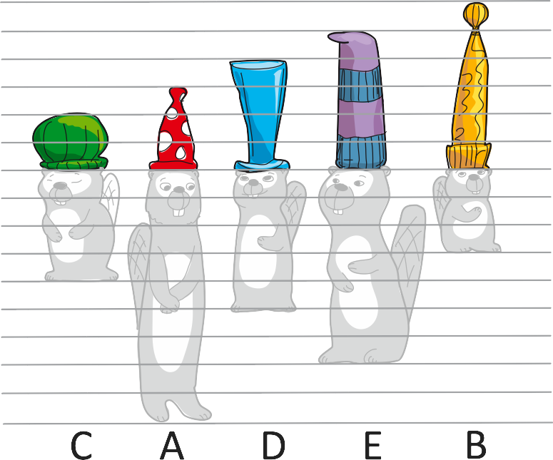

This is Informatics
In informatics, arranging in an ordered sequence is called sorting. It is astonishing how many things are sorted in our daily life. The lockers in an aqua park, the entries in dictionaries or telephone books. Without sorting the entries in a dictionary it is extremely hard to find a required item. Even the results of any internet browser request are ordered according to their relevance. The results of nearly all sport events are ordered due to the achievements. In all these cases the sorted items are easier to handle than unsorted items. Especially if there is a large number of items the advantage is much more evident.

This is Computational Thinking
First of all it is necessary to analyze the problem and to find out that to solve this problem, one needs to separate the height of the beavers from the height of their hats. Then by analyzing the data (the sequence of beaver hats) a sequence of rearrangements has to be found. The idea that moving taller hats to the right, respective hats with lower height to the left leads closer to the desired goal is a first step to create an algorithm where these steps are repeated until all beavers are in order.

Informatics Keywords and Websites
Sorting
https://en.wikipedia.org/wiki/Sorting
https://classic.csunplugged.org/documents/activities/sorting-algorithms/unplugged-07-sorting_algorithms.pdf

Computational Thinking Keywords and Websites

Wording and Phrases

Comments
Gerald Futschek, gerald.futschek@tuwien.ac.at, 2023-05-16: Reformulation of the task question for interactive and MC version to avoid technical terms. Description of This is Informatics and This is computational thinking in more detail.
EDIT ABOVE (keep this template and add above this line): author, e-mail, date (YYYY-MM-DD): Comment, including documentation of and reasons for changes, and precautions to take when further developing this task.
Overwhelming number of task versions. Two versions will be enough: multiple choice and drag and drop.

Review by: Goran Sukovic Review date: 2023-04-13
[AGE] Appropriate age level. A very nice task for the age group 6–8. It can be a very easy task for the age group of 8–10.
[IDEA] OK.
[TEXT] Please rephrase the question. For example: "sort the beavers according to hat size". Or, "sort the beavers in descending order of their hat sizes". Consider adding an "algorithms and programming" category to the task. The sorting is an algorithm that uses some data structures.
[EXPL] Good.
[TiI] The section is very short. Consider adding why sorting is important.
[TiCT] Clear and short.
[GRAPH] Very nice.

Review by: Jiří Vaníček
Good task for youngest pupils.
The question is wrong. We don't sort beavers according to their hats, but the SIZE of their hats. A hat is not a criterium suitable for sorting.
I think that reduction of task possibilities will make the file more clean (ascending or descending sort leads to the same task). Two possibilities - multiple-choice and drag-and-drop are enough.
I recommend to rearrange the explaining picture. Because children prefer comparing height in the upward direction, it would be better to move the hats vertically so that their bottoms lay on the same line.
Graphics is OK and nice.

ANSWER to the reviewers.
Thanks for noticing that beavers need to be sorted according their hats’ heights (HEIGHT, not SIZE!). The answer pictures Vaidotas will redraw later.

Graphics and Other Files
2023-LT-01-eng.odt This file. Valentina Dagienė
2023-LT-01-task-no-letters.svg, 2023-LT-01-answ5-1-no-letters.svg, 2023-LT-01-answ1-5-no-letters.svg, 2023-LT-01-task.svg, 2023-LT-01-answ5-1.svg, 2023-LT-01-answ1-5.svg, Vaidotas Kinčius
EDIT ABOVE (keep this template and add above this line): filename, author, source/self-made, license
Please indicate:
- Source of each image or of each other file to produce the task image(s):
(URL and/or author)
- License for each image.
Note: If the source of an image is unclear, it might be copyrighted and cannot be used in the task.

Authors, Contributors, and Editors (incl. Graphics)
Author Valentina Dagienė, valentina.dagiene@mif.vu.lt, Lithuania
Graphics Vaidotas Kinčius, vaidotas.kincius@gmail.com, Lithuania
Editor at IBW 2023: Gerald Futschek, gerald.futschek@tuwien.ac.at, Austria.
Contributor at IBW 2023: Wolfgang Pohl, pohl@bwinf.de, Germany
IBW 2023: Darija Dasović, darija.dasovic@ucitelji.hr, Croatia, redesigned the graphics 05/17/2023
EDIT ABOVE (keep this template and add above this line): author / contributor / editor, e-mail, country.

License

Copyright © 2023 Bebras – International Challenge on Informatics and Computational Thinking. This work is licensed under a Creative Commons Attribution-ShareAlike 4.0 International License. https://creativecommons.org/licenses/by-sa/4.0/.

