2023-LT-02-deu Photo
6yo–8yo:  – | 8yo–10yo:  easy | 10yo–12yo:  – | 12yo–14yo:  – | 14yo–16yo:  – | 16yo–19yo:  –
Answer Type: Multiple-Choice with Images (☑ keep order of multiple-choice/-select)
Categories (click to choose):  ☐ algorithms and programming  ☑ data structures and representations |  |  | ☐ computer processes and hardware  ☐ communication and networking  ☐ interactions, systems and society
Equivalent Tasks: I am pretty certain there have been similar tasks (about finding matching orderings), but I do not remember at this time.

Body
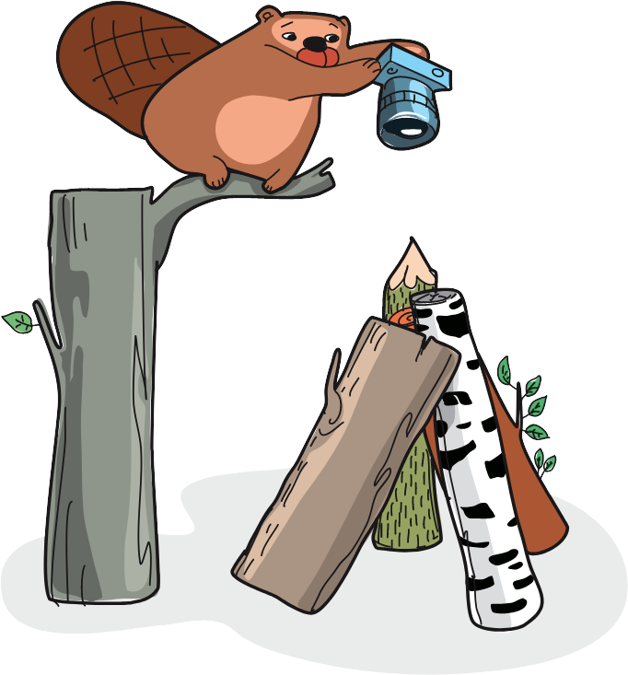
Der Biber hat gerade ein Foto gemacht.

Question / Challenge
Welches der vier Fotos ist es?

Answer Options / Interactivity Description

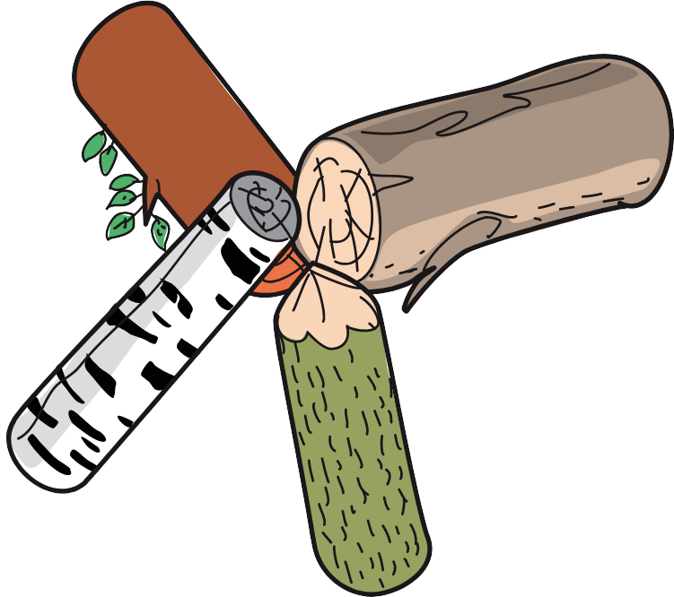 | 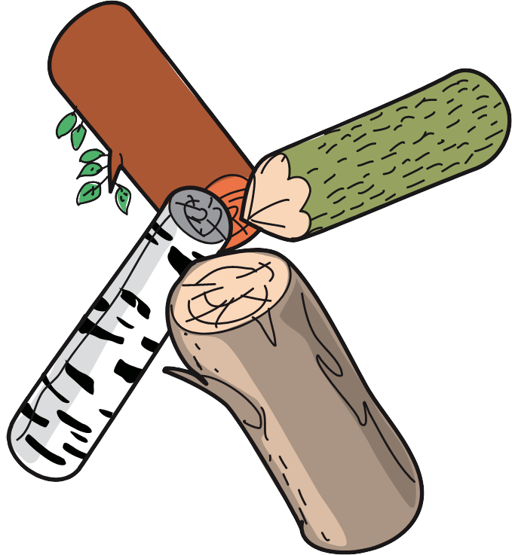 | 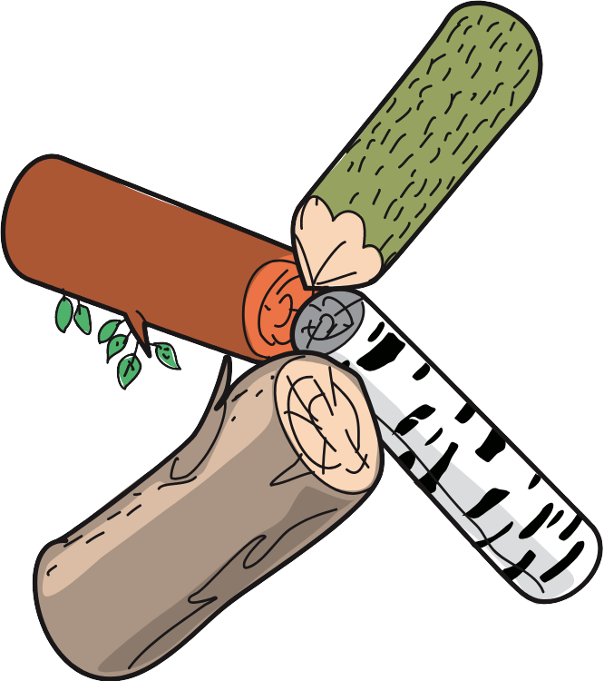 | 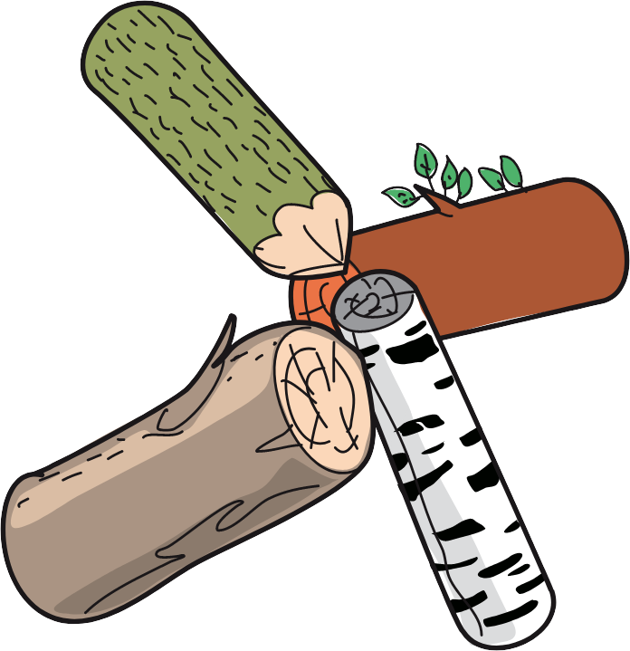
A) | B) | C) | D)

Answer Explanation
D) ist die richtige Antwort.
Um zu bestimmen, wie die Baumstämme auf dem Foto aussehen, die Lage der Baumstämme zueinander analysieren. Ein möglicher Lösungsansatz wäre folgender:
Hier befindet sich der Baumstamm mit dem spitzen Ende (der wie ein Bleistift aussieht) zwischen den beiden braunen Baumstämmen, was die beiden Antwortmöglichkeiten A) und C) ausschließt. Außerdem kann man sehen, dass der Biber beim Fotografieren den "Bleistift"-Baumstamm links vom großen braunen Baumstamm (dem ohne Blätter) sieht. Dies ist nur bei Antwort D) der Fall.

This is Informatics
In dieser Biberaufgabe wird die Reihenfolge der Baumstämme betrachtet. Was bei wenigen Elementen (hier vier Baumstämmen) durch einfaches „Hinsehen“ und Vergleichen der Nachbarpaare möglich ist, erfordert bei Problemen mit viel mehr Elementen ein automatisiertes Vorgehen. Dazu müssen die Elemente in einer geeigneten Datenstruktur wie einer verketteten Liste gespeichert werden:
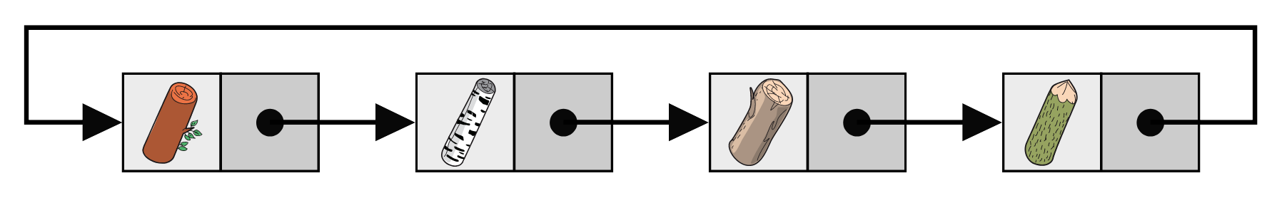
In einer verketten Liste wird jedes Datenelement in einem einzelnen Knoten gespeichert. Zusätzlich ist in jedem Knoten ein Verweis auf den nächsten Knoten in der Liste gespeichert. Enthält der letzte Knoten einen Verweis auf den ersten Knoten, so handelt es sich um eine ringförmige Datenstruktur. Das ist im Beispiel wichtig, damit man bei jedem beliebigen Baumstamm starten und die Liste durchlaufen kann.

This is Computational Thinking
Diese Aufgabe erfordert Abstraktionsvermögen - das Erkennen relevanter Informationen (die Anordnung von Baumstämmen in einem Kreis) und räumliches Denkvermögen (bei Veränderung der Darstellung von Objekten, bleiben ihre Beziehungen erhalten).

Informatics Keywords and Websites
Abstraction, order

Computational Thinking Keywords and Websites
Abstraction is important cocept of CT, see paper: https://files.eric.ed.gov/fulltext/EJ1329311.pdf

Wording and Phrases
EDIT HERE (delete this): list of words and phrases used to name important things mentioned in the task body (actors, activities/processes, concepts, definitions, objects, names, etc.) This is to ensure the consequent use of terminology in the task body and to facilitate translation.
log

Comments
EDIT ABOVE (keep this template and add above this line): author, e-mail, date (YYYY-MM-DD): Comment, including documentation of and reasons for changes, and precautions to take when further developing this task.

By: Lidia Feklistova (svn: feklistova)
on 2023-04-07
Assigned review
[AGE] In my opinion this task can be too hard for 6-8 yo, they may not have enough experience with spatial thinking. But for 8-10yo this task might be appropriate. I suggest hard level for 6-8 yo and medium for 8-10 yo.
[IDEA] The idea is good.
[TEXT] Short and clear.
[EXPL] Some examples-explanations why other figures are incorrect could be helpful.
[TiI] This part is missing.
[TiCT] OK
[GRAPH] Figures are clear and appealing, in SVG format. Unfortunately, there is no information about CC-license.
[AUTH] OK
[NAME] OK
[OTHER] Why the order of multiple-choice/-select should be kept? Informatics Keywords and Websites are missing.
========================================
By: Heikki Hyyrö (svn: hyrroe)
on 2023-04-11
Assigned review
[AGE] The task could be categorized as an easy one for also little bit older age groups?
[IDEA] The idea is good and seems original. Brings a new twist to the often appearing object ordering perception tasks.
[TEXT] The task text is very concise (only one sentence, and it already poses the question itself) while also being sufficient. No much room for improvement here!
[EXPL] The provided answer explanation seems like a quickly drafted sketch. It should be expanded into a more elaborate description (especially given that the task is directed towards the youngest students).
[TiI] The “It’s informatics” section is empty.
[TiCT] The “This is Computational Thinking” section exists and gives a short but reasonable description about how the task relates to computational thinking.
[GRAPH] The figures are cute cartoonish descriptions of a beaver and logs in svg format. No much room for improvement here, either.
[AUTH] Authors' names and emails are given.
[NAME] Seems ok.
[OTHER] -
========================================
By: Judith Lin (svn: lin)
on 2023-04-19
Assigned review
The idea of the task is good-- having the students to observe and find out the "ordering" of the logs. However, it is unclear to me why the answer is D. Maybe a more elaborate answer explanation would help. Also, the It's informatics section is missing.
Since two logs can be propped against each other to form an arch like the shape of "ʌ" (which means both logs are the same order), it might be a bit hard for the students to determine the order of the logs. This issue can be easily fixed by re-drawing the image.
Over all, it's an interesting and fun easy task.
========================================
Author: thanks for comments, everything is corrected
Wolfgang Pohl, pohl@bwinf.de, May 16, 2023 (IBW Hurghada, WG L4
- The task picture was changed so that it is clear the photo is taken from above the logs (bird’s eye view).
- The text was changed slightly to make clear that one of the pictures must be the photo taken.
- “This is Informatics” was changed to a text about an informatics concept (doubly-linked list). The previous text actually was about computational thinking. You can find it in the task proposal, if you would like to compare.

Graphics and Other Files
2023-LT-02-deu.odt This file. Valentina Dagienė
2023-LT-02-task.svg, 2023-LT-02asw-A.svg, 2023-LT-02asw-B.svg, 2023-LT-02asw-C.svg, 2023-LT-02asw-D.svg by Vaidotas Kinčius
EDIT ABOVE (keep this template and add above this line): filename, author, source/self-made, license
Please indicate:
- Source of each image or of each other file to produce the task image(s):
(URL and/or author)
- License for each image.
Note: If the source of an image is unclear, it might be copyrighted and cannot be used in the task.

Authors, Contributors, and Editors (incl. Graphics)
Author Valentina Dagienė, valentina.dagiene@mif.vu.lt, Lithuania
Graphics Vaidotas Kinčius, vaidotas.kincius@gmail.com, Lithuania
Editor at IBW 2023: Wolfgang Pohl, pohl@bwinf.de, Germany: Modifications as explained in the comments.
Translation into German: Liam Baumgarten, liam.baumann@ocg.at, Austria
Contirbutor: Kirsten Schlüter, kirsten.schlueter@sonnwendjoch.de, Germany

License

Copyright © 2023 Bebras – International Challenge on Informatics and Computational Thinking. This work is licensed under a Creative Commons Attribution-ShareAlike 4.0 International License. https://creativecommons.org/licenses/by-sa/4.0/.

