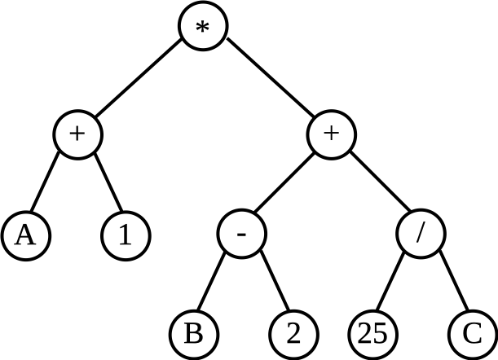
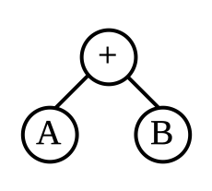
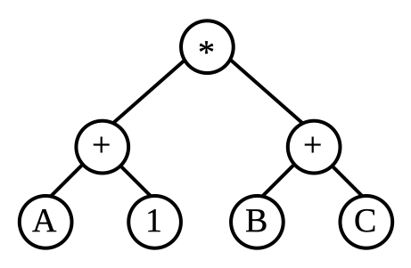
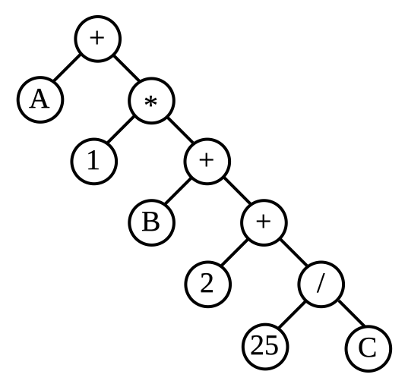
2023-RO-02-eng.odt Reverse Polish notation
6yo–8yo:  – | 8yo–10yo:  – | 10yo–12yo:  – | 12yo–14yo:  hard | 14yo–16yo:  medium | 16yo–19yo:  easy
Answer Type: Multiple-Choice with Images (☐ keep order of multiple-choice/-select)
Categories (click to choose):  ☐ algorithms and programming  ☑ data structures and representations |  |  | ☐ computer processes and hardware  ☐ communication and networking  ☐ interactions, systems and society
Equivalent Tasks: None

Body
Little Beaver and his friend thought of transforming the mathematical operations: addition (+), subtraction (-), multiplication (*), division (/), into a graphic representation, which they would then encode as follows (for A, B and C are variables or constants):
- The operation A+B is represented in the image below:  where the coding rule is: A B +. | - The operation (A+1)*(B+C) is represented in the image below:  where the coding rule is: A 1 + B C + *.

Question / Challenge
For coding rule A 1 + B 2 + * 25 C / + choose the correct representation from the following images:

Answer Options / Interactivity Description
a) | b)
c)  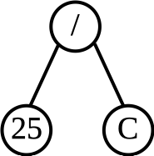  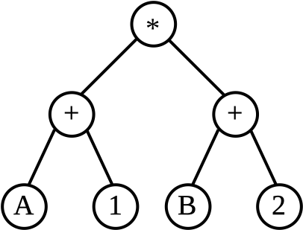  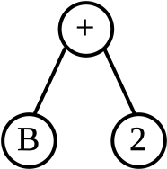  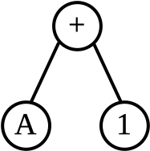  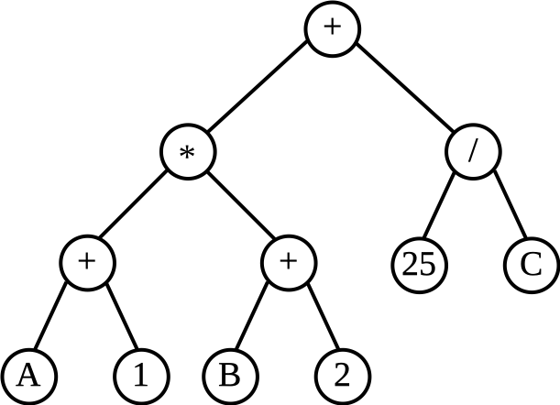  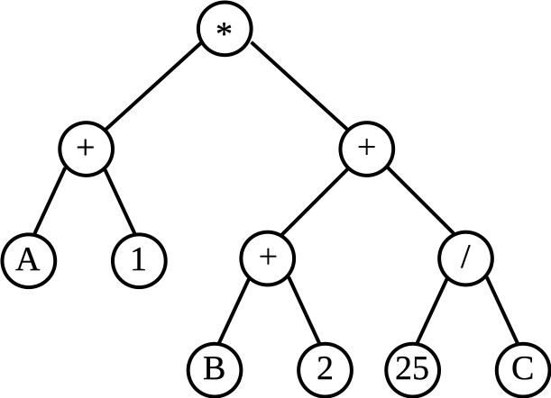 | d)

Answer Explanation
The correct answer is c.
A 1 + is represented as

B 2 + is represented as

A 1 + B 2 + * is represented as

25 C / is represented as

Therefore, A 1 + B 2 + * 25 C / + is represented as

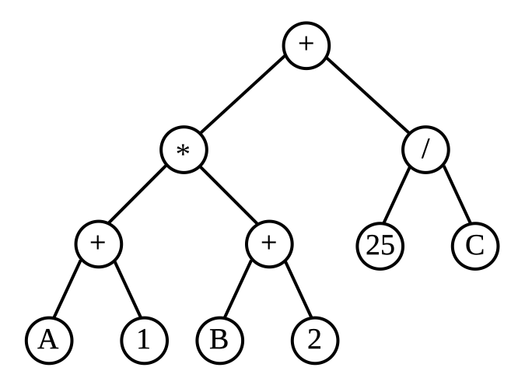

Answer a is not correct because it corresponds to the coding: A 1 B 2 25 C / + + * +
Answer b is not correct because it contains the minus operation - which does not appear in the given expression.
Answer d is not correct because it corresponds to the coding: A 1 + B 2 + 25 C / + *

This is Informatics
The reverse Polish notation (RPN) is a format utilized by compilers, which are types of translators that convert programming languages understood by humans into machine code comprehensible by computers. It is employed to evaluate expressions present in any program.
This notation transforms an expression of the form "operand1 operator operand2" (where the operand can be a variable or a constant, and the operator represents operations like addition, subtraction, multiplication, division, etc.) into "operand1 operand2 operator". For instance, the expression A + B becomes A B +.
In the field of computer science, a tree is a commonly used abstract data type that often represents a hierarchical structure with interconnected nodes. Each node in the tree can have multiple children (depending on the tree type) but must have exactly one parent, except for the root node, which has no parent. These constraints ensure that there are no cycles or loops (i.e., no node can be its own ancestor), and each child can be treated as the root node of its own subtree.
Every expression can be associated with a binary tree, which is a structure composed of nodes and edges (connections between nodes). In a binary tree, each node can have connections with at most two other nodes on a subsequent level.

This is Computational Thinking
The problem can be solved by decomposing expressions into smaller expressions and by using examples that work as models in building the tree associated with the expression.

Informatics Keywords and Websites
Binary tree, reverse polish notation
Reverse Polish notation - Wikipedia

Computational Thinking Keywords and Websites
Computational Thinking Definition | Learning.com

Wording and Phrases
Coding, representation, operations, expressions

Comments
Raluca Constantinescu, raluca.constantinescu@ecdl.ro, 2023-05-04

Graphics and Other Files
2023-RO-02-eng.odt This file.
example 1.svg
example 2.svg
answer a.svg
answer b.svg
answer c.svg
answer d.svg

Authors, Contributors, and Editors (incl. Graphics)
Author: Laura Ungureanu, lauungureanu@gmail.com, Romania, 2023-03-30
Contributor: Raluca Constantinescu, raluca.constantinescu@ecdl.ro, Romania, 2023-03-30
Edited by Thomas Ioannou, Ioannouthomas@gmail.com, Cyprus, and Omar Colon Reyes, omar.colon4@upr.edu, Puerto Rico, 2023-05-14
Edited by Khairul Anwar, khairul@aidan.com.my, Malaysia, and Gohar Khachatryan, goharvardanyan002@gmail.com, Armenia, 2023-05-16

License

Copyright © 2023 Bebras – International Challenge on Informatics and Computational Thinking. This work is licensed under a Creative Commons Attribution-ShareAlike 4.0 International License. https://creativecommons.org/licenses/by-sa/4.0/.

