J2EE Connector

Overview of the JPPF Resource Adapter

What is it?
The JPPF Resource Adapter is a JCA-compliant resource adapter module that encapsulates a JPPF client. It provides J2EE application servers with an access to JPPF grid services. It is intended for deployment as either a standalone module or embedded within an enterprise application, while preserving the ease of use of JPPF.

Features
- Supports the same configuration properties as a standalone JPPF client, including server discovery, connection to multiple drivers, connection pool per driver
- Supports disconnection from, and reconnection to, any JPPF driver
- Compliant with the JCA 1.5 specifications
- API similar to that of the standard JPPF client (submit(job))
- No transaction support

Architecture
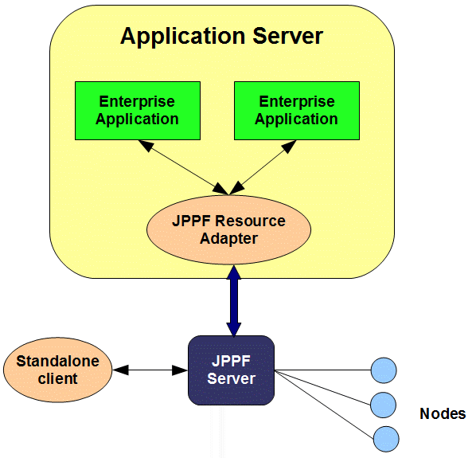

Supported Platforms
Note: we have not tested all versions of all platforms, thus it is possible that the integration, with the version of the application server you are using, may not work out-of-the-box. We hope that the existing framework and instructions will allow you to adapt the build scripts and code to do so. If you have issues with a specific port, or if you wish to report one that is not specified in this documentation, we invite you to provide your feedback and comments on the JPPF Forums.

Technology | Tested Platforms
Operating System | All Windows systems supporting JDK 1.5 or later  All Linux and Unix systems supporting JDK 1.5 or later
JVM | Sun JDK 1.5 and later  IBM JVM 1.5 and later  BEA JRockit 1.5 and later
Application Server | JBoss 4.0.x, 4.2.x, 5.0.x, 5.1.x  Oracle OC4J 10.1.3.x  Sun AS 9.0.x, Glassfish 2.x  IBM Websphere Application Server 6.1.x, 7.0.x  Oracle Weblogic 9.x, 10.x  Apache Geronimo 2.1.x

Configuration and build

Requirement
For building, configuring and customizing the JPPF Resource Adapter, your will need the latest version of the JPPF source code distribution. It can be found on the JPPF download page. The name of the file should be '''JPPF-2.x-j2ee-connector.zip'''

Build structure
The J2EE connector has the following folder structure:

Folder | Description
root folder | The root folder, contains the build.xml Ant build script
appserver | contains common and application server-specific configurations for the JPPF resource adapter and the demo application
build | this folder contains all jars, .ear and .rar files resulting from the build
classes | contains the compiled code of the JPPF resource adapter
config | contains application server-specific resources for the deployment of the resource adapter
docroot | contains resources for the build of the demo application on some application servers
src | contains the source code for the resource adapter and demo application.

Building the JPPF resource adapter
To build the resource adapter:

- Open a command prompt
- Go to the JPPF-2.x-j2ee-connector folder
- Enter “ant build”
- The resulting .rar and .ear files are generated in the “build” subfolder.

Configuring the resource adapter and demo application
The configuration files and deployment descriptors are all contained in the '''appserver''' folder. The detailed content of this folder is as follows:

Folder | Description
appserver | root folder, contains:  - the resource adapter's deployment descriptor ra.xml. It is in this file that you set the configuration parameters for the connection to the JPPF drivers, by setting the values of the configuration properties as follows:  <config-property>  <config-property-name>ClientConfiguration</config-property-name>  <config-property-type>java.lang.String</config-property-type>  <config-property-value>  # any server on the network will be automatically detected  jppf.local.execution.enabled = true  # create a pool of 5 connections for each detected server  jppf.pool.size = 5  </config-property-value>  </config-property>  - the demo application's deployment desciptor application.xml
appserver/common | contains files common to all application servers, for the demo enterprise application
appserver/<server_name> | root of <server_name>-specific configuration and deployment files. Contains a commons-logging.properties file where you can configure which logging framework will be used (i.e. Log4j, JDK logger, etc...)
appserver/<server_name>/application | contains <server_name>-specific deployment descriptor for the demo application, for example: weblogic-application.xml.
appserver/<server_name>/docroot | contains a <server_name>-specific JSP for the demo application. The specificity is the JNDI name used to look up the JPPF connection factory. It relates to the corresponding resource-ref defined in the web.xml descriptor.
appserver/<server_name>/ra | contains a <server_name>-specific deployment descriptor for the resource adapter. It generally contains the definition of the corresponding JCA connection factory. Not all application servers require one. Example: weblogic-ra.xml.
appserver/<server_name>/WEB-INF | contains the <server_name>-specific deployment descriptors for the demo web application. The specificity is mostly in the resource-ref definition of the JNDI name ofr the JPPF connection factory. For example: web.xml and jboss-web.xml.

How to use the connector API
To use the JPPF Resource Adapter from your code, follow these steps:

Submitting the tasks
In the following example, a JPPF job is submitted asynchronously. The submission returns an ID that can be used later on to check on the job status and retrieve its results.

// Perform a JNDI lookup of the JPPF connection factory
InitialContext ctx = new InitialContext();
Object objref = ctx.lookup("eis/JPPFConnectionFactory");
ConnectionFactory factory =
(ConnectionFactory) PortableRemoteObject.narrow(objref, ConnectionFactory.class);
// Obtain a JPPF Connection from the connection factory
JPPFConnection connection = (JPPFConnection) factory.getConnection();
// Use the connection to submit your JPPF job
JPPFJob job = new JPPFJob();
job.addTask(new DemoTask());
// Use the connection to submit your JPPF tasks and obtain a submission ID
String submitID = connection.submitNonBlocking(job);
// close the connection
connection.close();

Checking the status and obtaining the results
Here, we check on the status of a job and process the execution results or the resulting error:

// Obtain a JPPF Connection from the connection factory
JPPFConnection connection = getConnection();
// Use the connection to check the status from the submission ID
JPPFSubmissionResult.Status status = connection.getSubmissionStatus(submitID);
if (status.equals(JPPFSubmissionResult.Status.COMPLETE))
{
// if successful process the results
List<JPPFTask> results = connection.getSubmissionResults(submitID);
}
else if (status.equals(JPPFSubmissionResult.Status.FAILED))
{
// if failed process the errors
}
// close the connection
connection.close();

Synchronous execution
It is also possible to execute a job synchronously, without having to code the job submission and status checking in two different methods. The JPPFConnection API provides the method waitForResults(String submitID), which waits until the job has completed and returns the execution results. Here is an example use:

// Submit a job with the specified number of tasks and return the execution results
public List<JPPFTask> submitBlockingJob(int nbTasks) throws Exception
{
List<JPPFTask> results = null;
JPPFConnection connection = null;
try
{
// get a connection to the resource adapter
connection = getConnection();
// create a new job
JPPFJob job = new JPPFJob();
job.setId("test job");
// add the tasks to the job
for (int i=0; i<nbTasks; i++) job.addTask(new MyTask(i));
// submit the job and get the submission id
String submitID = connection.submitNonBlocking(job);
// wait until the job has completed
results = connection.waitForResults(submitID);
}
finally
{
if (connection != null) connection.close();
}
// now return the results
return results;
}

Please note that, when using the synchronous submission mode from within a transaction, you must be careful as to how long the job will take to execute. If the job execution is too long, this may cause the transaction to roll back if the execution time is longer than the transaction timeout.

Using submission status events
Example:

JPPFConnection connection = getConnection();
JPPFJob job = new JPPFJob();
JPPFTask task = new DurationTask(duration);
job.addTask(task);

// A status listener can be added at submission time
// using another form of the method JPPFConnection.submitNonBlocking()
String id = connection.submitNonBlocking(job, new SubmissionStatusListener()
{
public void submissionStatusChanged(SubmissionStatusEvent event)
{
String id = event.getSubmissionId();
SubmissionStatus status = event.getStatus();
System.out.println("submission [" + id + "] changed to '" + status + "'");
}
});

// or after the tasks have been submitted
connection.addSubmissionStatusListener(id, new SubmissionStatusListener()
{
public void submissionStatusChanged(SubmissionStatusEvent event)
{
String id = event.getSubmissionId();
SubmissionStatus status = event.getStatus();
switch(status)
{
case COMPLETE:
// process successfull completion
break;
case FAILED:
// process failure
break;
default:
System.out.println("submission [" + id + "] changed to '" + status + "'");
break;
}
}
});
connection.close();

Deployment on a J2EE application server

Deployment on JBoss

Deploying the JPPF resource adapter
copy the file "'''jppf_ra_JBoss.rar'''" in this folder: <JBOSS_HOME>/server/<your_server>/deploy, where <JBOSS_HOME> is the root installation folder for JBoss, and <your_server> is the server configuration that you use
(JBoss comes with 3 configurations: "default", "minimal" and "all")

Creating a connection factory
Create, in the <JBOSS_HOME>/server/<your_server>/deploy folder, a file named jppf-ra-JBoss-ds.xml. Edit this file with a text editor and add this content:

<?xml version="1.0" encoding="UTF-8"?>
<connection-factories>
<no-tx-connection-factory>
<jndi-name>eis/JPPFConnectionFactory</jndi-name>
<application-managed-security/>
<rar-name>jppf_ra_JBoss-rar</rar-name>
<connection-definition>javax.resource.cci.ConnectionFactory</connection-definition>
<adapter-display-name>JPPF</adapter-display-name>
<min-pool-size>0</min-pool-size>
<max-pool-size>10</max-pool-size>
<blocking-timeout-millis>50000</blocking-timeout-millis>
<idle-timeout-minutes>15</idle-timeout-minutes>
</no-tx-connection-factory>
</connection-factories>

You can also download this file.

Deploying the demo application
Copy the file “JPPF_J2EE_Demo_JBoss-4.0.ear” in the <JBOSS_HOME>/server/<your_server>/deploy folder

Deployment on Oracle OC4J 10.3.1.x

Deploying the resource adapter
- in the OC4J administration console, go to "Applications"
- select "Standalone Resource Adapters" view

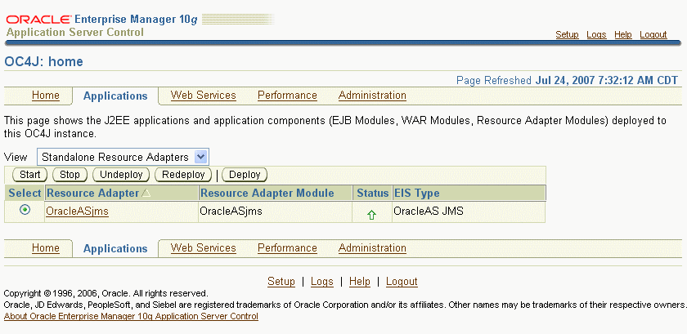

- click on "deploy"
- step 1: browse to the file "jppf_ra_Oracle.rar"

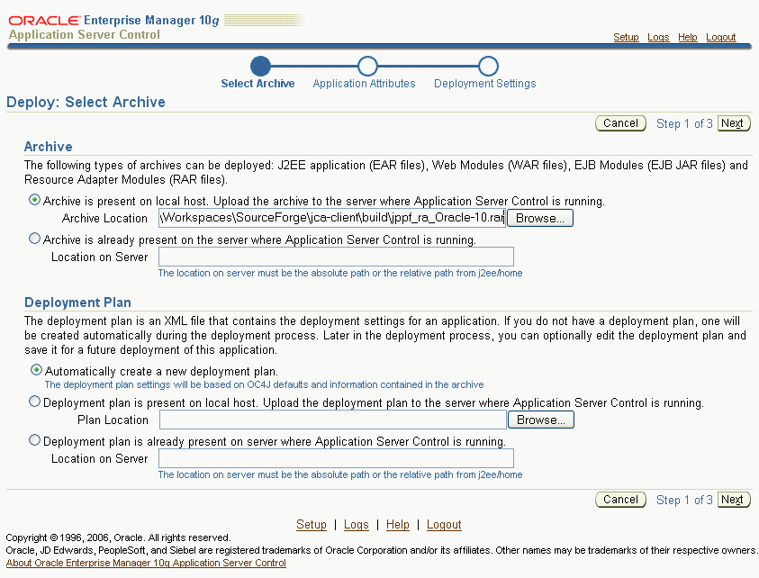

- click "next"
- step 2: enter "JPPF" as the Resource Adapter Name

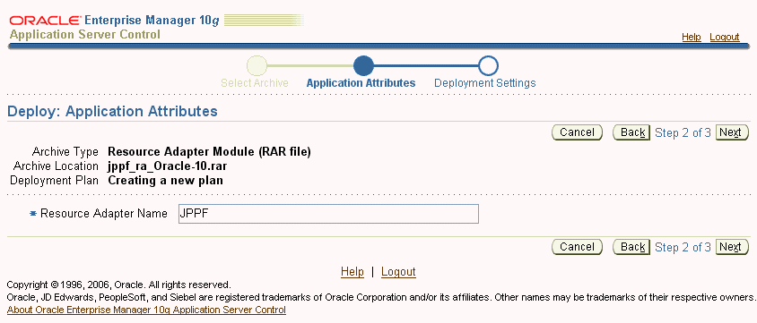

- click "next"
- step 3: click on "deploy"
- after deployment is complete, click on "return"
- restart the application server

Deploying the demo application
- in OC4J console, go to "Applications"
- select "Applications" view

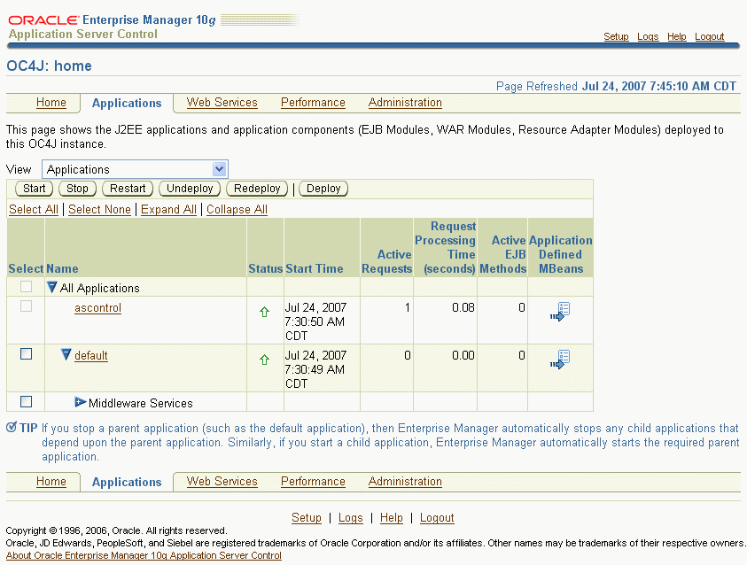

- click on "deploy"
- step 1: browse to the file "JPPF_J2EE_Demo_Oracle.ear"
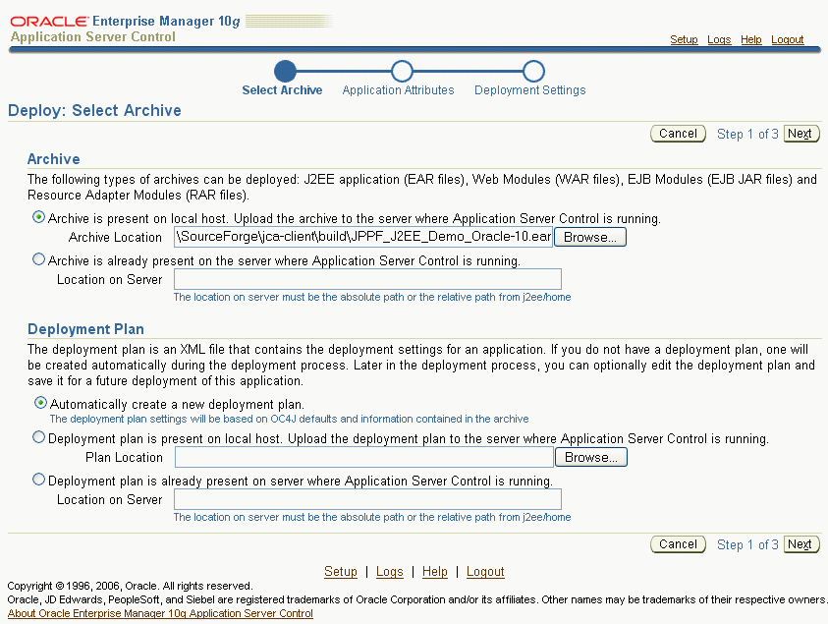

- click "next"
- step 2: enter "jppftest" as the Application Name

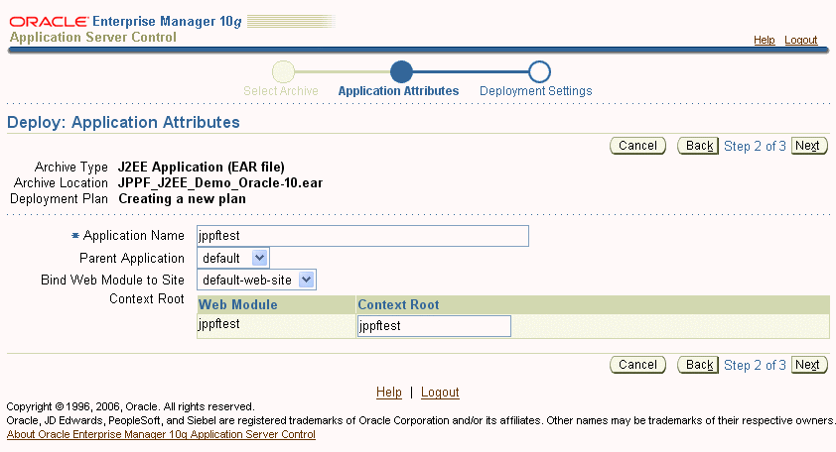

- click "next"
- step 3: click on "deploy"
- after deployment is complete, click on "return"
- restart the application server

Deployment on SunAS / Glassfish

Deploying the Resource Adapter
- in Sun AS console, go to "Applications > Connector modules"

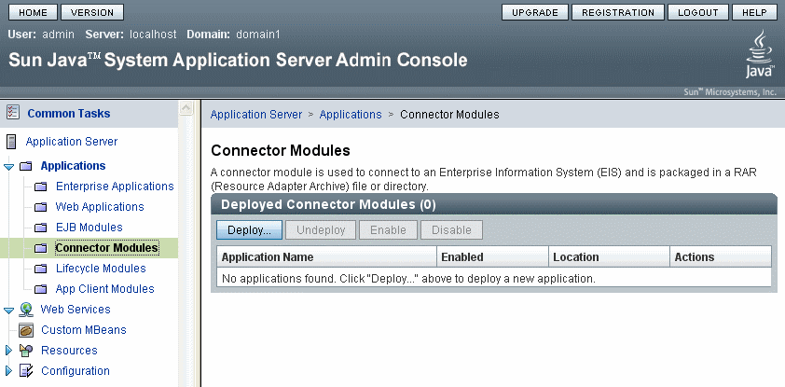

- click on "Deploy"
- step 1: browse to the "jppf_ra_Glassfish.rar" file

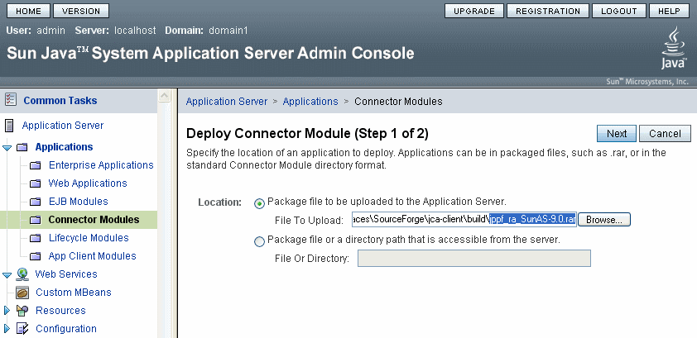

- click "next"
- step 2: leave all default settings and click "Finish"

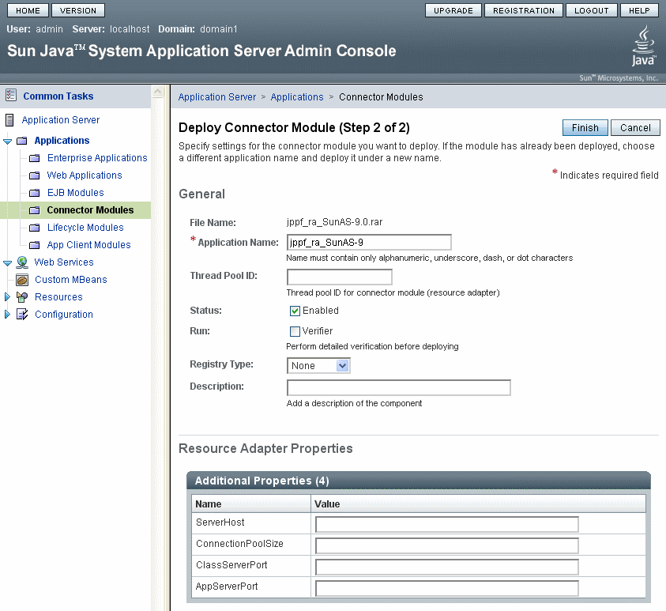

Creating a connector connection pool
- in the console tree on the left, go to "Resources > Connectors > Connector Connection Pools"

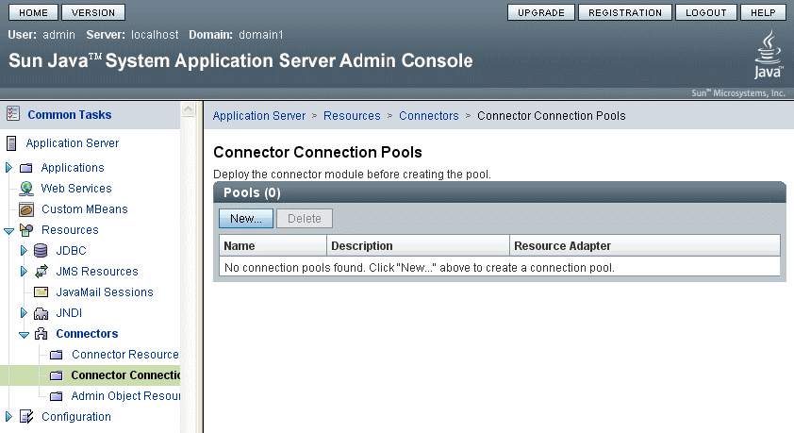

- click on "New"
- step 1: enter "JPPFConnectionPool" as the connection pool name and select "jppf_ra_Glassfish" for the resource adapter

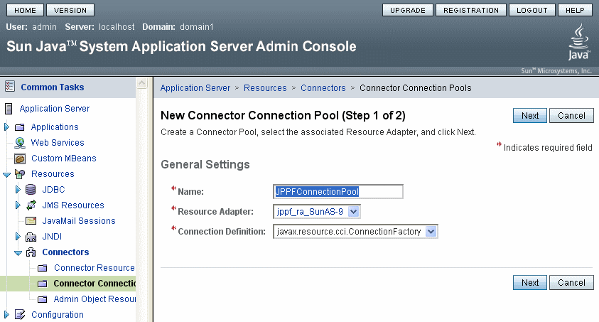

- click "next"
- step 2: set the pool parameters, select "NoTransaction" for transaction support

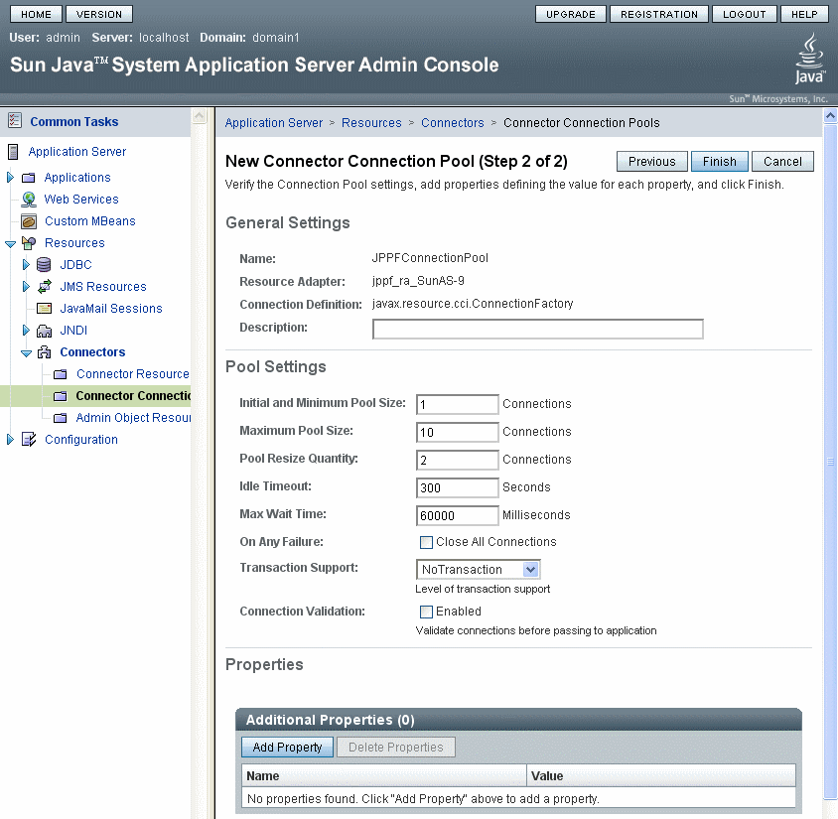

- click "Finish"

Creating a connection factory
- in the console tree on the left, go to "Resources > Connectors > Connector Resources"

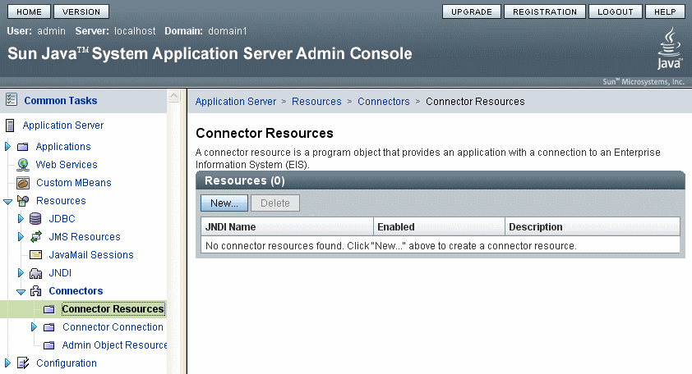

- click on "New"
- for the jndi name, enter "eis/JPPFConnectionFactory"
- for the connection pool, select "JPPFConnectionPool"

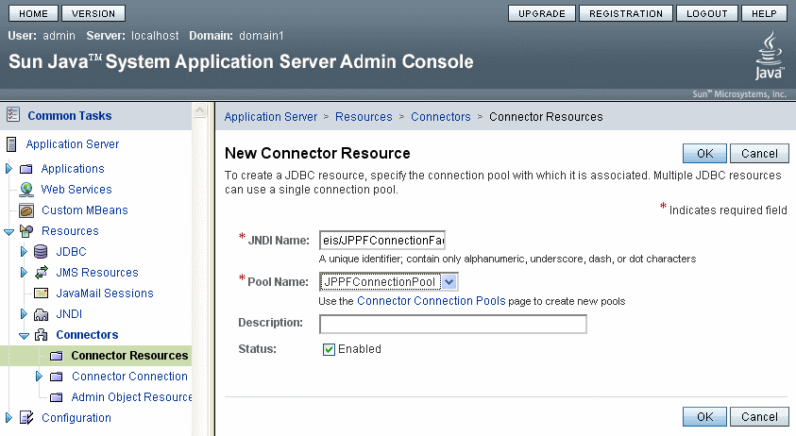

- click "OK"
- restart the application server

Deploying the demo application
- in SunAS console, go to "Applications > Enterprise Applications"

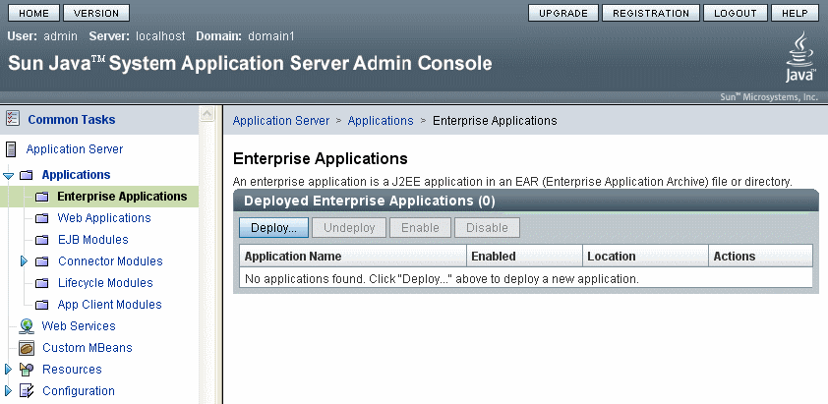

- click on "Deploy"
- step 1: browse to the file "JPPF_J2EE_Demo_Glassfish.ear"

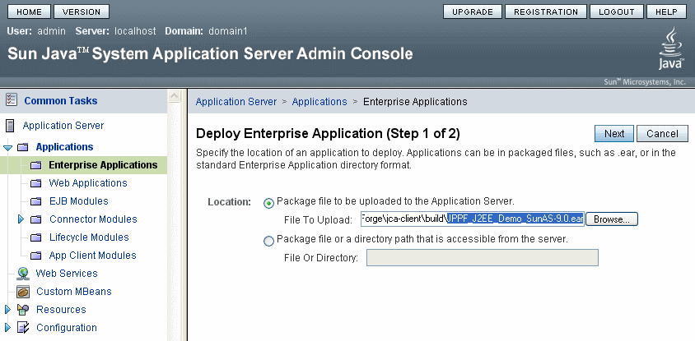

- click "next"
- step 2: leave all default values

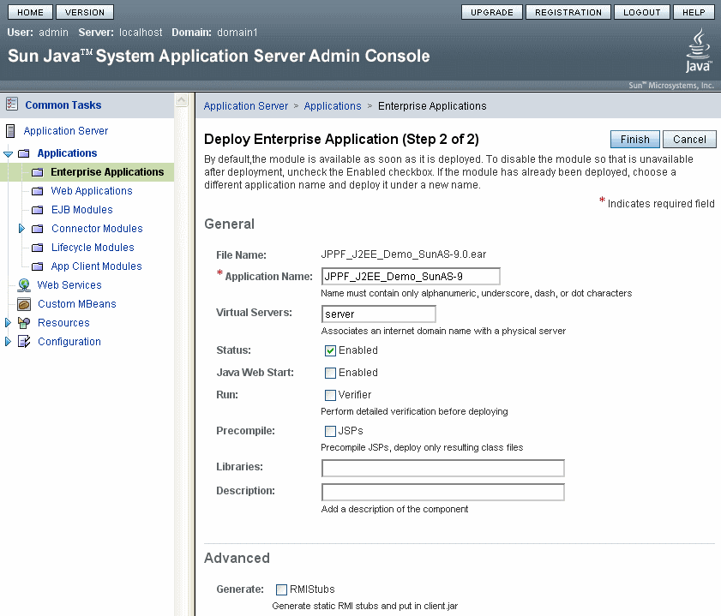

- click "Finish"
- restart the application server

Deployment on Websphere

Deploying the Resource Adapter
- in WAS console, go to "Resources > Resource Adapters > Resource adapters"
- select scope = "Node"

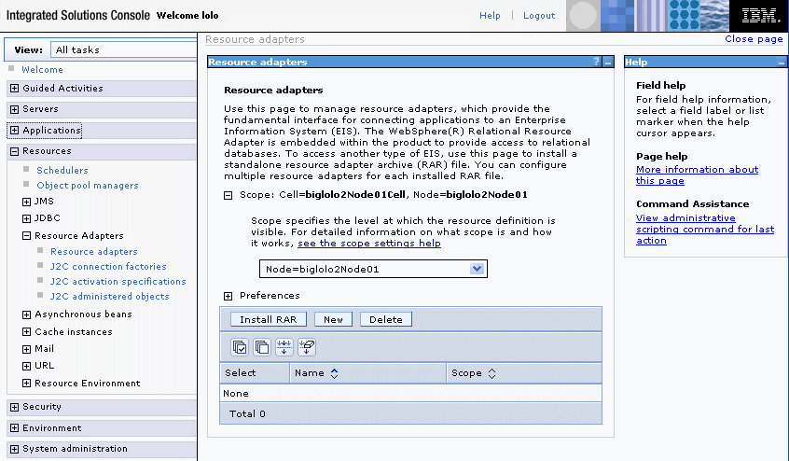

- click "Install RAR"

- in the "Install RAR file" page, browse to the "jppf_ra_Websphere.rar" file

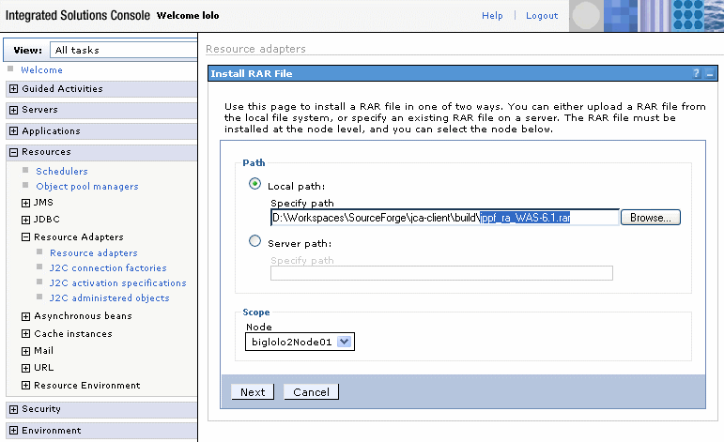

- click "Next"
- click "OK"
- click "Save directly to the master configuration"

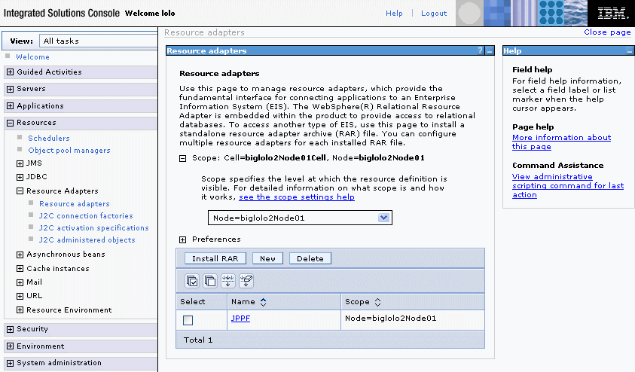

Creating a connection factory
- in the list of resource adapters, click on "JPPF"
- in "Additional Properties", click on "J2C connection factories"
- click on "New"
- enter "JPPF Connection Factory" for the name and "eis/JPPFConnectionFactory" for the JNDI name, leave all other parameters as they are

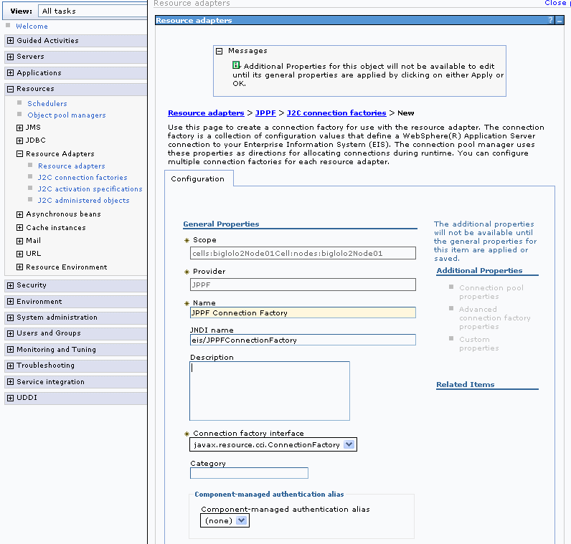

- click "OK"
- click "Save directly to the master configuration"
- Restart the application server

Deploying the demo application
- in Websphere console, go to "Applications > Enterprise Applications"

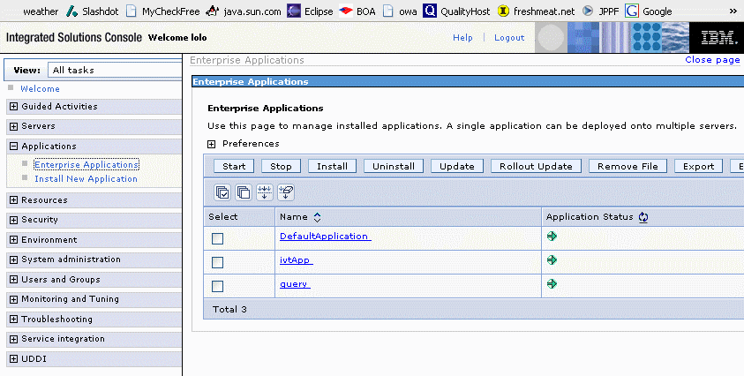

- click on "Install"
- browse to the file "JPPF_J2EE_Demo_Websphere.ear"
- select "Prompt me only when additional information is required".

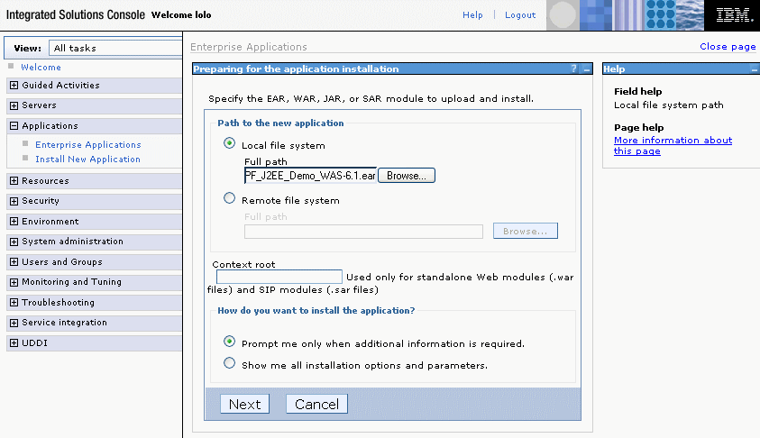

- click "Next"
- step 1: click "Next"
- step 2: check module "jppftest"

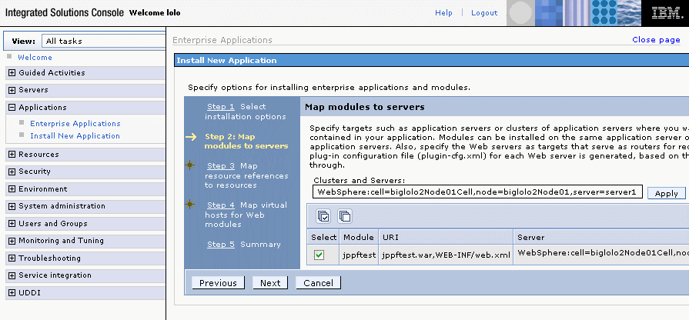
- click "Next"
- step 3: select "None" for the authentication method
- check the "jppftest" module and enter "eis/JPPFConnectionFactory" as Target Resource JNDI Name

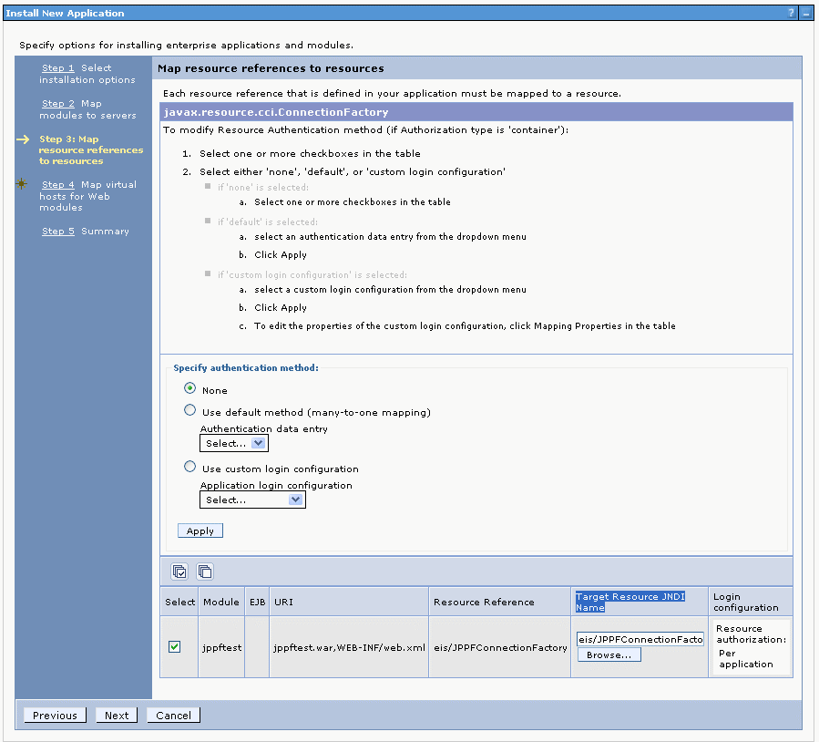

- click "Next"
- step 4: check the "jppftest" module and keep "default_host" as the Virtual host

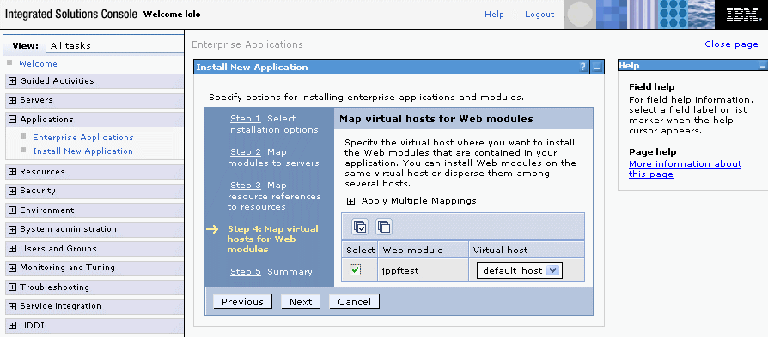

- click "Next"
- step 5: click "Finish"
- click "Save directly to the master configuration"
- in the list of enterprise applications, check "JPPF Demo"

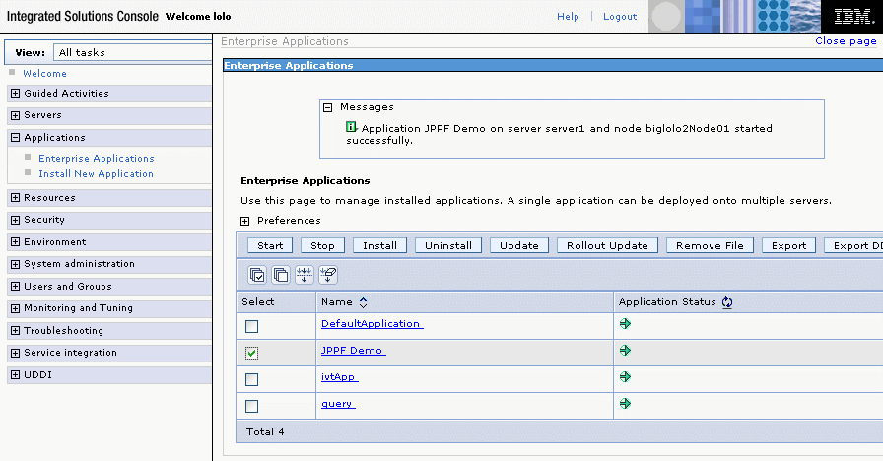

- click on "Start"
- restart the application server

Deployment on Weblogic

Deploying the resource adapter
- in Weblogic console, go to "Deployments"
- click on "Lock & Edit"

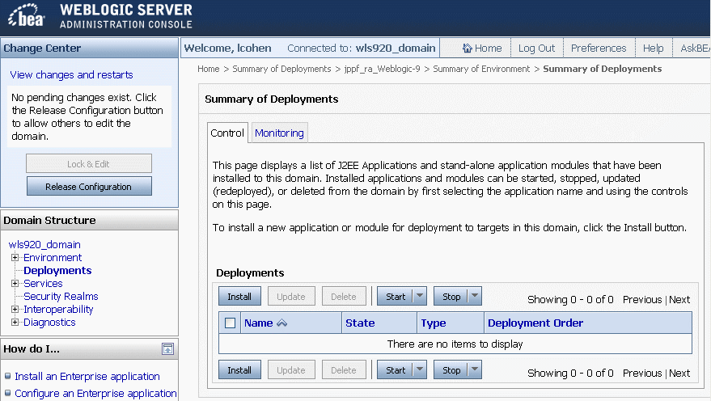

- click "Install"
- navigate to the "jppf_ra_Weblogic.rar" file and select it

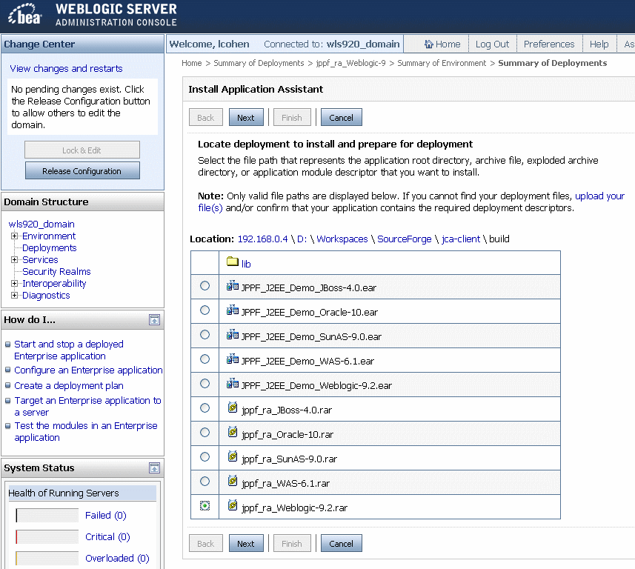

- click "Next"
- click "Next"
- click "Finish"

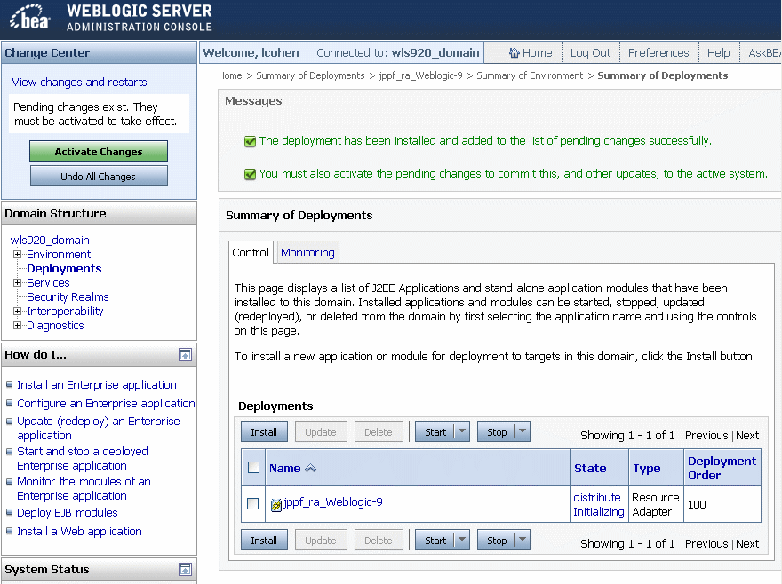

- click "Activate Changes"
- in the list of deployments, check "jppf_ra_Weblogic"
- select "Start > Servicing all requests"

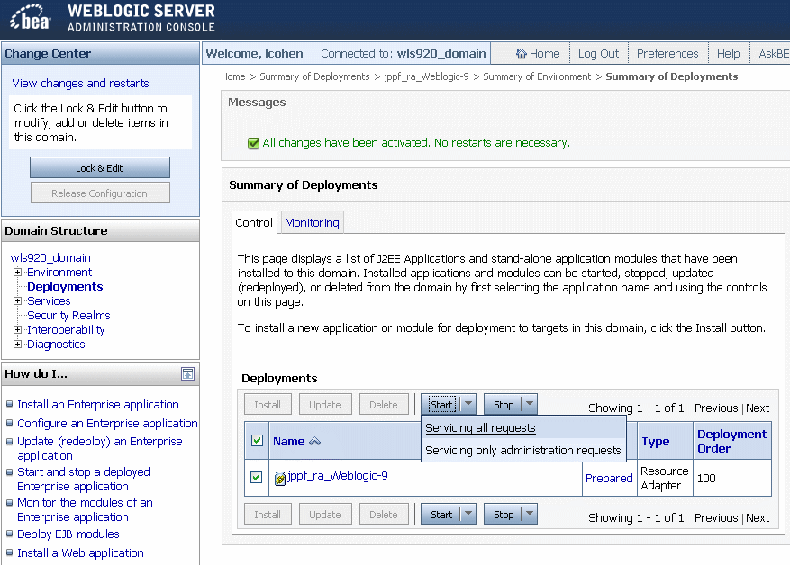

- Click "Yes"
- the state of the resource adapter must now show as "Active"
- restart the application server

Note: In the Weblogic output console, you will probably see periodic messages saying that 2 threads are stuck. These warnings are harmless. The related threads are required by the JPPF resource adapter and should not be interrupted. The period of these warnings is determined by a setting of the Weblogic instance called "Stuck Thread Timer Interval", set to 60 seconds by default. Consult with your administrator if you need to change that interval.

Deploying the demo application
- in Weblogic console, go to "Deployments"
- click on "Lock & Edit"

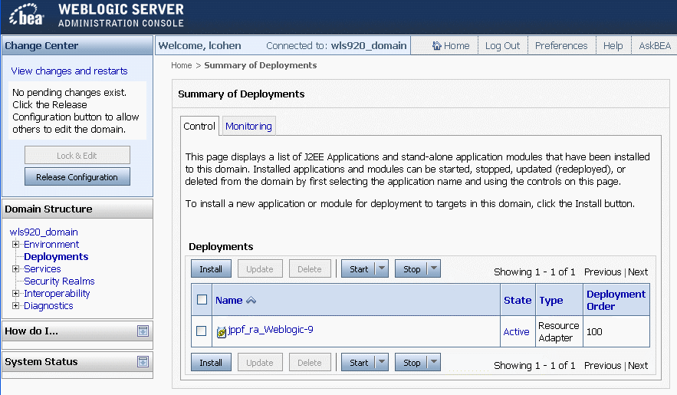

- click "Install"
- navigate to the "JPPF_J2EE_Demo_Weblogic.ear" file and select it

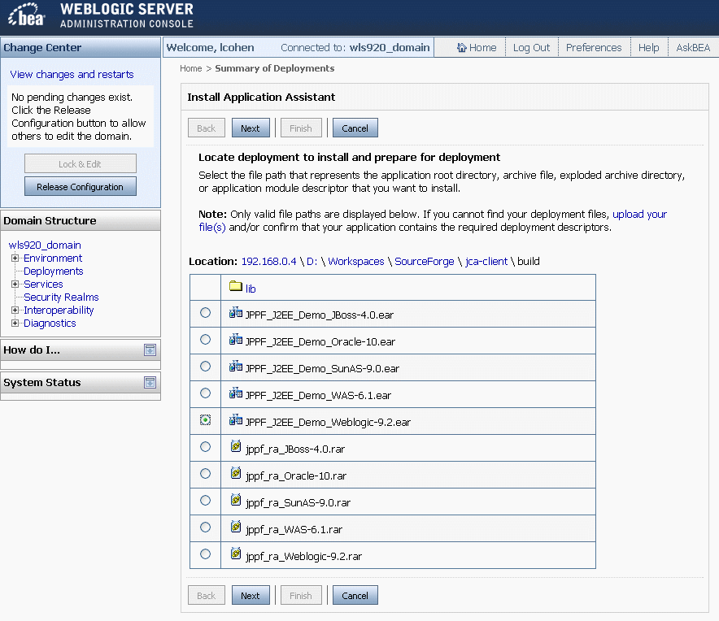

- click "Next"
- click "Finish"

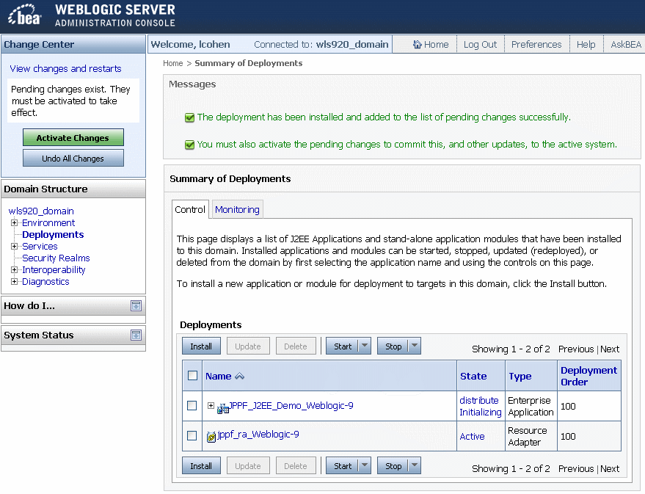

- click "Activate Changes"
- in the list of deployments, check "JPPF_J2EE_Demo_Weblogic"
- select "Start > Servicing All Requests"

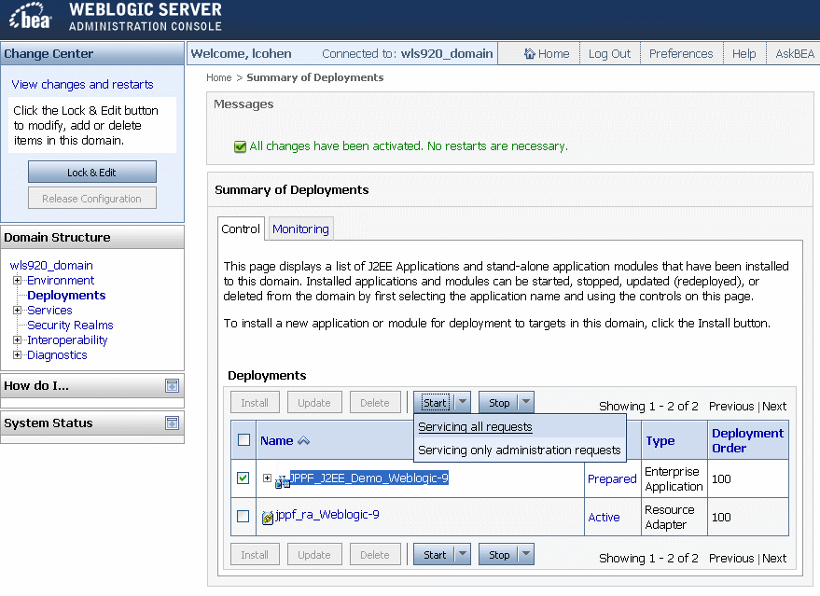

- Click "Yes"
- the state of the demo application must now show as "Active"
- restart the application server

Deployment on Apache Geronimo

Deploying the resource adapter
- In the Geronimo administration console, click on “Applications > Deploy new”
- In the “Archive“ field, navigate to the file “jppf_ra_Geronimo.rar”

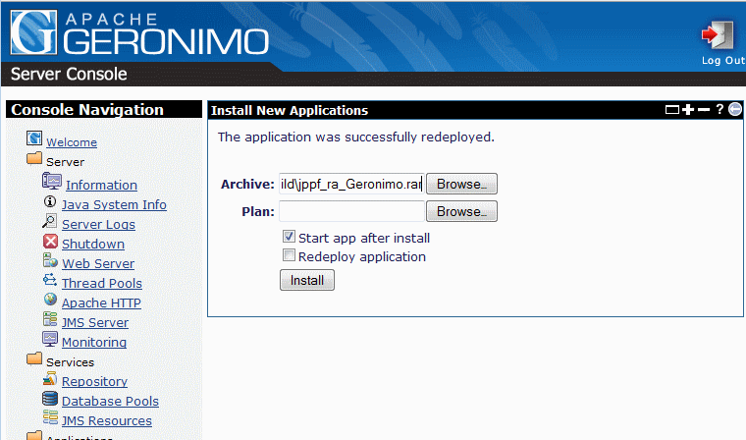

- click on “Install”

Deploying the demo application
- In the Geronimo administration console, click on “Applications > Deploy new”
- In the “Archive“ field, navigate to the file “JPPF_J2EE_Demo_Geronimo.ear”

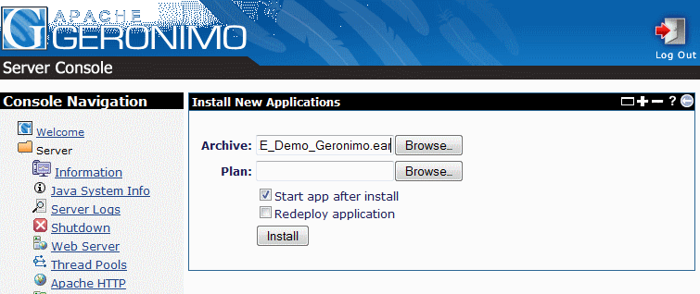

- click on “Install”

Packaging your enterprise application
For a J2EE enterprise application to work with the JPPF JCA connector, it is necessary to include a JPPF utility library called jppf-j2ee-client.jar, which can be found in the jca-client/build/lib folder. To ensure that this library can be made visible to all modules in the application, we recommend the following way of packaging it:

* add jppf-j2ee-client.jar in a lib folder under the root of the EAR file
* for each EJB, Web or Resource Adapter module of your application that will use JPPF, add a Class-Path entry in the META-INF/manifest.mf of the module, which will point to the JPPF library, for instance:
Class-Path: lib/jppf-j2ee-client.jar

In a typical J2EE application, it would look like this:

MyApplication.ear/

lib/
jppf-j2ee-client.jar

MyEJBModule.jar/
...
META-INF/
manifest.mf:
...
Class-Path: lib/jppf-j2ee-client.jar
...
...

... other modules ...

MyWebApp.war/
...
META-INF/
manifest.mf:
...
Class-Path: lib/jppf-j2ee-client.jar
...
...

Note: If you only need to use JPPF from a web application or module, then you can simply add jppf-j2ee-client.jar to the WEB-INF/lib folder of the war file.

Creating an application server port
If the JPPF resource adapter does not include, out-of-the-box, a port for your application server, or your application server version, this section is for you. Here is a sequence of steps to create your own port:

1. copy one of the existing application server-specific folder in JPPF-2.0-j2ee-connector/appserver and give it a name that will distinguish it from the others. This name will be used throughout this process, so please make sure it is both unique and meaningful. For the sake of this exercise, we will use a generic name: "MyServer-1.0"

2. After creating the JPPF-2.0-j2ee-connector/appserver/MyServer-1.0 folder, edit the relevant configuration files and deployment descriptors.

3. Open the build.xml build script, in the jca-client folder, with a text editor.

4. At the start of the file, you will see the following section:

<!-- ========================================================================= -->
<!-- definition of application server-specific properties -->
<!-- the value is used to generate the names of the corresponding EAR and RAR -->
<!-- ========================================================================= -->
<property name="was" value="Websphere"/>
<property name="jboss" value="JBoss"/>
<property name="oracle" value="Oracle"/>
<property name="sunas" value="Glassfish"/>
<property name="weblogic" value="Weblogic"/>
<property name="geronimo" value="Geronimo"/>

You can add your own property here, for instance:

<property name="myserver10" value="MyServer-1.0"/>

The property value must be the name of the folder you just created.

5. (optional) navigate to the Ant target "ear.all" and add your own invocation for generating the demo application EAR:

<antcall target="ear">
<param name="appserver" value="${myserver10}"/>
<param name="include.client.classes" value="true"/>
</antcall>

You may also remove or comment out those you do not need.

6. Navigate to the Ant target "ear.all" and add your own invocation for generating the resource adapter RAR:

<antcall target="rar"><param name="appserver" value="${myserver10}"/></antcall>

You may also remove or comment out those you do not need.

