Photography Company Project
Team Name: Team Photography
Member Names:
David Mallett, Jonathon Kennedy, Jesse Ackley

CSC480A Computer Science Capstone Project I
Project Proposal
National University, San Diego, CA
Term

Instructor
Professor Alexander Finch

Contents
1.0 Introduction 3
2.0 Background and the Need for the Project 3
3.0 Project Objectives and Scope 3
4.0 Customers and Stakeholders 3
5.0 Project Requirements 3
5.1 Functional Requirements 4
5.2 Non-Functional Requirements 4
5.3 High Level Use Case Scenarios 4
6.0 Project Assumptions and Constraints 4
7.0 Project Delivery Methods 4
8.0 Project Issues and Risks 4
9.0 Evaluation, Selection of Technology and Tools for Project Implementation. 5
10. Prioritized Feature List and estimates 5
11.0 Initial Architecture Design 5
12.0 Agile Team Formation, Responsibilities and Implementation Iterations (schedule). 5
12.1. Team Responsibilities: 5
12.2 Iteration Plan 5
13.0 Conclusion 6
References 6
Appendix 6
Attachments, if any. 6
List of Abbreviations 6
Definitions 6

Introduction
Cherished Memories Photography relies on a team of remote employees located overseas to edit and process large volumes of images. However, the company currently lacks a centralized system to track employee productivity, monitor task completion, and measure processing times across its workflow. This limited visibility makes it difficult for management to evaluate performance, identify inefficiencies, and establish realistic benchmarks for project planning.

This project proposes the development of a prototype dashboard designed to provide real-time insight into employee activity and workflow performance. The system will track key metrics such as task completion, time spent on editing tasks, and overall processing duration. By organizing and visualizing this data, the dashboard will enable management to better understand operational efficiency, support data-driven decision-making, and improve overall productivity within the organization.

Background and the Need for the Project
The client is a photography company that relies on a team of approximately twenty remote workers located overseas to edit and process images. Currently, there is no centralized system in place to effectively track employee performance, monitor task completion, or measure the time required for images to move through the production cycle. One of the primary challenges identified is the lack of clear performance metrics. The company needs a way to determine how long it takes for images to be processed, how individual employees contribute to overall output, and how to establish realistic performance benchmarks based on collective data. Without this information, it is difficult for the business to identify inefficiencies or optimize workflows. The need for this project arises from the company’s desire to gain visibility into its operations and improve productivity. Even a basic proof of concept that introduces structured tracking and reporting will provide immediate value by offering insights that are currently unavailable.

Project Objectives and Scope
This project is intended to provide the photography company with a prototype dashboard that gives management visibility into employee productivity, workflow timing, and optimization. From the customer’s perspective, the goal is to better understand how photo editing tasks move through the work cycle, time spent in each stage, and how work is distributed across the team. The dashboard should help the company identify trends, establish realistic performance benchmarks, and use that information to improve planning for future photography clients.
Objectives:
OBJ-1: Project and Assignment Management.
Enable managers to create, update, and manage employee assignments for projects
OBJ-2: Task and Workflow Tracking.
Track task types, assign tasks, and monitor workflow progression.
OBJ-3: Time Tracking and Data Collection.
Measure time spent on tasks and projects, including full workflow cycle time.
OBJ-4: Image and Production Metrics.
Track image counts, completion status, and workflow throughput.
OBJ-5: Reporting and Visibility.
Provide dashboards and reports for monitoring employee and project performance.
OBJ-6: Performance Metrics and Analytics.
Calculate KPIs such as averages, total hours, and efficiency indicators.
OBJ-7: Employee Data Management.
Maintain employee-related data including cost and rate information.
OBJ-8: Security and Access Control.
Restrict system access and enforce role-based permissions.

In scope:
The scope of this project is to design and develop an MVP or prototype for a productivity tracking dashboard for internal business use. The prototype will focus on collecting, displaying, and summarizing employee task data related to photo editing workflows. It will include sample dashboard views, basic reporting features, and KPIs such as task completion, time spent per task, average turnaround time, and employee productivity trends.

Out of scope:
This project does not include a full production deployment, enterprise level security hardening, or integration with all existing business systems. It is not intended to replace the company’s full operational workflow tools. Since this is only a proof of concept, the deliverable is meant to validate the idea and demonstrate functionality rather than serve as a finished system.

Customers and Stakeholders
The primary customer for this project is Cherished Memories Photography. This customer wants a tool that can monitor employee productivity, measure editing turnaround times, and generate KPIs for operational decision-making. The main business users are likely the company owner, managers, or operations leads who need insight into team performance and workflow efficiency. Other stakeholders may include the employees, since their work activity will be tracked through the dashboard and their performance data will contribute to the reported KPIs.

Project Team
In addition to the customer and business stakeholders, the project team plays a critical role in the successful design and development of the system. The team is responsible for requirements analysis, system design, implementation, testing, and delivery of the prototype.
The project team consists of:
- Jonathon Kennedy – Project Manager / Developer
- Jesse Ackley – Developer / Analyst
- David Mallett – Developer / Tester
Each team member contributes to the Agile development process and may take on multiple roles as needed to ensure the successful completion of the project.

Project Requirements
The system requirements for this project are derived directly from the objectives outlined in Section 3.0 and are based on the needs of the customer. These requirements define the expected functionality, performance, and overall behavior of the proposed system.
To ensure clarity and proper alignment, each requirement is uniquely identified and mapped back to a corresponding project objective using a traceability structure. Functional requirements are labeled as FR-x.x and non-functional requirements are labeled as NFR-x.x, where each grouping corresponds to a specific objective (OBJ-x) defined in Section 3.0.
This traceability ensures that all requirements are justified, measurable, and directly support the intended outcomes of the project. It also provides a clear linkage between business needs, system design, and validation criteria.
The requirements are divided into two main categories: functional requirements and non-functional requirements.
Functional requirements describe the specific features and capabilities the system must provide to support business operations such as task tracking, reporting, and data management.
Non-functional requirements define the system’s performance, usability, reliability, security, and scalability expectations. These requirements ensure that the system not only functions correctly but also delivers a consistent and efficient user experience.
In addition to direct functional needs, the system must meet performance expectations related to responsiveness, data accuracy, and reporting capabilities. These expectations will guide system design decisions and serve as criteria for testing and evaluation.
Sections 5.1 through 5.3 provide a structured breakdown of system requirements. Section 5.1 organizes functional requirements by objective to maintain alignment with Section 3.0. Section 5.2 defines non-functional requirements with measurable criteria. Section 5.3 presents high-level use case scenarios that reference requirement identifiers rather than full descriptions, ensuring consistency and maintainability.

Functional Requirements

The system shall:

OBJ-1: Project and Assignment Management
- FR-1.1 Allow managers to create employee assignments
- FR-1.2 Allow managers to update employee assignments
- FR-1.3 Allow managers to delete employee assignments

OBJ-2: Task and Workflow Tracking
- FR-2.1 Capture task types per project
- FR-2.2 Categorize task types (editing, culling)
- FR-2.3 Assign tasks to employees

OBJ-3: Time Tracking and Data Collection
- FR-3.1 Provide start timer for task tracking
- FR-3.2 Provide stop timer for task tracking
- FR-3.3 Record time spent on tasks
- FR-3.4 Record time spent on projects
- FR-3.5 Store elapsed time at task level
- FR-3.6 Store elapsed time at project level

OBJ-4: Image and Production Metrics
- FR-4.1 Store total number of images per project
- FR-4.2 Store completed images
- FR-4.3 Store remaining images
- FR-4.4 Update image counts dynamically

OBJ-5: Reporting and Visibility
- FR-5.1 Generate employee activity reports
- FR-5.2 Generate project progress reports
- FR-5.3 Generate time utilization reports
- FR-5.4 Generate image processing reports

OBJ-6: Performance Metrics and Analytics
- FR-6.1 Calculate average time per task
- FR-6.2 Display average time per task
- FR-6.3 Calculate average time per image
- FR-6.4 Display average time per image
- FR-6.5 Calculate total hours per employee
- FR-6.6 Display total hours per employee
- FR-6.7 Calculate total hours per project
- FR-6.8 Display total hours per project
- FR-6.9 Provide feasibility analysis data
- FR-6.10 Display analytical insights
OBJ-7: Employee Data Management
- FR-7.1 Store employee hourly rates
- FR-7.2 Update employee hourly rates
- FR-7.3 Associate rates with cost calculations

OBJ-8: Security and Access Control
- FR-8.1 Restrict system access to authorized users
- FR-8.2 Restrict dashboard access to managers
- FR-8.3 Restrict report access to managers

Non-Functional Requirements
The system shall meet the following performance and quality attributes:

NFR-1: Performance Requirements

NFR-1.1 System shall load dashboards within 2–5 seconds under normal usage

NFR-1.2 System shall load reports within 2–5 seconds under normal usage

NFR-1.3 System shall support concurrent data entry by multiple users

NFR-1.4 System performance shall not degrade during concurrent usage

NFR-1.5 Reports shall be generated within 5 seconds

NFR-1.6 Metrics calculations shall complete within 5 seconds

NFR-2: Usability Requirements

NFR-2.1 System interface shall be intuitive for non-technical users

NFR-2.2 System interface shall be easy to navigate

NFR-2.3 Dashboard layout shall be visually clear

NFR-2.4 Dashboard shall be suitable for presentations and screen sharing

NFR-3: Reliability and Data Integrity

NFR-3.1 System shall ensure accuracy of stored data

NFR-3.2 System shall maintain consistency of stored data

NFR-3.3 System shall prevent data loss during normal operation

NFR-3.4 System shall maintain data integrity during concurrent usage

NFR-4: Security Requirements

NFR-4.1 System shall enforce user authentication

NFR-4.2 System shall restrict access based on user roles

NFR-4.3 System shall protect sensitive business data from unauthorized access

NFR-5: Scalability and Flexibility

NFR-5.1 System architecture shall support future feature enhancements

NFR-5.2 System architecture shall support increasing data volume

NFR-5.3 System shall support additional users without major redesign

NFR-5.4 System shall allow future integration with external systems (e.g., APIs, databases)

NFR-6: Deployment Requirements
- NFR-6.1 System shall be delivered as a web-based application
- NFR-6.2 System shall be accessible through modern web browsers
- NFR-6.3 System shall require no installation of additional software
- NFR-6.4 System shall support responsive design for mobile and tablet use

High Level Use Case Scenarios
Use Case 1: Manage Project Assignments
Description:
A manager creates, updates, or deletes employee assignments for a project.
Actor:
Manager
Related Requirements: FR-1.1, FR-1.2, FR-1.3
Use Case 2: Track Task Activity
Description:
A manager assigns tasks and tracks time using a start/stop timer.
Actor:
Manager
Related Requirements: FR-2.1, FR-2.2, FR-2.3, FR-3.1, FR-3.2, FR-3.3, FR-3.4, FR-3.5, FR-3.6
Use Case 3: Monitor Project Progress
Description:
A manager views image-related metrics to evaluate project status.
Actor:
Manager
Related Functional Requirements: FR-4.1, FR-4.2, FR-4.3, FR-4.4
Use Case 4: Generate Reports
Description:
A manager generates reports summarizing system data.
Actor:
Manager
Related Functional Requirements: FR-5.1, FR-5.2, FR-5.3, FR-5.4
Use Case 5: Analyze Efficiency
Description:
A manager reviews calculated metrics to identify performance trends.
Actor:
Manager
Related Functional Requirements: FR-6.1 – FR-6.8
Use Case 6: Evaluate Project Feasibility
Description:
A manager uses system insights to determine if a project can be completed within constraints.
Actor:
Manager
Related Functional Requirements: FR-6.9, FR-6.10
Use Case 7: Manage Employee Data
Description:
A manager maintains employee-related cost data.
Actor:
Manager
Related Functional Requirements: FR-7.1, FR-7.2, FR-7.3
Use Case 8: Secure System Access
Description:
The system ensures only authorized users can access features.
Actor:
System / Manager
Related Functional Requirements: FR-8.1, FR-8.2, FR-8.3

Project Assumptions and Constraints
This section identifies the key assumptions, constraints, and project priorities that may impact the development and implementation of the system. These factors help define the boundaries of the project and guide decision-making throughout the development process.
Assumptions represent conditions believed to be true for the purposes of planning and design, while constraints define limitations such as time, resources, and scope. Project priorities highlight the most critical aspects of the system that must be emphasized to ensure a successful outcome.

The following assumptions are made for the successful development and use of the system:
- Managers will serve as the primary users of the system
- Employees will not require initial access to dashboards or analytics features
- Task timing will be manually recorded using a start/stop mechanism
- The system will be developed as a prototype (proof of concept) rather than a full production solution
- A web-based platform will be prioritized over mobile implementation
- The system will be used primarily for internal business analysis and decision-making

The project is subject to the following limitations:
- The project must be completed within a limited timeline (course duration)
- Development will be carried out by a small student team
- Access to real production data is limited or unavailable
- There is no dedicated project budget
- The project scope must remain focused on core functionality to ensure completion within constraints

The following priorities will guide development and decision-making:
- Ensure accurate tracking of time and task activity
- Provide meaningful and actionable reporting for management
- Enable evaluation of project feasibility based on collected data
- Deliver a clear, professional, and easy-to-use dashboard interface
- Prioritize web-based accessibility for ease of use and deployment

Project Delivery Methods
The system will be delivered as a prototype web-based application accessible through standard web browsers.
To ensure accessibility and long-term usability for the client, the team will provide both a live hosted demo and source code delivery.
The selected delivery approach is:
- A live hosted prototype deployed using a cloud platform (e.g., AWS, Azure, or similar)
- A GitHub repository containing the full source code, documentation, and setup instructions
The GitHub repository will be made available to the client with read access and will remain active for a minimum of 12 months after project completion. Hosting will be managed by the development team during the project lifecycle. This ensures the client can review, reuse, or extend the system beyond the course timeline.
The hosted application URL will remain active for at least 30–60 days after final delivery, based on hosting limitations and cost considerations.
This approach was selected because:
- It provides immediate usability via a browser (no installation required)
- It ensures transparency and ownership through source code access
- It aligns with team feasibility given time and resource constraints
- It supports future scalability if the client chooses to expand the system
If preferred by the client, the system can alternatively be delivered as a locally deployable package with setup instructions.

Project Issues and Risks

 | Issue or Risk Brief Detail | Risk Probablity: High, Medium, Low | Mitigation Plan | Responsibility | Status: Open, WIP, Closed
1 | Limited project timeline (course duration) may prevent full feature completion | High | Prioritize MVP features only; use Agile sprints with clear deliverables; defer non-critical features | Project Manager | Open
2 | Small team size may lead to workload imbalance or delays | Medium | Clearly define roles; distribute workload evenly; conduct regular check-ins to adjust tasks | Entire Team | Open
3 | Lack of access to real production data may limit dashboard accuracy and usefulness | Medium | Use realistic sample/mock data; validate assumptions with client; design system to easily integrate real data later | Developers | Open
4 | Inexperience with selected technologies/tools may slow development | Medium | Choose familiar technologies where possible; allocate time for learning; use online resources and tutorials | Developers | Open
5 | Data accuracy and integrity issues due to manual time tracking | Medium | Implement validation checks; provide clear UI instructions; include error handling for incorrect inputs | Developers/Testers | Open
6 | Performance issues when handling concurrent users or data processing | Low | Optimize queries and data handling; test with simulated concurrent users; monitor performance during development | Developers | Open
7 | Scope creep (adding features beyond MVP) may delay completion | High | Strictly follow defined scope; require team agreement for any changes; prioritize backlog items carefully | Project Manager | Open
8 | Communication challenges within team or with stakeholders | Medium | Schedule regular meetings; use collaboration tools (Teams/Slack); document decisions clearly | Project Manager | Open
9 | Security risks due to basic authentication implementation in prototype | Low | Implement basic authentication best practices; document future security improvements for production | Developers | Open
10 | Deployment/environment issues (hosting, browser compatibility) | Low | Test on multiple browsers; use simple hosting solution; validate deployment early in development | Developers/Testers | Open

9.0 Evaluation, Selection of Technology and Tools for Project Implementation.

The technology and tool selection for this project is guided by the needs already identified in this proposal, including a web-based prototype, dashboard reporting, KPI visualization, management-level access control, responsive browser access, and support for future enhancement. Because this project is a proof of concept with a limited timeline and a small student team, the selected tools will emphasize ease of development, low cost, maintainability, and the ability to clearly demonstrate core functionality.
A modern web application stack will be used for this project. The stack will consist of React for the front end, Node.js with Express for the back end, PostgreSQL for the database, and Chart.js for data visualization. React is well-suited for building reusable interface components for dashboards and reporting screens. Express provides a lightweight and flexible framework for building web applications and APIs. PostgreSQL is a strong choice for this project because it is widely recognized for reliability, data integrity, and extensibility. Chart.js is well-suited for presenting KPI data via dashboard elements such as bar charts, line charts, and summary graphs.
The supporting tools for development are GitHub for version control and team collaboration, and Postman for API testing and validation. Git and GitHub support collaborative development by tracking change history and allowing the team to manage contributions effectively. Postman is useful for sending API requests and creating tests during the development of the application backend.

10.0 Product Backlog: Prioritized Feature List and Effort Estimates (hrs.)

Priority | Backlog Item | Description | Estimate (hrs.)
2 | User authentication and role control | Implement secure login and restrict the dashboard and reports to authorized management users | 10
1 | Project and employee assignment management | Allow managers to create, update, and delete project assignments for employees | 15
1 | Task type and task assignment management | Allow managers to define task categories and assign tasks to employees | 10
1 | Time tracking module | Implement start and stop timer functionality and store elapsed time for tasks and projects | 20
1 | Image metrics tracking | Store total images, completed images, and remaining images for each project | 10
1 | Core database design and setup | Create a database scheme for users, employees, projects, tasks, time entries, rates, and image metrics | 15
1 | KPI dashboard | Build dashboard views showing employee productivity, average task time, average image time, and total hours worked | 20
3 | Employee rate management | Store and update employee hourly rates and connect rates to project cost calculations | 10
2 | Reporting module | Generate employee activity, project progress, time utilization, and image processing reports | 15
3 | Validation and error handling | Add checks to improve data accuracy and reduce manual input errors in time tracking and project data | 10
3 | Testing and bug fixing | Perform functional testing, integration testing, usability testing, and bug resolution | 15
3 | Deployment and demo preparation | Prepare sample data, final hosted prototype, and demonstration environment for presentation | 10

10.1 Backlog Management Approach
The product backlog will be managed using Agile methodology to support iterative development and continuous improvement. A project management tool such as Jira will be used to track backlog items, assign tasks, and monitor progress throughout the project lifecycle. Alternatively, a lightweight tool such as Trello or Excel may be used if simplicity is preferred.
Each backlog item will be converted into user stories and assigned to specific iterations (sprints), as outlined in the project schedule. Tasks will be tracked using standard workflow states such as To Do, In Progress, Testing, and Completed. The team will conduct regular sprint planning sessions to prioritize work, daily stand-up meetings to track progress, and sprint reviews to evaluate completed features. This approach ensures transparency, accountability, and alignment with project goals.

10.2 Estimation Methodology
The effort estimates for each backlog item were developed using a combination of relative complexity analysis and task decomposition. Each feature was evaluated based on the expected level of effort required across the frontend, backend, database design, and testing activities.
Features with higher complexity, such as the time tracking module and KPI dashboard, were assigned higher estimates due to the need for multiple system components, business logic implementation, and integration between modules. Simpler features, such as basic data management or validation, were assigned lower estimates due to reduced complexity and fewer dependencies.
Estimates also account for the small team size and the academic nature of the project, which may introduce a learning curve. Additionally, the estimates assume that the system is being developed as a prototype (MVP) rather than a full production system and therefore focus only on core functionality.
These estimates are considered preliminary and may be refined during sprint planning as the team gains a better understanding of implementation details and project velocity.

11.0 Initial Architecture Design
The proposed system will follow a three-tier architecture consisting of a presentation layer, application layer, and data layer. This design separates system responsibilities and improves scalability, maintainability, and flexibility. Each layer can be developed and modified independently while still functioning as part of a unified system.

11.1 Architecture Overview
The presentation layer will be implemented using React and will serve as the primary interface for user interaction. This layer will include dashboards, reporting views, login screens, and data entry forms. It is responsible for capturing user input and displaying processed data in a clear and visual format. Communication between the presentation layer and the backend will occur through RESTful API calls.
The application layer will be developed using Node.js with the Express framework. This layer will manage all business logic, including task assignment, time tracking calculations, KPI generation, and report processing. It will act as the intermediary between the frontend and the database, ensuring that data is validated, processed, and returned correctly. The application layer will expose API endpoints that allow the frontend to retrieve and submit data securely.
The data layer will use PostgreSQL as the relational database management system. This layer will store structured data such as employees, projects, tasks, time entries, image metrics, and user authentication data. Relationships between entities will be defined using primary keys and foreign keys to maintain data integrity and consistency.

11.2 Data Model Description
The system data model is designed to support the core functions of project tracking, workflow management, time recording, and performance reporting. A relational database structure will be used to ensure efficient storage, retrieval, and analysis of data.
The Users entity will store authentication credentials and access roles to ensure secure system access. The Employees entity will maintain employee information used for assignment tracking and productivity analysis. The Projects entity will store project-level information, including project status, assigned employees, and workload details.
The Tasks entity will represent individual work items within a project, such as editing or culling, and will be assigned to employees. The Time Entries entity will capture start times, stop times, and calculated durations for tasks and projects. The Image Metrics entity will track total images, completed images, and remaining images for each project. The Employee Rates entity will store hourly rate information used for cost calculations and feasibility analysis.
Relationships between these entities will be established through primary and foreign keys. For example, a project may contain multiple tasks, each task may be assigned to one employee, and each task may have multiple time entries associated with it. This structure supports accurate reporting and KPI calculations.
A UML class diagram or entity relationship diagram will be developed in a later phase to visually represent these relationships.

11.3 System Data Flow and API Interaction
The system will operate using a client-server model in which the frontend communicates with the backend through API requests. When a user interacts with the system, the presentation layer sends a request to the application layer. The backend processes the request, interacts with the database, and returns a response to the frontend.
During user authentication, login credentials entered in the frontend are sent to the backend for validation. The backend checks the credentials against stored user data. If authentication is successful, a secure token is generated and returned to the frontend. This token is used in future requests to verify user identity and enforce access control.
When tasks are created or updated, the frontend sends task data to the backend. The backend processes the request and stores the information in the database. When tracking is performed, timestamps are sent to the backend, which calculates elapsed time and stores the results in the Time Entries table.
When the dashboard is accessed, the frontend requests performance data from the backend. The backend retrieves data from multiple tables, performs calculations such as average task time and total hours worked, and returns the results in a structured format. The frontend then displays this data using charts and visual elements.
The backend also performs data validation to ensure that all inputs meet required formats and constraints. If invalid data is detected, the system returns an error message to the frontend so the user can correct the issue.

11.4 Key System Components
The system will include several integrated components that support core functionality. These include a user authentication module for access control, a project and assignment management module for managing work distribution, a task management module for tracking work activities, and a time tracking module for recording task durations. Additional components include an image metrics module for tracking production output and a reporting and analytics module for generating dashboards and insights.

11.5 Design Approach Justification
An object-oriented and modular design approach has been selected to support flexibility and future scalability. Each system component can be developed and tested independently while maintaining overall system integration. This approach allows the system to be extended in the future with additional features, external integrations, or enhanced reporting capabilities.
The architecture provides a clear separation of responsibilities across layers, ensuring that the system remains adaptable and maintainable as requirements evolve.

12.0 Agile Team Formation, Responsibilities, and Implementation Iterations (schedule).

12.1. Team Responsibilities
The team will follow Agile principles with clearly defined roles while allowing flexibility due to the small team size.
Team Member | Role | Responsibilities
Jonathon Kennedy | Project Manager / Scrum Master | Sprint planning, task assignment, progress tracking, stakeholder communication
Jesse Ackley | Developer / Analyst | Requirements analysis, backend development, database design
David Mallett | Developer / Tester | Frontend development, UI design, testing and validation

Team Collaboration
- Daily stand-up meetings (15 minutes)
- Weekly sprint planning and review meetings
- Continuous communication via collaboration tools (e.g., Discord)
- Shared GitHub repository for version control

12.2 Iteration Plan
The project will be completed over four iterations (2 weeks each).
Iteration 1 (Weeks 1–2) | Iteration 2 (Weeks 3–4) | Iteration 3 (Weeks 5–6) | Iteration 4 (Weeks 7–8)
Features | Features | Features | Features
Set up development environment and tools | Implement task management functionality | Implement image metrics tracking | Complete reporting module
Design database schema | Develop time tracking module (start/stop timer) | Develop KPI calculations | Perform system testing and debugging
Implement basic user authentication | Begin backend API development | Build dashboard visualizations (Chart.js) | Improve UI/UX design
Develop project and assignment management features | Initial frontend layout for dashboard | Begin reporting module | Prepare deployment and demo environment
 |  |  | Final presentation and documentation

13.0 Conclusion
This project proposes the development of a prototype dashboard designed to improve productivity tracking and operational visibility for a photography company with a remote workforce. By implementing features such as time tracking, task management, KPI reporting, and dashboard visualization, the system will provide valuable insights into workflow efficiency and employee performance.
The project will be executed using Agile methodology, allowing the team to deliver incremental functionality through iterative development cycles. This approach ensures flexibility, continuous improvement, and alignment with project goals.
The final delivery will demonstrate the feasibility and value of a centralized tracking system, providing a strong foundation for future expansion into a full-scale production solution.

References
- Pressman, R. S. 2020. Software Engineering: A Practitioner’s Approach 9th edition.
- Agile Alliance. https://www.agilealliance.org/
- Node.js Documentation. https://nodejs.org/
- React Documentation. https://react.dev/
- PostgreSQL Documentation. https://www.postgresql.org/docs/

Appendix
Additional materials such as UML diagrams, wireframes, and system flowcharts will be included as the project progresses.

Attachments, if any.

Use Case Diagram 1: Core Work Management
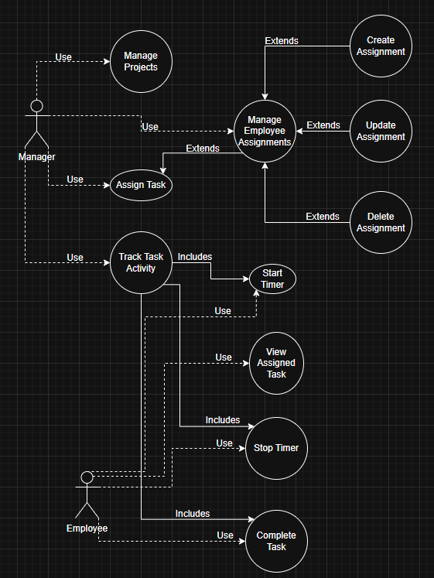

Use Case Diagram 2: Monitoring, Reporting and Analytics
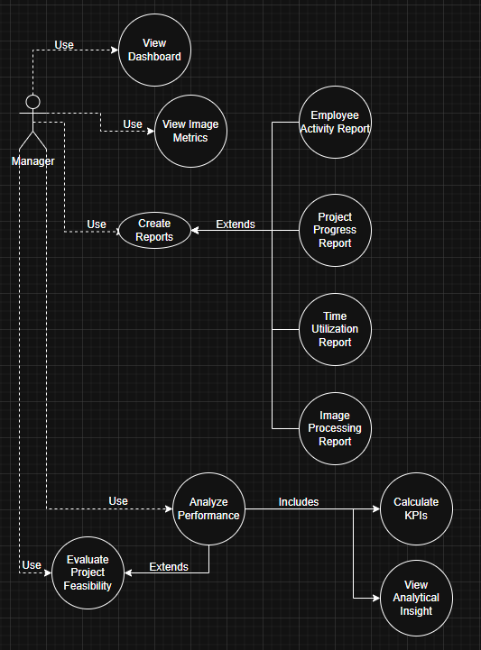

Use Case Diagram 3: Admin and Security
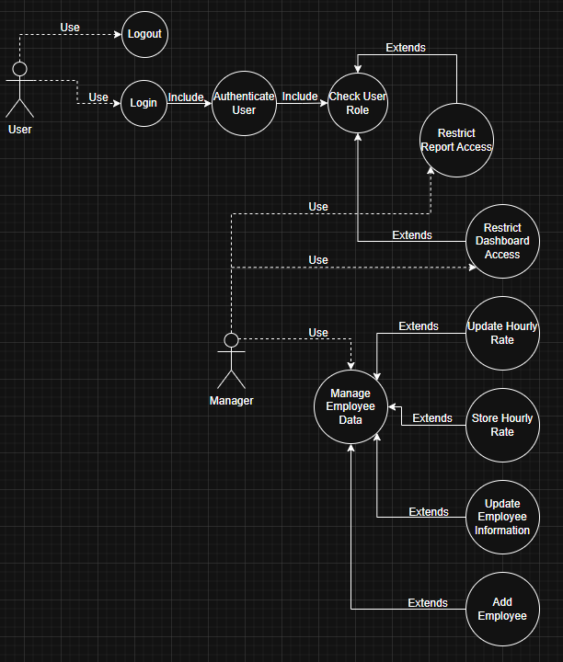

Main Class Diagram
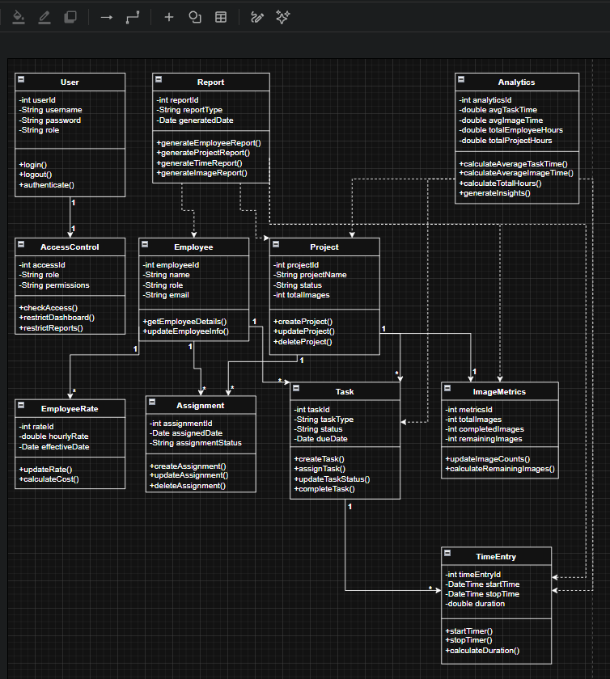

List of Abbreviations
- KPI – Key Performance Indicator
- MVP – Minimum Viable Product
- API – Application Programming Interface
- UI – User Interface
- UX – User Experience

Definitions
- Dashboard: A visual interface displaying key data and performance metrics.
- Time Tracking: The process of recording the duration spent on tasks or projects.
- Prototype: An early version of a system used to demonstrate functionality and validate concepts.

