PWD: command used to get present working directory.



VI editor: VI is a text editor in unix environment, which helps to edit any plan text files. Widley used in writing programs.

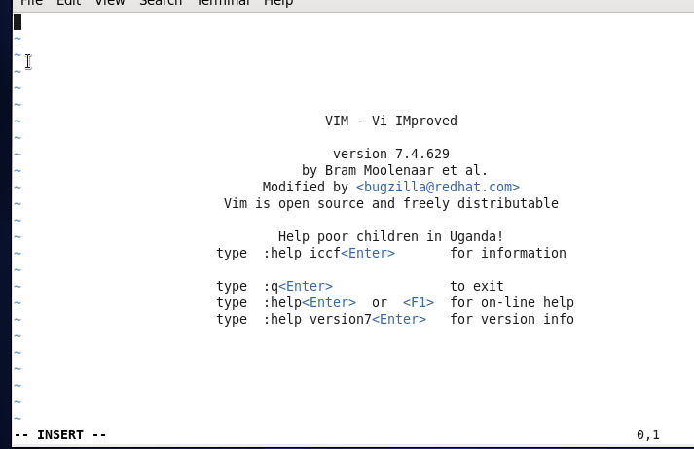

TOUCH : command used to change the file modified time and access time and also used to crate empty text files.

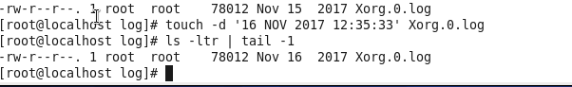

MKDIR : used to create directories in Unix system.

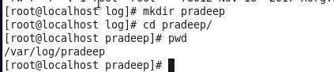

Rm : used to delete files in unix system.

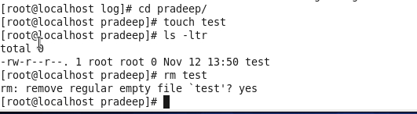

Ls : used to list the files in a directory.

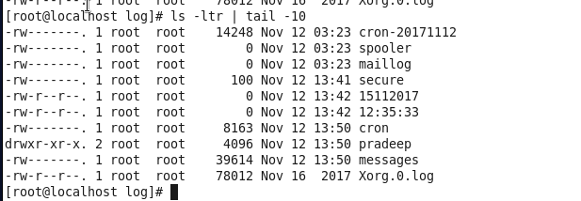

Echo : used to display a line of text.



CAT: used to display content of text files.

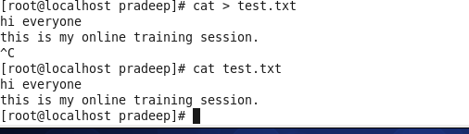

WHO: shows which used has logged in

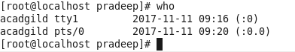

CD: used to navigate from one directory to anoither directory.

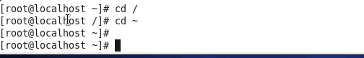

DATEL : to display system date.

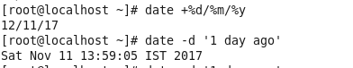

CAL: to display calendar.

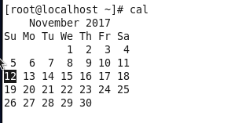

MV : to rename a file and also used to move files to different directory.

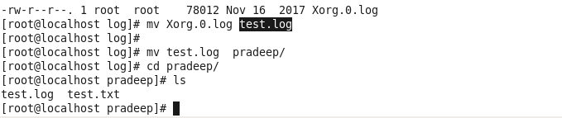

CP : used to copy files to different directory or the same direcotry wihtout deleting the source file.



Which : which helps to display complete path of a file

