***Oozie Work flow:***

Workflow in Oozie is a sequence of actions arranged in a control dependency DAG (Direct Acyclic Graph). The actions are in controlled dependency as the next action can only run as per the output of current action. Subsequent actions are dependent on its previous action. A workflow action can be a Hive action, Pig action, Java action, Shell action, etc. There can be decision trees to decide how and on which condition a job should run.

A fork is used to run multiple jobs in parallel. Oozie workflows can be parameterized (variables like ${nameNode} can be passed within the workflow definition). These parameters come from a configuration file called as property file

***Oozie Benefits:***

Is the tool in which all sort of programs can be pipelined in a desired order to work in Hadoop’s distributed environment. Oozie also provides a mechanism to run the job at a given schedule.

It is tightly integrated with Hadoop stack supporting various Hadoop jobs like Hive, Pig, Sqoop, as well as system specific jobs like Java and Shell.

***Sqoop Workflow:***

The traditional application management system, that is, the interaction of applications with relational database using RDBMS, is one of the sources that generate Big Data. Such Big Data, generated by RDBMS, is stored in Relational Database Servers in the relational database structure.

When Big Data storages and analyzers such as MapReduce, Hive, HBase, Cassandra, Pig, etc. of the Hadoop ecosystem came into picture, they required a tool to interact with the relational database servers for importing and exporting the Big Data residing in them. Here, Sqoop occupies a place in the Hadoop ecosystem to provide feasible interaction between relational database server and Hadoop’s HDFS.

The following image describes the workflow of Sqoop.

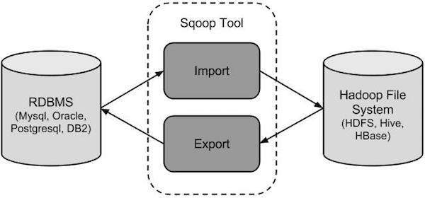

**Sqoop Import**

The import tool imports individual tables from RDBMS to HDFS. Each row in a table is treated as a record in HDFS. All records are stored as text data in text files or as binary data in Avro and Sequence files.

**Sqoop Export**

The export tool exports a set of files from HDFS back to an RDBMS. The files given as input to Sqoop contain records, which are called as rows in table. Those are read and parsed into a set of records and delimited with user-specified delimiter.

***Sqoop Benefits:***

Sqoop is a tool designed to transfer data between Hadoop and relational database servers. It is used to import data from relational databases such as MySQL, Oracle to Hadoop HDFS, and export from Hadoop file system to relational databases.