1. Below Directory has been created in HDFS.

/user/acadgild/hadoop

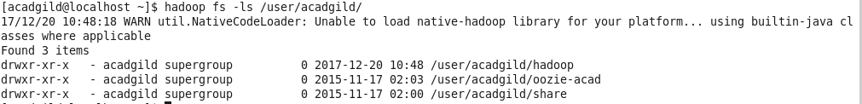

1. Word count file has been created in HDFS dir.

