1. File with date’s and sample temperature’s.

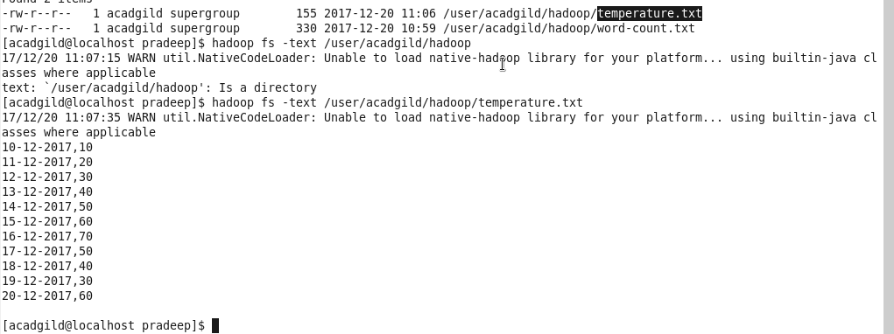

1. Changing permission for owner and group.

