Joseph Crockett  
ES 207- Environmental Data Analysis  
February 11, 2016

**Homework Assignment 2**

**Objective:**

Measurements from four project sites in Northern California are being analyzed to estimate aboveground carbon stock. Based on a subsample of the most frequently occuring tree genera in the data, we will test whether project areas are independant in terms of aboveground carbon stock, proxied by genera frequency. We hypothesize that productivity is based upon individual site characteristics rather than characteristics of specific genera.

**Methods:**

The data are first corrected for missing or unrealistic values, including unreported genus and dead wood. A subset of the most frequent genera is tested for independence (Chi-square test) based upon observaton frequency within genera by project site.

**Data:** Data from 4 Northern California riparian project sites between 3/20/2012 and 10/14/2013: Heritage Oak Winery, Cosumnes River Preserve, Sacramento River Red Bluff to Hwy 32, and Napa. Observations and field measurements of woody plant heights, DBH (diameter at breast height). Samples were identified by genus-Species.

**Code:**

library(ggplot2)  
 library(reshape)  
 #read data into r  
 ripdata <- read.csv("~/Desktop/Documents/Writings/Spring 2016/ES 207/Labs/Lab1/riparian_survey.csv", stringsAsFactors = F)  
   
 #summarize data, looking for false values.  
   
 summary(ripdata)

## SurveyID ProjectID LocationName Date   
## Min. : 6.0 Length:4632 Length:4632 Length:4632   
## 1st Qu.: 56.0 Class :character Class :character Class :character   
## Median :731.0 Mode :character Mode :character Mode :character   
## Mean :442.4   
## 3rd Qu.:803.0   
## Max. :857.0   
## Collectors Longitude Latitude SurveyTypeID   
## Length:4632 Min. :-122.9 Min. :36.46 Length:4632   
## Class :character 1st Qu.:-122.1 1st Qu.:38.26 Class :character   
## Mode :character Median :-121.4 Median :38.28 Mode :character   
## Mean :-121.7 Mean :38.64   
## 3rd Qu.:-121.4 3rd Qu.:38.59   
## Max. :-121.2 Max. :40.12   
## Plot.Name SpeciesVarietalCode SpeciesVarietalName  
## Length:4632 Length:4632 Length:4632   
## Class :character Class :character Class :character   
## Mode :character Mode :character Mode :character   
##   
##   
##   
## Measurement CanopyID Woody_DBH_cm Woody_Height_m   
## Min. : 1.00 Length:4632 Min. :-9999.0 Min. :-9999.00   
## 1st Qu.: 7.00 Class :character 1st Qu.: 6.4 1st Qu.: 4.10   
## Median : 17.00 Mode :character Median : 10.5 Median : 7.00   
## Mean : 26.65 Mean : -911.5 Mean : -293.94   
## 3rd Qu.: 37.00 3rd Qu.: 20.0 3rd Qu.: 10.73   
## Max. :156.00 Max. : 229.5 Max. : 104.00

str(ripdata)

## 'data.frame': 4632 obs. of 15 variables:  
## $ SurveyID : int 6 6 6 6 6 6 6 6 6 7 ...  
## $ ProjectID : chr "Heritage Oak Winery" "Heritage Oak Winery" "Heritage Oak Winery" "Heritage Oak Winery" ...  
## $ LocationName : chr "RIP01" "RIP01" "RIP01" "RIP01" ...  
## $ Date : chr "3/20/2012" "3/20/2012" "3/20/2012" "3/20/2012" ...  
## $ Collectors : chr "G. Venicx, K. Swan, M. Vaghti, C. Guillen" "G. Venicx, K. Swan, M. Vaghti, C. Guillen" "G. Venicx, K. Swan, M. Vaghti, C. Guillen" "G. Venicx, K. Swan, M. Vaghti, C. Guillen" ...  
## $ Longitude : num -121 -121 -121 -121 -121 ...  
## $ Latitude : num 38.1 38.1 38.1 38.1 38.1 ...  
## $ SurveyTypeID : chr "Plant" "Plant" "Plant" "Plant" ...  
## $ Plot.Name : chr "RIP01" "RIP01" "RIP01" "RIP01" ...  
## $ SpeciesVarietalCode: chr "ACNE" "POFR" "POFR" "POFR" ...  
## $ SpeciesVarietalName: chr "Acer negundo" "Populus fremontii" "Populus fremontii" "Populus fremontii" ...  
## $ Measurement : int 1 2 3 4 5 6 9 1 21 1 ...  
## $ CanopyID : chr "" "" "" "" ...  
## $ Woody_DBH_cm : num 6.5 9.3 6.5 7.6 6.3 9.9 7 12.4 18.9 6.5 ...  
## $ Woody_Height_m : num 2.57 5.08 3.74 2.68 3.03 4.53 4.4 7 8.1 4.61 ...

#changing Project Codes to simplified codes  
 tempo <- unique(ripdata[,2])  
 tempn <- c("HOWY","CORP", "SRRB","NASO")  
 ripdata$ProjCode <- tempn[match(ripdata[,2], tempo)]  
   
 #removing rows with species name = "Not Recorded","Unknown", or "dead wood" or illogical values, like negative values for DBH  
   
 unique(ripdata[,10])

## [1] "ACNE" "POFR" "FRLA" "JUHI"   
## [5] "QULO" "SALA6" "AECA" "SAEX"   
## [9] "SAGO" "DEAD" "MAPO" "SANIC6"   
## [13] "PRUNUS" "CEOC" "ALRH" "COGL"   
## [17] "SALA3" "PLRA" "VICA" "SANIC4"   
## [21] "MAAL(MAPO)" "AIAL" "SANIC5" "UNKNOWN"   
## [25] "SALASIO" "SALAS" "SALU" "QUKE"   
## [29] "PATO" "BAPI" "JURE" "SUNI(SANI)"   
## [33] "Not Recorded" "SALE(SALA3)" "UMCA" "SALAE"   
## [37] "PSME" "NODE(UNKNOWN)" "QUAG" "SESE"   
## [41] "ARME" "SALIX" "ACMA"

unique(ripdata[,11])

## [1] "Acer negundo" "Populus fremontii"   
## [3] "Fraxinus latifolia" "Juglans hindsii"   
## [5] "Quercus lobata" "Salix lasiolepis"   
## [7] "Acsculus californica" "Salix exigua"   
## [9] "Salix gooddingii" "dead wood"   
## [11] "Maclura pomifera" "Sambucus nigra ssp. canadensis"  
## [13] "Prunus sp." "Cephalanthus occidentalis"   
## [15] "Alnus rhombifolia" "Cornus glabrata"   
## [17] "Platanus racemosa" "Vitis californica"   
## [19] "sambucus nigra ssp. canadensis" "Ailanthus altissima"   
## [21] "Unknown" "Salix lasiandra var. lasiandra"  
## [23] "Quercus kelloggii" "Paulownia tomentosa"   
## [25] "Baccharis pilularis" "Juglans regia"   
## [27] "Sambucus nigra ssp. Canadensis" "Not Recorded"   
## [29] "Umbellaria californica" "Salix laevigata"   
## [31] "Pseudotsuga menziesii" "Sequoia sempervirens"   
## [33] "Arbutus menziesii" "Salix sp."   
## [35] "Acer macrophyllum"

dim(ripdata) # number of rows before data cleansing

## [1] 4632 16

ripdata <- ripdata[!(ripdata[,14] == -9999 | ripdata[,15] == -9999 | ripdata[,14] < 0 | ripdata[,10] == "Not Recorded" | ripdata[,10] == "UNKNOWN" | ripdata[,10] == "NODE(UNKNOWN)" | ripdata[,11] == "Unknown" | ripdata[,11] == "dead wood" | ripdata[,11] == "Not Recorded" ), ]  
   
which.max(ripdata[,15])

## [1] 3911

ripdata[3911,]

## SurveyID ProjectID LocationName Date Collectors  
## 4605 857 Cosumnes River Preserve Denier 9/1/2013 RH,DB,AS,CK  
## Longitude Latitude SurveyTypeID Plot.Name SpeciesVarietalCode  
## 4605 -121.38 38.31 Plant 6 FRLA  
## SpeciesVarietalName Measurement CanopyID Woody_DBH_cm Woody_Height_m  
## 4605 Fraxinus latifolia 90 89 1.4 104  
## ProjCode  
## 4605 CORP

#A height of 104 m and a dbh of 1.4 cm seems unlikely.   
  
ripdata <- ripdata[-3911,]  
 which.max(ripdata[,15])

## [1] 3270

ripdata[3270,]

## SurveyID ProjectID LocationName Date Collectors Longitude  
## 3707 809 Napa_Sonoma Pepperwood 10/1/2013 ZS,WS,MM,GB -122.69  
## Latitude SurveyTypeID Plot.Name SpeciesVarietalCode  
## 3707 38.59 Plant S02013_100 PSME  
## SpeciesVarietalName Measurement CanopyID Woody_DBH_cm  
## 3707 Pseudotsuga menziesii 6 86.4  
## Woody_Height_m ProjCode  
## 3707 57.4 NASO

which.max(ripdata[,14])

## [1] 617

ripdata[1348,]

## SurveyID ProjectID LocationName Date  
## 1358 66 Cosumnes River Preserve Tall Forest 10/20/2012  
## Collectors Longitude Latitude SurveyTypeID  
## 1358 Eric, Ellen, Suzanne, Jana, Mehrey -121.45 36.46 Plant  
## Plot.Name SpeciesVarietalCode SpeciesVarietalName Measurement  
## 1358 CRP73 QULO Quercus lobata 1  
## CanopyID Woody_DBH_cm Woody_Height_m ProjCode  
## 1358 35.8 11.8 CORP

ripdata[617,]

## SurveyID ProjectID LocationName Date  
## 622 31 Cosumnes River Preserve Accidental Forest 7/25/2012  
## Collectors Longitude Latitude SurveyTypeID  
## 622 Paul, Erik, Liz, John, Melissa -121.4 38.27 Plant  
## Plot.Name SpeciesVarietalCode SpeciesVarietalName Measurement CanopyID  
## 622 CRP11 POFR Populus fremontii 6   
## Woody_DBH_cm Woody_Height_m ProjCode  
## 622 229.5 19 CORP

#229.5 cm DBH and 19 m height seems appropriate.  
  
 which.min(ripdata[,7])

## [1] 1348

#The CORP value in the south west seems strange  
 ripdata[1349,]

## SurveyID ProjectID LocationName Date  
## 1359 66 Cosumnes River Preserve Tall Forest 10/20/2012  
## Collectors Longitude Latitude SurveyTypeID  
## 1359 Eric, Ellen, Suzanne, Jana, Mehrey -121.45 36.46 Plant  
## Plot.Name SpeciesVarietalCode SpeciesVarietalName Measurement  
## 1359 CRP73 QULO Quercus lobata 2  
## CanopyID Woody_DBH_cm Woody_Height_m ProjCode  
## 1359 65.6 21.1 CORP

range(ripdata[ripdata[,16] == "CORP",7])

## [1] 36.46 38.36

sum(ripdata[,7] == 36.46)

## [1] 12

#10 points have the same latitude. This could be a recording error by a researcher or an actual location. The rest of the points for that site are 38.46. I conclude that changing the values of 36.46 to 38.46 is acceptable.  
   
 ripdata$Latitude[ripdata$Latitude == 36.46] <- 38.46  
 dim(ripdata) #number of removed rows after data cleansing

## [1] 3931 16

#We removed 4632 to 3270 rows from the original dataset.   
   
 #Summarize by project code  
 ProjLoc <- aggregate(cbind(Longitude, Latitude) ~ ProjCode, data = ripdata, mean)

#Step 2: Species Selection  
   
 #Separating the genera out of the genus - species, and finding the 5 most frequent occurances by project site.  
 #SpeciesVarietalName is separted by a space, that can be used to split the terms.  
   
 ripdata$Genus <- sapply(strsplit(ripdata$SpeciesVarietalName, " "),"[[", 1)  
   
 #freqtable based on project genus ~ site  
 genfreq <- table(ripdata[,17],ripdata[,16])  
 genfreq

##   
## CORP HOWY NASO SRRB  
## Acer 149 21 69 218  
## Acsculus 8 39 0 0  
## Ailanthus 0 0 0 19  
## Alnus 5 0 23 2  
## Arbutus 0 0 8 0  
## Baccharis 0 0 0 1  
## Cephalanthus 7 0 0 0  
## Cornus 4 0 0 0  
## Fraxinus 402 7 12 46  
## Juglans 74 7 16 221  
## Maclura 5 0 0 0  
## Paulownia 0 0 0 1  
## Platanus 12 0 0 49  
## Populus 557 109 67 91  
## Prunus 47 0 0 0  
## Pseudotsuga 0 0 38 0  
## Quercus 639 14 10 40  
## Salix 499 123 35 132  
## sambucus 4 0 0 46  
## Sambucus 4 0 5 0  
## Sequoia 0 0 34 0  
## Umbellaria 0 0 2 0  
## Vitis 10 0 0 0

#graph by genus ~ site  
genfreq_m <- melt(t(genfreq))  
ggplot(data = genfreq_m, aes(x = Var.2, y = value, fill = Var.1)) +geom_bar(stat = "identity", position = "stack") + theme_bw() + theme(axis.text.x = element_text(angle = 90)) + labs(title = "Genus by Site", x = "Genus", y = "Count")

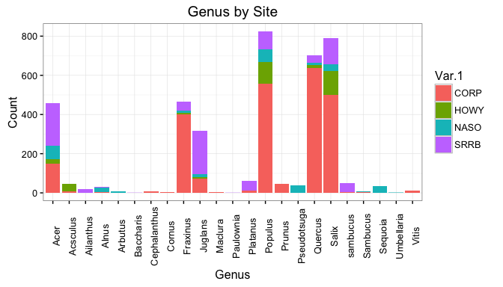

sss <- (aggregate(genfreq_m$value, by = list(Category = genfreq_m$Var.2), FUN = sum))  
 head(sss[order(-sss[,2]),], 5)

## Category x  
## 14 Populus 824  
## 18 Salix 789  
## 17 Quercus 703  
## 9 Fraxinus 467  
## 1 Acer 457

#the 5 genus with the greatest frequency are Populus (824), Salix (789), Quercus (703), Fraxinus (467), Acer (457)  
   
ripdata_s5 <- subset(ripdata, Genus == "Populus" | Genus == "Salix" | Genus == "Quercus" | Genus == "Fraxinus" | Genus == "Acer",)

#Step 3: Test for independence  
 genfreq_s5 <- table(ripdata_s5[,17],ripdata_s5[,16])  
 genfreq_s5

##   
## CORP HOWY NASO SRRB  
## Acer 149 21 69 218  
## Fraxinus 402 7 12 46  
## Populus 557 109 67 91  
## Quercus 639 14 10 40  
## Salix 499 123 35 132

chisq.test(x = genfreq_s5)

##   
## Pearson's Chi-squared test  
##   
## data: genfreq_s5  
## X-squared = 757.47, df = 12, p-value < 2.2e-16

#A p.value < 2.2e-16 is less than the .05 significance level, we reject the null hypothesis that the subset of genera is independant of site location.

#Step 4: Mapping Project location  
 ggplot(data = ripdata, aes(x = Longitude, y = Latitude)) + geom_point(aes(color = Genus, shape = ProjectID), alpha = .5) + borders("state", xlim = range(ripdata[,6]), ylim = range(ripdata[,7])) + theme_minimal() + labs(title = "Site Location and Distribution of Genera", x = "Longitude", y = "Latitude")

##   
## # ATTENTION: maps v3.0 has an updated 'world' map. #  
## # Many country borders and names have changed since 1990. #  
## # Type '?world' or 'news(package="maps")'. See README_v3. #

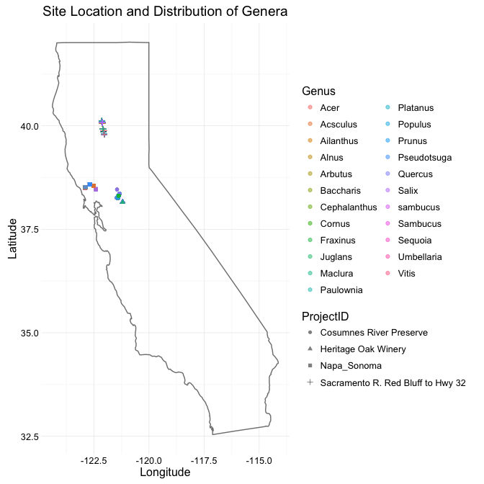

#Step 5: Save df  
 write.csv(ripdata_s5, file = "~/Desktop/Documents/Writings/Spring 2016/ES 207/Labs/Lab1/riparian_survey_subset.csv")  
   
 #Step 6: Commit to Git

**Results:**

We removed 1362 rows from the original dataset due to illogical values or unknown species name, and modified 12 rows to reflect a data input error (latitude were misrecorded as two degrees lower than actual project site latitudes). By ranking the frequency of observed genera across project sites, we determined that that the five most frequently observed genera are Populus (824), Salix (789), Quercus (703), Fraxinus (467), and Acer (457). A chisquared test of independence on these five genera vs site location leads us to reject the null hypothesis that frequency is independent of site location (P value < 2.2e-16).

**Discussion:**

The result of the chisquared test, that frequency and site location are not independent, reflects what is seen in figure 1. The Consume River Preserve site had the highest overall proportion of the five most frequent genera, followed by the Sacramento Red River Bluff site. However, frequency of occurence is not enough for us to estimate differences in carbon stocks. We could be seeing high occurances of young trees following fire.

**Limitations**:

The limitations of a chi squared test are that observations must be independant, expressed in terms of frequency, and with a count ideally greater than 50. The subset we used met all those criteria: plants could only be one genus, we transformed counts into frequency, and each subsetted genus had more than 50 observations. However, the chi squared test is unable to tell us anything about the correlation between site area and genus frequency. Further testing is necessary to determine the relationship, if any.