ASSIGNMENT – 8
Date : 24/08/16

1.When to use (Rapid Application Development) RAD model,When not to use (Rapid Application Development) RAD model.

Ans. RAD (Rapid Application Development) model can be used when,
- change requirements are accommodated.
- Product are delivered with the help of few people in shorter period of time. That is projects with short durations.
- When resources with high business knowledge are available RAD SDLC model can be choosen.
- Reusability of software components are required.
- Automated code generation are required.
- The budget is high enough to afford the cost along with the cost of automated code generating tools.

RAD (Rapid Application Development) model cannot be used when,
- There is no highly skilled developers /designers are not available.
- Customer are not willing to compromise on Quality.
- Unable to afford the cost of the modelling and automated cost generation methods.
- The customer does not require only the prototype model.

2.Define an ER diagram of a software Organization with all the relationship
model that was discussed in the classroom.

Ans. An ER diagram of a software organization
Entities: Employee
Department
Project
Item
Clients

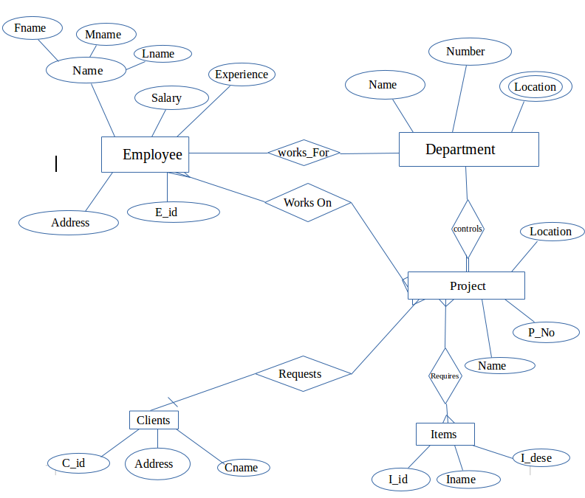

3. Describe the Entity Relationships for the following diagram.

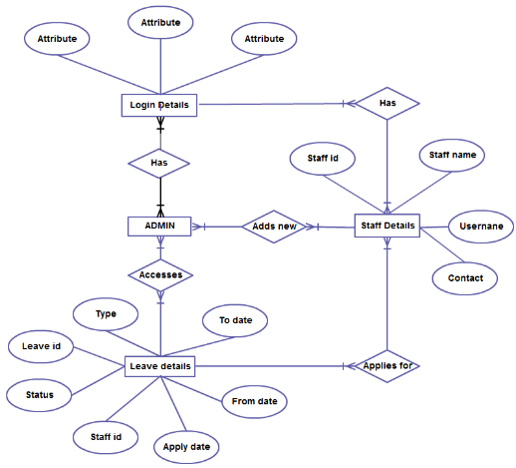

Ans.
The Entity Relationships
Login Details entity - has many to many relationship with the ADMIN.
ADMIN entity – has many to many accesses relationship with the leave details entity.
Leave details entity – has many to many applies for relationship with staff details entity.
Staff Details entity – has many to one relationship with the Login details entity.

