ASSIGNMENT -9
Date : 25/08/16

1.Draw a Use Case Diagram for an online Library Management System.

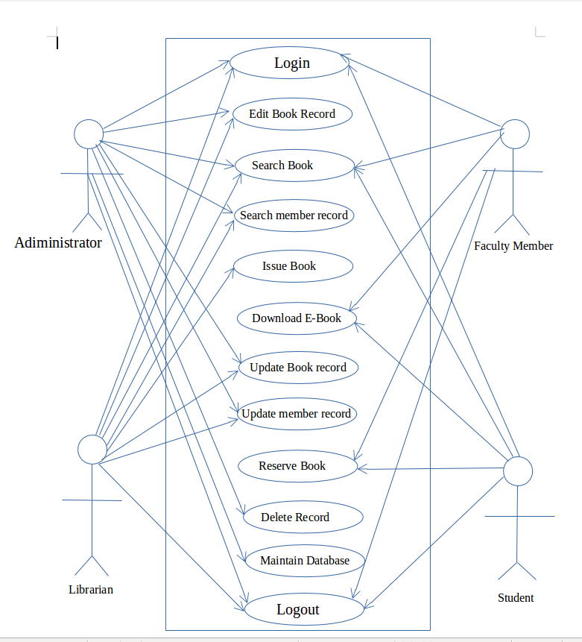

2.List down the best practices from Agile/Scrum methodology.

Ans. The best practices of Agile /Scrum methodology are
- The development processes and practices faclitated by the role of the Scrum Master.
- Then the planning of the pokers to estimate the duration of the sprint tasks.
- Daily standup meeting to discuss about the work done and on going processes on the project.
- Self organised team management (Dev team).
- Burn up and Burn down charts easily helps to know about the progress as well as the estimation and requirement.
- Ready for accepting changes as well as implimenting it.
- Collaboration within the team as well as the client ,which brings out successfull outcomes.

3.Collaboration
a.How does collaboration help agile development?

Ans. Collaboration is the key thing for Agile methodology ,if collaboration is accomplished then agile can be practiced easily. It makes the entire group to work as a team towards successful outcomes.

b.What if the team is distributed and can you achieve the same
productivity?

Ans. Even if the team is distributed yes the same productivity can be achieved through daily standup meetings which is to be carried out effectively. It helps to bring out new ideas and sort out the wrong decisions that have been made mainly through these meetings. Face to face conversation is more effective.

c.What would you do to achieve the productivity for a distributed
team?

Ans. Try to collaborate with all the teammates(all departments in the project) talk about the work process like whats going on regarding the project?is there any new changes?.
Make sure that meetings are held properly and effectively. Also collaborate with the client even through a video conference.

4.What is Sprint Zero in Agile?
Describe the activities that are done in Sprint Zero

Ans .Sprint Zero in Agile is the step in which the very initial required things are
done. The activities that are done in sprint zero are starts building up the team required for the project and setting up logistics.
Also the initial requirements and architectures envisioning are done such as identifying the scope of the project at least in the high level,requirements from the stakeholders,DFD and use case diagrams.

