EXPERIMENT 8
Question:
Write the Python program to implement DFS.
Aim
To write a Python program to implement the Depth First Search (DFS) algorithm to traverse a graph.
Algorithm
- Start the program.
- Create a graph using a dictionary.
- Start DFS from the given node.
- Mark the node as visited and print it.
- Visit each unvisited neighboring node recursively.
- Repeat until all reachable nodes are visited.
- Stop the program.
Code:
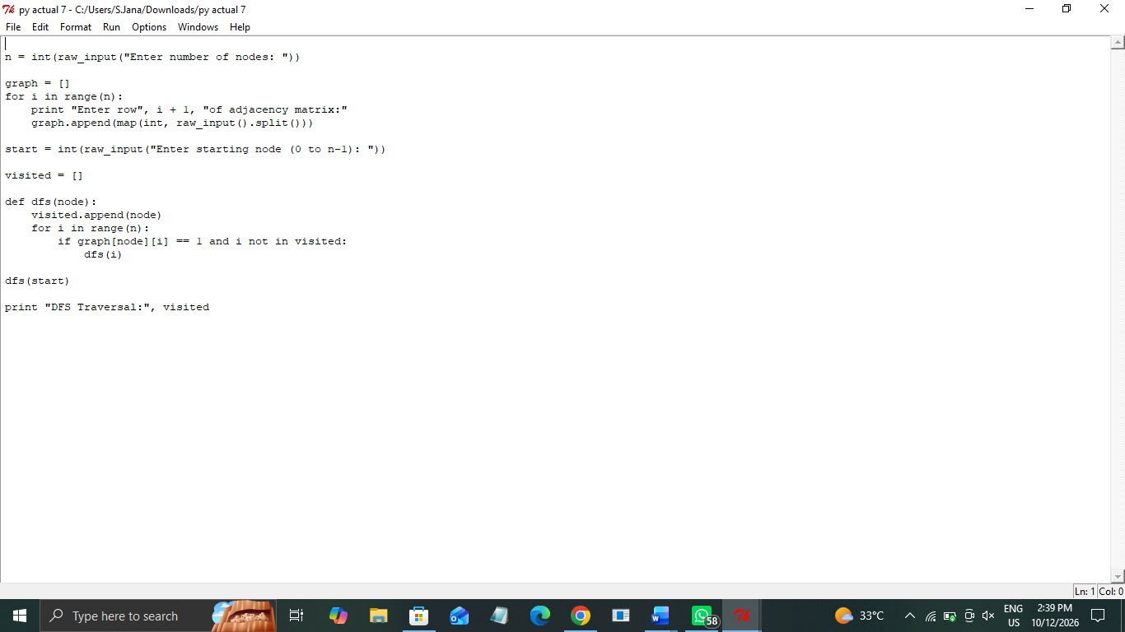

Output: 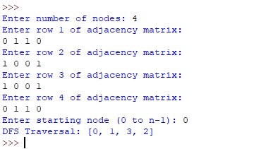

Result
Thus, the Python program to implement the Depth First Search (DFS) algorithm was executed successfully, and all reachable nodes of the graph were visited.

