EXPRIMENT 6

Question:

Write the python program for Vacuum Cleaner Problem

Aim:
To write a Python program for the vacuum cleaner problem, where an agent cleans two rooms (A and B) by sensing its location and whether the room is clean or dirty.

Algorithm:
- Start.
- Take the status of Room A and Room B (Clean or Dirty) as input.
- Take the starting location of the vacuum cleaner (A or B).
- Check the current room:
  - If the room is Dirty, then Suck (clean it).
  - Else if the location is A, then Move Right to B.
  - Else if the location is B, then Move Left to A.
- Update the room status or location after the action.
- Repeat steps 4 and 5 until both rooms are Clean.
- Stop.

Code:
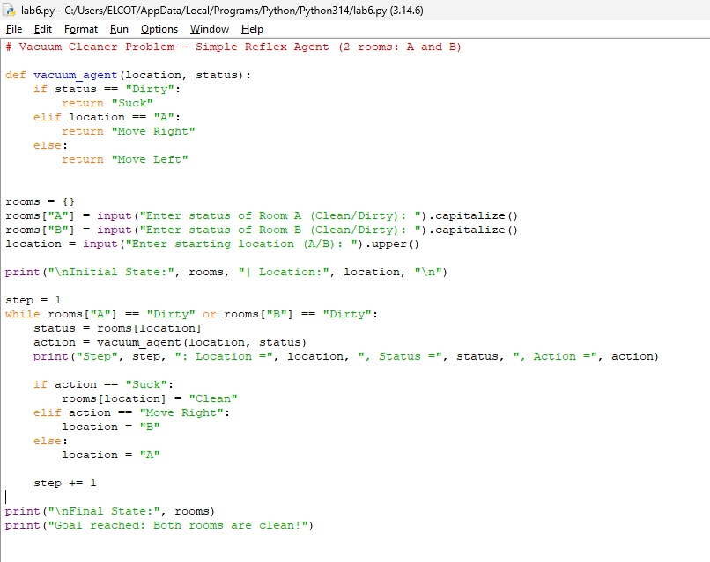

Output:

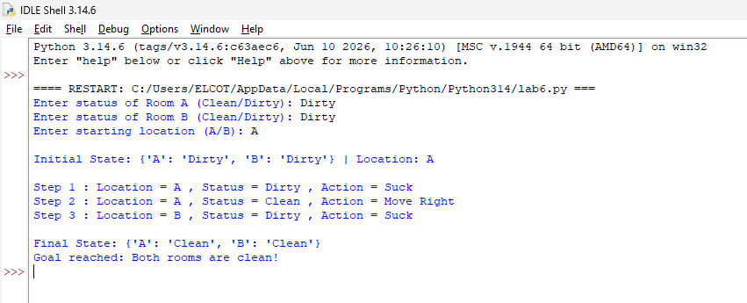

Result :
The program ran successfully.
- The vacuum cleaner started in Room A. Both rooms were dirty.
- It cleaned Room A first.
- Then it moved to Room B.
- It cleaned Room B also.
- Now both rooms were clean, so the program stopped.

