Aim
To write a Python program to solve the 8-Queen problem using the Backtracking method.

Algorithm
- Place one queen in each row.
- Check whether the position is safe.
- A queen should not be in the same column or diagonal as another queen.
- If the position is safe, place the queen.
- If no safe position is available, go back and try another position.
- Continue until all 8 queens are placed.

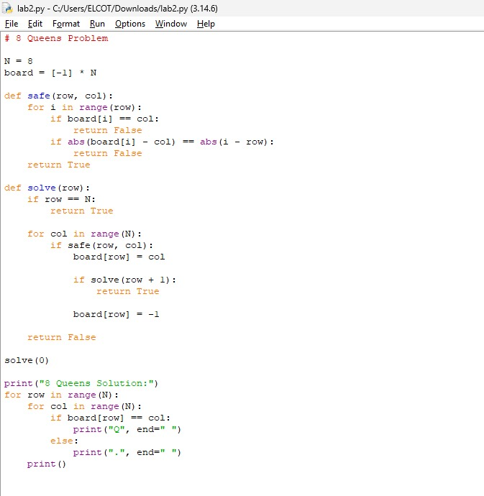

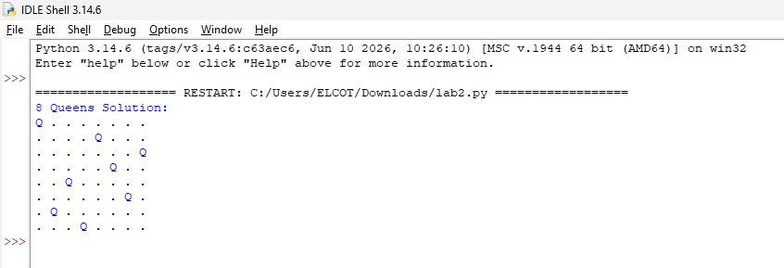

Result :
Thus, the 8-Queen problem was successfully solved using the Backtracking method in Python.

