EXPERIMENT 9
Question: Write the Python program to implement Travelling Salesman Problem.
Aim:
To write a Python program to solve the Travelling Salesman Problem and find the minimum cost tour.
Algorithm:
1. Start the program.
2. Read the distance matrix representing the distances between cities.
3. Generate all possible tours starting from the first city.
4. Calculate the total cost of each tour, including the return to the starting city.
5. Find the tour with the minimum cost.
6. Display the shortest path and minimum cost.
7. Stop the program.
Code:
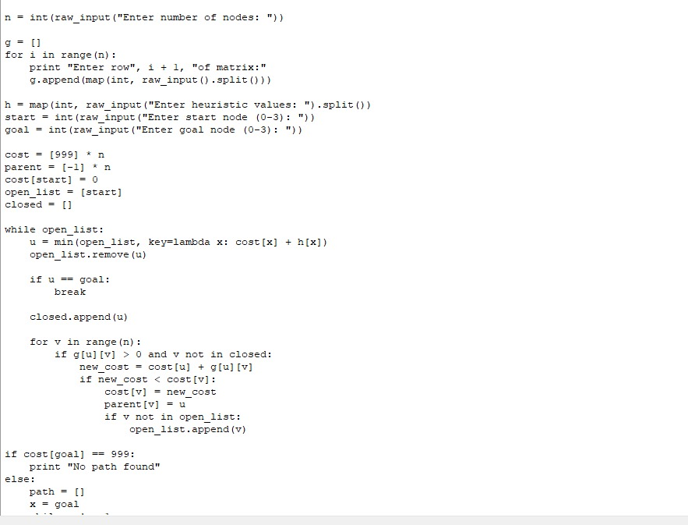

Output:

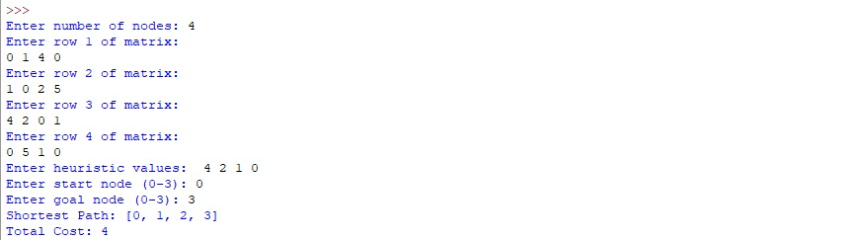

Result:
Thus, the Python program to solve the Travelling Salesman Problem was executed successfully, and the minimum cost tour was obtained.

